Ikhlaq Ahmad

Dr. Mazidi

CS 4395

March 11, 2023

Web Crawler

The knowledge base was created as a pickle file by gathering data from all the text files from different link. The data was then parsed for the most relevant and import terms. Then I manually selected, as per the instructions, and made a multi-value dictionary and dumped it as a pickle file. The dictionary was made based on the most important term that was found in the tokenized sentences.

Below (next page) have the screenshots:

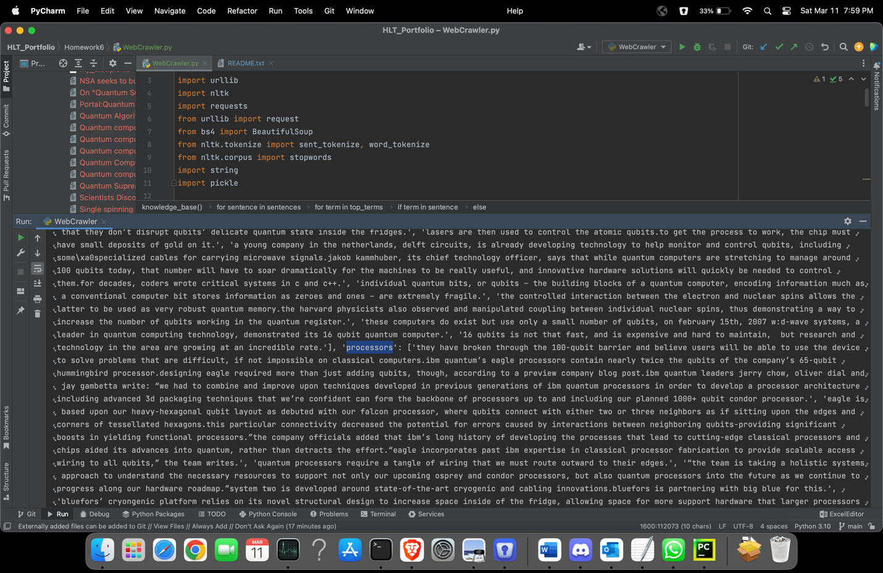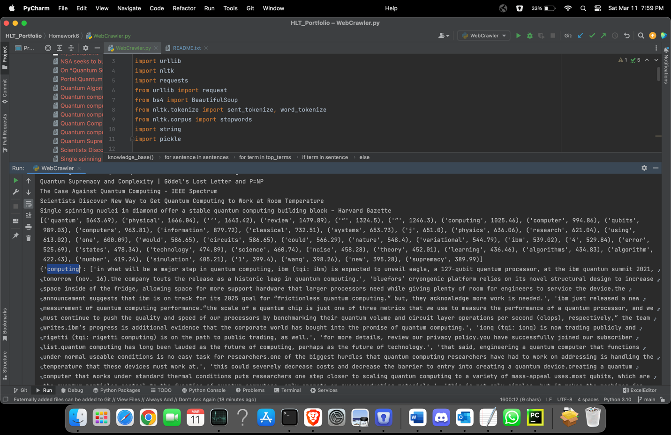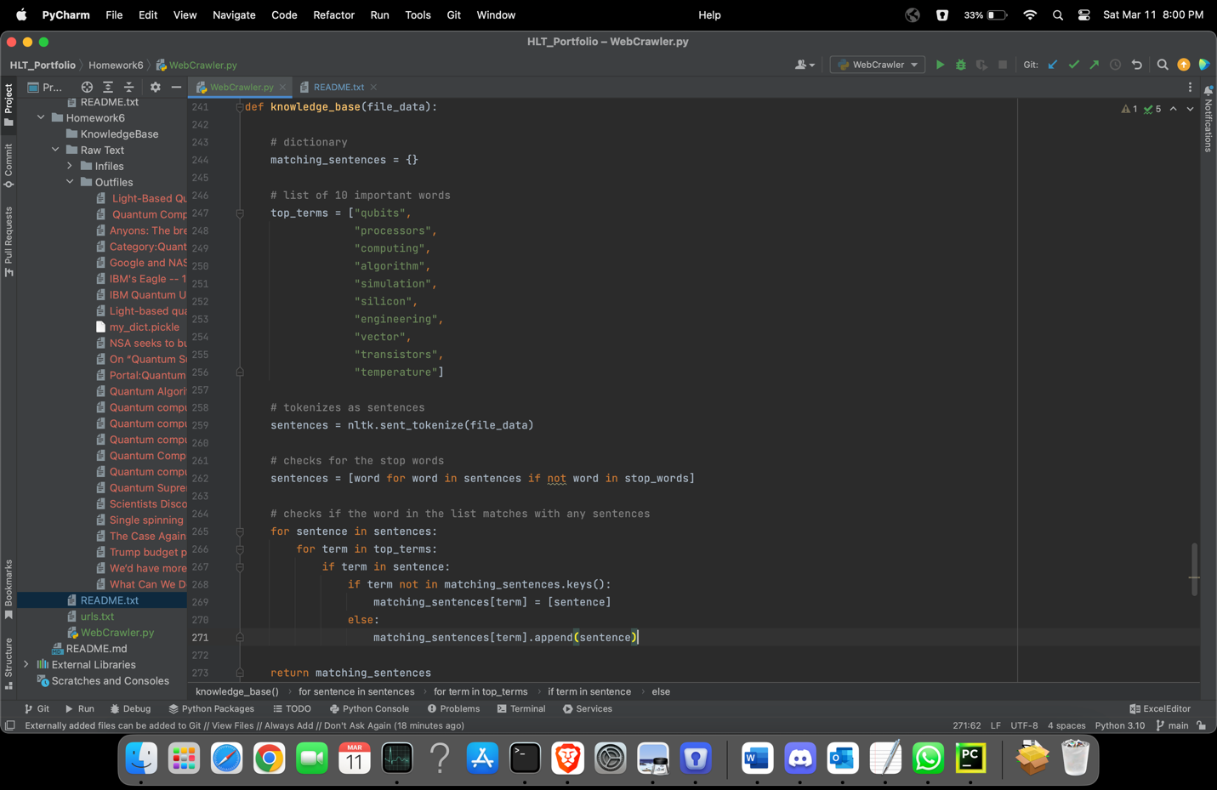

Sample dialog:

Bot: Hello, ask me anything!

User: Tell me about quantum computing

Bot: Quantum computer are super computers which use qubits to perform logical operations

User: Who has the fastest quantum computer?

Bot: According to Wikipedia, IBM has the fastest quantum computer.