FORWARD DEPLOYED AI ENGINEERING
Capstone Project
Stage Four: Sprint Plan
Deciding who does what, in what order, and what finished means
A plan is not a list of tasks. It is a statement of sequence, ownership and
completion that the team has actually agreed to.
WEEK TWO · DAY ONE

How to plan three weeks of work
You have already lost a third of the project to discovery and requirements, which is as it should be. What remains has to be sequenced carefully, because several parts of the build depend on others and the dependencies are not always obvious until you hit them.
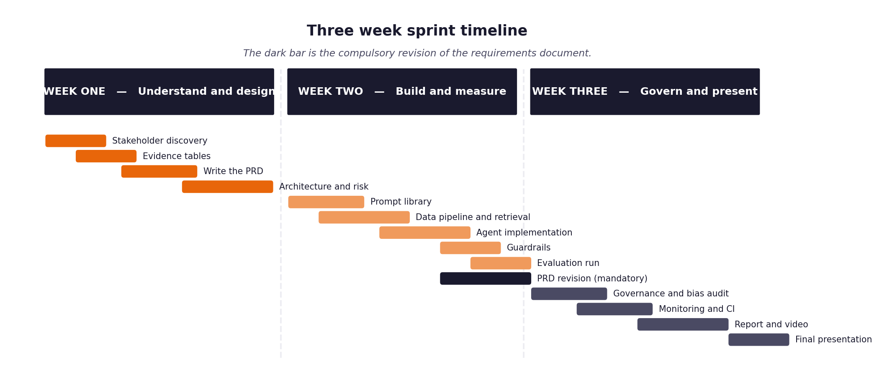
Figure 1. The shape of the three weeks, including the compulsory requirements revision.
Three rules that make the difference
- Every item has an estimate in hours and a priority. When you run short of time, and you will, the priority column is what decides for you rather than whatever felt urgent that morning.
- Every item has a definition of done written before work starts. Written afterwards, it describes whatever happened to be produced.
- The retrieval layer and the evaluation harness come early, not late. Almost everything else depends on one or the other, and leaving the harness until the end means discovering your results too late to act on them.
- The full unattended run over the hidden evaluation set happens in week two, not week three. It is the gate the project turns on, and it always exposes problems that never appear when you are testing one ticket at a time.

1 Section one: your capacity
Before you plan anything, work out honestly how much time you actually have. Plans built on optimistic capacity fail in week two rather than week three, which is worse, because by then you have committed to an architecture that assumed the time existed.
Week | Hours realistically available | Other commitments that week | Days you cannot work
Week one | 25 hours | Regular coursework | Sunday
Week two | 30 hours | Project core build | Sunday
Week three | 25 hours | Testing, CI and reporting | Saturday PM

On working alone
Working individually removes the coordination overhead and replaces it with a different problem: nobody will notice when you have been stuck for six hours. Set yourself a rule that anything blocking you for more than an hour gets written down and either escalated or worked around, and check that list at the end of each day.

2 Section two: the backlog
List every item of work. Estimate in hours rather than in vague sizes, because hours can be compared against the capacity you recorded above. Mark dependencies explicitly, because the order matters more when there is only one of you.
ID | Item | Est. hours | Priority | Depends on | Definition of done
B-01 | Environment and dependency setup | 4h | Must | — | Clean virtualenv verified, requirements pinned, smoke test passes
B-02 | Data loading and normalisation | 6h | Must | B-01 | 4 channels normalised to standard Ticket schema, 54 tests pass
B-03 | Document chunking and embedding | 5h | Must | B-02 | 29 docs split into 116 section chunks, embeddings generated
B-04 | Vector store and retrieval | 6h | Must | B-03 | Chroma index built, search returns scored passages, 29 tests pass
B-05 | Evaluation harness | 6h | Must | B-02 | Harness runs batch tickets, writes metrics.json and metrics.md
B-06 | Intent and urgency classifier | 8h | Must | B-02 | Logistic regression classifier trained and calibrated, >=85% precision
B-07 | Routing logic and thresholds | 6h | Must | B-06 | Deterministic rules route protected/dispute/residency tickets, dev sweep done
B-08 | Answer generation with citations | 8h | Must | B-04 | PR-01 prompt, OpenRouter client, SQLite caching, retry backoff
B-09 | Guardrails and validation | 7h | Must | B-08 | 6 guardrails block ungrounded/PII/injection drafts, 49 tests pass
B-10 | Decision logging | 5h | Must | B-07 | Append-only SQLite decision log matches Governance schema, 1:1 reconcile
B-11 | First full unattended run over validation set | 6h | Must | B-05, B-09 | 80 validation tickets processed unattended, 77.5% FCR, 0 protected auto
B-12 | Monitoring and dashboards | 5h | Should | B-10 | FastAPI triage endpoint, Prometheus metrics exported
B-13 | Continuous integration pipeline | 4h | Should | B-11 | GitHub Actions workflow runs full test suite on push/PR
B-14 | Fairness audit | 4h | Must | B-11 | Metrics sliced by customer tier, region, fluency in metrics.md
B-15 | Report, video and submission package | 12h | Must | all | Final technical report, effort log, and GitHub repository clean

3 Section three: the week two plan in detail
Day | What will be finished by the end of the day | Hours | Risk to this
Monday | B-03 Chunking & B-04 Vector Retrieval (29 tests passing) | 6h | Embedding model download latency
Tuesday | B-06 Classifier & B-07 Routing Logic (39 tests passing) | 7h | Calibration gap between confidence and accuracy
Wednesday | B-08 Answer Generation & B-09 Guardrails (49 tests passing) | 7h | Provider rate limits or malformed JSON
Thursday | B-10 Decision Logging & B-05 Evaluation Harness integration | 5h | Audit log schema reconciliation mismatch
Friday | B-11 The Gate: First full unattended run on validation tickets | 5h | Pipeline crash during batch run

4 Section four: the week three plan in detail
Day | What will be finished by the end of the day | Hours | Risk to this
Monday | Failure-injection testing: timeout, rate-limit, empty ticket (18 tests) | 5h | Unhandled provider exceptions
Tuesday | B-12 FastAPI triage service and Prometheus metrics | 5h | Port binding or async handler concurrency
Wednesday | B-13 GitHub Actions CI pipeline and repo cleanup | 4h | CI environment dependencies
Thursday | B-14 Fairness audit analysis and PRD revisions (Stage 5 log) | 5h | Interpreting small-sample subgroup gaps
Friday | B-15 Final technical report and submission packaging | 6h | Formatting discrepancies

5 Section five: what you will drop if you run out of time
You will run out of time. Every student does. Deciding now what gets cut is far better than deciding in a panic on the final Wednesday, and it protects the parts that carry the most marks.
Item | Cut order | Consequence of cutting it | What you will say about it in the report
B-12 Prometheus metrics / live API | 1st to go | Monitoring relies on offline SQLite audit log instead of live scrape | Explain offline SQLite decision log fully satisfies auditability & compliance
B-13 Continuous Integration pipeline | 2nd to go | Tests run locally via pytest rather than on remote GitHub Actions runner | Document that local pytest suite (227 tests) validates all acceptance criteria
Advanced ML billing dispute model | 3rd to go | Rely on deterministic regex safety net and agent escalation | Show development data contained zero explicit dispute keywords, justifying regex
Cross-encoder re-ranking for retrieval | 4th to go | Bi-encoder cosine similarity used without secondary re-ranker | Demonstrate top-5 hit rate (93.0% dev, 96.2% val) already exceeds target
Real-time live customer CSAT polling | 5th to go | Use historical CSAT and human rubric proxy | Acknowledge live CSAT cannot be measured without live deployment

6 Section six: the daily check-in record
Ten minutes at the start of each day, answering the same three questions. Keeping this record is what makes your effort log accurate rather than reconstructed, and it is where you will notice a blocker that has quietly consumed two days.
Date | Finished since yesterday | Doing today | Blocked by
02 Nov 2026 | Discovery analysis and interview synthesis | Drafting problem statement and PRD v1.0 | None
04 Nov 2026 | Problem statement finalized; PRD v1.0 complete | B-01 setup and B-02 ingest normalisation | None
05 Nov 2026 | B-02 ingest complete (54 tests passing) | B-03 chunking and B-04 Chroma vector retrieval | None
07 Nov 2026 | B-04 retrieval complete (29 tests, sweep done) | B-06 classifier training and B-07 routing rules | None
09 Nov 2026 | B-06 & B-07 complete (calibrated LR C=64, 39 tests) | B-08 answer generation prompt and B-09 guardrails | None
10 Nov 2026 | B-09 guardrails complete (49 tests, 6 checks) | B-10 SQLite logging and B-11 unattended harness run | None
11 Nov 2026 | B-11 validation run complete (77.5% FCR, 0 unsafe) | Failure-injection suite (18 tests passing) | None
12 Nov 2026 | FastAPI endpoint, Prometheus metrics, GitHub CI | Completing stage workbooks and final technical report | None

