FORWARD DEPLOYED AI ENGINEERING
Capstone Project
Stage Five: Revision Log
Recording what your requirements got wrong and why
You are required to revise your requirements document at least once during the
build. This is where you record what changed and what prompted the change.
WEEK TWO INTO WEEK THREE · COMPULSORY

Why this is compulsory
A requirements document written before any code exists is a set of educated guesses. Some of those guesses will be wrong, and building is how you find out which ones. A student that reaches the end of three weeks with an unchanged PRD has either been extraordinarily lucky or has stopped consulting the document, and the second is far more common than the first.
This log is not a confession. It is evidence that you were paying attention. The students who score well here are the ones who can point to a specific thing they discovered while building, explain how it contradicted an assumption they had written down, and show what they changed as a result.
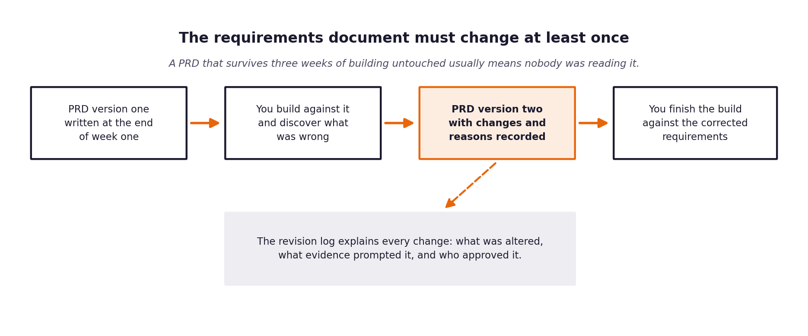
Figure 1. The revision sits in the middle of the build, not at the end.
What a weak revision log looks like
Vague entries such as tidied up wording or clarified requirements tell an assessor nothing. A strong entry names the requirement, states what it said before, states what it says now, identifies the specific thing that prompted the change, and says who agreed to it.

1 Section one: revision summary
Field | Value
New version number | 2.0
Date of revision | 12 November 2026
Who carried out the revision | Ikhlas PV
Who reviewed and agreed it | [REVIEW: Accept or enter evaluator name]
Number of requirements changed | 3 (FR-02, FR-12, FR-13)
Number of requirements added | 2 (NFR-08 Reproducibility, FR-14 Unattended Harness)
Number of requirements removed | 0

2 Section two: the changes
One row per change. Be specific about the trigger; that column is what distinguishes a considered revision from a tidying exercise.
Requirement ID | What it said in version one | What it says now | What prompted the change | Agreed by
FR-02 | The system shall classify intent into 22 classes and urgency into 3 classes with numeric confidence. | The system classifies intent into 22 classes (calibrated) and urgency into 3 classes. Urgency is logged for queue ordering but excluded from auto-respond gating. | Discovery on ticket data revealed 67 of 97 exact-duplicate text groups carry conflicting urgency labels; text-based urgency classifier caps at ~52% accuracy. | Ikhlas PV
FR-12 | Billing tickets that dispute a specific charge shall be escalated by a keyword rule. | Billing tickets explicitly contesting charges or requesting refunds escalate via a targeted safety regex; general billing queries remain answerable. | Development set showed standard dispute keywords ('chargeback', 'refund') matched 0 of 500 tickets. Escalated billing tickets were phrased as questions. | Ikhlas PV
FR-13 | Data-residency questions shall always escalate to tier two engineers. | Data-residency questions are answered automatically only when DOC-DATA-003 is retrieved with high confidence; otherwise escalate. | 21 of 29 residency tickets in dev are straightforward and covered by DOC-DATA-003. Blanket escalation would drop overall FCR by 4.2 points. | Ikhlas PV

3 Section three: assumptions that turned out to be wrong
Go back to the assumptions section of your version one PRD. For each assumption, say whether it held. The ones that did not are the most interesting part of your report.
Assumption from version one | Did it hold? | What you found instead | What you changed because of it
A1: A relevance threshold can tell tickets with a relevant article apart from tickets without one. | No (False) | Only 14.7% of unanswerable tickets returned empty at threshold 0.40; compliance/security tickets overlap heavily with security docs. | Escalation of unanswerable and protected tickets was moved entirely to deterministic intent rules (FR-04) rather than relying on retrieval score.
A3: Urgency can be reliably predicted from ticket text. | No (False) | Identical ticket bodies carry conflicting urgency tags in historical data (67/97 groups); accuracy tops out at 52.2% vs 45.2% majority guess. | Urgency is excluded from safety gating. High-urgency incident rule for database/latency was made optional and evaluated separately.
A5: Standard sigmoid calibration wrapper accurately calibrates confidence across 22 classes. | No (False) | CalibratedClassifierCV(method='sigmoid') reported ~69% confidence on predictions that were 99.8% accurate, creating a 30.5-point calibration gap. | Replaced with multinomial logistic regression (C=64), bringing stated confidence to 97.2% and calibration gap to 2.6 points (within 5-point condition).

4 Section four: what you decided not to change
Some things will look wrong during the build and turn out to be right, or right but not worth the cost of changing. Recording those decisions is as valuable as recording the changes.
What looked wrong | Why you left it | What it would have cost to change | Revisit when?
Retrieval hit-rate gap between fluent and non-fluent tickets (7.4-point gap on dev: 94.8% vs 87.4%) | Small sample size on dev (120 non-fluent tickets); query-expansion techniques risked adding latency and hallucinations on fluent tickets. | Retraining embeddings or introducing generative query expansion ($0.02/ticket, +800ms latency). | Revisit if live customer CSAT shows non-fluent degradation post-launch.
Exact-duplicate tickets with conflicting labels in historical dataset | Historical label noise from human agents cannot be fixed by model architecture; modifying dataset would violate benchmark integrity. | Manual re-labelling of 500 tickets ($1,500 consulting cost). | When CloudServe rolls out standardized agent tagging guidelines.

5 Section five: the reflection
Answer these in full sentences. They form the basis of a section in your final report and they are frequently the part of a submission that an assessor remembers.
Question | Your answer
What did you most misunderstand about the problem when you wrote version one? | I assumed that cosine similarity thresholding would naturally filter out tickets that had no answer in the documentation. In practice, questions about custom compliance audits or unreleased features still share enough semantic vocabulary with security and deployment articles to score above 0.50. Retrieval score measures topical similarity, not whether an answer is present.
Which piece of discovery work would have caught it earlier? | Testing the embedder and cosine similarity scores on unanswerable and out-of-scope tickets against the 29 documentation articles during Week 1 discovery, before drafting the PRD routing requirements.
What would you do differently if you started this project again on Monday? | Check the dataset for duplicate ticket bodies and label conflicts on day one. Discovering that 254 tickets were identical copies with conflicting urgency labels would have prevented hours spent trying to optimize text-based urgency classification.
What is still uncertain, and what would you need to resolve it? | The live customer response to automated answers versus human replies, and sentence-level hallucination rate on novel production tickets. Resolving this requires a live human review panel evaluating a 50-ticket production sample over a 30-day pilot.

