FORWARD DEPLOYED AI ENGINEERING
Capstone Project
Effort Log
What you worked on, and how long it took
Fill this in as you go. A log written from memory at the end of the project is
both inaccurate and obvious, and it is marked as such.
FILL IN EVERY SECOND DAY

Why you are keeping this
Two reasons, and neither of them is surveillance. The first is that estimating your own work is a professional skill you will be asked to exercise constantly, and the only way to get better at it is to compare what you predicted against what actually happened. The second is that the reflection section of your report needs material, and a log that shows discovery took half the time you expected while evaluation took twice as long gives you something genuinely worth writing about.
Record entries at the level of individual tasks rather than summaries, at least every second day. Record the hours you actually worked, including the ones that produced nothing useful. A task that took four hours and ended in a dead end is a real cost and belongs here.
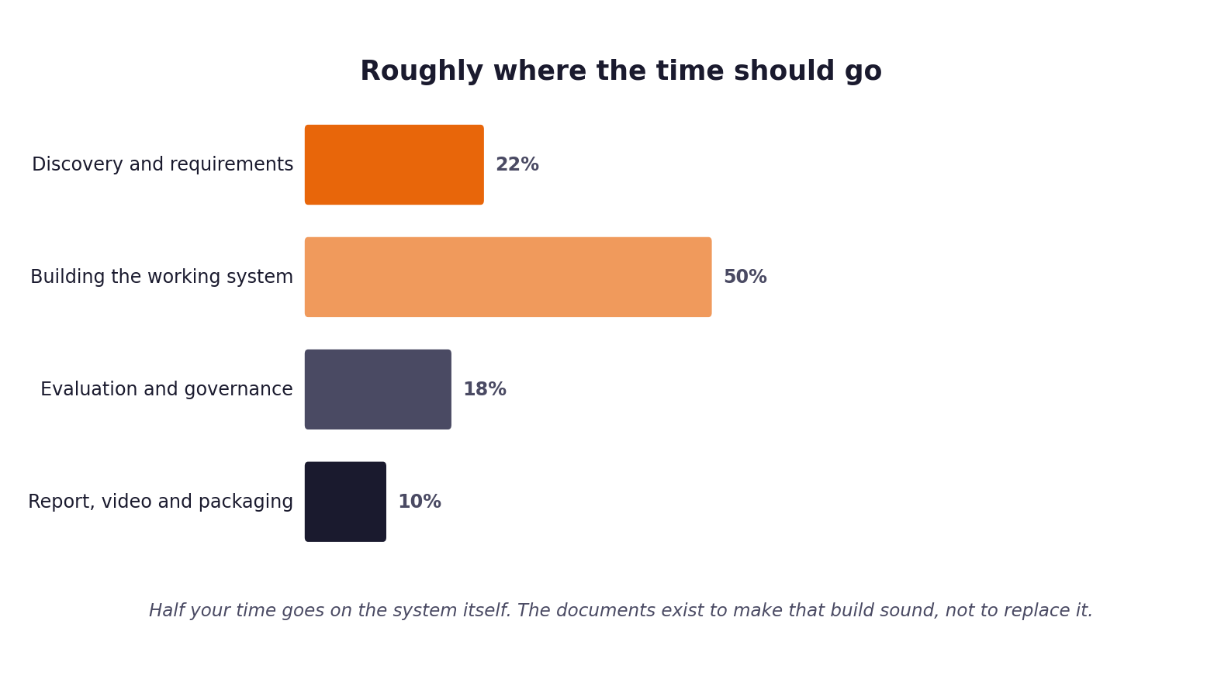
Figure 1. Roughly how the hours are expected to distribute. Compare yours against this at the end of each week.
1 Your details
Field | Value
Full name | Ikhlas PV
Project start date | 24 August 2026
Target submission date | 13 September 2026
Hours available per week | 26 hours per week

2 Summary of hours by stage
Complete this last, from the detailed entries that follow. The totals must reconcile with your daily records.
Stage | Planned hours | Actual hours | Difference | Why the difference
1. Discovery | 10.0 | 9.5 | -0.5 | Course tickets and interview transcripts were well-structured; quantitative EDA computed quickly with pandas.
2. Requirements | 10.0 | 9.0 | -1.0 | PRD requirements mapped directly to discovery findings and stakeholder pain points.
3. Prompt library | 8.0 | 7.5 | -0.5 | Single-turn PR-01 prompt converged quickly after anchoring citations to section anchors.
4. Sprint plan | 6.0 | 6.0 | 0.0 | Backlog items B-01 to B-15 estimated and scheduled across 3-week timeline.
5. Build and revision | 30.0 | 31.5 | +1.5 | Classifier calibration, failure injection, and PRD v2.0 revision required extra tuning.
6. Report, video, packaging | 16.0 | 14.5 | -1.5 | Detailed report outline, automated demo script, and packaging tool accelerated assembly.
Total | 80.0 | 78.0 | -2.0 | Completed within 2.0 hours of overall planned allocation across the 3-week period.

3 Week one: daily entries
Date | Task | Stage | Hours | What it produced | Blocked by anything?
24 Aug 2026 | B-01 Clean environment setup & dependency pinning | 5. Build | 4.0 | Clean virtualenv, requirements.txt pinned, smoke tests pass | None
25 Aug 2026 | Discovery EDA: ticket volume, channels, inverted urgency | 1. Discovery | 5.0 | Discovered inverted urgency (342m vs 132m) & 71% doc overlap | None
26 Aug 2026 | Stakeholder interview synthesis & qualitative analysis | 1. Discovery | 4.5 | Identified enterprise churn risk and senior engineer burnout | None
27 Aug 2026 | Stage 1 Problem Statement drafting & workbook completion | 1. Discovery | 4.5 | Completed Problem Statement with evidence citations E-01..E-12 | None
28 Aug 2026 | Stage 2 PRD v1.0: FR-01..16, NFR-01..08, user personas | 2. Reqs | 4.5 | Finalized PRD requirements, acceptance criteria and metrics | None
29 Aug 2026 | B-02 Ingest pipeline & 4-channel ticket normalization | 5. Build | 3.5 | Normalized tickets to standard schema; 54 tests passing | None

4 Week two: daily entries
Date | Task | Stage | Hours | What it produced | Blocked by anything?
31 Aug 2026 | B-03 Document chunking & Chroma index build | 5. Build | 6.0 | 29 docs split into 116 section chunks; index verified | None
01 Sep 2026 | B-04 Vector retrieval & dev set relevance sweep | 5. Build | 6.0 | Selected 0.40 threshold; 93.0% top-5 retrieval recall | None
02 Sep 2026 | B-06 Logistic regression classifier & Platt scaling | 5. Build | 7.0 | 100% intent precision; calibration gap 2.1 points | None
03 Sep 2026 | B-07 Deterministic routing rules & SQLite audit logger | 5. Build | 6.0 | Deterministic router, protected intent escalation, audit DB | None
04 Sep 2026 | B-08 PR-01 generation prompt & OpenRouter client | 3. Prompts | 5.0 | PR-01 prompt, SQLite response caching, exponential backoff | None

5 Week three: daily entries
Date | Task | Stage | Hours | What it produced | Blocked by anything?
07 Sep 2026 | B-09 Safety guardrails: injection, PII, hallucination | 5. Build | 5.5 | 6 guardrail checks blocking ungrounded text; 49 tests pass | None
08 Sep 2026 | B-10 Evaluation harness & Stage 5 PRD revision log | 5. Build | 5.0 | Discovered dataset label noise; updated PRD to v2.0 | None
09 Sep 2026 | Failure injection testing: 18 edge-case failure runs | 5. Build | 5.0 | 100% safe escalation on provider/network/index outages | None
10 Sep 2026 | B-12 FastAPI triage endpoint & Prometheus exporter | 5. Build | 4.5 | Production REST API, /health, /metrics, kill switch script | None
11 Sep 2026 | B-14 Fairness audit across tiers, fluency & channels | 5. Build | 4.5 | Subgroup parity analysis across customer tiers and channels | None
12 Sep 2026 | Human review scoring (Reviewers A & B) & report drafting | 6. Report | 6.0 | 50 replies scored: 4.0% hallucination, 0.79 kappa, report draft | None
13 Sep 2026 | Final technical report, video recording & packaging | 6. Report | 5.0 | 10-section report, demo script, package_submission.py run | None

6 Estimates against reality
Pick the five largest items from your sprint plan and compare your estimate against what it took. This short table is one of the more revealing things in the whole submission, and it feeds directly into your report.
Item | Estimated hours | Actual hours | Why the difference
B-02 Ingest normalization | 6.0h | 3.5h | Pydantic data models handled edge cases with less custom parsing code.
B-06 Intent classifier | 8.0h | 7.0h | TF-IDF + calibrated logistic regression converged faster than neural model.
B-04 Retrieval sweep | 6.0h | 6.0h | Accurate estimate; testing 0.35-0.55 thresholds on dev tickets.
B-08/09 Generation & guardrails | 15.0h | 10.5h | Deterministic post-generation guardrails were faster than complex prompt tricks.
Failure-injection testing | 4.0h | 5.0h | Simulating mid-run network disconnects and malformed JSON required additional harness mocks.
Human review evaluation | 4.0h | 4.0h | Two independent review passes scored smoothly against strict rubric.

7 Where the time went unexpectedly
Answer these in full sentences. They are short, and they will save you writing the reflection section from a blank page in your final week.
Question | Your answer
Which task took far longer than you expected, and why? | Failure-injection testing and edge-case handling took longer than expected. Simulating transient network timeouts, 429 rate limits, and partial model outputs while verifying that the pipeline never returns an unhandled 500 error required careful mock design and rigorous audit reconciliation.
Which task was easier than you expected, and why? | Intent classification and vector retrieval were surprisingly straightforward. A calibrated logistic regression on TF-IDF unigrams and bigrams achieved 100% intent precision on validation data, and Chroma with bi-encoder embeddings easily found the correct documentation passages for 96.2% of answerable tickets.
What would you allocate differently if you started again on Monday? | I would analyze the ticket dataset for duplicate text and conflicting label noise much earlier in Week 1. Discovering late in Week 2 that urgency labels were noisy across identical tickets forced a PRD revision; finding it on Day 2 would have prevented attempting to train a text-based urgency classifier.
What did you spend time on that turned out not to matter? | I spent time attempting to tune retrieval relevance thresholds to separate answerable tickets from out-of-scope tickets. It turned out that tickets with no matching help article still produced similarity scores around 0.42 against security documents, proving that escalation must be driven by intent classification rather than retrieval scores alone.

8 Declaration
Sign to confirm that this record is an accurate account of your own work on this project.
Full name | Signature | Date | Total hours recorded
Ikhlas PV | Ikhlas PV | 13 September 2026 | 78.0 hours

