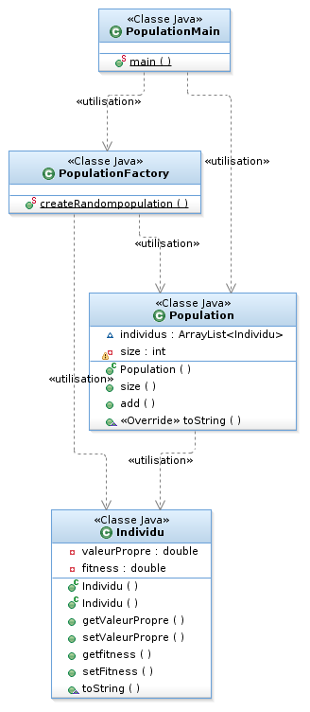

Diagramme Tme1

---------------------------------------------------------------------------------

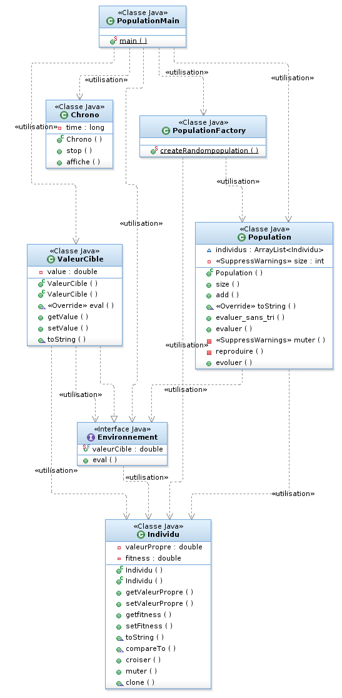

Diagramme Tme2

--------------------------------------------------------------

Diagramme Tme3

-----------------------------------------------------------------------------

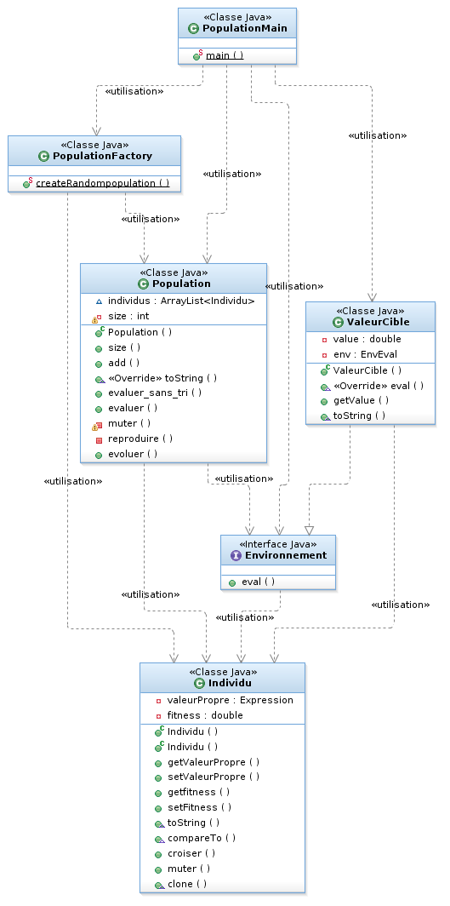

Diagramme Tme4_pobj.algogen1

Diagramme Tme4_pobj.arith2

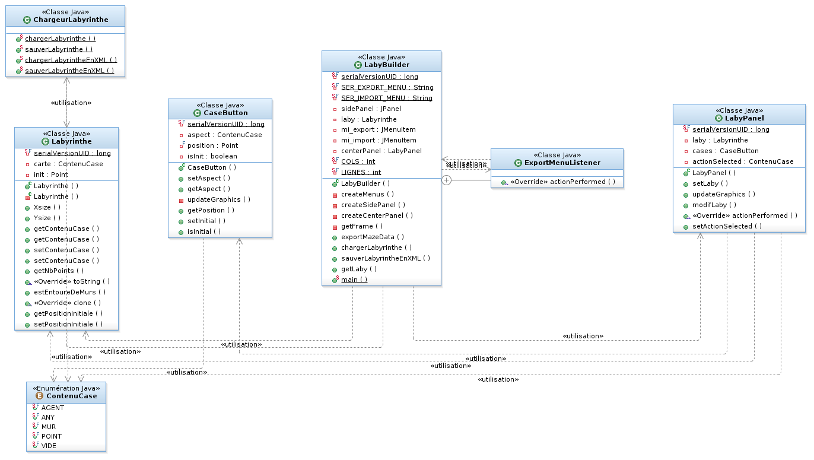
Diagramme Tme5_agent.laby

____________________________________________________________

Diagramme Tme5_agent&control

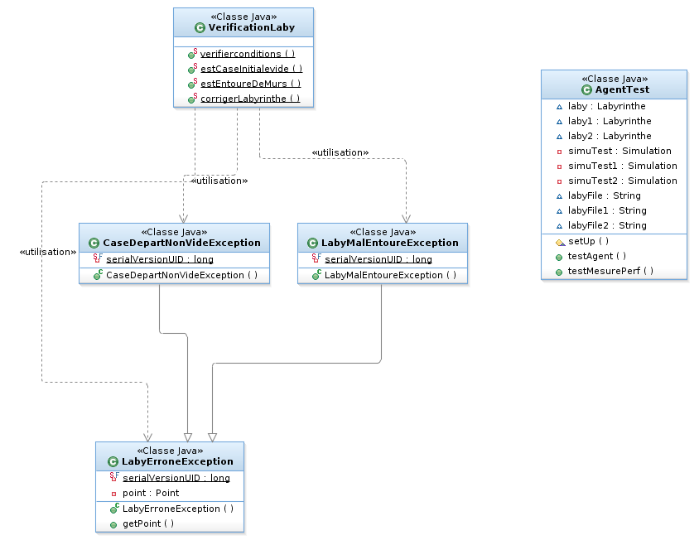

Diagramme Tme5_Exception & agent_test

Diagramme Tme6 uml_pobj_arith

Diagramme Tme6 uml_pobj_algogen

----------------------------------------------------------------

Diagramme Tme6 uml_pobj_algogen.adapter

------------------------------------------------------------------------------------

Diagramme Tme7 oberver

Diagramme Tme8_ Iterator

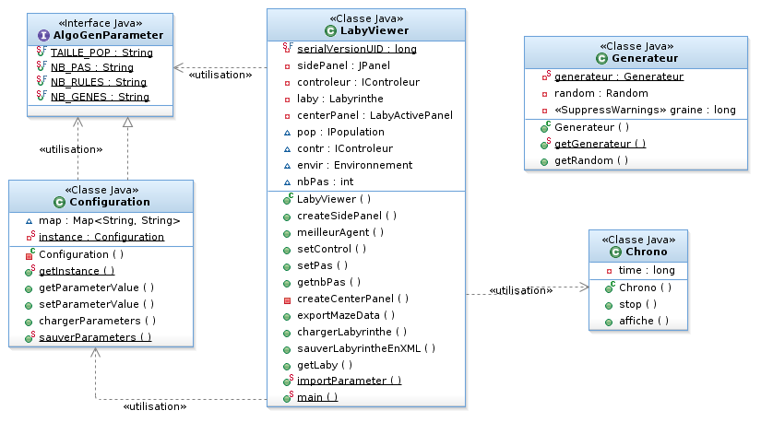

Diagramme Tme9_Singleton

