**Kemenristek Dikti Nomor: 108/KPT/I/2018**

 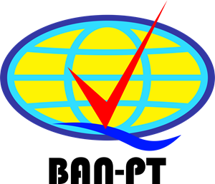

**Tahun Lulus  
Date of Graduation  
25 Juli 2018**

**Nomor Pokok Mahasiswa  
STUDENT NUMBER  
14155066**

**Lahir di  
BORN IN  
Sukabumi, Indonesia 10/09/1995**



**Wakil Rektor Bidang Akademik**

**VICE RECTOR OF ACADEMIC**

**Prof. Dr. Ir. H. Koesmawan, M.Sc, MBA, DBA**

**Program Studi Sistem Informasi**

**INFORMATION SYSTEM STUDY PROGRAM**

**IJAZAH**

**CERTIFICATE**

**ZAENAL ALAMSYAH**

**Dr. H. Kurniawan, ST, M.Si, MM.**

**Rektor**

**RECTOR**

**Diberikan dan ditetapkan di**

**ISSUED AND SPECIFIED IN**

**Sukabumi, 20 December 2018**

**Beserta segala hak dan kewajiban melekat pada gelar tersebut**

**WITH ALL THE RIGHTS AND OBLIGATION THERE ATTACHED**

**Kepadanya diberikan gelar**

**IS THEREFORE AWARDED OF**

**Sarjana Komputer ( S.Kom )**

**Yang telah mengikuti pendidikan Program Sarjana**

**HAVING FULFILLED ALL THE REQUIREMENT OF THE UNDERGRADUATE DEGREE**

**diberikan kepada**

**PRESENTED TO**

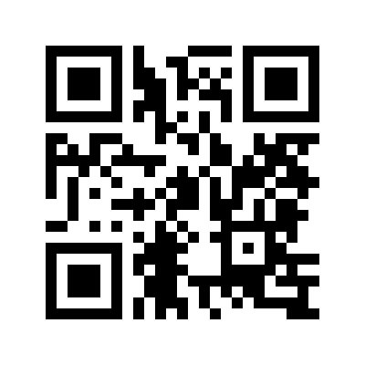

**UN6.0004 I 47/B30.000883**

**Nomor**

**NUMBER:**