***Research Question:***

Is there growth for evolution of Africa’s Mobile Industry?

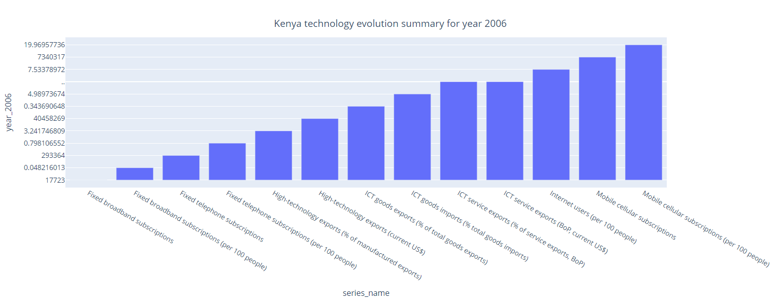

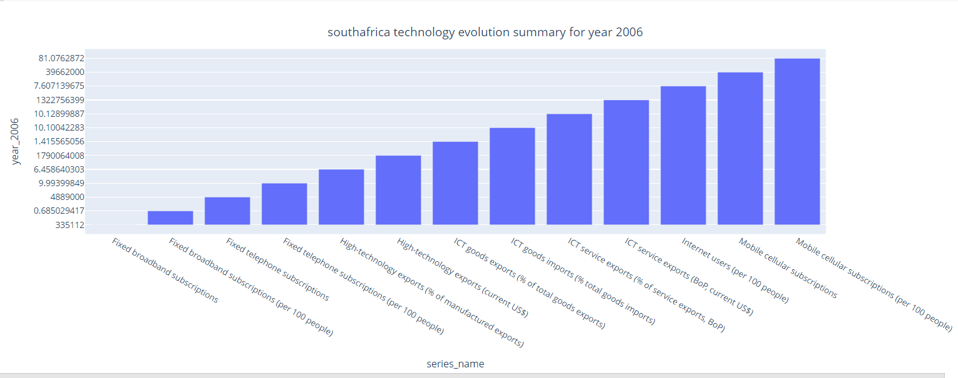

To digest and appreciate if there is room for growth in the evolution of Africa’s mobile industry, I biased my interests on Kenya and South Africa.

From above fig, we can note that there is an upward trend for the uptake in technology/mobile in the Africa industry.

Interests in Fixed telephone subscriptions are rising in both countries (Kenya and South Africa) and Africa in general, however, at a much slower rate compared to mobile subscriptions. This is based on the consensus that over the years technology has greatly advanced from 2G through 5G. Fixed telephone subscriptions based on 2G are relatively old and the uptake would not be as great throughout Africa in comparison to other newer technologies UMTS(3G), LTE (4G) and 5G.

Africa’s population is largely comprised of the youth i.e. below 40years stretched to 50years. As such, this generation is interested in the advancements currently being experienced in the world i.e. from various mobile apps to IOT solutions and even near real time evolutions. Thus, there is hunger by the youth to indulge in new technologies for increased customer experience;

i)Keeping in touch and sharing of data. The youth who comprise the majority population in Africa are now connected via various mobile applications e.g. whatsapp, Instagram, imo lite and such like just to mention a few. From the figs above for Kenya and South Africa, there is a growing trend in internet users ( per 100 people) meaning more and more people are getting connected to the internet and to the world at large. This obviously dictates that as human beings we are conforming to our social being of keeping in touch, connected and sharing data.

ii)Trade. Above figures also portray an increase in ICT goods imports, ICT service imports, ICT goods exports and even high technology exports. This depicts a positive reflection of the evolution of Africa’s mobile industry since there is a lot of trade based on mobile technology; the exports and imports allow for revenue generation not only for consumers but also enterprises. In addition to that, the governments in Africa gain in tax for the various series in technology evolution. This increase in trade allows for other direct related services that progress hand in hand with the mobile industry evolution such as customer service support for the IOT and other services.

iii) Employment. From the figures above, with the increase in ICT goods imports, ICT service imports, ICT goods exports and even high technology exports, human resource will increase to handle the demand in the growing mobile industry evolution in Africa. As such, we have seen the rise of many companies from the period year 2006 – 2016 provided in the data set…companies such as Safaricom, Airtel , Zuku, Premium rate service providers, content provides etc. Moreover, there have been a rise in ICT incubation centers, Ihubs and training centers like Moringa. All these have provided a source of employment majorly to the youth and also as a source of tax to the government.

***My recommendation:***

There is still a lot of room in the ICT space in Africa and at large evolution of Africa’s mobile industry. Thus, both consumer and enterprise investment is encouraged in Africa with a promising return in positive uptake of technology services in the various series’ portrayed in the figures above.