* 1. Installation

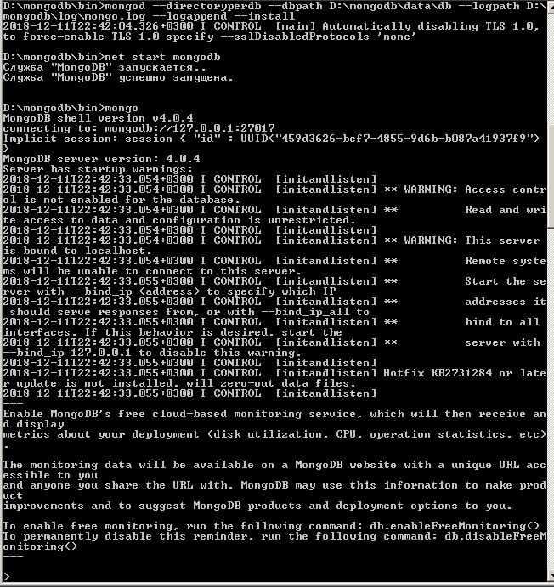

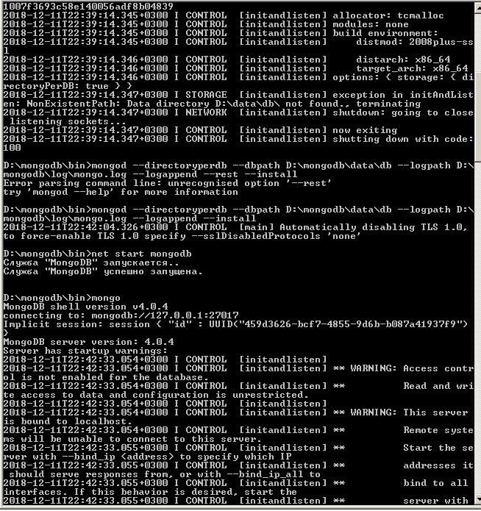

Check loaded DB:

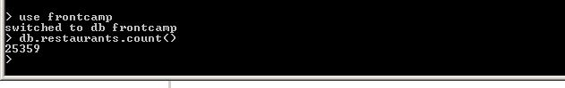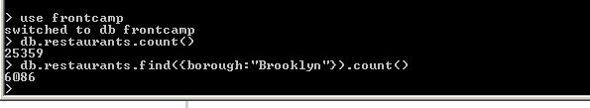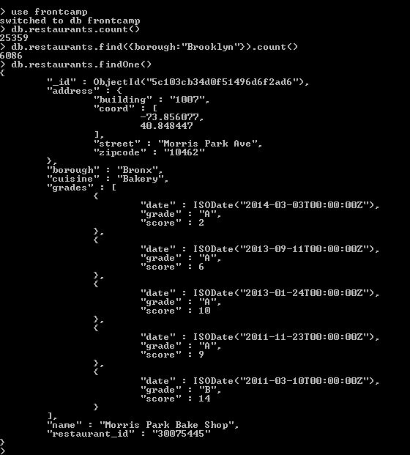

1. Work with DB
2. db.restaurants.find({"cuisine": "Chinese", "borough": "Queens"}, {"name":1})

D:\projects\frontcamp\31_mdb.JPG

1. db.restaurants.find({},{\_id:1}).sort({"grades.score": -1}).limit(1)

D:\projects\frontcamp\32_mdb.JPG

1. db.restaurants.updateMany({"borough": "Manhattan"}, {$push:{"grades":{"grade": "A", "score": 7, "date": ISODate()}}})

D:\projects\frontcamp\33_mdb.JPG

1. db.restaurants.find({$and: [{"grades.8.score":{$exists: true}},{"grades.8.score":{$lt: 7}}]}, {"name":1 ,\_id:0})

D:\projects\frontcamp\34_mdb.JPG

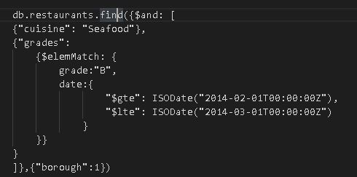

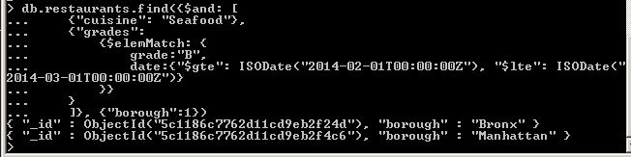

1. Work with indexation
2. db.restaurants.createIndex({"name" : 1}, {"name" : "myFirstIndex"})

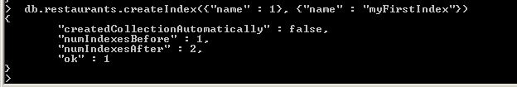

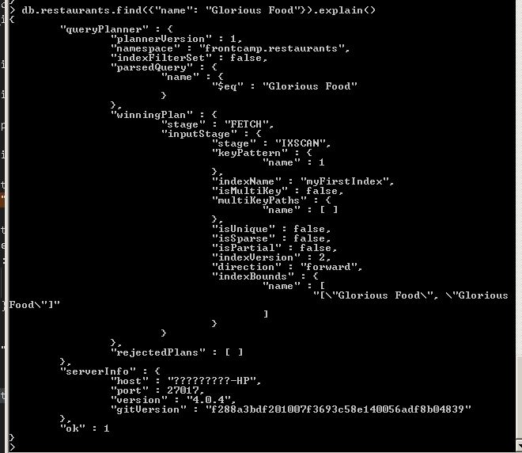

1. db.restaurants.dropIndex({"index-name" : "myFirstIndex"})

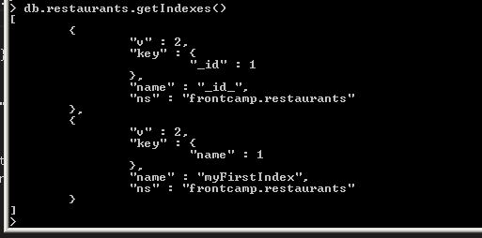

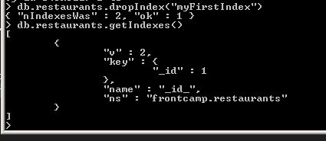

1. db.restaurants.createIndex({"restaurant\_id" : 1})

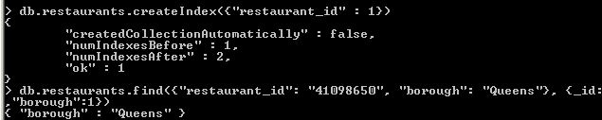

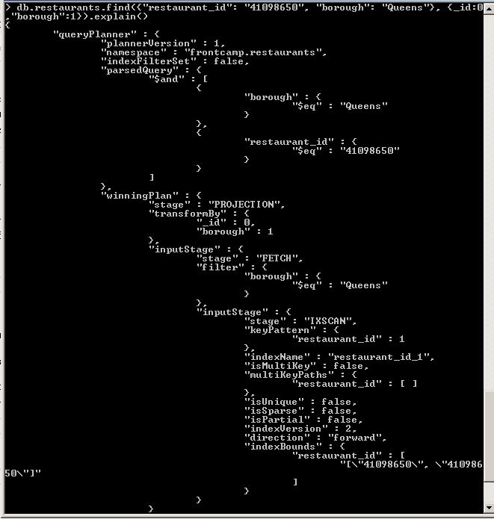

1. db.restaurants.createIndex({"cuisine" : 1},{partialFilterExpression:{"borough":"Staten Island"}})

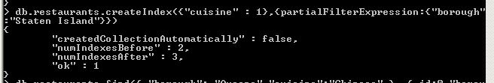

db.restaurants.find({ "borough": "Staten Island","cuisine":"Chinese" }, {\_id:0,"borough":1}).explain()

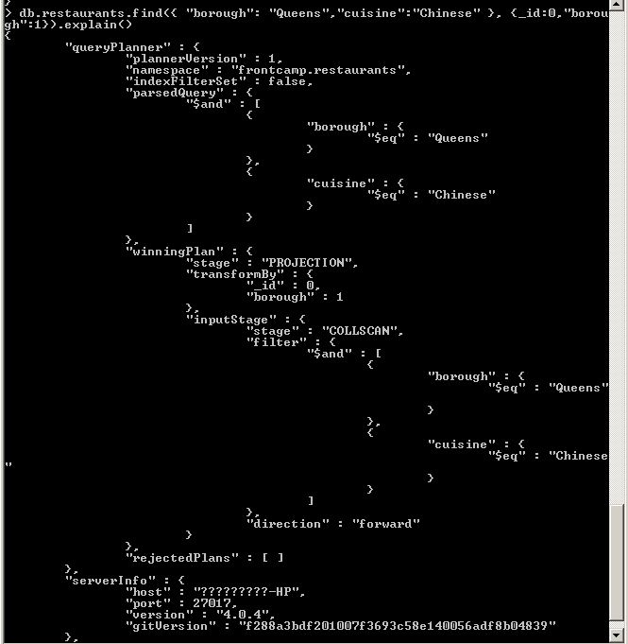

db.restaurants.find({ "borough": "Queens","cuisine":"Chinese" }, {\_id:0,"borough":1}).explain()

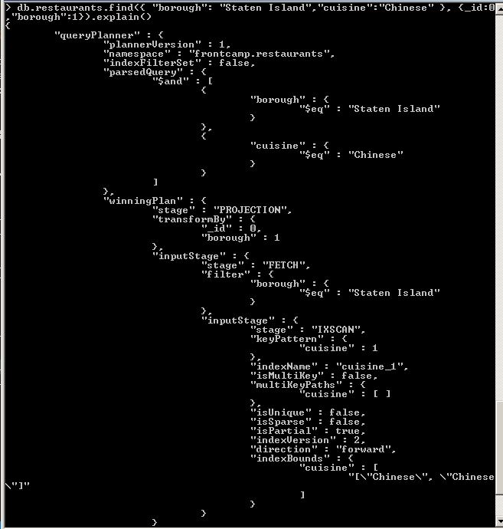

db.restaurants.find({ "borough": "Queens","borough": "Manhattan" }, {\_id:0,"borough":1}).explain()

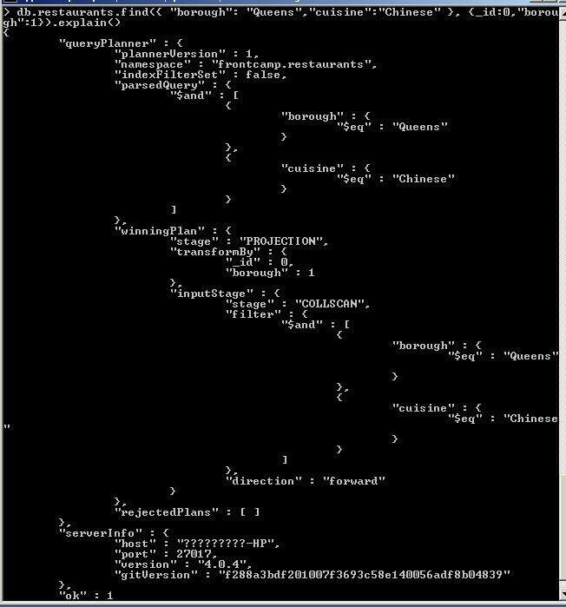

1. db.restaurants.createIndex({"grades.score" : 1})

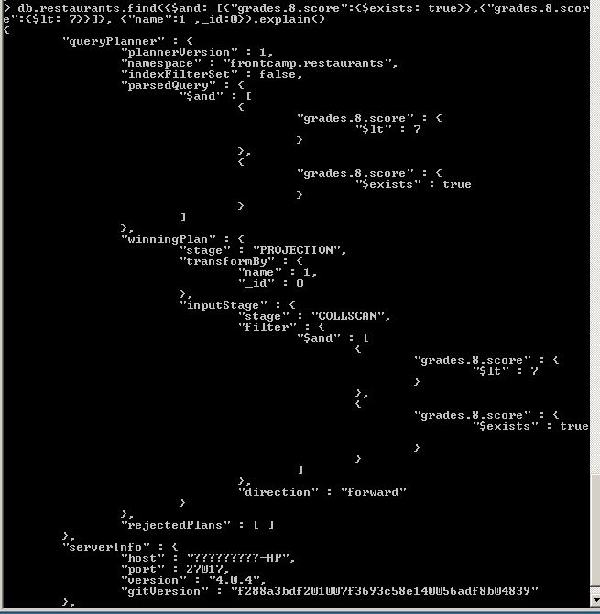

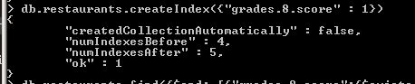

db.restaurants.find({$and: [{"grades.8.score":{$exists: true}},{"grades.8.score":{$lt: 7}}]}, {"name":1 ,\_id:0}).explain()

