Software Engineering | SEN202 | Fall 2017

Department of Computer Science
Sindh Madressatul Islam University

Breakfast Recipe

Muhammad Nabeel Ahmed (16SBSCSM078) Kishor Kumar (16SBSCSM074) SECTION: 4B

Acknowledgements

Abstract
Breakfast Recipe is Web site to help out in learning the cocking and to know the recipes of the dishes By using the videos and instruction.

Table of Content

- Introduction
- Purpose of the project
- Scope of the project
- Feasibility Assessment
- Requirements Specification
- Functional requirements
- Non-functional requirements
- Software Design
- ERD
- System Interfaces

INTRODUCTION
In software project we are going to implement a website of breakfast recipes which provides the platform of videos and recipes requires list where everything is explained about it and how to make the particular recipe. This S.E Website project is to provide all the information related to recipes and how to cock particular recipe what are resources are required for that are mentioned. This is site is developed by using HTML, CSS, Bootstrap, JavaScript, JQuery and on backend PHP language is used. This site depend on 4 pages namely contact, about, home and one for recipes. User who wants to contact for any query can submit by using contact us form which records the data using database and other works are also done. Home page contain the videos tutorial of cocking the particular recipe of breakfast. Our main focus is Breakfast. Breakfast contains the recipes in grid .this site also contain a slider. And search bar. It is responsive site so it can be run on any device. In cell phones the Navigation bar is collapase and converted in a selection button.

PURPOSE OF PROJECT

TO Provide a Best platform to the users and lovers of cooking.
- Teaching them how to cook perfectly to those whom wants to learn.

- And provide all information related to recipes of breakfast

Helping girls aa good housewife’s in house. And boys also in the cooking fields

SCOPE OF PROJECT
- The other recipes like dinner, Lunch can also be included
- Shopping of products.
- Online shopping can be done.

Requirements Specification
- Functional requirements
Javascript, PHP, Xampp server, Sublime text editor,JQuery
- Non-Functional requirements
HTML, CSS, Bootstrap,

System Interfaces
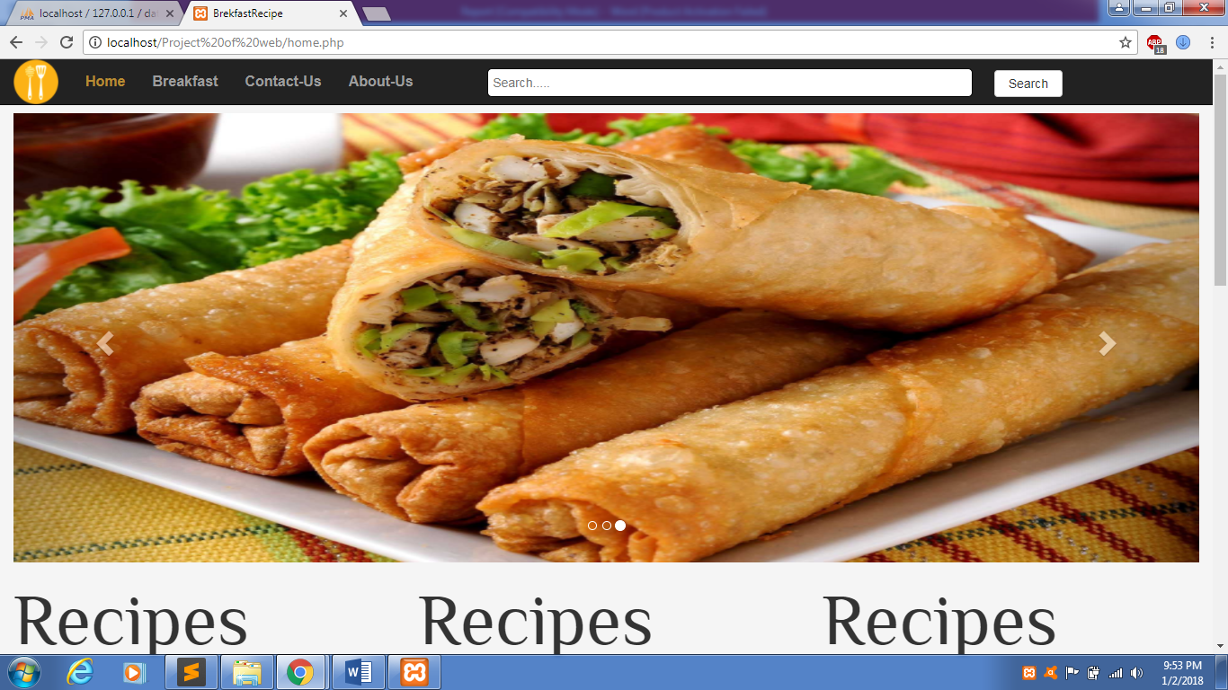

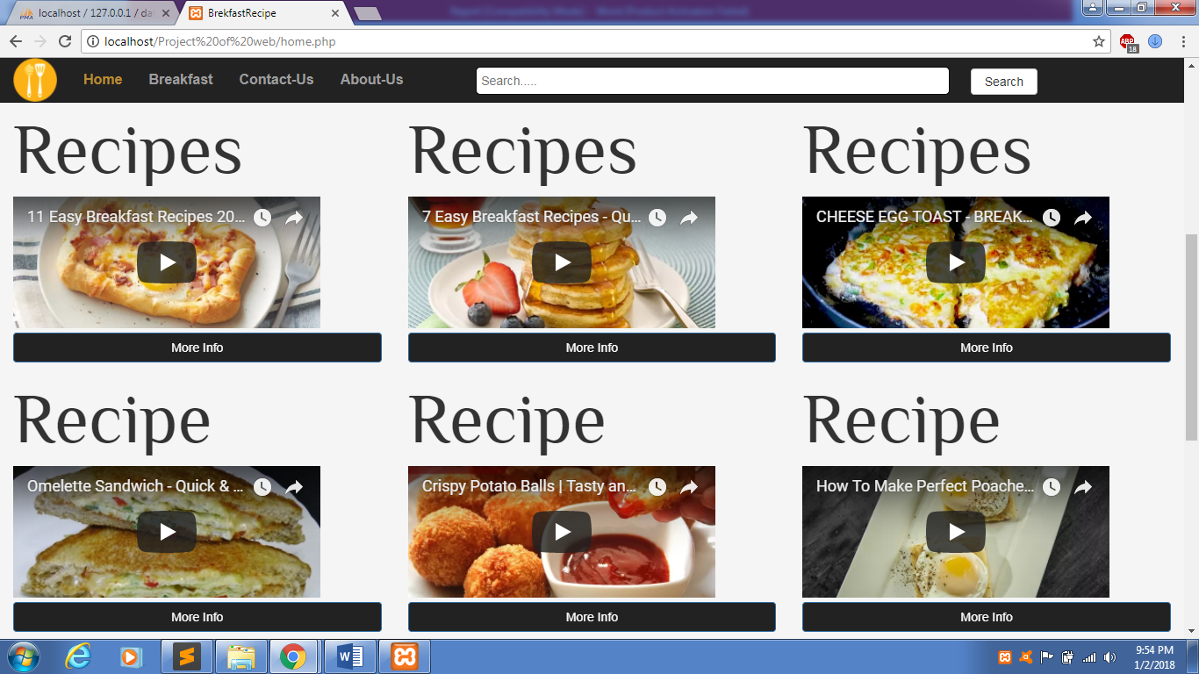
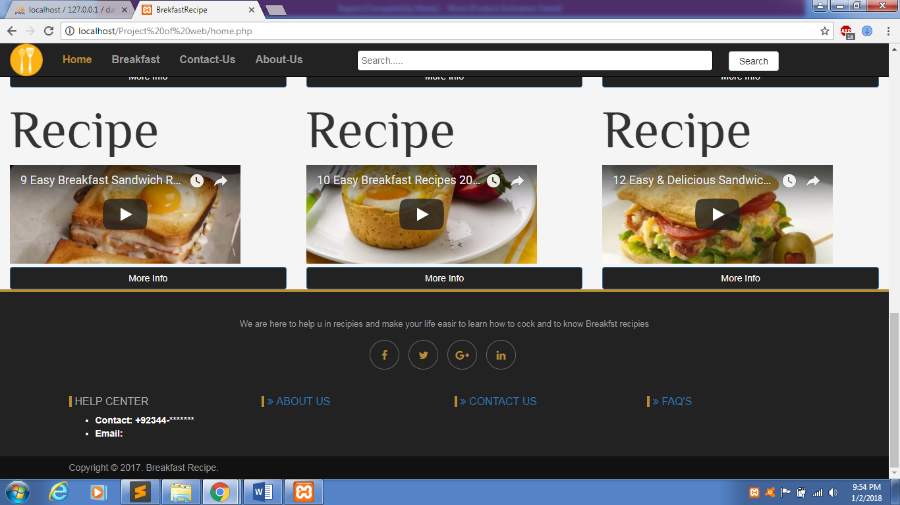
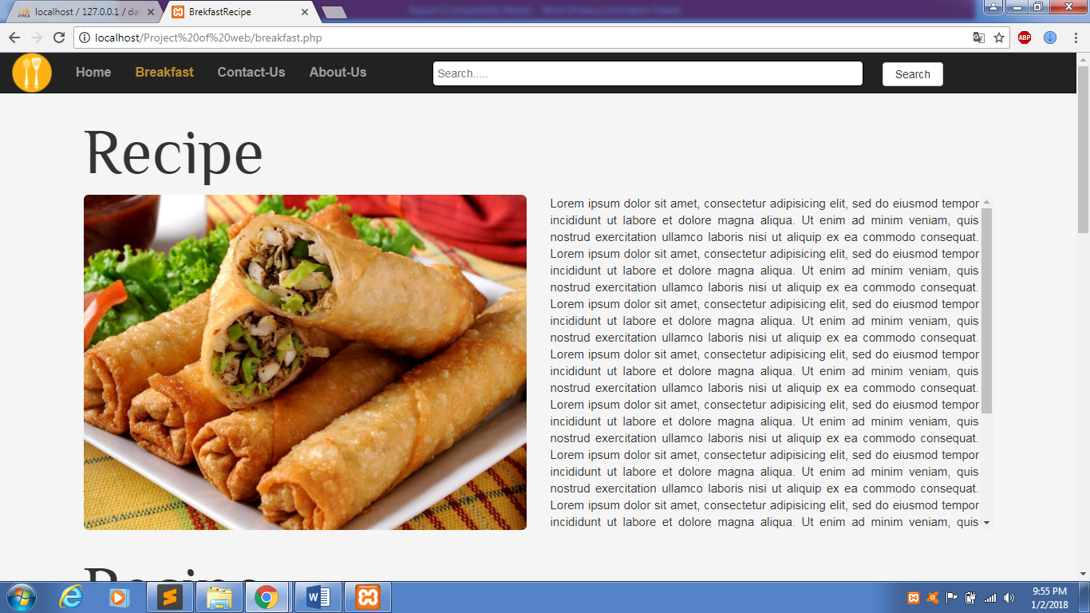
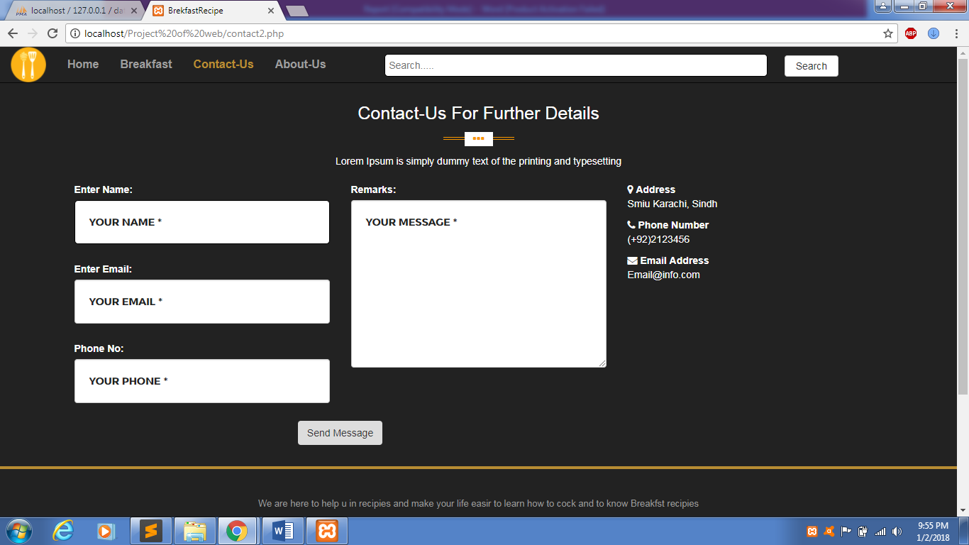
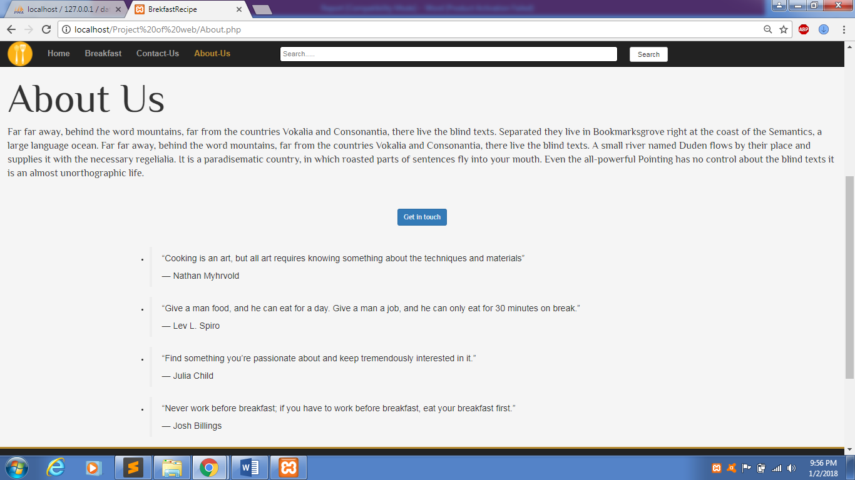

CONCLUSION
It’s a site to provide the help for the users and to contact the audience and give them a plat form where all the recipes and cocking methods are given them free of cost

REFRENCES
https://www.w3schools.com/html

