Adrián Quirós Martín y Iñaki Urrutia Sánchez SEMINARIO 2

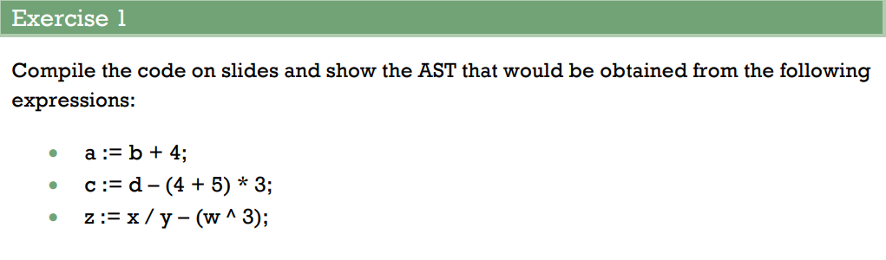
→ a := b + 4;

|L --> node (=)
ID (a)
node (+)
ID (b)
NUM (4)

→ c := d - (4 + 5) * 3;

|L --> node (=)
ID (c)
node (-)
ID (d)
node (*)
node (+)
NUM (4)
NUM (5)
NUM (3)

→ z := x / y - (w ^ 3);

|L --> node (=)
ID (z)
node (-)
node (/)
ID (x)
ID (y)
node (^)
ID (w)
NUM (3)

