**Applied Artificial Intelligence Project -2**

**Username:** tarantino

**Domain:** Football Players Evaluation Engine (FPEE) using Fuzzy Jess

The rule-based expert system is designed using JESS Rule Engine and can predict whether a player is a good fit for the team. In this system, each player has to take three tests – skill test, team player test, a passing test, a pace test and a fitness test. I have considered these three parameters, as they are the basic requirements to play football. Apart from the above-mentioned parameters, I have also considered age and relevant experience as a factor in determining the players’ ability. All factors do not carry the same weightage and are tweakable easily as per the requirements. The overall rating system is strict as it is required that players should be exceptional to get into top teams to improve them. The addition to the previous project is that I have now fuzzified the values

**Structure of the system** – The system was designed to interact with the user by letting the user enter certain scores, it then computes the final rating of the player and recommends if he/she should be bought to play for the team or not. The various input values to the system are:

* Age of the player
* Years of relevant experience (in the Premier League)
* Skills score (1-10)
* Team Player (1-10)
* Score on the pace test (1-10)
* Score on the passing test (1-10)
* Score on the fitness (1-10)

Once we get all the scores from the user, we now run the rule engine, which has rules pertaining to all the various combinations of values for these five factors. It evaluates the final rating of an employee based on the value of all these factors and gives the recommendation. As mentioned before different importance or weight given to the five factors depending on their logical importance towards the final rating.

**Knowledge Base:** The knowledge base used by my system consists of the following:

**Facts:**

1. Questions: This consists of questions and these questions have an id to distinguish them and the type, which specifies what type of answer the system is expecting. The various questions are:

* Age - What is the player's age?
* Experience - How many years of relevant experience does the candidate have?
* Skills: How good can he handle the ball and beat the players?
* Team Player – How good of a team player is he as football is a team sport.
* Pace-score - How much did the candidate score on the pace test?
* Passing-score - How much did the candidate score on the passing test?
* Fitness-score - How much did the candidate score on the fitness test?

**Test Cases:**

1)

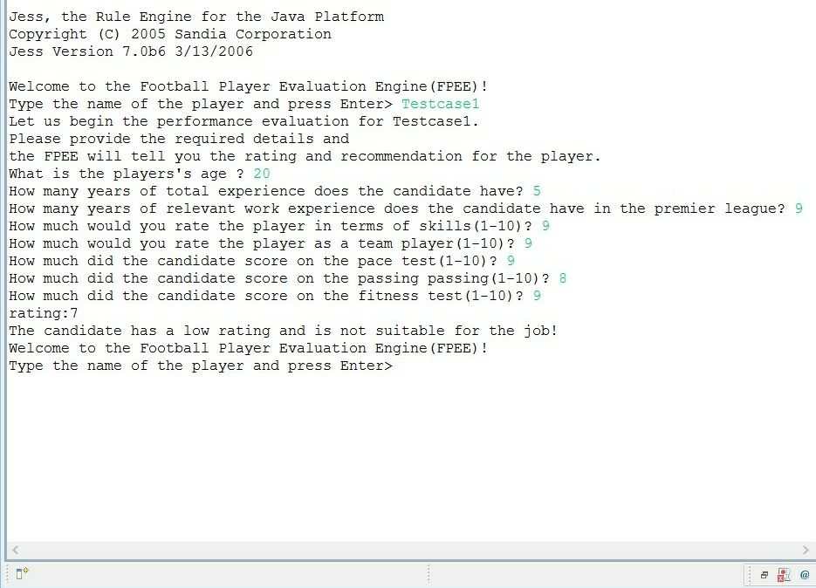

2)

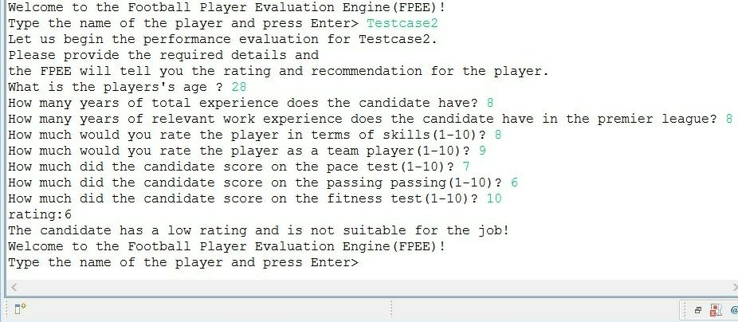

3)

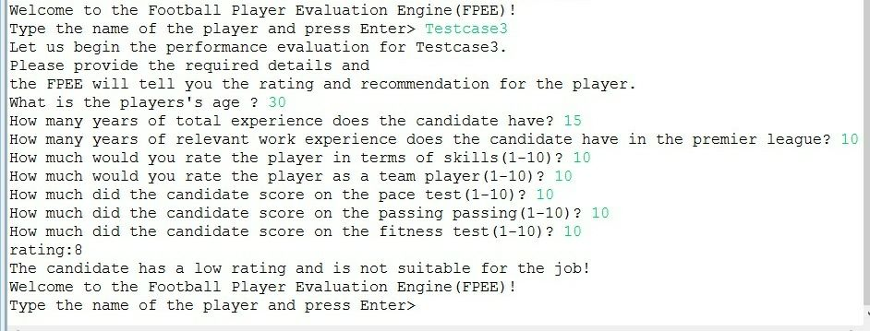

**Valid cases:**

* You can try any values between 1 and 10.
* Age suitable for paying football (I have kept the age bar high to accommodate other sports such as golf, which has higher retirement age if required).
* Relevant years of experience playing top level football, which should obviously be logical with respect to the age of the candidate (for example, a candidate can’t be 25 years old and have 20 or 30 years of experience).

**Expected Output:**

* The expert system would give you a rating for the player and a recommendation whether the candidate would be a good fit for the team. The ratings range from 1-10, considering the immense amount of competition for in the football world, the system recommends only the candidates who have a rating of eight and above to give a real sense of the competition.