**Applied Artificial Intelligence Project - 3**

**Username:** tarantino

**Domain:** Football Players Evaluation Engine (FPEE) using Bayesian Networks in Netica

In this project, I have not only included the basic attributes of a football player’s game but also included the behavioural aspect of it. The six basic attributes of ant football player are passing, pace, physical strength, shooting, dribbling and defending. I have pre-set the probabilities to the average score of a “top flight” player. Then we come down to the behavioural aspect of a player. This contains attributes like decision-making, team player and understanding the game. The behavioural and the basic attributes combine to give us an outcome for the player. We can see if the player is well suited to be a defender, midfielder or an attacker. I have another attribute called as “All Rounder” which estimates if a player is fit to play all three roles.

**Test Case:**

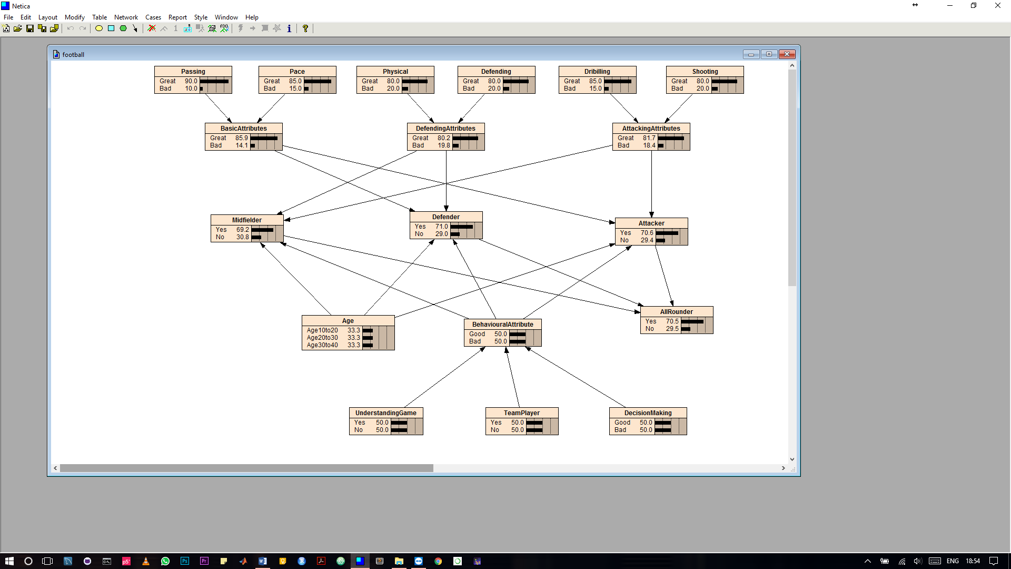

**How To:**

1. Open the “football.neta” file in Netica.
2. Play with the probabilities.