Univariate Analysis: Gender

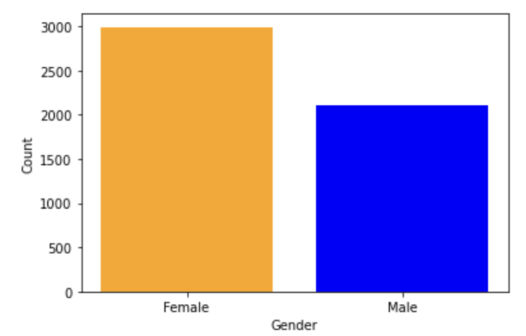

From this bar graph, it is clear that the number of Females is higher than the number of Males. More women were included in the dataset than men. Precisely counting the number of females and males, 2994 females and 2115 males were included in the dataset. There are 879 more women in the dataset than men.

Univariate Analysis: Age

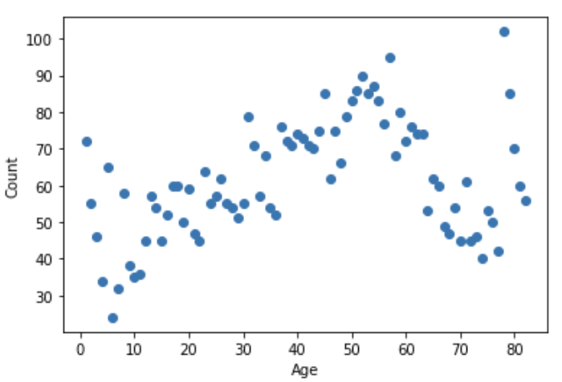

From this scatter plot, one can see that the majority of ages included in the dataset are from 40-80 years old. There are some outliers in the age column of the dataset. It is unclear if babies at age 1 and children were actually included in the dataset or if it was a mistake by the person who created this dataset.

Bivariate Analysis: Gender vs. Stroke

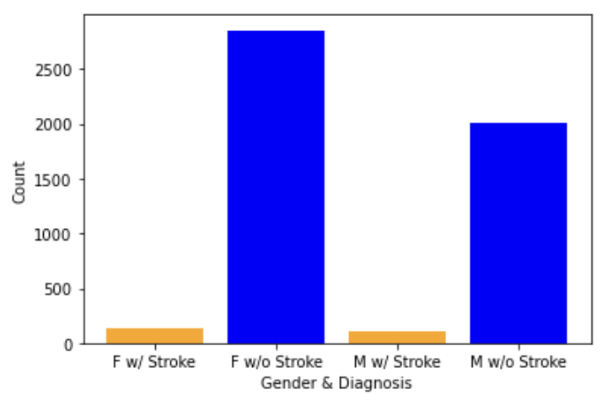

From this bar graph alone, the number of females with stroke and without stroke are higher than those for men. However, knowing that there are more females than males in this dataset, the amount of women and men with stroke and without stroke seem consistent with each other and almost equal.

Bivariate Analysis: Age vs. Stroke

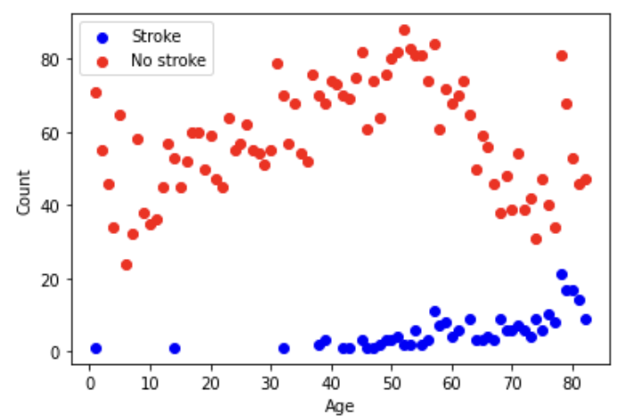

From this scatter plot, it can be clearly seen that the age range of people with stroke is from ages 40-80 years old. It can be concluded that people in later ages are more likely to get a stroke. Also, people with no stroke can be from ages 0 to 80 years old.

Multivariate Analysis: Gender vs. Age vs. Stroke

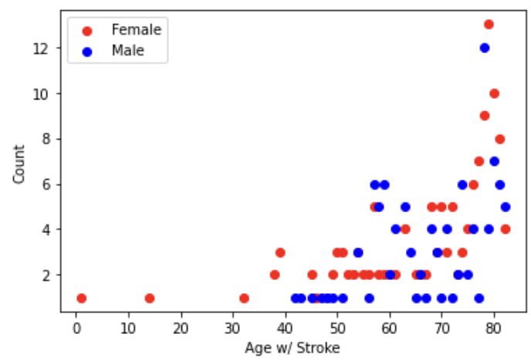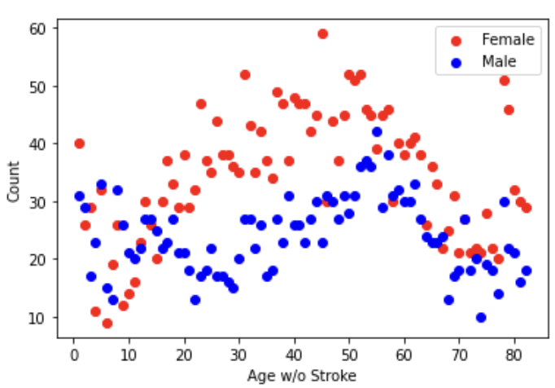

As concluded above, the same can be said for the top scatter plot (Age w/ Stroke vs. Count) that people with stroke are of ages 40-80 years old and those without stroke can be from ages 0-80 years old. Since there are more women than men in the dataset and counts for stroke and without stroke seem to be consistent/equal, gender does not play a major role in determining if someone will have a stroke.