The Haunted Signup Mansion: Ghost Hunt
Name: Mario Leonel Gutierrez Espinal
Track: Undergraduate
Date: October 28, 2026
GitHub: https://github.com/ikmroadrunnerllc-cmd/TABS_01/tree/activity10-signup-form

Part 1: Ghost Hunt Checklist
Test output screenshot:
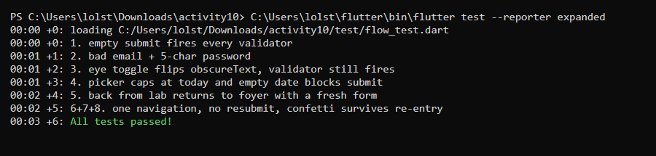

1. Empty fields + Join the Mansion. Expected: all Activity 10 validators fire.
What I saw:
Pressing Join with nothing typed showed four red errors: name, email, password and birth date.

Pass or fail: Pass

2. Email without @, password under 6 chars. Expected: correct error under the right field.
What I saw:
With casper.mansion.com and boo12, the email said it wasn't valid and the password said it needs 6 characters.
The name field had no error, so each message showed under the right box.
Pass or fail: Pass

3. Eye toggle. Expected: letters, then dots again; validator still works both ways.
What I saw:
The password started as dots, tapping the eye showed the letters, and tapping again hid them.
The short-password error still showed in both modes.
Pass or fail: Pass

4. Date picker. Expected: no future date selectable; empty date blocks submit.
What I saw:
Days after today were greyed out in the picker, so I couldn't pick a future date.
Leaving the date empty showed "Pick your birth date" and the form didn't submit.
Pass or fail: Pass

5. Back from the Lab. Expected: returns to the Foyer; typed values are gone.
What I saw:
I typed a name and pressed back. It took me to the Foyer, and when I came back in the form was empty.

Pass or fail: Pass

6. System Back from the Ballroom. Expected: does not resubmit the form.
What I saw:
System back on the Ballroom took me to the Foyer, not to the form, so nothing got sent again.

Pass or fail: Pass

7. Double-tap during loading. Expected: only one navigation happens.
What I saw:
After the first tap the spinner showed and the button stopped working. I only landed on the Ballroom once.

Pass or fail: Pass

8. Confetti, then leave and return. Expected: fires once on arrival; no crash.
What I saw:
Confetti played once when the Ballroom opened. I went home, signed up again, and nothing crashed.

Pass or fail: Pass

Part 2: Pumpkin Patch Answers

Answer 1
Prompt chosen:
The Reversed Trapdoor: what changes if pushReplacement becomes push?
Answer (3-5 sentences):
I changed Navigator.pushReplacement to Navigator.push in _submit and ran the app in Chrome.
After signing up, pressing back on the Ballroom took me back to the Lab instead of the Foyer.
My name, email and date were still filled in, because the Lab was never removed from the stack, just covered.
The Join button was also stuck on the spinner, because _submitting never got reset, so the form was frozen until I left.
pushReplacement swaps the Lab out for the Ballroom, so back skips the form. That's why I keep it.

Evidence (screenshots or test lines):
Code change: Navigator.pushReplacement( became Navigator.push( in lib/screens/signup_screen.dart.
Screenshot: the Lab with my old values still in it after pressing back from the Ballroom.
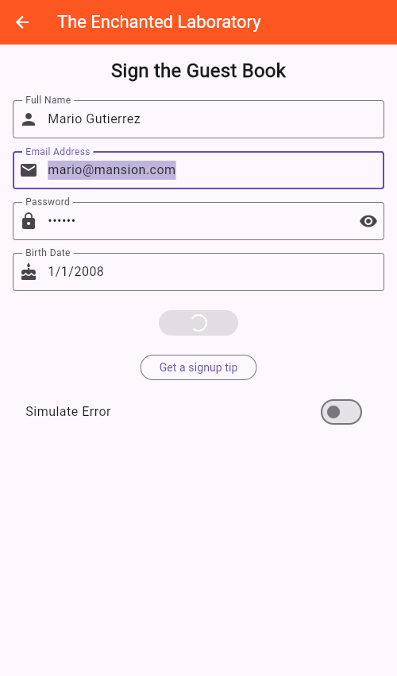

Answer 2
Prompt chosen:
Why does dispose() matter?
Answer (3-5 sentences):
The Lab makes four TextEditingControllers and the Ballroom makes a ConfettiController.
Those objects hold listeners and memory that stay alive after the screen is closed unless I free them.
dispose() runs when the screen leaves the stack, so I call .dispose() on each controller there, then super.dispose().
The old form skipped this, so every visit left controllers behind.
Now I can go through the mansion again and again with no leaks or errors.

Evidence (screenshots or test lines):
signup_screen.dart lines 41-46: dispose() frees the name, email, password and date controllers.
success_screen.dart lines 24-26: dispose() frees the confetti controller.
Test line: 00:02 +5: 6+7+8. one navigation, no resubmit, confetti survives re-entry
00:03 +6: All tests passed!

