Developing and Optimizing Data Structures for a Dynamic Inventory Management System in Python - Deliverable 4: Comprehensive Final Report

Rahul Solanki
School of Computer and Information Sciences, University of the Cumberlands
MSCS-532-B01: Algorithms and Data Structures
Dr. Michael Solomon
August 2, 2026

Abstract
This project designs, implements, and optimizes the data structures underlying a dynamic inventory management system in Python. Three purpose-chosen structures, a hash table for SKU lookup, a binary min-heap for low-stock alerting, and an ordered index for price-range queries, are first implemented from first principles as a correct proof of concept, then systematically optimized: an indexed heap with O(log n) updates and O(n) bulk construction, an open-addressing hash table with perturbed probing, a bisect-backed sorted array replacing an interpreted skip list, bulk loading, __slots__ records, and a scan-resistant LRU cache. A 65-case contract test suite validates baseline and optimized implementations identically, and a five-size benchmark (1,000 to 100,000 products) quantifies the impact: quantity updates accelerate by roughly 2,750 times and low-stock queries by roughly 3,403 times at 100,000 products, with peak memory reduced from 69.3 MiB to 57.6 MiB. The results illustrate that in interpreted languages, asymptotic analysis and constant-factor engineering are complementary, and both are necessary for scalable performance.

Introduction
Inventory management sits on the critical path of every commerce operation: each sale decrements stock, each delivery increments it, prices move with promotions, and the business continuously asks which products are about to run out and what is available in a given price band. The workload is dynamic (high mutation rates), skewed (a small fraction of products receives most traffic), and latency-sensitive. This project treats the inventory problem as a case study in deliberate data structure engineering: choosing structures whose asymptotic guarantees match each query pattern, implementing them from first principles in Python, measuring where theory and interpreter reality diverge, and optimizing with both asymptotic and constant-factor tools. The project spans four phases: design (Deliverable 1), proof of concept (Deliverable 2), optimization and evaluation (Deliverable 3), and this integrated report (Deliverable 4).
This report integrates the three prior deliverables into a single narrative and adds the retrospective analysis that only the completed project permits. Its contributions are: (1) a design that maps each of four query patterns to a data structure whose guarantees fit it, with rejected alternatives documented and justified; (2) from-scratch Python implementations of every structure in both a baseline and an optimized form, sharing one behavioral contract; (3) a 65-case test suite whose implementation-agnostic design is what makes the optimization claims verifiable; (4) a five-size, five-operation benchmark separating asymptotic improvements from constant-factor ones; and (5) two documented negative results, a generator-based probe loop and a polluted cache, that illustrate why interpreter-level constant factors must be treated as design inputs. The remainder of the report follows the project's own chronology: literature, requirements, design, proof of concept, testing, optimization, measurement, and finally discussion, limitations, and future directions. The complete source code, test suite, benchmark harness, measured results, and presentation materials accompany this report on GitHub: https://github.com/iknalos/MSCS-532-Project-Deliverable-4.
Literature Review
The theoretical foundations of the chosen structures are standard. Hash tables with chaining achieve O(1) expected operations under simple uniform hashing, and open addressing trades pointer chasing for probe sequences within a contiguous array (Cormen et al., 2022). Beyond linear probing, schemes such as cuckoo hashing achieve worst-case constant lookup by giving each key two candidate homes (Pagh & Rodler, 2004); its insertion cost profile makes it better suited to read-dominated tables, and it informed rather than dictated the design here. For priority queues, the binary heap provides O(log n) insertion and deletion in an implicit array (Goodrich et al., 2013); Fibonacci heaps improve decrease-key to O(1) amortized (Fredman & Tarjan, 1987), but their practical constant factors are famously unfavorable, a theme this project encounters repeatedly at smaller scale. Pugh's skip list achieves expected logarithmic performance through randomized node heights instead of rebalancing invariants (Pugh, 1990), making it one of the simplest ordered dictionaries to implement correctly. Finally, the log-structured merge-tree literature formalizes the read-write asymmetry of ordered indexes (O'Neil et al., 1996): structures optimal for reads are rarely optimal for writes, and the right choice depends on the measured mix, which is precisely the trade-off this project navigates when it replaces a skip list with a sorted array.
Two further strands of the literature shaped the work. Amortized analysis (Cormen et al., 2022) justifies the growth policies used throughout: doubling a hash table on overflow makes individual insertions occasionally expensive but constant on average, and the same accounting argument covers the sorted array's occasional large shifts under bulk construction. And the systems literature on buffer management motivates the caching design: caches serve skewed traffic well but are destroyed by sequential scans, so database buffer pools treat scan pages specially rather than letting them evict the hot set; this project reproduces that lesson in miniature when its range queries are made to bypass the lookup cache.
Application Context and Requirements
The system must support: product insertion and removal; exact-match SKU lookup; quantity updates on every sale or delivery; price updates; a low-stock alert returning the k scarcest products; price-band queries returning all products in [lo, hi] in price order; and category listing. Target scale for evaluation is 100,000 products, with lookup traffic following an 80/20 hot-key skew that models retail demand concentration. Durability and concurrency are explicitly out of scope; the contribution is the in-memory index layer.
Design and Rationale
No single structure serves all query patterns, so the design composes three indexes kept consistent by a facade class. The hash table serves as primary index (SKU to record) with O(1) expected operations. The min-heap keyed on quantity serves low-stock alerts, with the design explicitly flagging update-by-identifier as the future bottleneck, since a heap locates an arbitrary element only by O(n) scan unless a position index is maintained. The skip list keyed on the composite (price, SKU) serves range queries in expected O(log n + m); the composite key makes ordering total when prices tie. A second hash table maps categories to SKU sets. Every mutation validates inputs before touching any index, so failures leave the system consistent.
Alternatives were weighed explicitly. A self-balancing binary search tree offers worst-case logarithmic bounds where the skip list offers expected bounds, but at substantially higher implementation risk; Pugh (1990) reports skip lists competitive with or faster than balanced trees in practice. Cuckoo hashing guarantees worst-case constant lookup (Pagh & Rodler, 2004) but pays for it with eviction cascades on insertion, a poor fit for a mutation-heavy index. Fibonacci heaps improve decrease-key to O(1) amortized (Fredman & Tarjan, 1987), exactly the operation a quantity update performs, yet their pointer-heavy nodes and large constants make them slower than a well-engineered binary heap at this scale; the indexed binary heap adopted in Phase 3 captures most of the benefit at a fraction of the complexity. These rejections matter because they were made on predicted constant factors, and the measurement phase later confirmed how decisive constant factors are in an interpreted language.
Table 1 summarizes the complexity envelope the design committed to in Phase 1 and the envelope the optimized system actually achieves, making the two deliberate departures visible: the ordered index trades its logarithmic writes for linear shifts in exchange for C-speed reads, and every other operation either keeps or improves its designed bound.
Table 1
Designed versus achieved complexity per operation (n = catalog size, k = alert size, m = results returned, c = category size).
Operation | Structure | Phase 2 baseline | Phase 3 optimized
SKU lookup / insert / delete | Hash table | O(1) expected (chaining) | O(1) expected (open addressing)
Quantity update by SKU | Min-heap | O(n) scan + O(log n) sift | O(log n) via position map
Low-stock alert (top k) | Min-heap | O(n log n) per-query sort | O(k log k) frontier walk
Bulk construction | All indexes | O(n log n), n inserts | O(n), one pass + Floyd heapify
Price-range query | Ordered index | O(log n + m) expected (skip list) | O(log n + m), C-level bisect
Price update (ordered write) | Ordered index | O(log n) expected | O(n) shifts (deliberate trade-off)
Category listing | Hash of SKU sets | O(1) + O(c log c) | O(1) + O(c log c)
Proof-of-Concept Implementation
Phase 2 delivered each structure as an independent Python module with no external dependencies, composed by an InventorySystem facade. The chaining hash table doubles capacity past a load factor of 1.0. The heap is an implicit array with iterative sift operations. The skip list draws node heights geometrically (p = 0.5, maximum level 16). The insertion path illustrates the composition:
The facade keeps all indexes consistent on every mutation (src/inventory.py).
def add_product(self, sku, name, category, price, quantity):
if sku in self._products:
raise DuplicateSKUError(f"SKU already exists: {sku}")
product = Product(sku, name, category, price, quantity)
self._products.put(sku, product) # hash table, O(1) exp.
self._stock_heap.push(quantity, sku) # min-heap, O(log n)
self._price_index.insert((price, sku), sku) # skip list, O(log n) exp.
...

A demonstration script exercises every operation on a readable catalog, including update propagation across indexes, deletion clearing all indexes, and the error paths for duplicate and unknown SKUs.
Two implementation decisions made in this phase carried disproportionate value later. First, strict module boundaries: each structure exposes a small interface and knows nothing about the others, so Phase 3 could swap an implementation behind the facade without touching callers. Second, honesty about known inefficiencies: the baseline heap's O(n) update-by-SKU and the per-query sort in low_stock were documented in the code as deliberate deferrals rather than silently accepted, which turned Phase 3 from an open-ended search for problems into the execution of an existing plan. The proof of concept was also kept free of premature optimization, so the Phase 3 comparison measures a representative straightforward implementation rather than a strawman.
Testing Methodology
Correctness rests on a 65-case unittest suite organized as implementation-agnostic contract classes: the same assertions run against the baseline and optimized versions of each structure and of the whole system. Coverage includes unit behavior (ordering, resizing, tombstones, duplicate keys), integration behavior (updates visible through every index), edge cases (empty structures, zero quantities, equal prices, negative inputs), and randomized workloads validated against reference models built on Python's own dict and sorted primitives. This contract design is what makes the Phase 3 performance claims trustworthy: both implementations are observably equivalent.
Stress-oriented cases probe the failure modes that unit tests miss: 2,500 delete-reinsert operations exercise tombstone reuse and compaction in the open-addressing table; growth tests push structures far past their initial capacities; duplicate identifiers, empty structures, zero quantities, equal prices, and negative inputs cover the boundary conditions; and cache tests verify that a removed product cannot be resurrected from the LRU cache. Because validation is cheap to rerun (the full suite completes in under a tenth of a second), it ran after every optimization step, which twice caught regressions before any benchmark was trusted.
Optimization
Phase 3 applied four structural optimizations, each moving a measured bottleneck. (1) The indexed heap adds a SKU-to-position dictionary maintained during sifts: update-by-SKU becomes O(log n), bulk construction uses Floyd's O(n) heapify, and the top-k query walks the heap as an implicit tree with a bounded frontier in O(k log k) instead of sorting all n entries (Cormen et al., 2022). (2) The open-addressing hash table stores keys and values in flat parallel arrays with CPython-style perturbed probing, a two-thirds load cap, and tombstones cleaned at resize. A first version generated probe indices with a Python generator and was slower than the chaining baseline; inlining the probe loop recovered the win. In interpreted code, constant factors are part of the design space, not an afterthought. (3) The sorted price index replaces the skip list with a sorted array driven by the C-implemented bisect module: writes pay O(n) shifts executed as a single memmove, reads cost O(log n + m) with C-speed comparisons, a deliberate read-write trade-off in the spirit of the LSM-tree analysis (O'Neil et al., 1996). (4) System-level: one-pass bulk_load, __slots__ on hot classes, and a 4,096-entry LRU cache for skewed lookups. An early version routed range-query results through the cache and lost its lookup gains to cache pollution; scan-type queries now bypass the cache, mirroring scan-resistant buffer replacement in database systems.
The top-k rewrite illustrates the character of the asymptotic work. The baseline answered low_stock(k) by sorting a copy of the entire heap array; the optimized version exploits the heap property itself, walking the implicit tree with a small auxiliary frontier so that no more than 2k + 1 entries are ever examined:
O(k log k) top-k via a frontier walk over the implicit heap tree (src/optimized/min_heap_opt.py).
def k_smallest(self, k):
out = []
frontier = [(data[0][0], 0)] # (key, index) min-frontier
while frontier and len(out) < k:
key, i = heapq.heappop(frontier)
out.append((key, data[i][1]))
for child in (2 * i + 1, 2 * i + 2):
if child < n:
heapq.heappush(frontier, (data[child][0], child))
return out

Performance Evaluation
Methodology first, because benchmark numbers are only as trustworthy as the procedure behind them. Both implementations are exercised by the same harness in the same CPython process conditions: synthetic catalogs of 1,000, 5,000, 10,000, 50,000, and 100,000 products are generated with a fixed random seed so every run and both implementations see identical data; each operation is timed as a batch (20,000 lookups, 200 updates, 200 range queries, 50 low-stock queries) rather than as single calls, which amortizes timer resolution and scheduler noise; lookup traffic follows an 80/20 hot-key skew modeling retail demand concentration; and peak memory is measured with tracemalloc on a full 100,000-product build. Results are written to CSV and plotted by the same script that the repository ships, so every number and figure in this report is regenerable from source.
Table 2 summarizes the speedups. The two asymptotic fixes dominate and diverge with n, reaching roughly 2,750 times faster updates and 3,403 times faster low-stock queries at 100,000 products (Figures 1 and 2). Constant-factor work yields steadier gains: bulk load about 2.4 times faster (Figure 3), skewed lookups about 1.4 times, and range queries about 1.6 times. Peak memory fell from 69.3 MiB to 57.6 MiB at 100,000 products (Figure 4), attributable to __slots__ records and flat arrays replacing per-node objects.
Table 2
Speedup of the optimized implementation over the Phase 2 baseline (wall-clock ratio).
n | Bulk load | Lookups | Qty updates | Range queries | Low-stock
1,000 | 1.8x | 1.7x | 16.0x | 1.3x | 8.6x
5,000 | 1.7x | 1.4x | 47.0x | 0.9x | 32.5x
10,000 | 1.8x | 1.3x | 147.4x | 1.2x | 140.9x
50,000 | 2.2x | 1.3x | 929.6x | 1.6x | 811.1x
100,000 | 2.4x | 1.4x | 2749.7x | 1.6x | 3402.8x

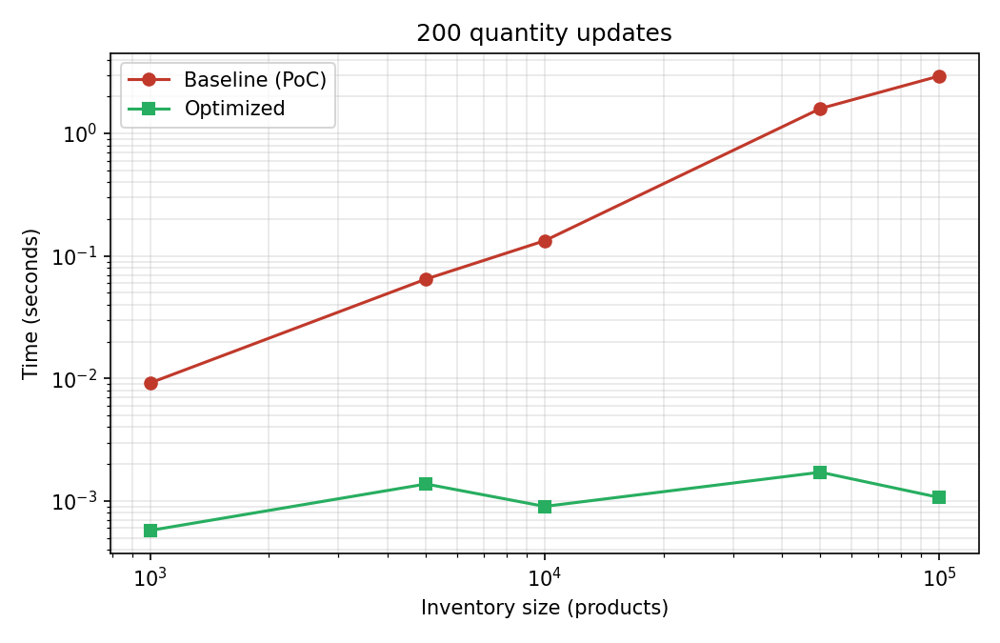
Figure 1
Quantity updates versus catalog size (log-log): removing the O(n) heap scan.
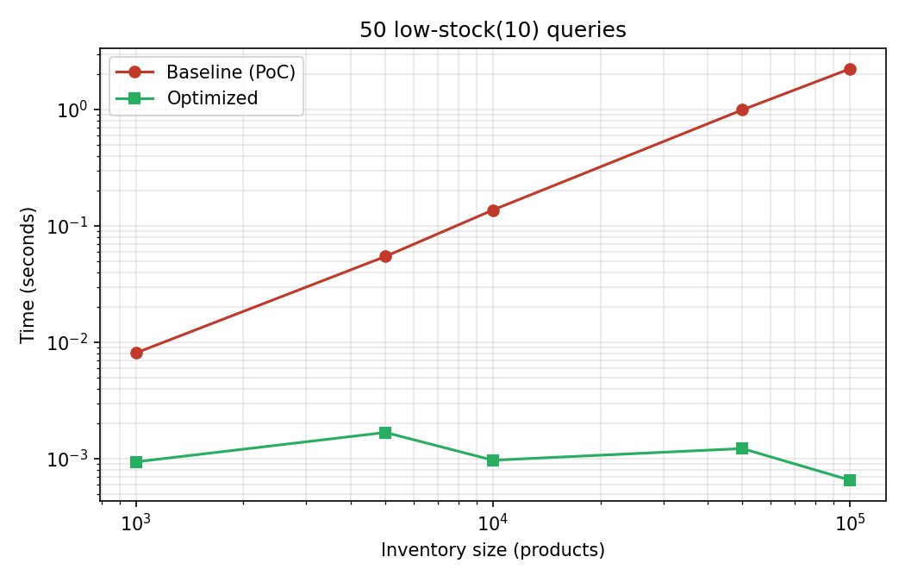
Figure 2
Low-stock queries versus catalog size (log-log): O(k log k) frontier walk versus per-query sort.
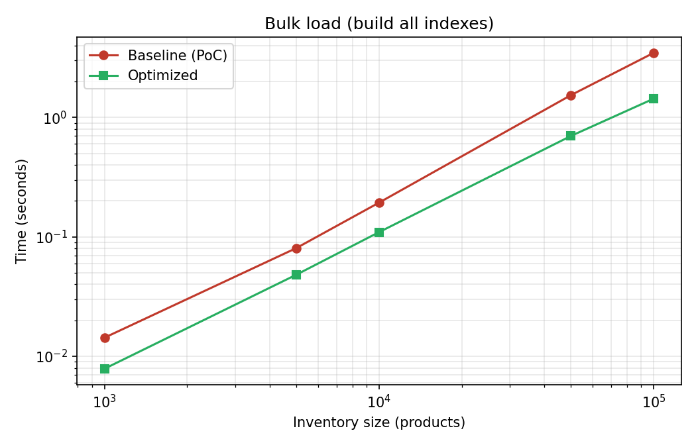
Figure 3
Bulk load versus catalog size (log-log): one-pass build with Floyd's heapify.
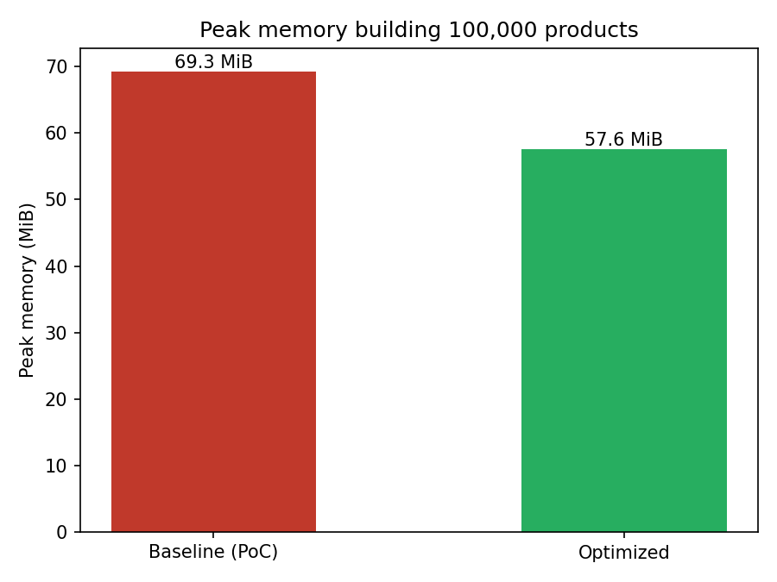
Figure 4
Peak memory building 100,000 products.
Reading Table 2 across its rows shows the two regimes clearly. The update and low-stock columns grow monotonically with n, from double digits at 1,000 products to four digits at 100,000, because the baseline pays an O(n) or O(n log n) term the optimized version does not; these ratios have no ceiling short of memory. The bulk-load, lookup, and range-query columns hover between roughly 1.3 and 2.4 at every size, the signature of a constant-factor improvement: valuable, but bounded. The one number that dips near 1.0 (range queries at 5,000 products) is measurement noise around a small absolute cost, a reminder that micro-benchmarks at millisecond scale carry variance and should be read for their trends rather than their third significant digit.
Discussion
Three lessons generalize beyond this system. First, asymptotics decide scalability: every speedup that grows with n came from removing an O(n) or O(n log n) term, and no amount of micro-tuning would have substituted. Second, in an interpreted language the constant factors are architectural: a skip list is asymptotically superior to a sorted array for writes, yet the array wins here because its inner loops run in C; the same logic briefly made the 'optimized' hash table slower until a generator was inlined. Third, workload awareness matters as much as structure choice: the LRU cache only pays off because retail traffic is skewed, and it only remained effective once scans bypassed it. The principal limitations are the O(n) writes of the sorted price index under write-heavy price churn, the single-process in-memory scope, and benchmarks on synthetic rather than production traces.
Several threats to validity deserve acknowledgment. The benchmark catalogs are synthetic, with uniformly random prices and quantities; real catalogs cluster around price points, which would change range-query selectivity. The 80/20 lookup skew is a modeling assumption, and the cache's contribution rises and falls with it. Wall-clock timings on a desktop operating system include scheduler noise, mitigated here by measuring batches of operations rather than single calls and by reading trends across five sizes rather than single points. Finally, both implementations are compared within the same interpreter version; a JIT-compiled runtime such as PyPy would shrink the interpreter-overhead effects that motivated the sorted-array trade-off, possibly reversing it. None of these threats affects the asymptotic conclusions, which are interpreter-independent.
Impact and Future Directions
The practical impact of the work is twofold. For the application domain, the measured end state means an inventory tier that absorbs the mutation rate of a mid-sized catalog on a single commodity process: at 100,000 products, quantity updates and low-stock alerts, the two operations on the sales hot path, run in microseconds rather than milliseconds, which is the difference between an index that can sit inside a request handler and one that needs asynchronous batching. For method, the project documents a transferable workflow: write the test contract before optimizing, let profiling rather than intuition nominate bottlenecks, distinguish asymptotic fixes from constant-factor fixes because they scale differently, and treat negative results as findings worth recording. The two failures preserved here, a generator that erased an algorithmic win and a cache destroyed by scans, are exactly the kind of interpreter-level effects that textbook analysis does not predict and that practitioners in managed languages meet constantly.
Natural extensions follow the limitations: a B-tree or LSM-style ordered index if price updates dominate (O'Neil et al., 1996); persistence via write-ahead logging; concurrency with fine-grained or lock-free structures; replaying production traces to validate the skew assumptions; and, if constant factors must shrink further, migrating hot inner loops to C extensions or arrays from the standard array module while keeping the Python API. A research-flavored direction is suggested by the sorted-array result: characterizing, for a given interpreter and read-write mix, the crossover point at which pointer-based ordered structures overtake contiguous ones would turn the ad hoc trade-off made here into a predictive model.
Conclusion
The project met its goals across all phases: a principled design mapping each query pattern to a suitable structure, a correct and fully tested proof of concept, and an optimization pass that preserved observable behavior under an identical test contract while improving every measured operation and reducing memory at scale. The end state is a system whose core operations are sublinear, whose remaining trade-offs are explicit and justified by the workload, and whose evaluation demonstrates the central engineering lesson of the course: theory chooses the structure, measurement validates the choice.

References
Cormen, T. H., Leiserson, C. E., Rivest, R. L., & Stein, C. (2022). Introduction to algorithms (4th ed.). MIT Press.
Fredman, M. L., & Tarjan, R. E. (1987). Fibonacci heaps and their uses in improved network optimization algorithms. Journal of the ACM, 34(3), 596–615. https://doi.org/10.1145/28869.28874
Goodrich, M. T., Tamassia, R., & Goldwasser, M. H. (2013). Data structures and algorithms in Python. Wiley.
O'Neil, P., Cheng, E., Gawlick, D., & O'Neil, E. (1996). The log-structured merge-tree (LSM-tree). Acta Informatica, 33(4), 351–385. https://doi.org/10.1007/s002360050048
Pagh, R., & Rodler, F. F. (2004). Cuckoo hashing. Journal of Algorithms, 51(2), 122–144. https://doi.org/10.1016/j.jalgor.2003.12.002
Pugh, W. (1990). Skip lists: A probabilistic alternative to balanced trees. Communications of the ACM, 33(6), 668–676. https://doi.org/10.1145/78973.78977

