Assignment 5: A Class-Based Ride Sharing System in Smalltalk and C++

Rahul Solanki
University of the Cumberlands
MSCS-632-M30: Advanced Programming Language
Jay Thom
November 8, 2026

Assignment 5: A Class-Based Ride Sharing System in Smalltalk and C++
I built the same ride sharing system in GNU Smalltalk 3.2.5 and in C++17. Each version has a Ride base class with three subclasses (StandardRide, PremiumRide, and SharedRide, which extends StandardRide), a Driver class, a Rider class, and a RideSystem class that gives each requested ride to the driver with the fewest rides. Premium rides go only to drivers rated 4.8 or higher. Both programs print the same 56 lines after their first line (Figure A14). The code is at https://github.com/iknalos/MSCS-632-M30-Assign-5, and the Appendix shows the code and sample runs.
Encapsulation
C++ states access rules in each class. Driver keeps its rating and its assignedRides_ list private, so other code can only add a ride with addRide(), count its rides, total its earnings, or get a copy of the list from rides(). updateRating() refuses values outside 1.0 to 5.0, and the Ride constructor throws an exception for a distance of zero or less. Ride keeps its own fields private too, so even subclasses store a fare through the protected method recordFare() (Stroustrup, 2013). Smalltalk has no access keywords: an object's instance variables can be used only by its own methods, and any method can be called by anyone (Goldberg & Robson, 1983). Driver has no method that returns assignedRides, so the list cannot be reached from outside, and rides returns a copy. Section 6 of each run shows both checks working (Figures A11 and A13).
Inheritance
In C++ the parent is named in the class header, as in class SharedRide : public StandardRide. Constructors are not inherited unless asked for, so each subclass adds a declaration such as using Ride::Ride; (Stroustrup, 2013). In Smalltalk a class is made by sending subclass: to its parent, as in Ride subclass: StandardRide. Subclasses use inherited instance variables directly, so StandardRide's fare reads distance with no getter, and class methods are inherited as well, so one constructor, id:from:to:miles:, builds every kind of ride. Both versions reuse the parent's formula the same way: SharedRide calls StandardRide::fare() in C++ and super fare in Smalltalk, then takes 30% off.
Polymorphism
In C++, fare(), rideType(), needsTopDriver(), and rideDetails() are virtual in Ride and marked override in the subclasses, and the destructor is virtual so rides are deleted correctly through Ride pointers. All rides sit in one std::vector<std::shared_ptr<Ride>>, and the loop in main.cpp calls rideDetails() and fare() on each, so each ride runs its own version (Figure A5). A virtual call inside a constructor runs the base version (Stroustrup, 2013), so the fare is worked out by fare() when needed rather than in the constructor. In Smalltalk every message is looked up in the receiver's class when it is sent (Goldberg & Robson, 1983), so no keyword is needed: the rides are kept in an OrderedCollection, and rides do: [:ride | ride rideDetails] works the same way (Figure A9). The dispatcher also asks each ride needsTopDriver instead of checking its class. In short, C++ makes the programmer declare access and dynamic binding and checks them when compiling, while Smalltalk applies both to every object by default.
References
Goldberg, A., & Robson, D. (1983). Smalltalk-80: The language and its implementation. Addison-Wesley.
Stroustrup, B. (2013). The C++ programming language (4th ed.). Addison-Wesley.
Appendix
Screenshots of the Code and Sample Output
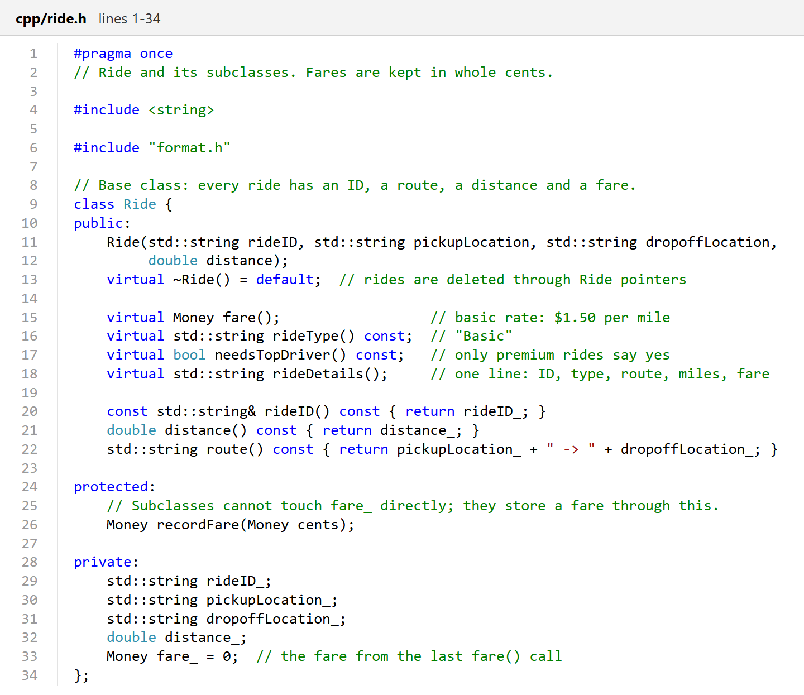
Figure A1
C++ Ride Base Class (cpp/ride.h)
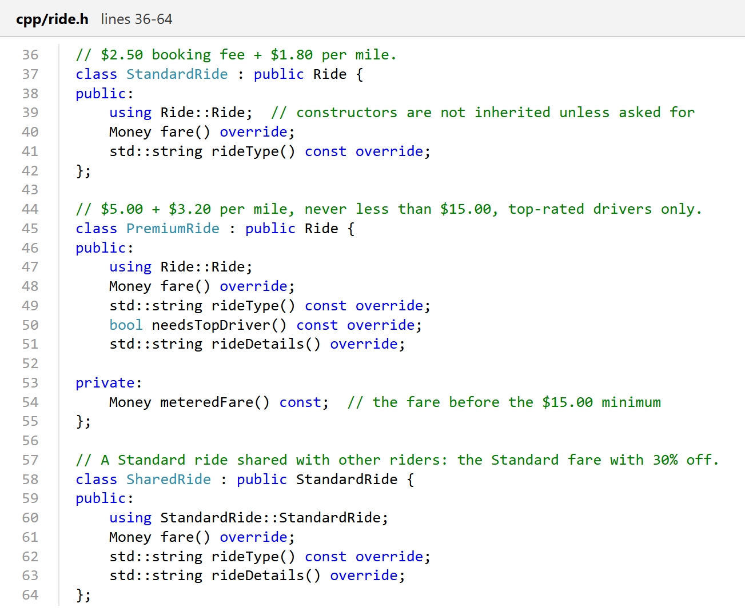
Figure A2
C++ StandardRide, PremiumRide, and SharedRide Subclasses (cpp/ride.h)
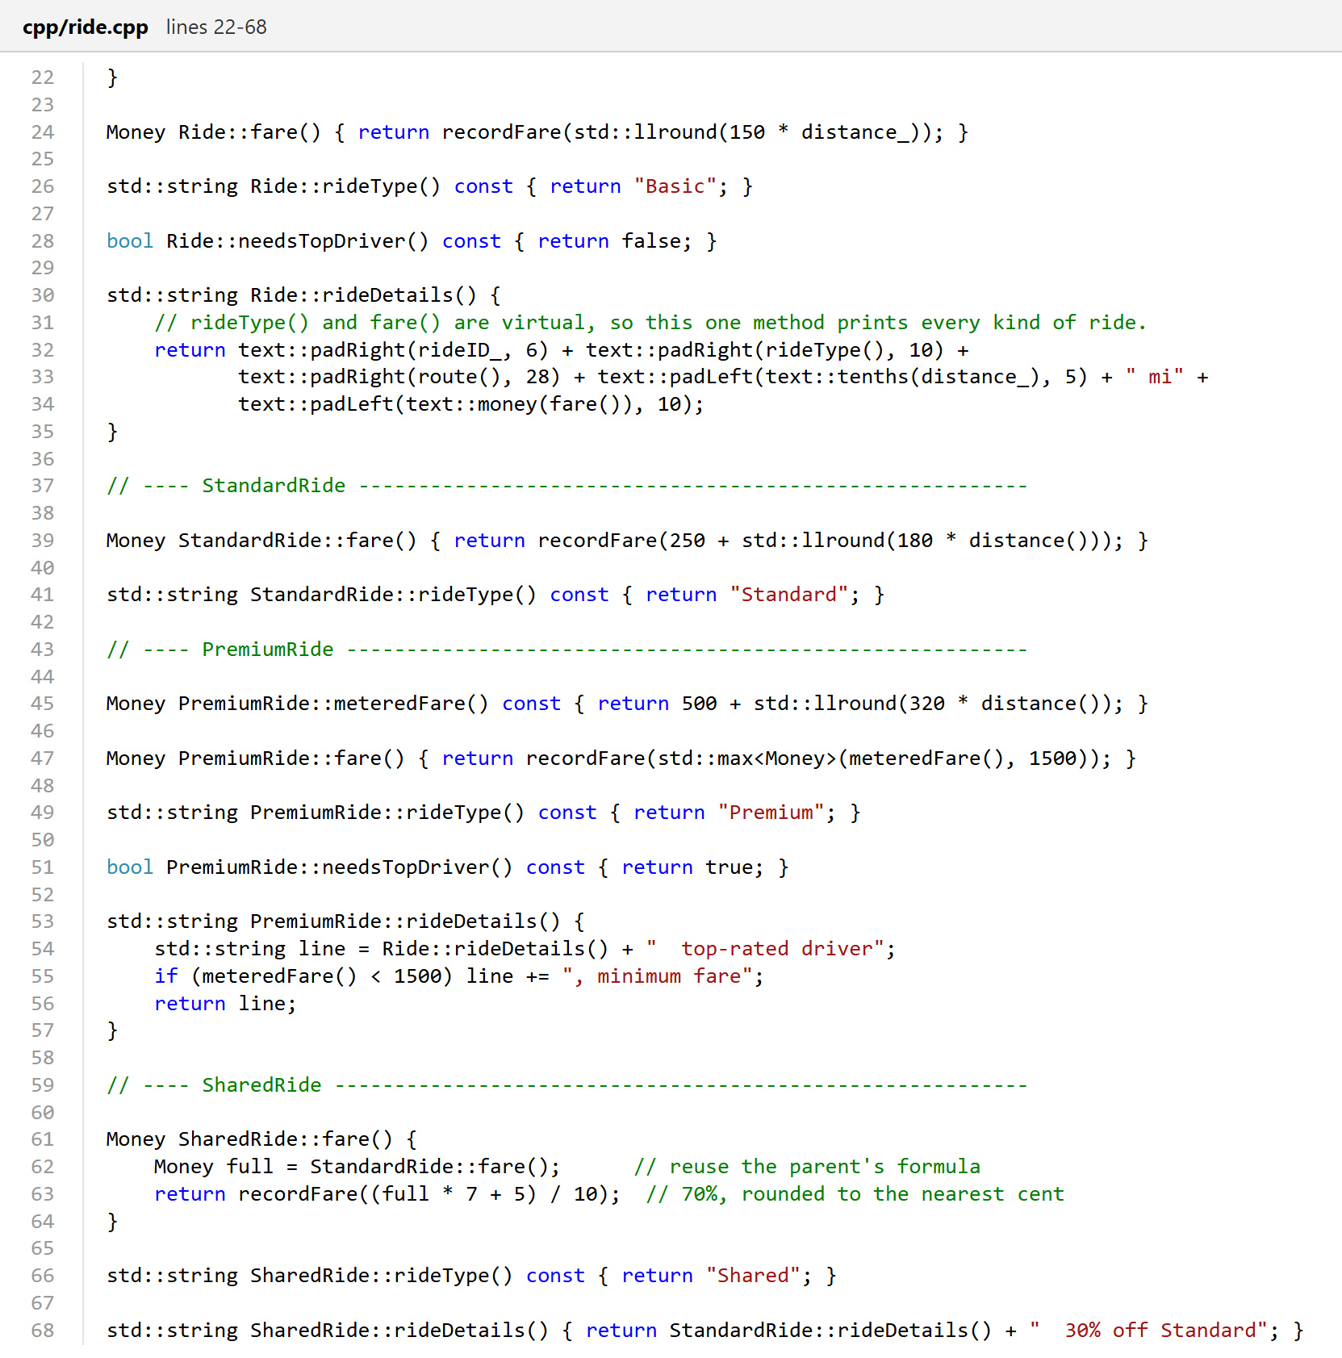
Figure A3
C++ Overridden fare() and rideDetails() Methods (cpp/ride.cpp)
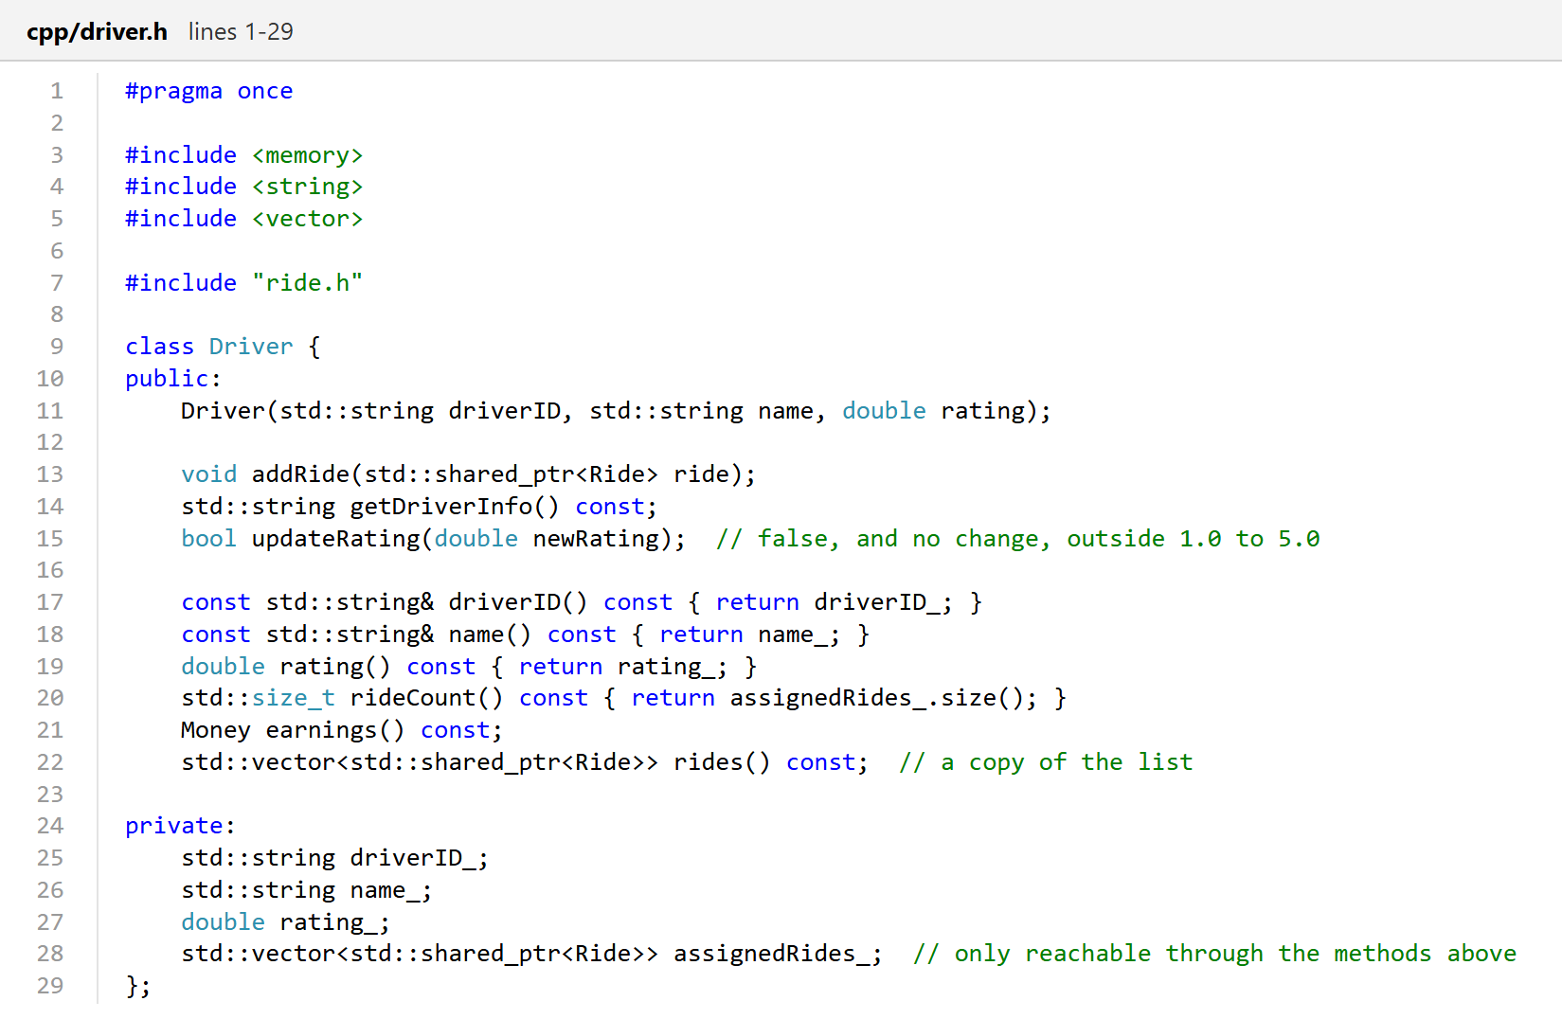
Figure A4
C++ Driver Class With a Private Ride List (cpp/driver.h)
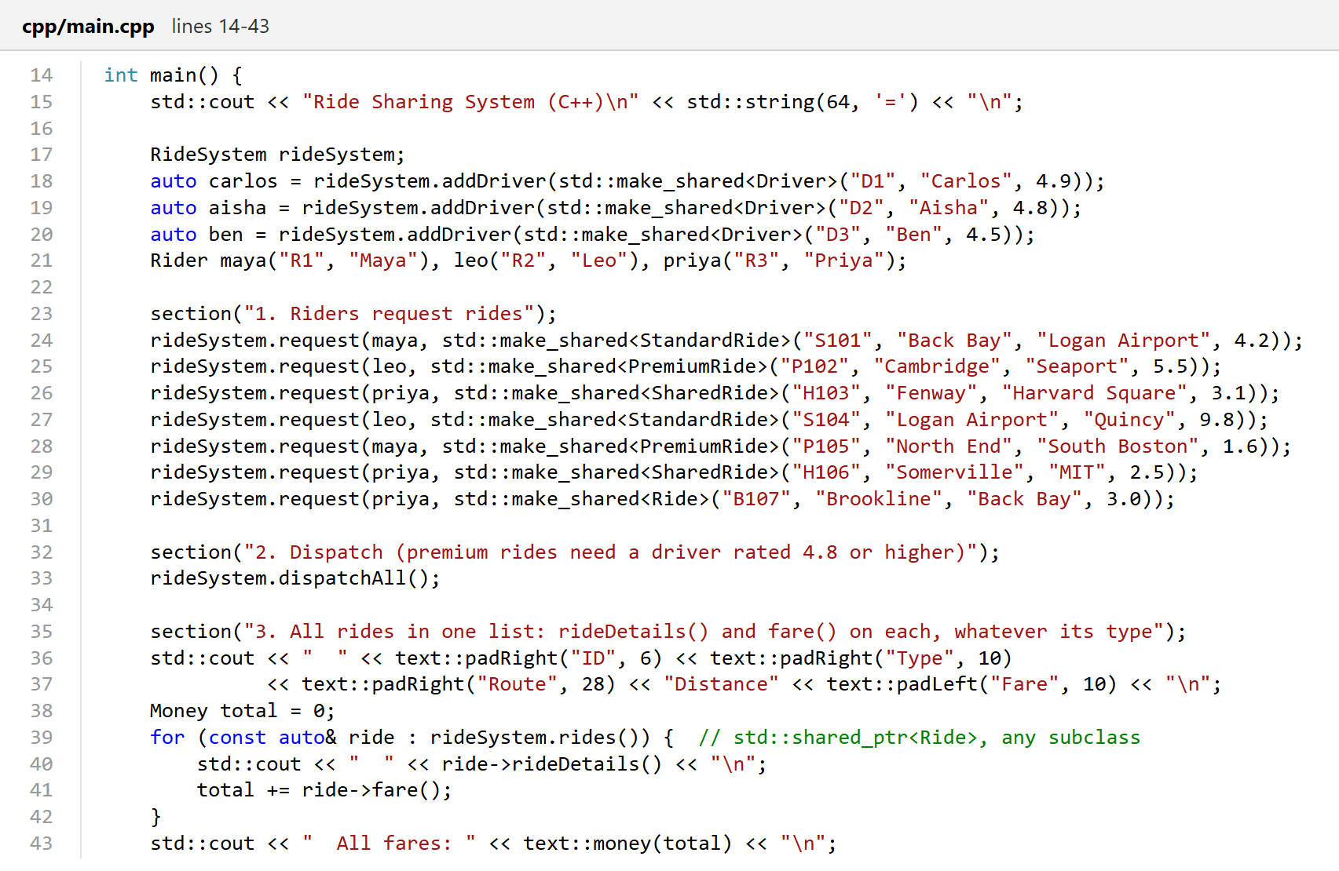
Figure A5
C++ Demo: Mixed Ride Types in One List (cpp/main.cpp)
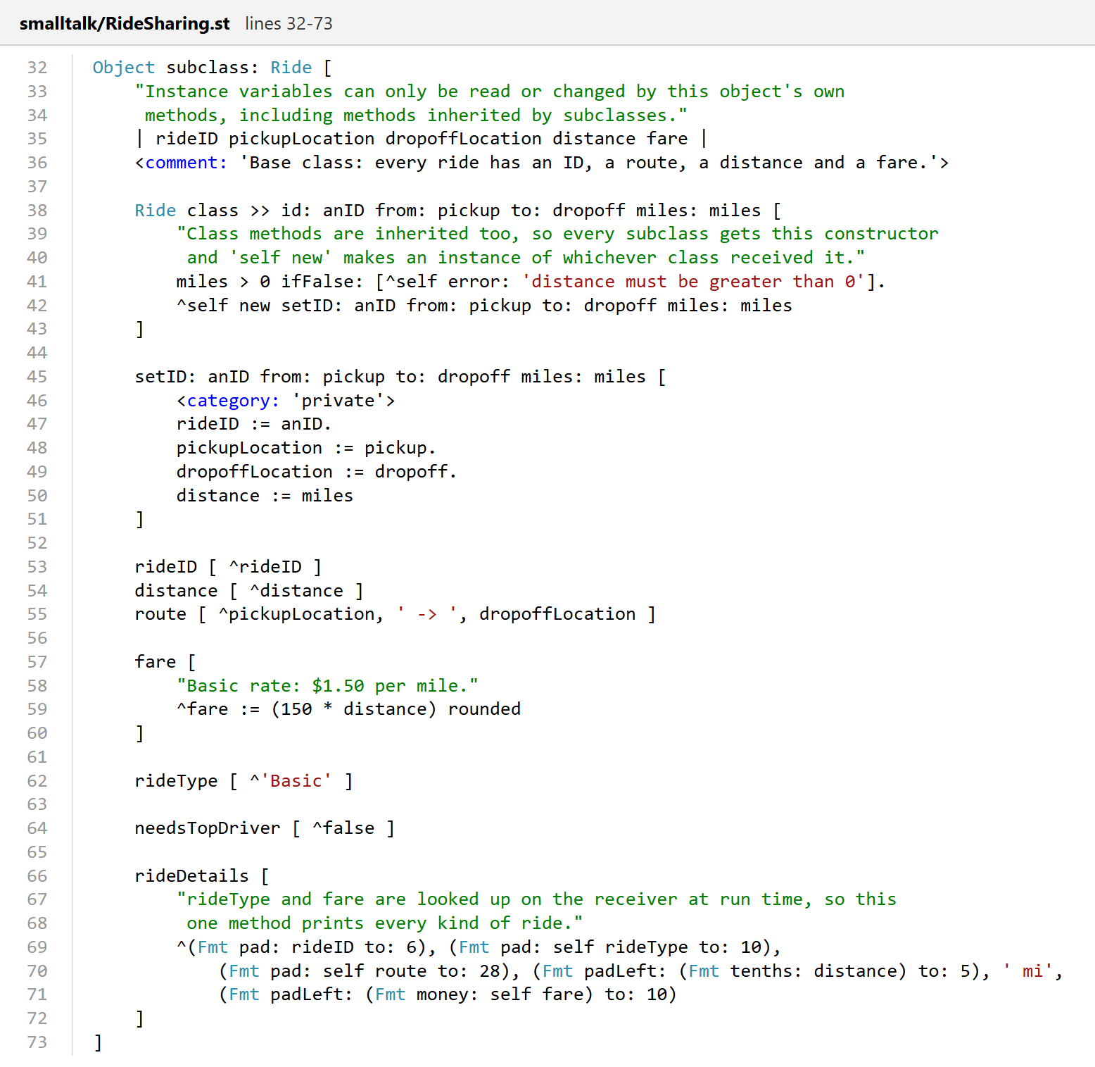
Figure A6
Smalltalk Ride Base Class (smalltalk/RideSharing.st)
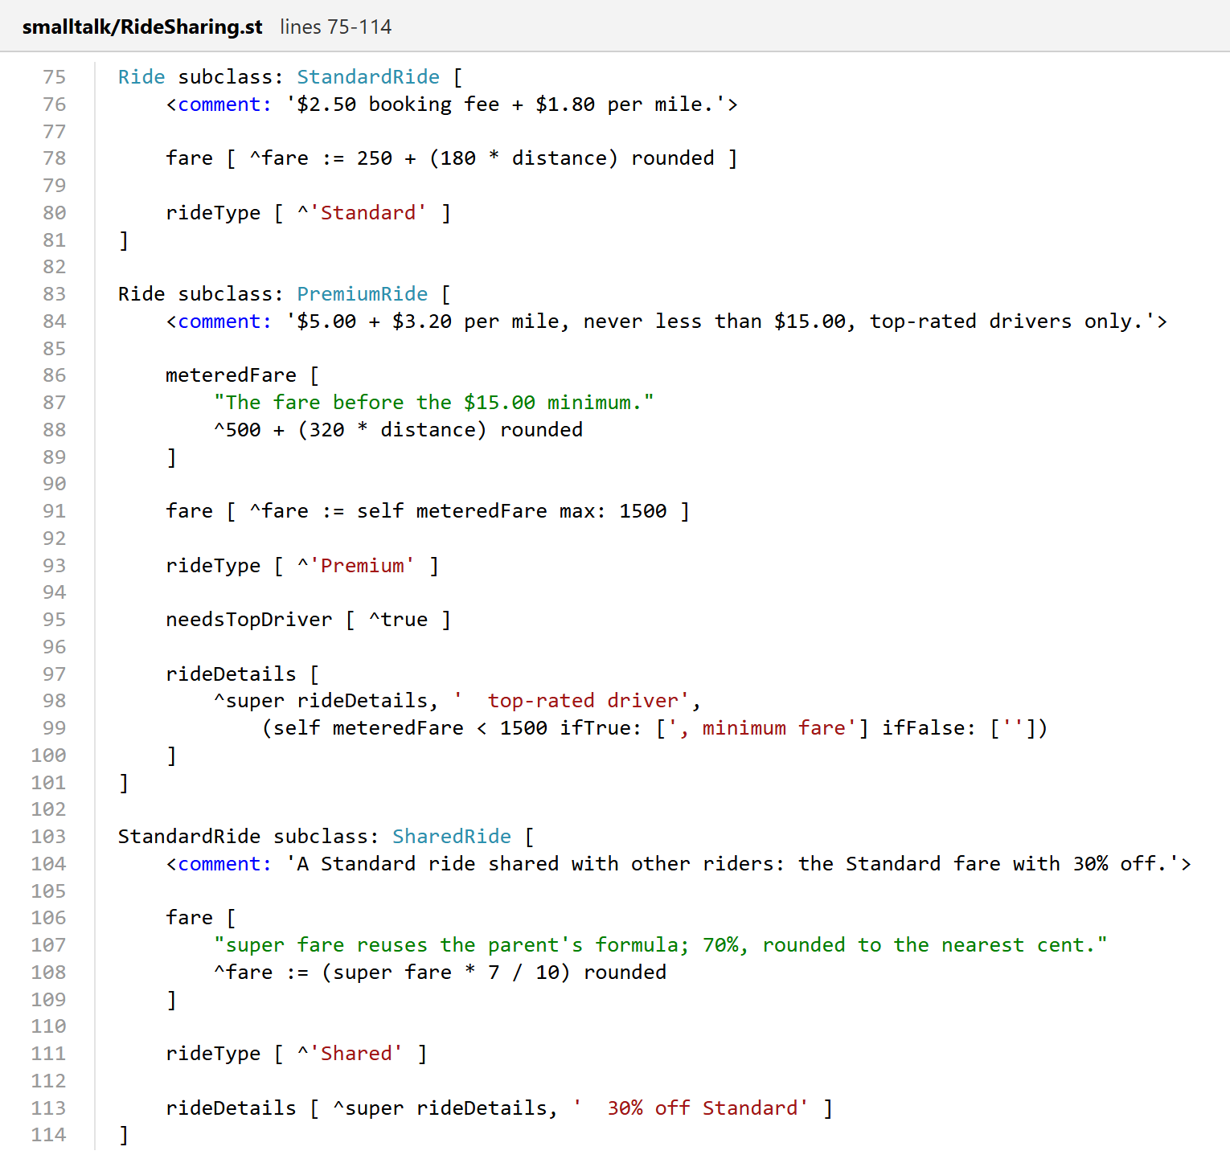
Figure A7
Smalltalk StandardRide, PremiumRide, and SharedRide Subclasses
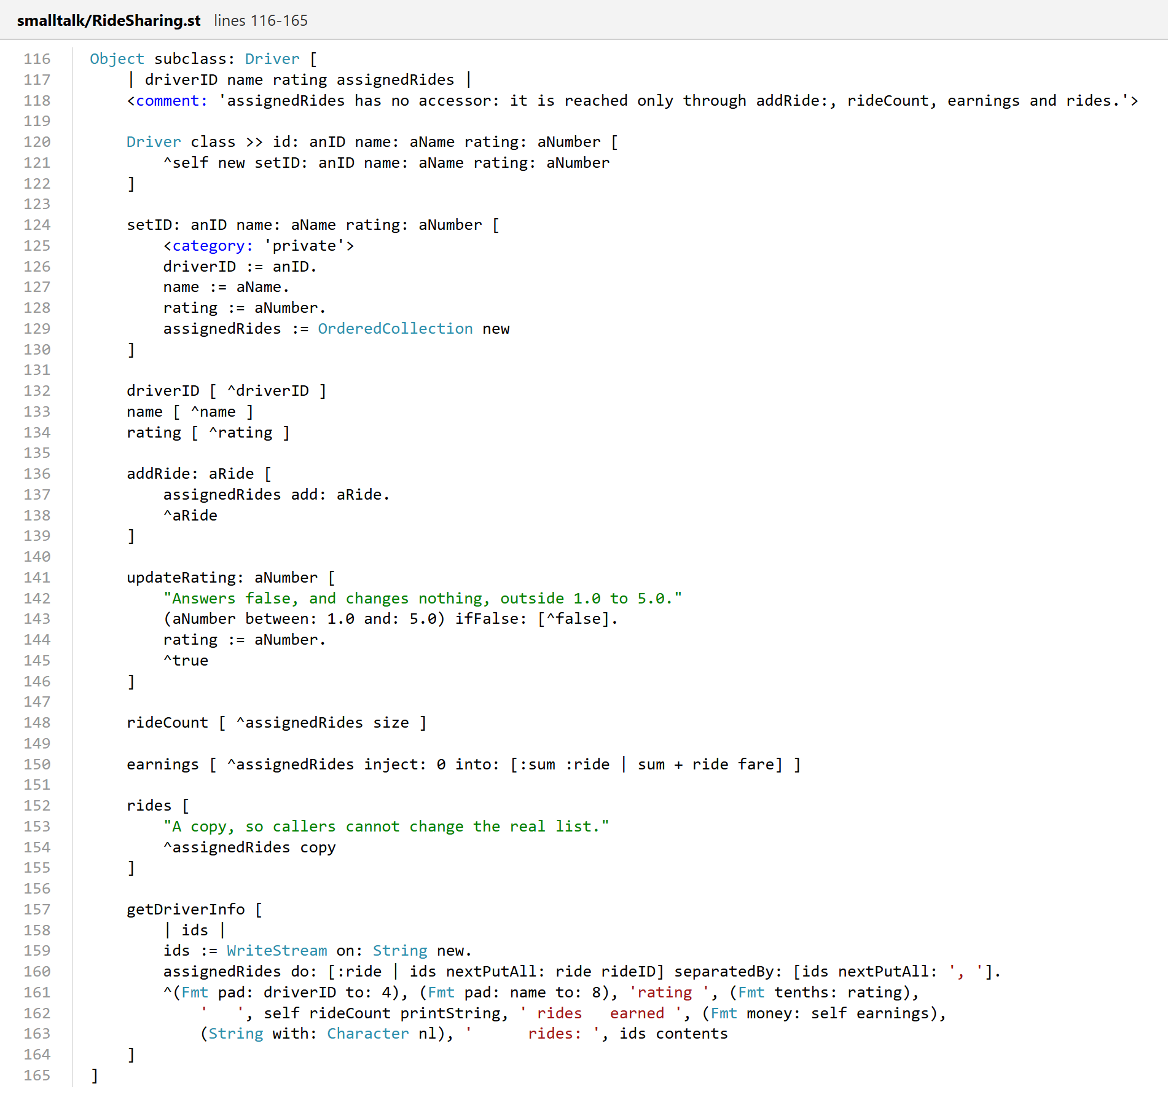
Figure A8
Smalltalk Driver Class (smalltalk/RideSharing.st)
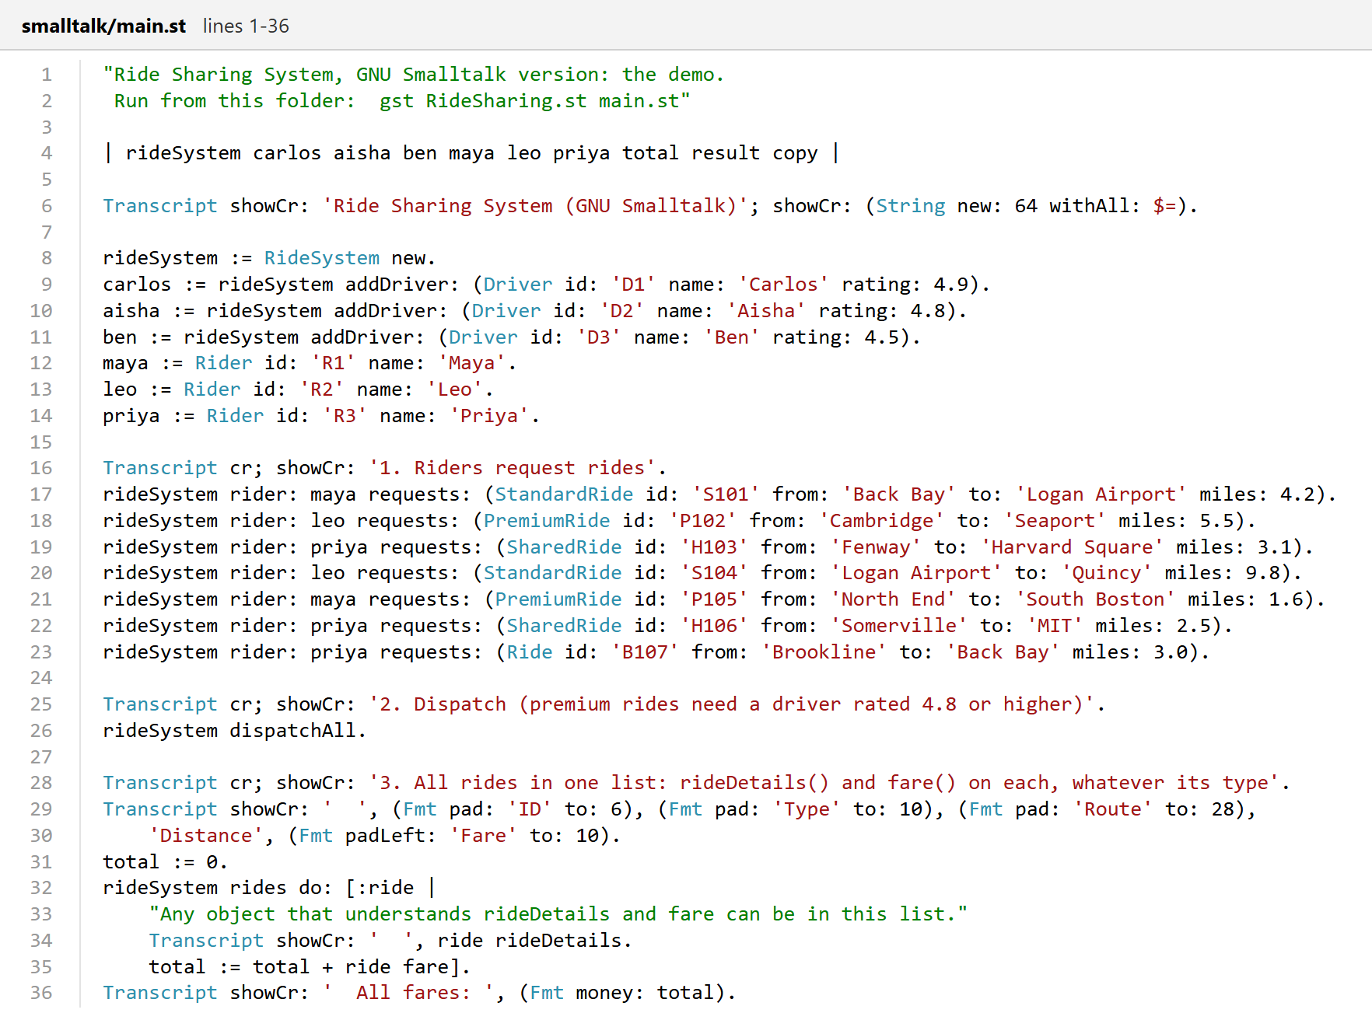
Figure A9
Smalltalk Demo: Mixed Ride Types in One List (smalltalk/main.st)
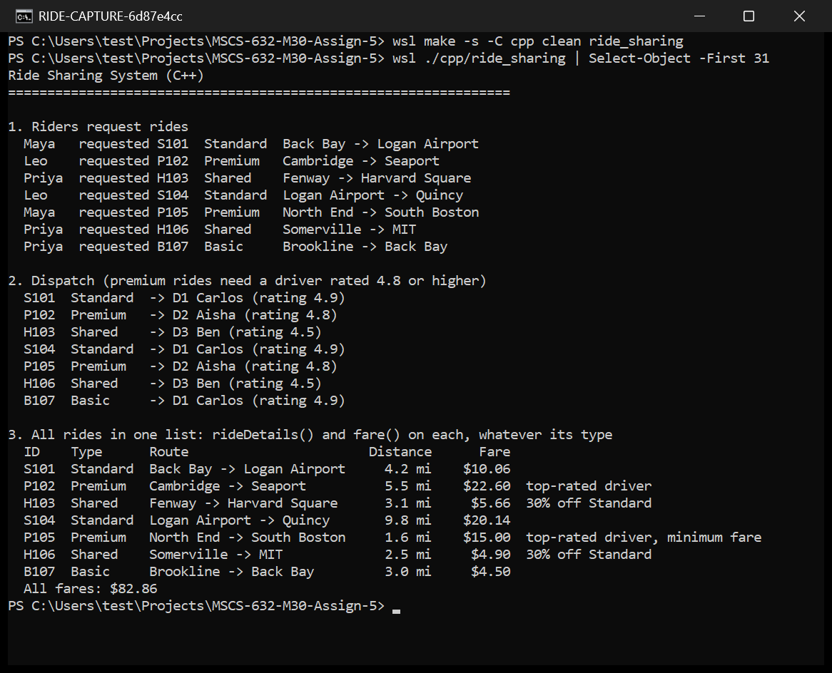
Figure A10
C++ Version Built and Run, Part 1: Requests, Dispatch, and All Rides
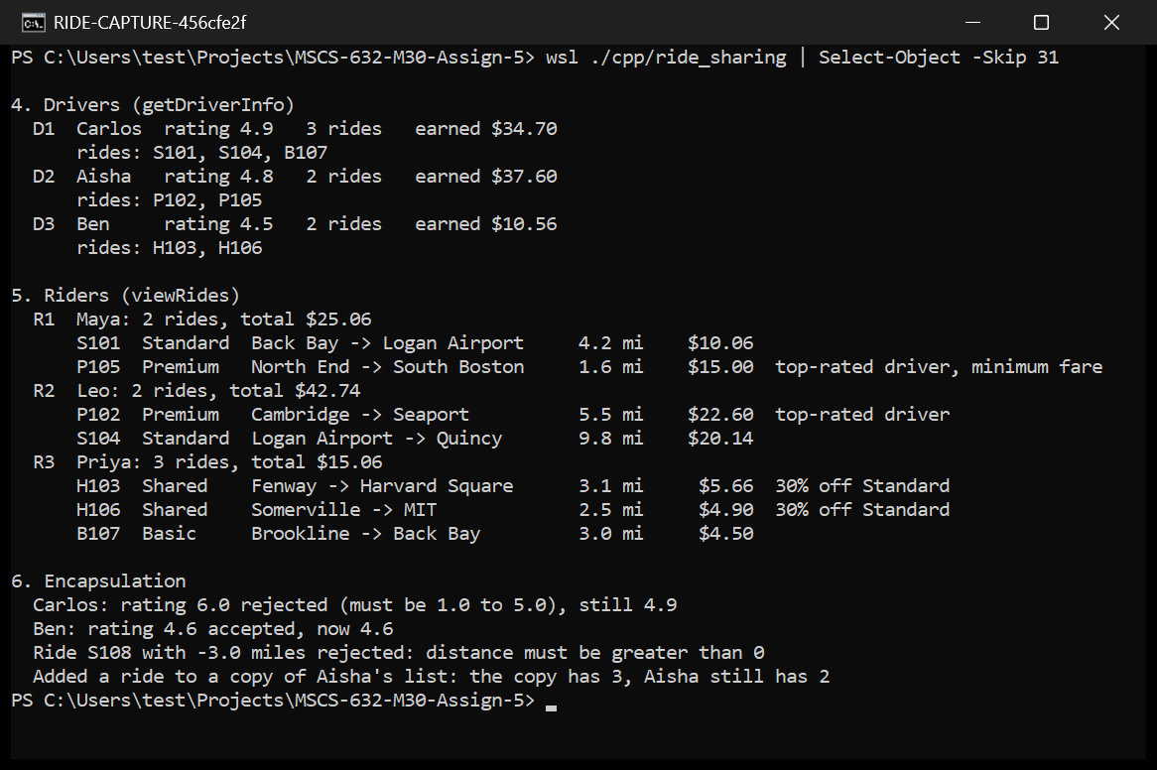
Figure A11
C++ Version, Part 2: Drivers, Riders, and Encapsulation Checks
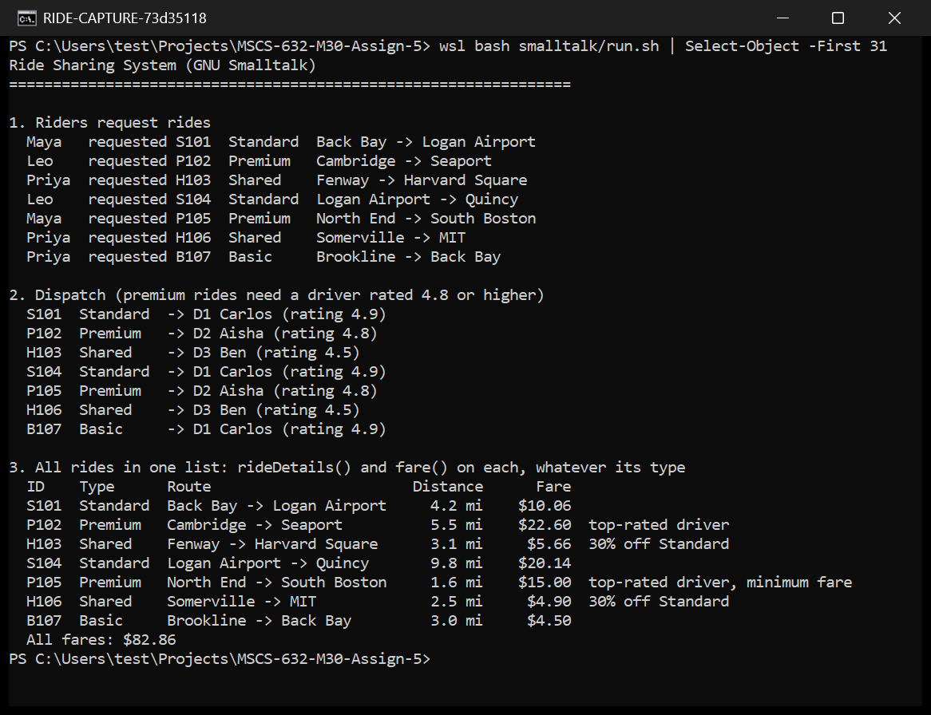
Figure A12
Smalltalk Version Run, Part 1: Requests, Dispatch, and All Rides
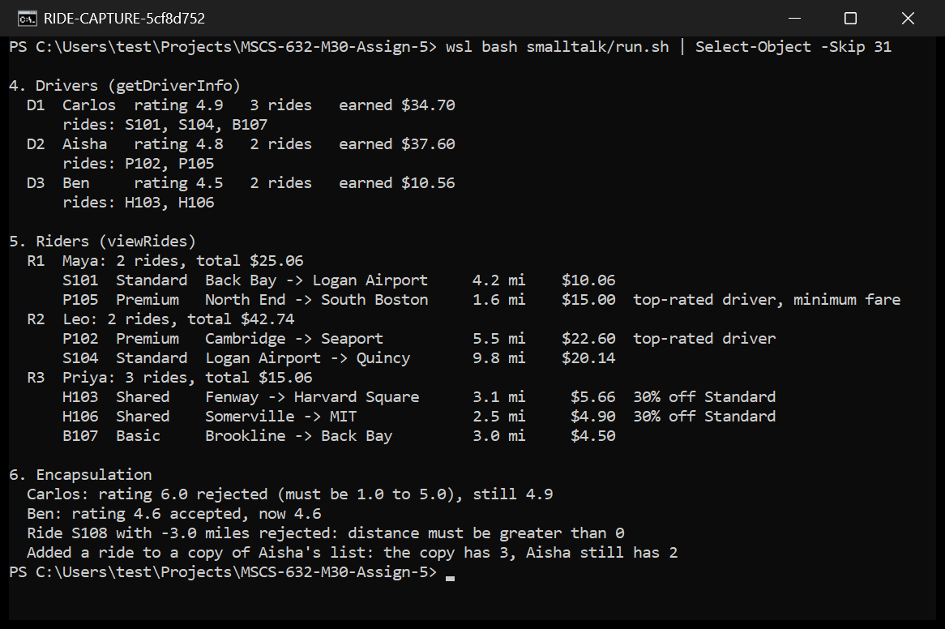
Figure A13
Smalltalk Version, Part 2: Drivers, Riders, and Encapsulation Checks
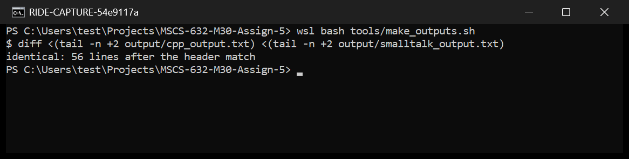
Figure A14
Both Outputs Compared: Identical After the Header Line

