ExpenseTracker: Core Functionality Implementation

Group Project Deliverable 2 (Saturday) - Option 1: Expense Tracker Application
Languages: Python and C++

Rahul Solanki, Krinal Soni, and Bijay Raj KC
University of the Cumberlands
MSCS-632-M30: Advanced Programming Language
Jay Thom
October 3, 2026

ExpenseTracker: Core Functionality Implementation
Status
The core of ExpenseTracker is implemented and operational in both languages. Each stores a seeded set of nine expenses with a date, an amount, a category and a description, lists them oldest first, filters them by category through an index, and reports totals by category and overall. Both report the same figures. Date-range filtering, keyword search, percentage shares, deletion, the interactive prompt, the benchmark and the automated tests are scheduled for Sunday.
Table 1
Requirement Status at the End of Day 2
Requirement | Status
Store expenses with date, amount, category and description | Complete
List every expense, oldest first | Complete
Filter by category using an index rather than a scan | Complete
Totals by category and overall | Complete
Date-range filter and keyword search | Day 3
Percentage shares, delete, interactive prompt, benchmark | Day 3
Unit tests | Day 3

Implementation
Both programs follow the two-layer design agreed on Friday: a store owns the records and answers queries, and a driver prints the results. The difference is visible in the first ten lines of each file. Python holds each expense as a dictionary inside a dictionary keyed by id, with a defaultdict mapping each category to a list of ids. C++ declares a struct whose fields are fixed at compile time, stores the records in a std::vector and indexes them with a std::unordered_map. Both indexes are hash tables, so the two programs do the same algorithmic work.
The second difference is in how a value enters the system. The Python store converts the amount with float(), which accepts an int, a float or the string "34.25" without complaint, and the demo ends by adding exactly such a string to show that it works. The C++ signature declares the parameter as a double, so the equivalent call is rejected by the compiler and never reaches a test. Dates show the same split: Python parses with datetime.strptime from the standard library, while the C++ version has a hand-written parse_date because C++20 supplies a calendar type but not a parser in this toolchain.
Verification
Both implementations were built and run in WSL2 Ubuntu 24.04 using Python 3.12.3 and g++ 13.3.0, so a single machine underlies every result. The C++ build is clean under -Wall -Wextra. Each program reports nine records totalling $511.94, and $546.19 after the tenth expense is added, with identical per-category totals.
Figure 1
Python Core Implementation Running
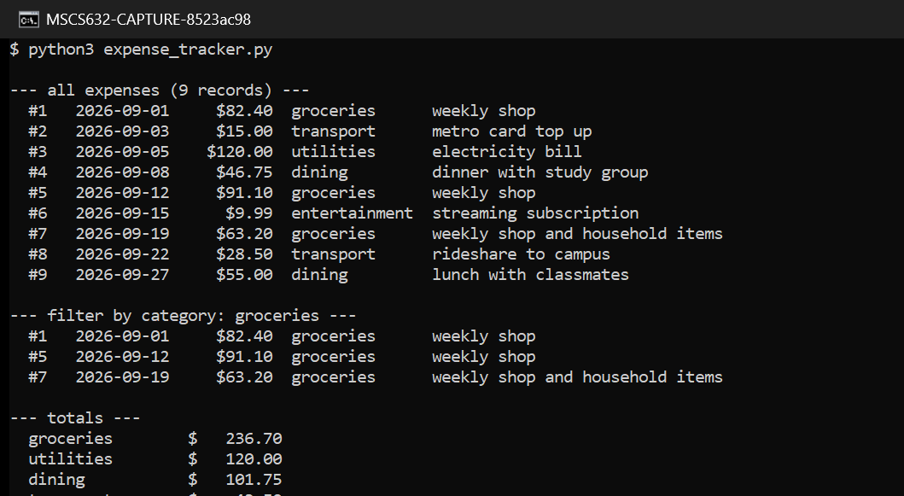
Note. The final line adds an amount supplied as the string "34.25", which Python accepts silently. The equivalent call does not compile in C++.
Figure 2
C++ Core Implementation Running
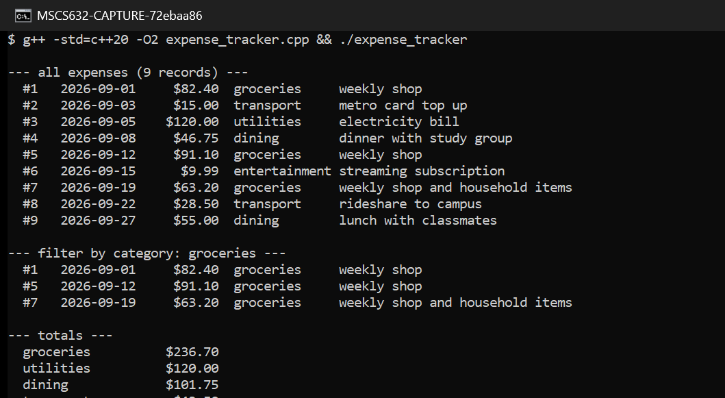
Note. The same nine records and the same totals, produced from a std::vector of structs indexed by a std::unordered_map.
Code Quality and Testing
Both files are organised the same way, with the record type first, then the store, then the driver, and each language-specific decision is commented where it occurs rather than only in this report. Testing at this stage was manual: confirming that the listing is ordered oldest first, that the category filter returns the three grocery records, and that the per-category totals sum to the overall total in both programs. Automated tests and a sanitizer run are part of Sunday’s deliverable.
Issues Found and Resolved
Two problems surfaced during the day. First, the C++ store indexes records by their position in the vector, and pushing a record while holding a reference to the vector’s contents is unsafe once the vector reallocates. We reserved capacity up front and took the category string before the move, which resolved it; the deeper consequence for deletion is deferred to Day 3. Second, category matching initially differed between the two programs because Python lower-cased the category on entry and C++ did not, so a search for "Groceries" returned three records in one program and none in the other. Both now normalise the category when the record is created.
Repository
The code, the README with build and run instructions, and these screenshots are in the repository at https://github.com/iknalos/MSCS-632-M30-Group-D2. The README documents the layout, the exact toolchain versions, the commands to build and run each implementation, and the language-specific features demonstrated in each file.

References
Python Software Foundation. (2026). The Python language reference (Version 3.14). Retrieved October 3, 2026, from https://docs.python.org/3/reference/
Stroustrup, B. (2013). The C++ programming language (4th ed.). Addison-Wesley.

