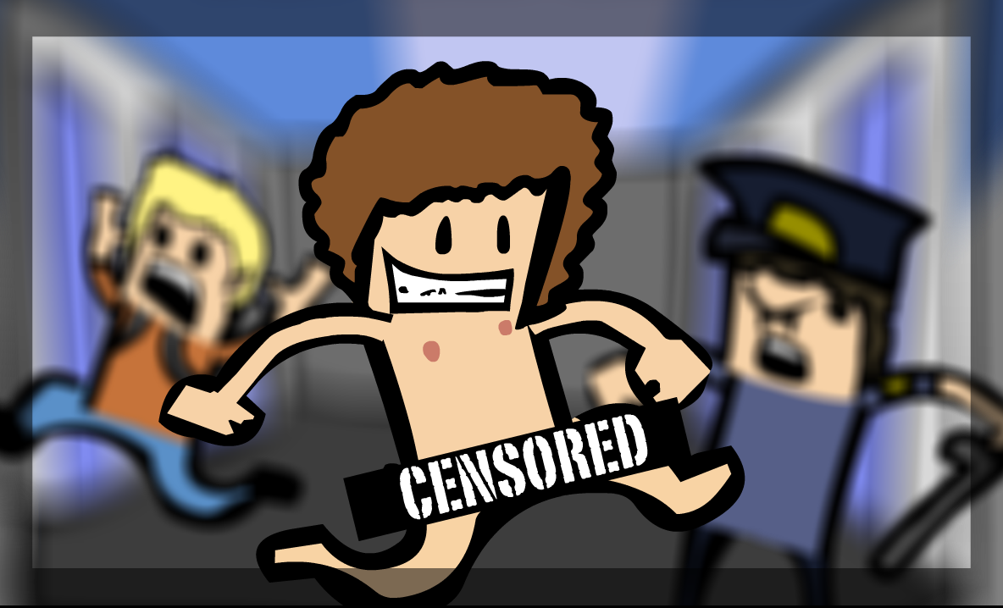

Superflash
“Let it all hang out”

Alex Attar
David Campbell
Jeffrey How
Addison Rodomista

Table of Contents
Executive summary 1
Overview 2
Game characters 3
User interface storyboards #
Technology plan #
Software architecture #
Controls #
Level design #
Mechanic analysis #
Artificial intelligence #
Physics #
Results #
User manual #

Executive summary

Overview

Game characters

User interface storyboards

Technology plan

Software architecture

Controls

Level design

Mechanic analysis

Artificial intelligence

Physics

Results

User manual

