CS4440 Notes
Introduction:
- Computer System
  - hardware
  - software
  - data
  - users
  - hierarchy
    - users → sw + data → OS → hw
  - computer system
    - applications (system + user)
      - can invoke/include library functions (1)
      - can make system call to kernel (1')
      - can access hardware (3)
    - system libraries
      - can access os kernel (2)
      - can access hardware (3)
    - os kernel
      - can access hardware
    - hw
  - note:
    - 1 + 1' = unix/linux approach
    - 1 + 2 = windows approach
      - application cannot access kernel directly
      - why?
        - Kernel changes can be accommodated with system libraries changes without changing applications
    - 3 = assembly
      - non-privileged instructions
      - note:
        - privileged instructions can only be invoked in kernel mode
    - how does system know which mode you are in?
      - Mode bits
        - 1 = user mode
        - 0 = kernel mode
        - set to 1 when application launches
- abstraction
  - add layer on top of existing layer
  - example:
    - read(fl, lblk, mm)
      - fl = file
      - lblk = logic block number
      - mm = memory
        - memory that hold data
        - buffer
      - steps:
      - I/O system
        - compute position of lblk
          - lblk contiguous but may not be on disk
        - move read write path to corresponding disk track
        - check for seek errors
        - read physical block into buffer
        - check for read errors
        - copy block from mm from the buffer
    - virtualization
      - cpu
        - cpu is time shared
          - given small slice of time of cpu time
        - virtual cpu can have virtual memory
      - memory
        - memory can be virtualized
          - virtual memory management
            - put part of program in memory
              - sufficient to run program
      - printer
        - spooling
          - when you send job to printer, its put on disk, not on the printer
          - much faster to transfer to disk (cpu to disk > cpu to printer)
            - useful because releases resources used to transfer
    - concurrency
      - example:
        - counter = 3;
        - p1
          - counter++;
        - p2
          - counter--;
        - steps:
          - p1
            - r1 ← counter
            - r1 ← r1 + 1
            - counter ← r1
          - p2
            - r2 ← counter
            - r2 ← r2 + 1
            - counter ← r2
        - result
          - p1 → p2: 3
          - p2 → p1: 3
            - above only in ideal execution, i.e., sequential execution
          - if execution non-sequential, result will vary

3/01/15
Monitors
- ADS – abstract data structure
Structure
- ep = entry point
- cv = condition variable
- ADD PHOTO1

bounded buffer problem:
- multiple producers, multiple consumers

monitor bounded_buffer
char buffer[n]
int nextin = 0, nextout=0;
      - accessed by consumers and producers
condition notempty, notfull

deposit(char c){
if (full_cnt == n) notfull.wait;
buffer[nextin] = c;
nextin=(nextin+1)%n;
full_cnt++;
notempty.signal;
/*different from semiphore, non-conditional
releases resources from buffer */
}

remove(char c){
if (full_count == 0) notempty.wait; //wait until buffer pool is empty
c = buffer[nextout];
nextout=(nextout + 1) % n;
full_cnt--; //consumed one buffer
notfull.signal; //equivalent to sending signal to producer
}
/* concurrency not high for this monitor
another process exist that share resources
function of monitor is to insure only one process is accessing critical section
enforces process to wait on condition variable*/

cobegin
p1//p2//p3//c1//c2
coend

p1: …
deposit(c);
c1:…
remove(c)

Readers Writers example:

moniter Readers_Writers{
int read_cnt = 0; writing = 0;
conditions OK_to_read, OK_to_write;

start_read(){
if(writing) OK_to_read.wait;
read_cnt++;
OK_to_read.signal;
}

finish_read(){
read_cnt –;
if(read_cnt == 0) OK_to_write.signal;
}

start_write(){
if((read_cnt != 0) || writing) OK_to_write.wait;
writing = 1;
}

finish_write(){
writing = 0;
if(!empty(OK_to_read)) OK_to_read.signal;
else OK_to_write.signal;
}
}

reader:
…
start_read();
file_access;
finish_read();

Simulate program execution:
- entry points:
bp(mutex);
…
body of F;
…
if(next_count > 0) //condition runs until cv is released
V(next); //semiphore used by similar process
else //if no similar (signaler???) process
bV(mutex);

- condition variables

x_count++ //keep track of how many process blocked by cv
if (next_count > 0)
V(next);
//next_count = num processes blocking signaler queue
else
bV(mutex);

P(x_sem); //always initialized to 0
x_count--;

- signaler queue
if(x_count > 0){
next_count++;
v(x_sem);
p(next);
next_count--;
}
Above are 3 aspects of the monitor that must be implemented

Producer_consumer problem in c:

pthread_cond_wait → first function needed for project 2
- want to use mutex to synchronize processes
  - but make sure to released
pthread_cond_signal
- takes one parameter, the signaler

cont_t empty, full;
mutex_t mutex;

void* producer(void* arg){
item_t i;
while(1){
pthread_mutext_lock(&mutex);
while(count == MAX)
pthread_cond_wait(&empty, &mutex);
put(i);
pthread_cond_signal(&full);
pthread_mutex_unlock(&mutex);
}
}

void* consumer(void* arg){
itm_t i;
while(1){
pthread_mutex_lock(&mutex); //C1
while(count == 0) // C2
pthread_cd_wait(&full, &mutex); //C3
int tmp = get(); //C4
pthread_cond_signal(&empty); //C5
pthread_mutex_unlock(&mutex); //C6
}
}

int buffer[MAX];
int fill, use, count = 0;

void put(int value){
buffer[fill] = value;
fill = (fill + 1)% MAX;
count++;
}

int get(){
int tmp = buffer[use];
ase = (use + 1)% MAX;
count--;
return tmp;
}

use while loop to ensure conditions are checked

consumer 1(C1, C2, C3) → producer 1(P1, P2, P3, P4, P4, P5, P6, P1, P2, P3)
→ consumer 2(C1, C2, C3, C4, C5, C6)
→ consumer 1(C4)
- buffer is empty, so cannot get item from buffer
- while loop helps address this issue

reusable resources:
p1:
- open(f1 w);
- open(f2, w);
p2:
- open(f2, w);
- open(f1, w);

above situation causes deadlock

consumable resources:

3/15/16

Logical-to-Physical Address Binding

logical address space (LAS)
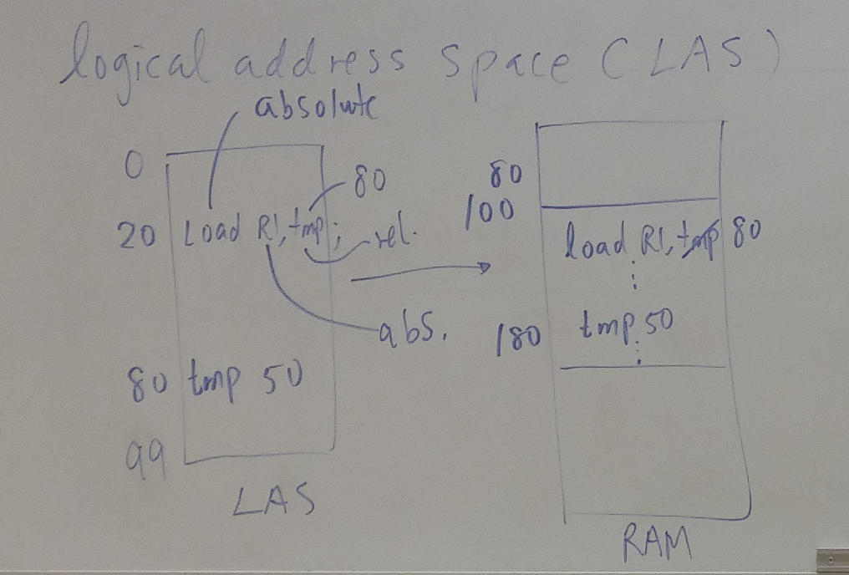

static binding/assignment
- resources allocated before run time
- assignment
  - predefined
  - compilation time
  - link time
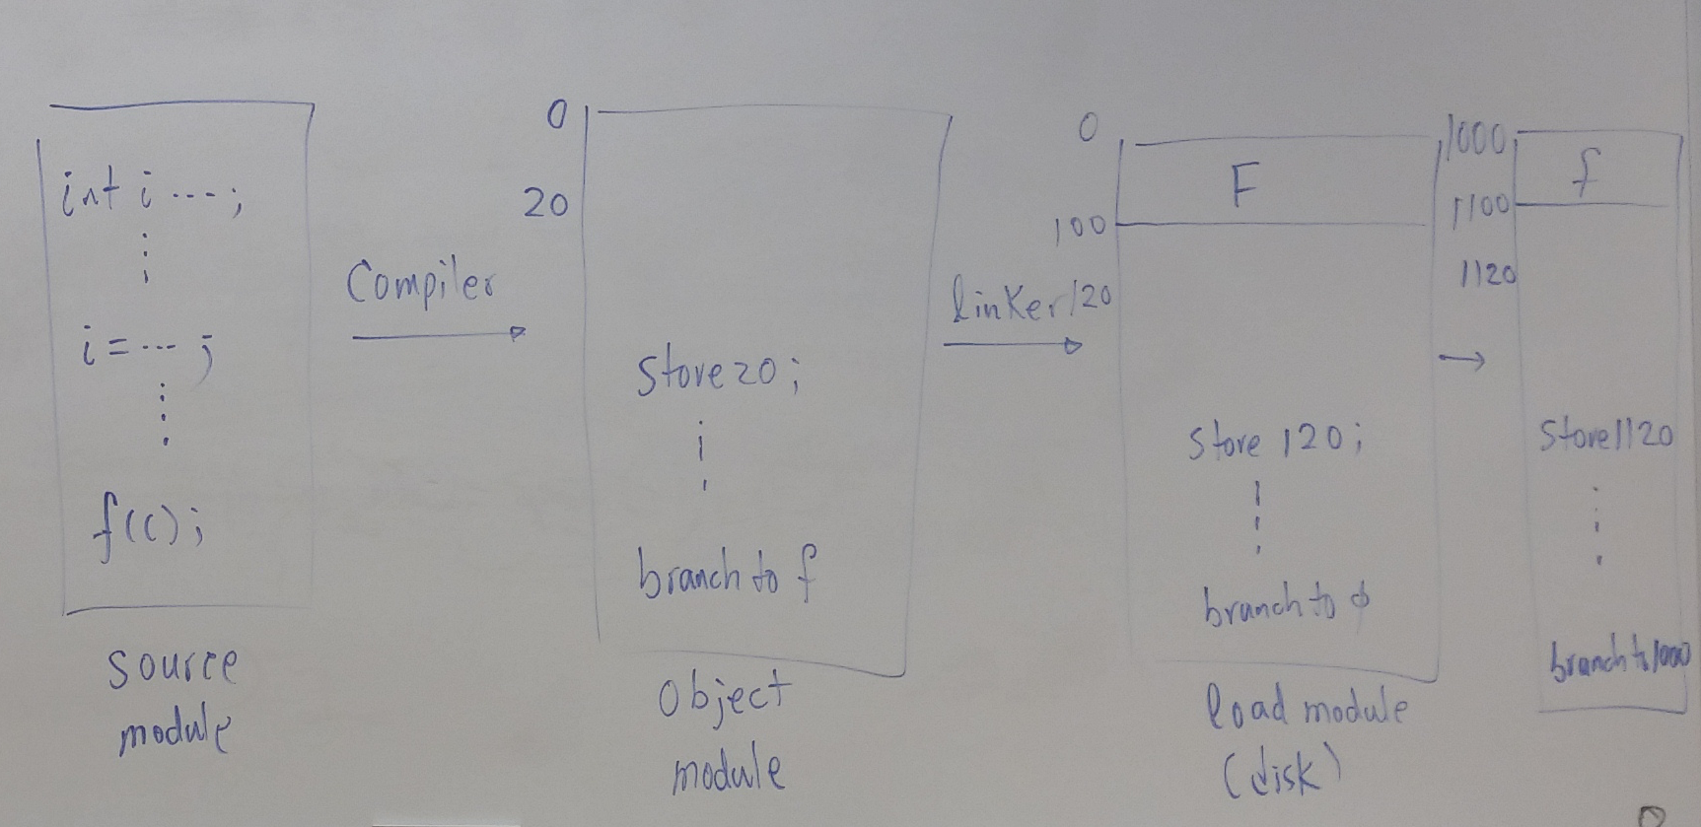

dynamic binding/assignment
- allocation of resources variables
  - can be done at the start of the program
  - can be done at compilation
    - compiler dictates memory allocation
    - but normally not the case
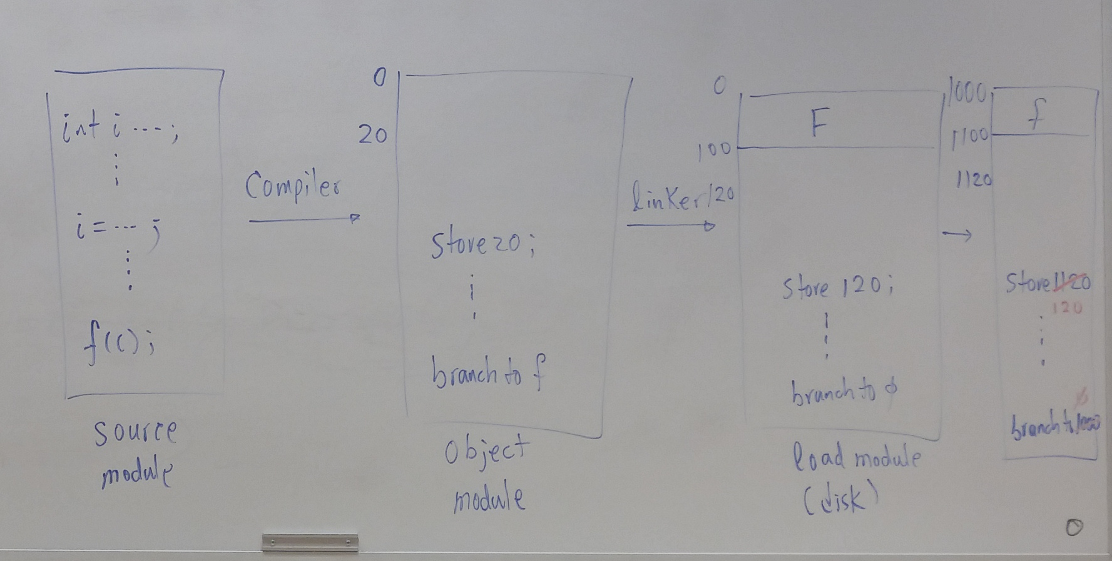
Relocation Register (RR)
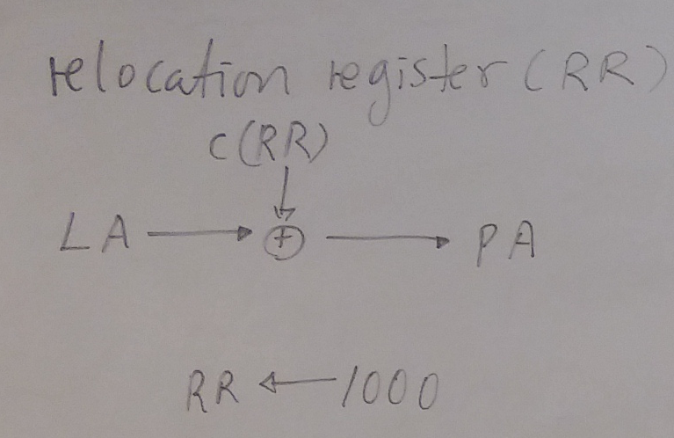

Contiguous Memory Allocation:
- traditional memory management
- whole program loaded into memory
- best fit
  - process that fits best into partition is used
- queues
  - separate/multiple
    - 1 program for each partition
    - problems:
      - stack/heap can flow out of partition
        - solve by finding larger partition
        - difficult with static binding
        - dynamic binding not supported
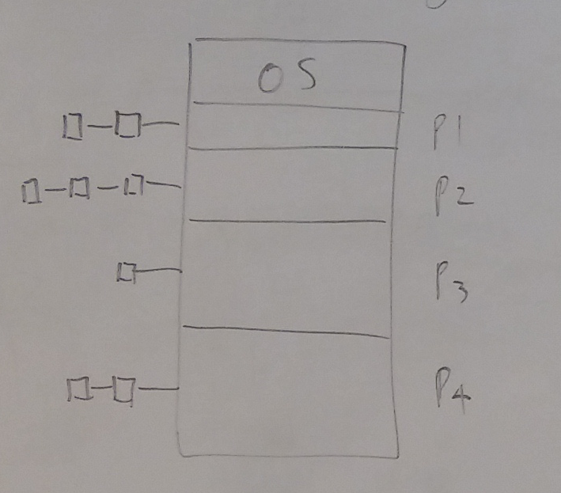

    - called static or fixed partitioning
  - single
    - search for process that will fit into an open partition
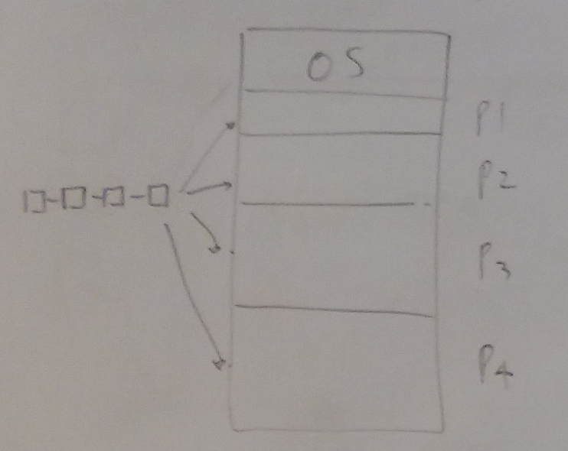

- dynamic partitioning (variable)
  - strategies
    - first-fit
      - check partitions sequentially until a partition with sufficient size is found for the first process
    - next-fit
    - worst-fit
      - searches entire list of partitions available for worst fit
        - creates bigger holes, which can potentially be used to hold other processes
    - best-fit
      - searches entire list of partitions available for best fit
    - first, worst & best fit perform comparably
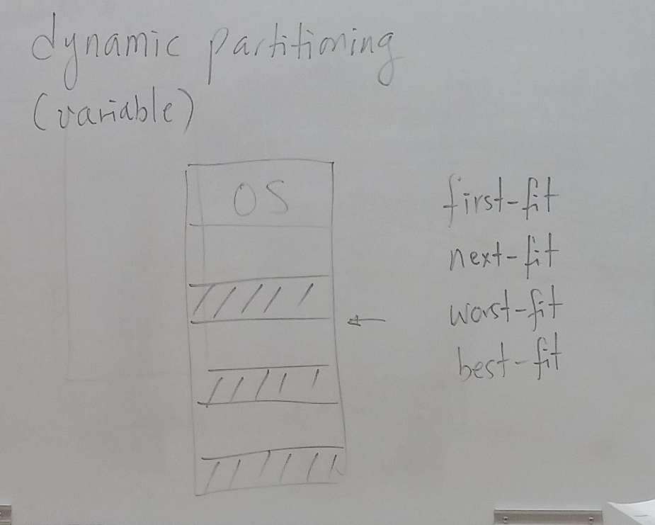

- garbage collection/compaction
- coalescing
  - merging adjacent blocks to create larger partitioning
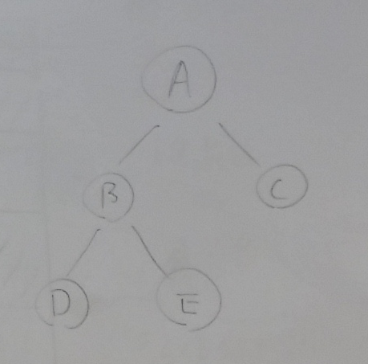

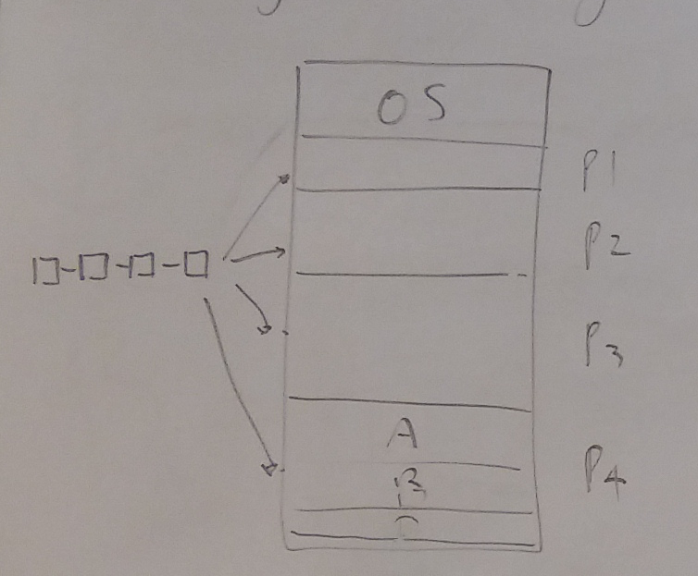

- processes can overlay other processes when the other process has returned control to the parent process
  - IF each partition is big enough to fit branches of tree

implementation of dynamic partitioning
- linked list approach
- f = free, o = occupied, s = size
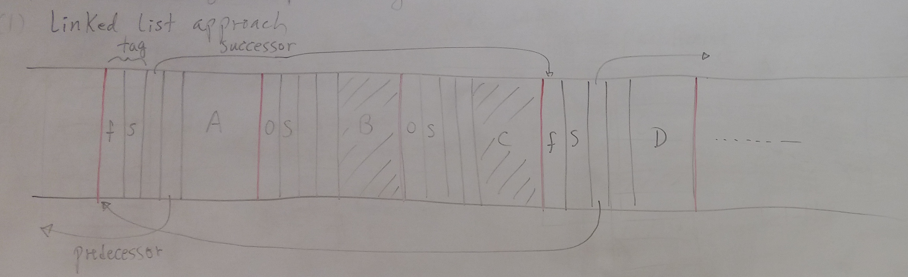
- to coalesce:
  - change s value in preceding partition
  - however, difficult to determine whether partition is free
- bit map approach
  - each block is assigned bit to indicate whether a partition is free or not

