# **USB KEYBOARD (HID)**

1. **Descriptors** [**(GitHub Docs)**](https://github.com/tmk/tmk_keyboard/wiki/USB:-Descriptor)

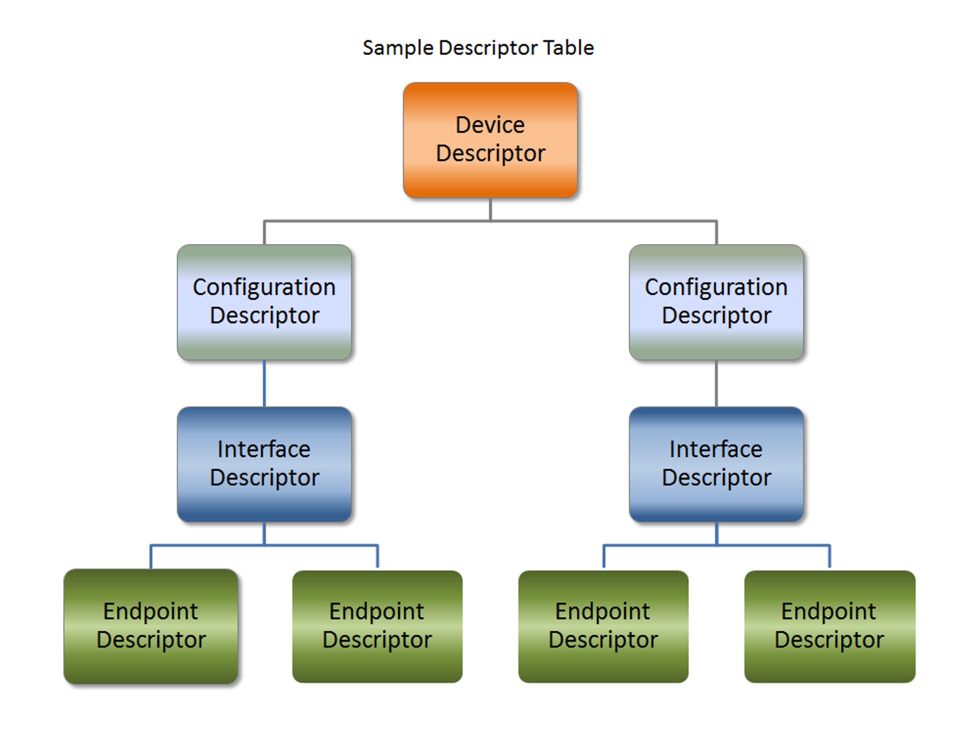

1. Device descriptor
   1. The Device Descriptor provides general information about the USB device, such as its USB version, device class, subclass, protocol, and vendor/product IDs.
   2. Structure

• bLength: Length of the descriptor (typically 18 bytes for a device descriptor).

• bDescriptorType: Descriptor type (0x01 for device descriptor).

• bcdUSB: USB version (e.g., 0x0200 for USB 2.0).

• bDeviceClass: Device class (0x00 for devices with no class, HID devices have 0x03).

• bDeviceSubClass: Device subclass (typically 0x01 for HID).

• bDeviceProtocol: Protocol used by the device (0x01 for HID).

• bMaxPacketSize0: Maximum packet size for endpoint 0 (usually 64 bytes for most devices).

• idVendor: Vendor ID (assigned by USB-IF).

• idProduct: Product ID (assigned by the manufacturer).

• bcdDevice: Device release number.

• iManufacturer: Index of manufacturer string descriptor.

• iProduct: Index of product string descriptor.

• iSerialNumber: Index of serial number string descriptor.

• bNumConfigurations: Number of configurations the device supports (usually 1).

1. Configuration Descriptor
   1. The Configuration Descriptor describes the device’s power requirements, number of interfaces, and how each interface is structured.
   2. Structure

• bLength: Length of the descriptor (usually 9 bytes).

• bDescriptorType: Descriptor type (0x02 for configuration descriptor).

• wTotalLength: Total length of the configuration descriptor and all associated descriptors.

• bNumInterfaces: Number of interfaces the device supports.

• bConfigurationValue: Value used to select this configuration.

• iConfiguration: Index of the configuration string descriptor.

• bmAttributes: Attributes of the configuration (e.g., bus-powered or self-powered).

• bMaxPower: Maximum power required by the device (in 2mA units).

1. Interface Descriptor
   1. The Interface Descriptor describes a single interface within a configuration. For USB keyboards, this will describe the HID interface.
   2. Structure

• bLength: Length of the descriptor (usually 9 bytes).

• bDescriptorType: Descriptor type (0x04 for interface descriptor).

• bInterfaceNumber: Index of the interface.

• bAlternateSetting: Index of the alternate setting for the interface (usually 0).

• bNumEndpoints: Number of endpoints used by this interface.

• bInterfaceClass: Class of the interface (0x03 for HID).

• bInterfaceSubClass: Subclass of the interface (0x01 for Boot Interface).

• bInterfaceProtocol: Protocol used by the interface (0x01 for keyboards).

• iInterface: Index of the interface string descriptor.

1. Endpoint Descriptor
   1. The Endpoint Descriptor describes the endpoints used for communication with the device, including the type of transfer and the maximum packet size.
   2. Structure

• bLength: Length of the descriptor (usually 7 bytes).

• bDescriptorType: Descriptor type (0x05 for endpoint descriptor).

• bEndpointAddress: Address of the endpoint (includes direction: IN or OUT).

• bmAttributes: Endpoint attributes (e.g., control, interrupt, bulk, isochronous).

• wMaxPacketSize: Maximum packet size for the endpoint.

• bInterval: Interval for interrupt endpoints (e.g., 10 ms for a keyboard).

1. Report Descriptor
   1. The Report (HID) Descriptor describes the functionality of the HID interface, such as the protocol and report descriptors. The report descriptor defines how the data (key codes) are sent between the device and the host.
   2. Structure

• bLength: Length of the descriptor (usually 9 bytes).

• bDescriptorType: Descriptor type (0x21 for Report (HID) descriptor).

• bcdHID: HID version number.

• bCountryCode: Country code for the device.

• bNumDescriptors: Number of additional descriptors.

• bDescriptorType: Type of the additional descriptor (0x22 for HID Report Descriptor).

• wDescriptorLength: Length of the HID Report Descriptor.

1. **HID Report (Data Transfer)**
2. The HID Report is the actual data sent by the keyboard (or another HID device) to the host. The structure of this report is defined by the HID Report Descriptor (not in this file). For a keyboard, the report will contain key codes and modifier states (e.g., if Shift or Control keys are pressed)

<https://wiki.osdev.org/USB_Human_Interface_Devices#%22GetReport%22_request>

<https://www.usb.org/sites/default/files/hid1_11.pdf>

<https://github.com/espressif/esp-idf/blob/master/examples/peripherals/usb/host/hid/main/hid_host_example.c#L263>