Note to Reader:

This workbook contains the complete Debt Equity Model. Before we begin, you need to ensure that iterative calculations are on in Excel. If you have already enabled iterative calculations, skip down to “**Instructions.”**

**Windows:**

* 1. To turn on iterative calculations, go to “File” and go into “Options”

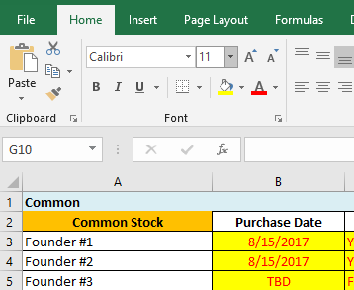 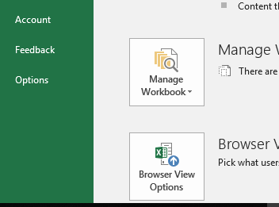

* 1. Go to the “Formulas” tab and check the “enable iterative calculations” box.

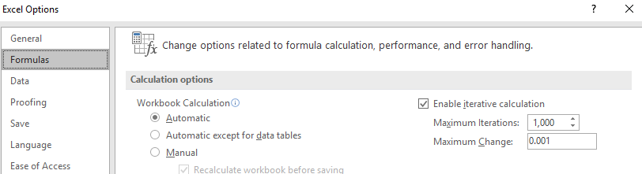

* 1. Close the option window and you’re all set!

**Mac**:

On the menu bar at the top of the screen, click “Excel,” then “Preferences…”

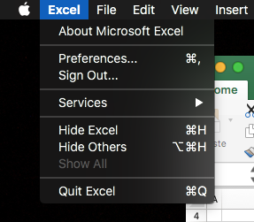

1. Under “Formulas and Lists,” click “Calculation.” 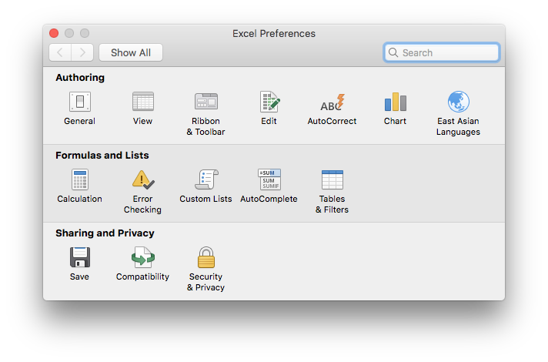
2. If it’s not already checked, tick the “Use iterative calculation” checkb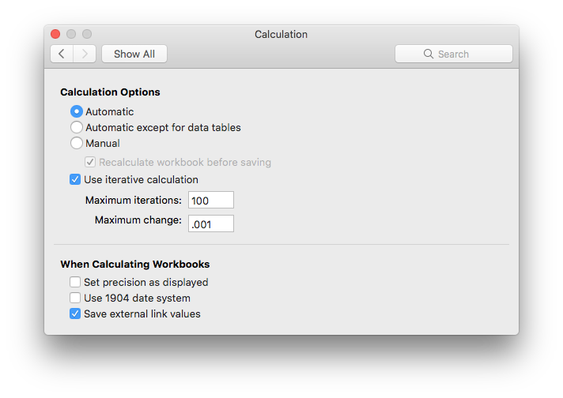
3. Close the preferences window. You’re all set!

**Instructions**:

These are the instructions to filling out the model. There are 6 key tabs (listed in order as provided in the model):

1. **Common**
2. **SAFEs & Notes**
3. **Pro Forma – Series A Inputs**
4. **Post Money Cap Table**
5. **Waterfall – Single Scenario**
6. **Waterfall – Three Scenarios**



Each tab will be discussed individually in the order above. As you become more familiar with the model, you may fill it out in any order you want. For the purposes of these instructions, we will stick with order as listed.

As a general rule, anything that is highlighted in yellow with red text can be changed. These are the model inputs. DO NOT modify the format of the cells (e.g. change something “general” to “text” or “number” to “text”, etc.). This will inevitably result in cascading impacts that can break the model. Leave all cell formats as-is.

**Common:**

* Cell A1 is the name of your company. Enter the name in this cell

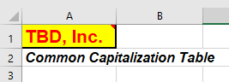

* In the Common Stock section (rows 8:18), you will enter in the following:
  + 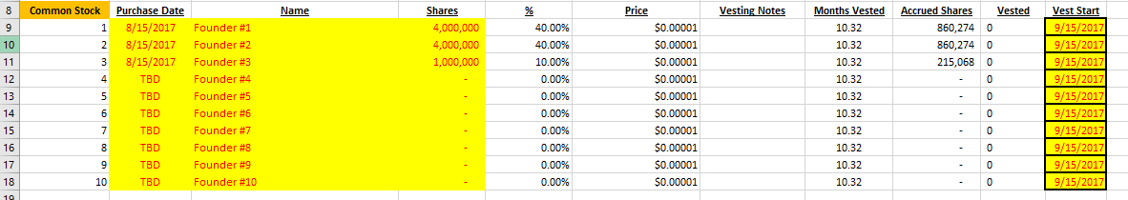Name of the person receiving the stock, the purchase date of the stock, the number of shares, and the vest start date.
* In the Stock Options sections (rows 23:44), you will enter the following:
  + Cell D23 is the total Equity Incentive Plan – this is the total pool of stock you have set aside for your employees
    - There is no grant date or vest start date for this number.
  + For the rest of the rows you will fill out the employee name, the grant date, the shares (which cannot be more than the Equity Incentive Plan), and the vest start date.
* 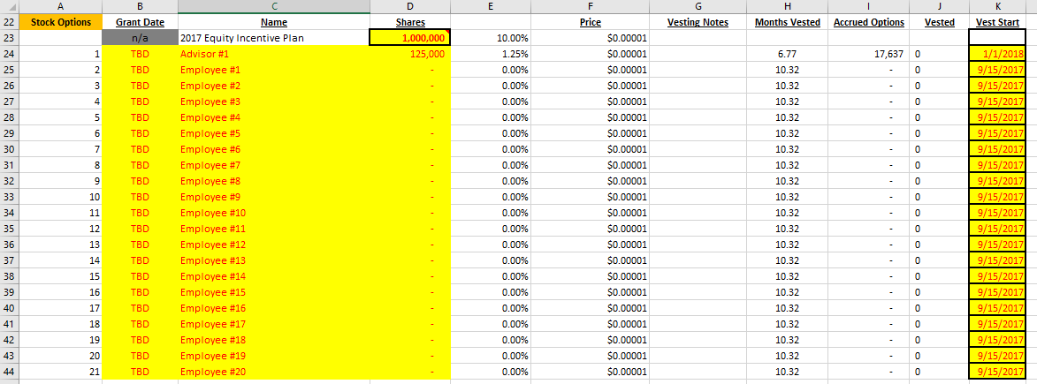This is everything you need to input on this tab; nothing else should be touched.

**SAFEs & Notes**

* On this tab you will only input data in rows (5:24).

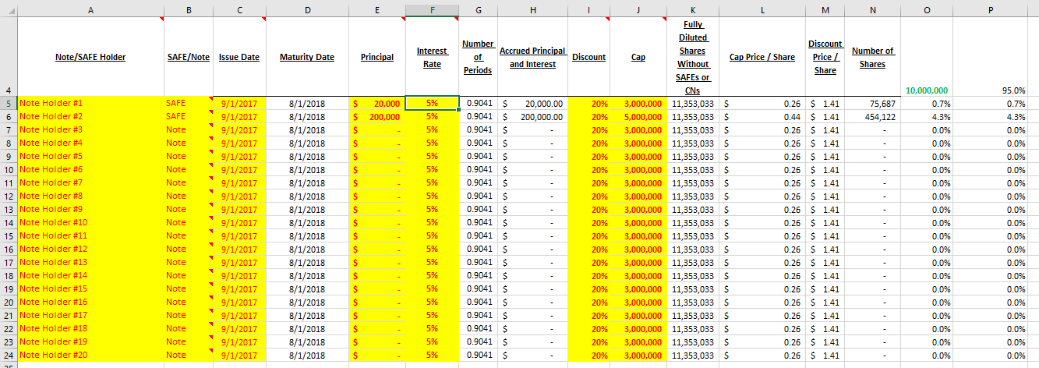

* Enter the note/SAFE holder name, select with a dropdown SAFE or Note, the issue date, the principal, interest rate, discount, and cap.
* This is everything you need to input on this tab; nothing else should be touched.

**Pro-Forma – Series A Inputs**

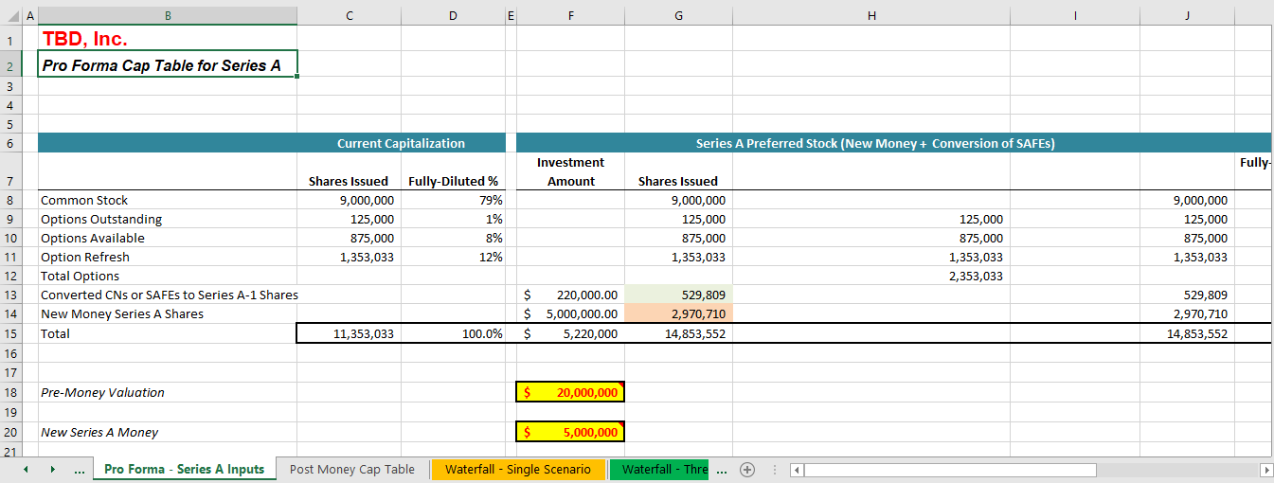

* On this tab you will only input data into 4 cells:
  + F18, the Pre-Money Valuation



* + F20, the New Series A Money



* + 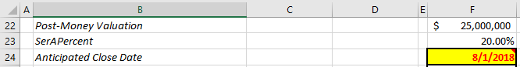F24, the Anticipated Close Date (this is the Maturity Date on the SAFEs & Notes tab)
  + F30, the % Option Refresh

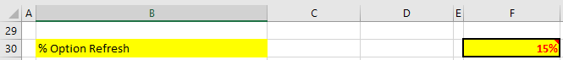

* This is everything you need to input on this tab, nothing else needs to be touched

**Post Money Cap Table**

* There is nothing to edit on this tab
* This tab shows the outcome from the inputs on the other tabs

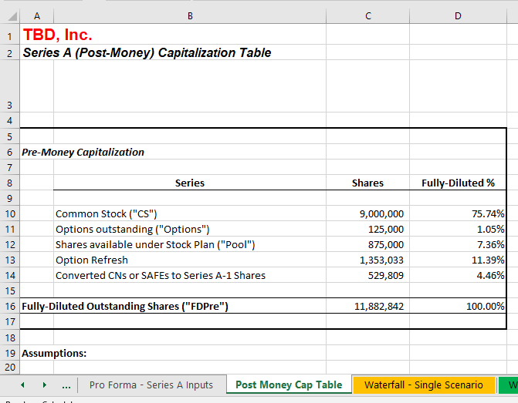

**Waterfall – Single Scenario**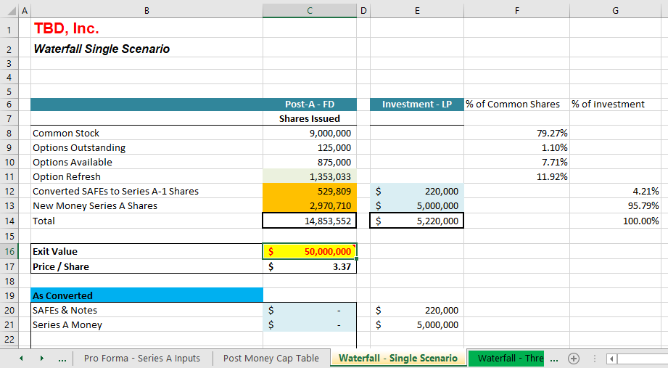

* On this tab you will only input data into 1 cell:
  + C16, the Exit Value

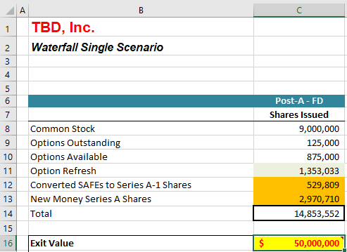

* This allows for a quick evaluation of price/share and gives a quick overview of the exit strategy
* This is everything you need to input on this tab, nothing else needs to be touched

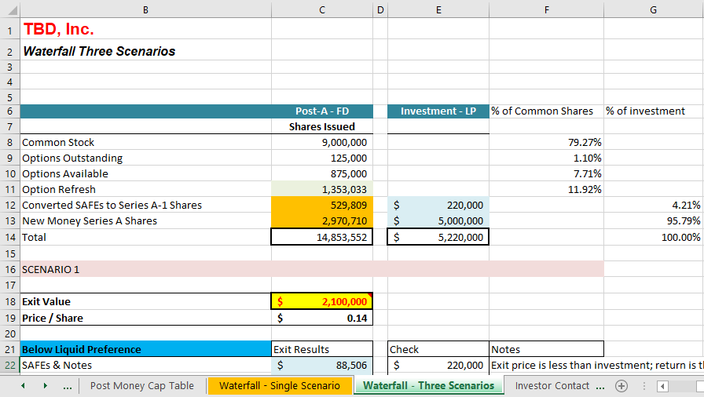**Waterfall – Three Scenarios**

* This tab is like the Waterfall – Single Scenario, but gives a more detailed breakdown of the logic behind the exit strategy
* It allows you to put in three different exit values and will produce the price/share and the logic behind the exit results

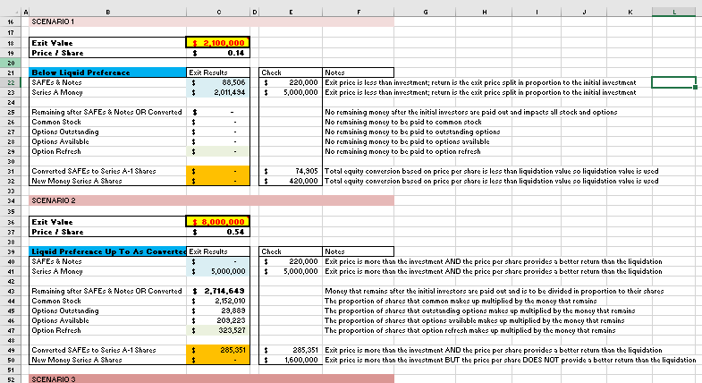

* You will only enter data into 3 cells:
  + C18, Exit Value (Scenario 1)

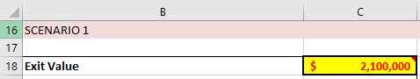

* + C36, Exit Value (Scenario 2)

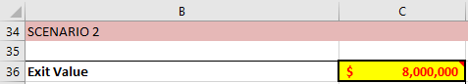

* + C54, Exit Value (Scenario 3)

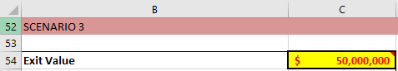

* This is everything you need to input on this tab, nothing else needs to be touched

**Final Note:** If you do not have an input for a cell that allows for an input, make sure to leave it as-is. DO NOT delete any of the input place holders. You can alter them with a different input (e.g. on the Common tab, change the Equity Incentive plan from 1,000,000 to 0 or 1,000,000 to 500,00, but ***DO NOT DELETE*** the input.