Installing and configuring Spark and HDFS using Docker containers

HDFS and Spark architecture
HDFS is a distributed file system from which Spark jobs can read and write data.
Cluster node roles: 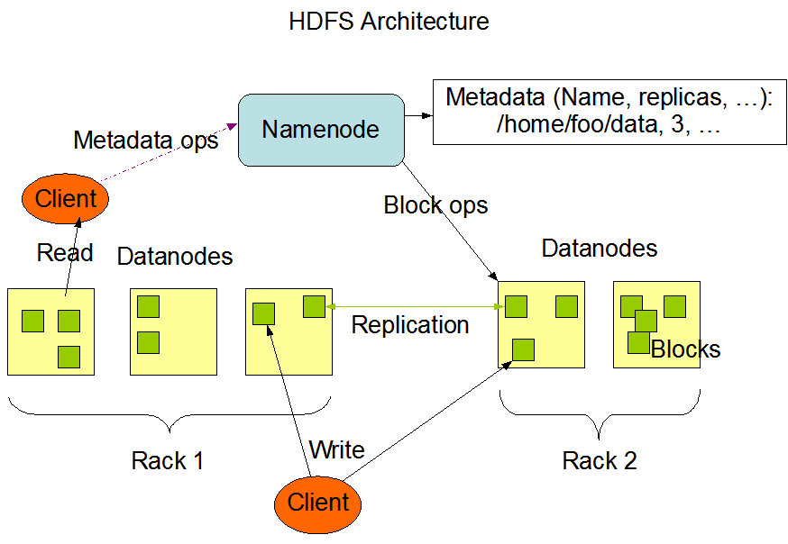
- HDFS NameNode: The NameNode is the most important HDFS node. It knows which DataNode stores each block of every file.
- HDFS DataNode: DataNodes store HDFS file blocks on their local file systems and serve those blocks when clients request them.
Spark is a unified distributed processing system for data analysis. It includes the Map/Reduce programming model as well as libraries for machine learning, SQL processing, and more.
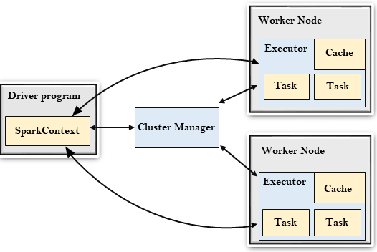
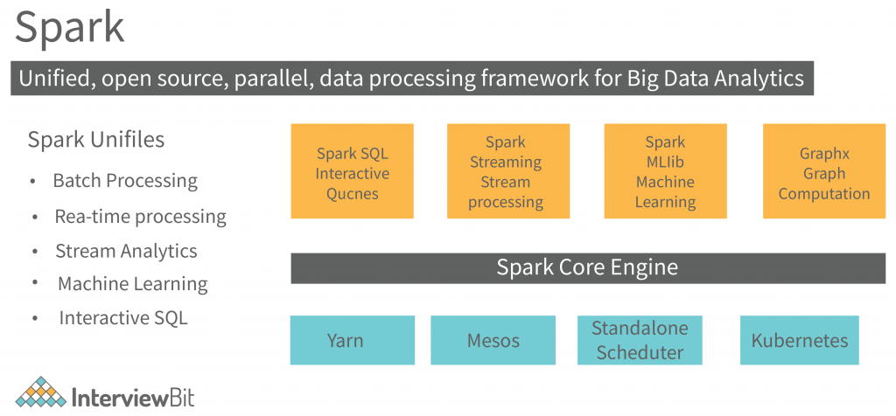
- Spark Master: The Spark Master controls the available resources and launches/manages distributed applications across the cluster.
- Spark Worker: A Worker runs on each cluster node and manages the distributed tasks assigned to that node.
- Spark Driver: The Driver acts as the controller of a Spark application and maintains its overall execution state.

Basic Docker concepts
To build the above infrastructure on a personal computer, we use Docker containers. The most important concepts are the following:
- Docker image: A static package that contains everything required to run an application, including code, dependencies, and runtime environment. To run a container, Docker first retrieves the corresponding image from an image repository. For example, the following command downloads and runs the official hello-world image:
docker run hello-world
- Dockerfile: A text file containing the instructions required to build a Docker image. It defines the base image, dependencies, and runtime configuration. The example below builds an image based on Python and runs a local app.py file.
Open the Ubuntu terminal and run:
mkdir compose-example
cd compose-example
Create a local app.py file:
nano app.py
Add the following content:
print("Hello from Docker!")
Save the file (CTRL+X, then Y, then Enter).
Now create a local Dockerfile:
nano Dockerfile
Add the following content:
FROM python:3.9
COPY app.py /app.py
CMD ["python", "/app.py"]
Save the file (CTRL+X, then Y, then Enter).
Build and run the image with the following commands:
docker build -t my-python-app .
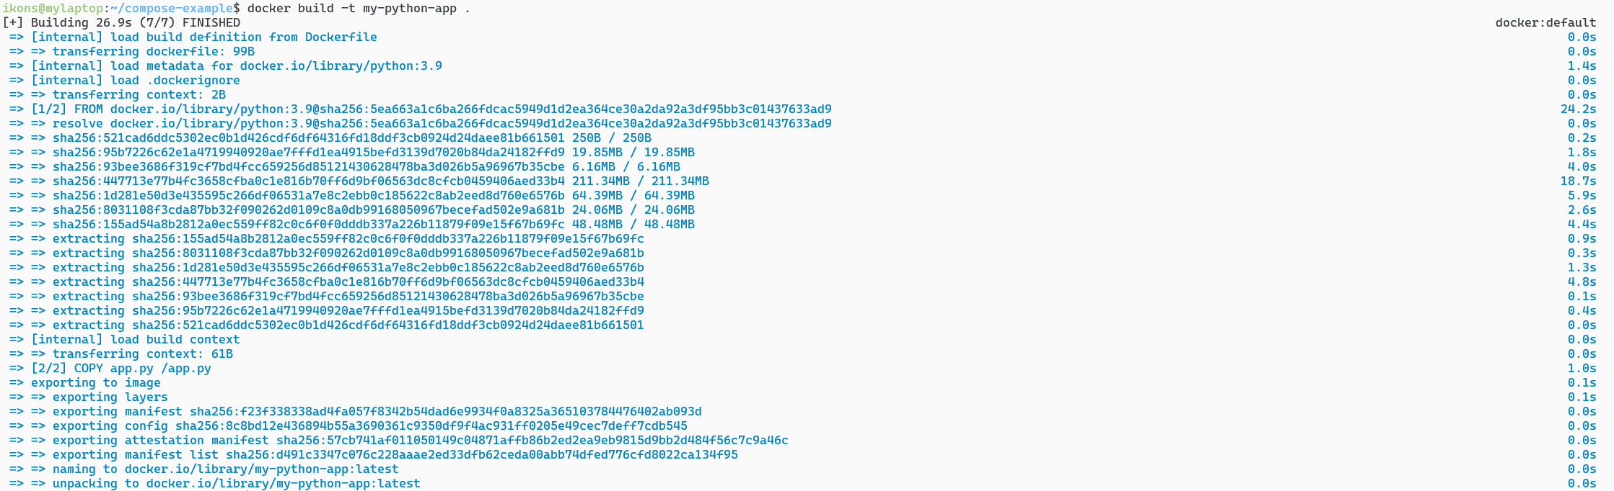
docker run my-python-app
To run the built image as a container, use the command above. The first time you run it, Docker downloads the required dependencies. On subsequent runs, this is no longer necessary.
- Docker Compose: A tool that manages multiple containers through a docker-compose.yml file, defining services, networks, and persistent storage.
- Docker containers have an ephemeral file system, so data stored only inside the container is lost when the container is removed.
- Volume: A storage mechanism that lets containers preserve data even after restart or deletion. Docker uses persistent volumes for long-term storage. Volumes can be created, named, and mounted into containers.

Installing Apache Spark and HDFS locally with Docker containers
Move to the example directory:
cd ~/bigdata-dsml/docker/01-lab1-spark-hdfs/
Inside it you will find the following files:
- docker-compose.yml: Creates a local infrastructure consisting of:
  - one HDFS cluster with one NameNode (namenode) and three DataNodes (datanode1, datanode2, datanode3)
  - one Spark cluster with one Master (spark-master) and three Workers (spark-worker1, spark-worker2, spark-worker3)
- Dockerfile.master: Dockerfile used to build the spark-master image, based on the official Apache Spark image.
- Dockerfile.worker: Dockerfile used to build the worker images, also based on the official Apache Spark image.
- spark-defaults.conf: Default Spark configuration shared by the master and workers.
- startup.sh and worker.sh: Shell scripts executed when the spark-master and spark-worker containers start.
Starting the infrastructure: Run the following command to launch the environment. Important: you must be inside the 01-lab1-spark-hdfs directory for it to work correctly.
docker-compose up --build -d
The first execution may take 1–2 minutes, depending on your internet connection and computer speed, because Docker must pull the required images, build the custom images, and start the containers.
If everything works correctly, Docker Desktop will show the stack as running (green dot).
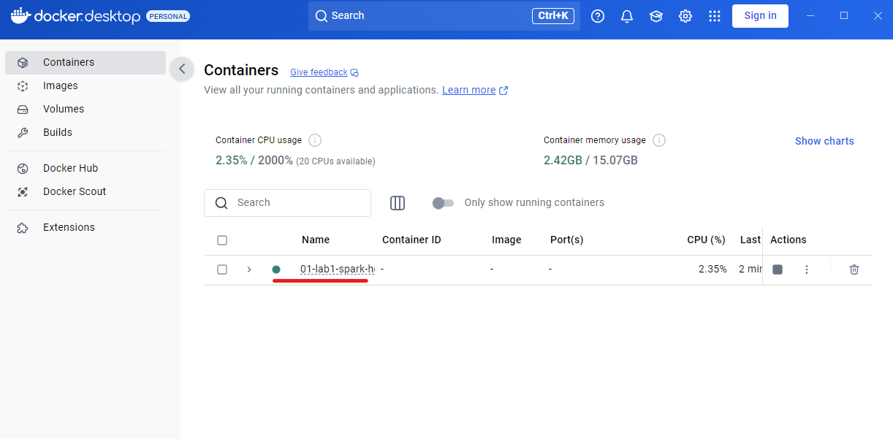
You can also list the containers from the terminal:
docker ps
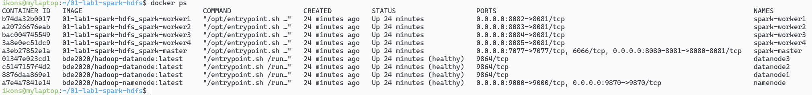
Click on 01-lab1-spark-hdfs in Docker Desktop to see the individual containers.
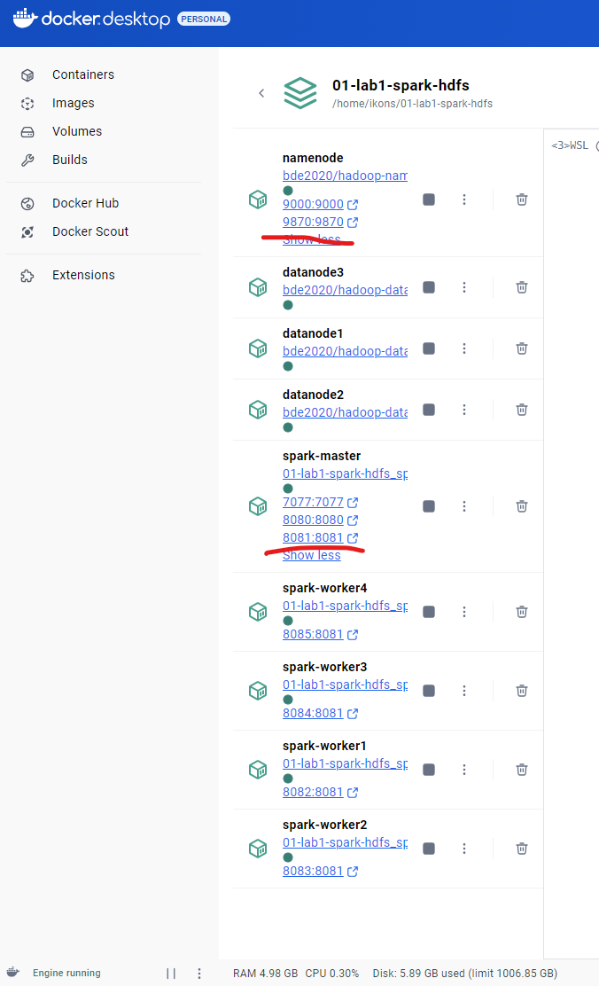
Whenever you see pairs of numbers such as 9870:9870, it means that the container exposes a service (usually an HTTP site, but not necessarily). This service is accessible from your host operating system, either by clicking the link directly or by opening it in a browser.
For example, hdfs-namenode serves:
http://localhost:9870
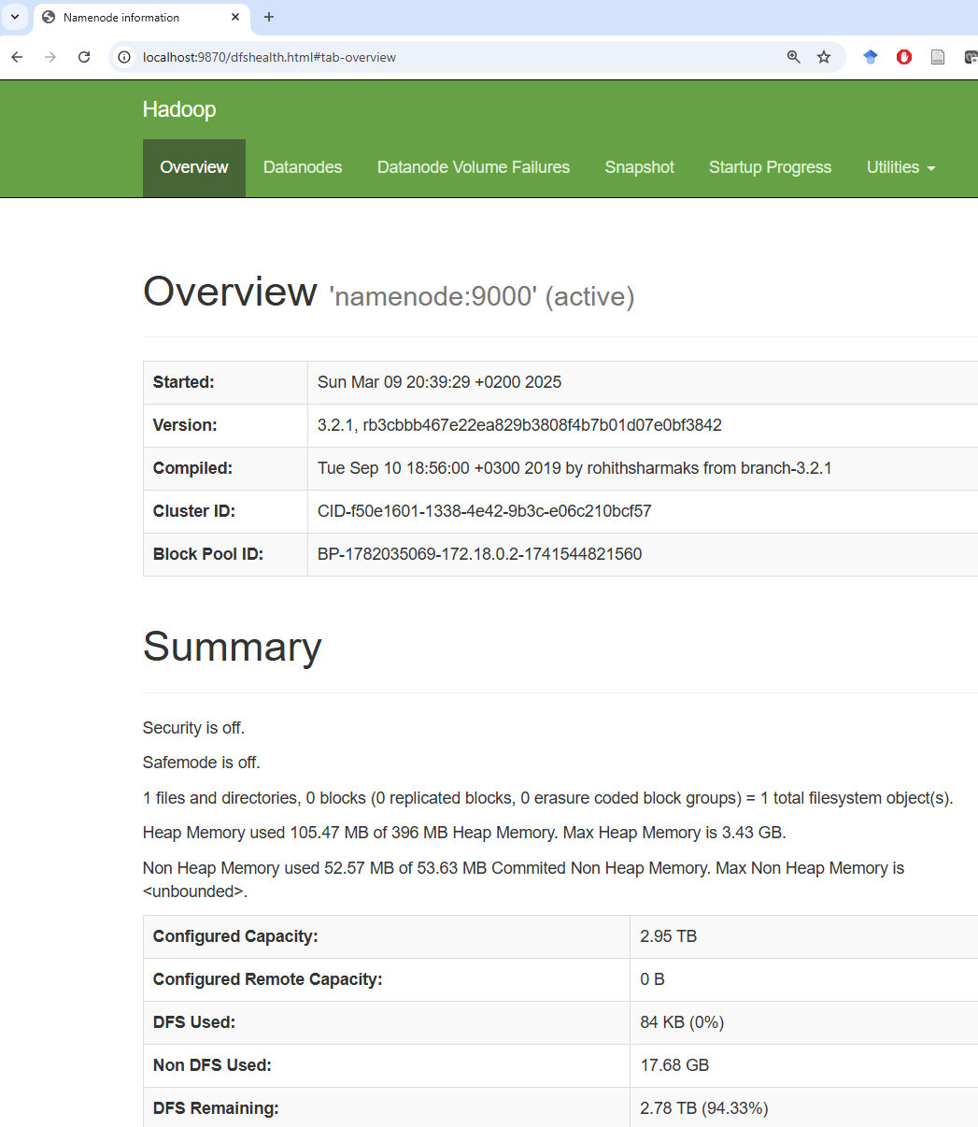
And spark-master serves the Spark UI at:
- http://localhost:8080
- http://localhost:8081 for the History Server (all jobs executed so far)
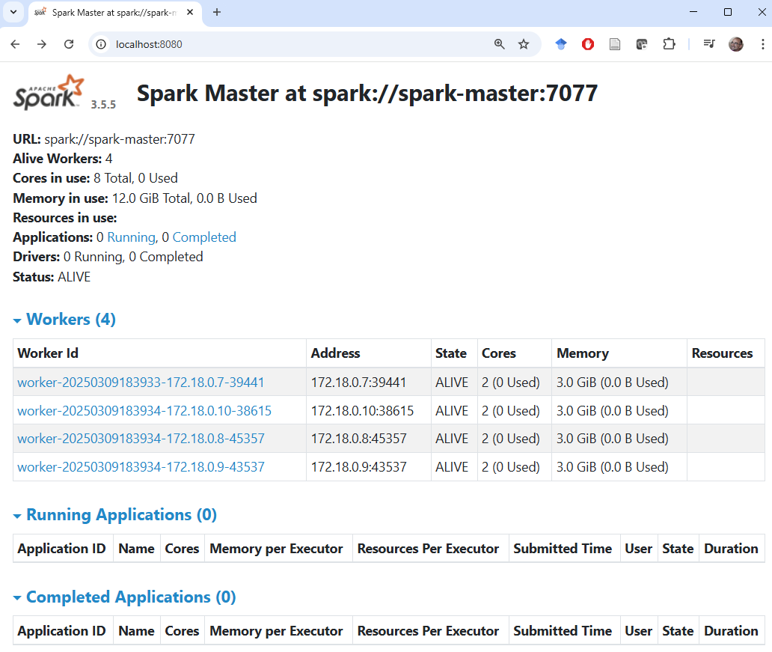
In the Volumes section you can see all persistent volumes used by the stack. These volumes are declared in docker-compose.yml and are created automatically by docker-compose up.
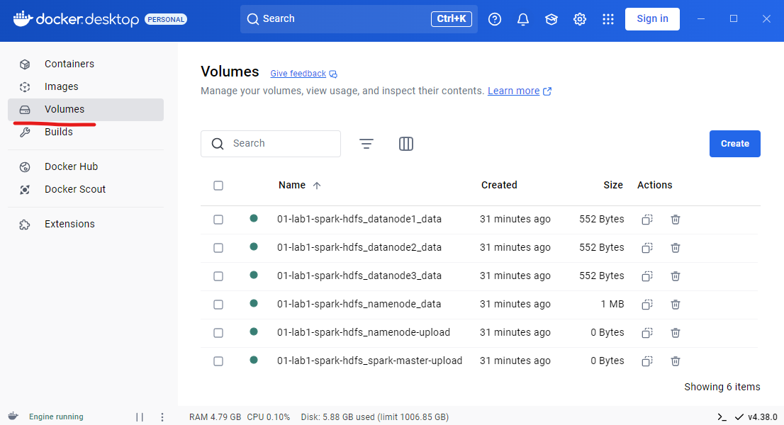
You can also list volumes from the terminal:
docker volume ls
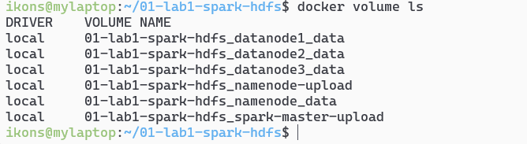
In the Docker setup used here, volumes are stored as subdirectories under a local directory of the Docker server.
Because the local Docker server is itself a virtual machine, that directory is part of the Docker VM file system.
To see this, open a Windows terminal (right-click the Windows icon → Terminal) and run:
wsl -l -v
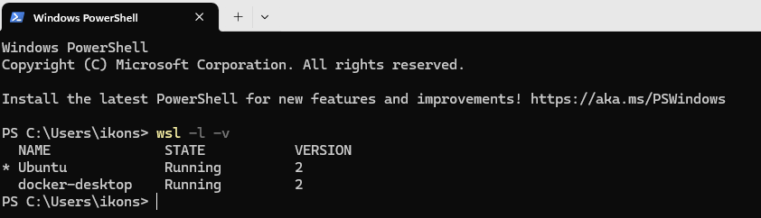
This shows that the machine runs two virtual environments: Ubuntu (where you execute the Docker commands) and docker-desktop, which runs the Docker daemon itself.
The persistent volumes live inside the file system of the docker-desktop VM.
These volumes can be accessed from the Windows host via the following folder:
\\wsl.localhost\docker-desktop\mnt\docker-desktop-disk\data\docker\volumes
Open Windows Explorer and paste the above path in the address bar. There you will see all directories used as persistent Docker volumes. Each one contains a _data subdirectory; whatever you place there becomes visible inside any container that mounts that volume.
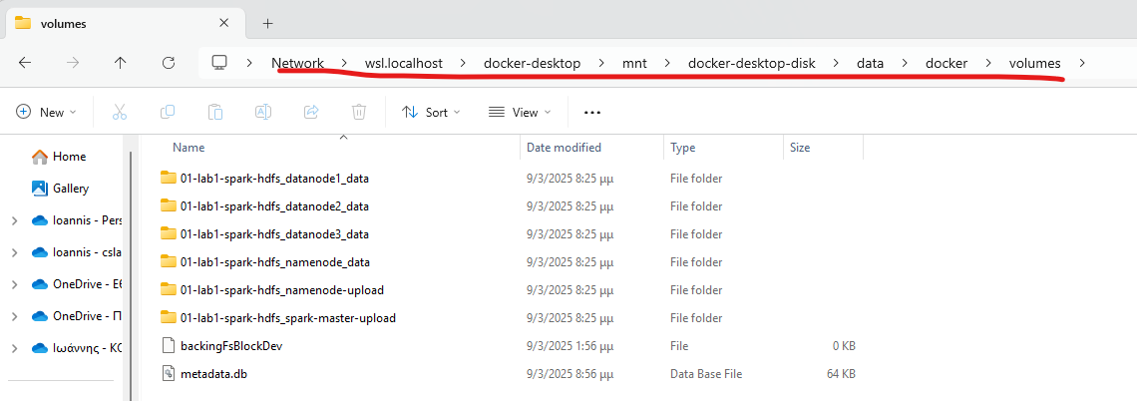
Initializing the HDFS file system: The first time you create the environment, you must also create the required HDFS directories for uploading files and storing Spark execution logs. Run the following commands from the Ubuntu shell:
docker exec namenode hdfs dfs -mkdir -p /user/root
docker exec namenode hdfs dfs -mkdir -p /logs
docker-compose stop spark-master
docker-compose rm -f spark-master
docker-compose up -d spark-master
These commands run hdfs dfs through the NameNode container and create two directories:
- /user/root, where you will store input files
- /logs, where Spark job logs will be stored so you can later inspect what was executed and whether it completed successfully
You also restart the spark-master container so that the History Server works correctly.
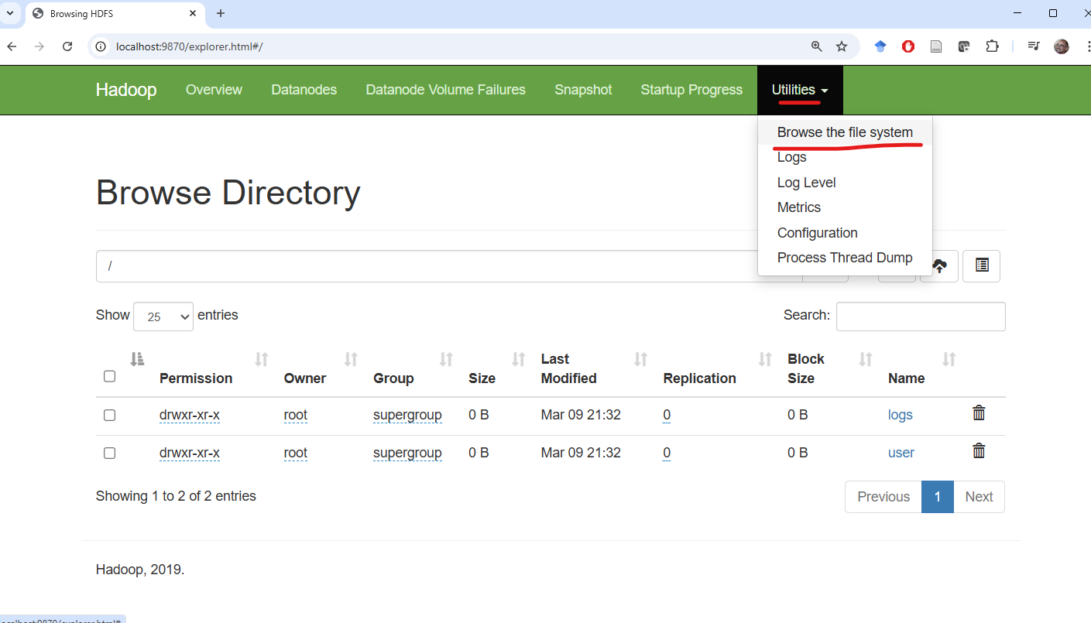

Running programs on the cluster
Run the following command to estimate π using a Monte Carlo simulation in Java:
docker exec spark-master /opt/spark/bin/spark-submit --class org.apache.spark.examples.JavaSparkPi /opt/spark/examples/jars/spark-examples.jar
If it executes correctly, you will see output similar to:
Pi is roughly 3.14638
Run the following for the equivalent Python example:
docker exec spark-master /opt/spark/bin/spark-submit /opt/spark/examples/src/main/python/pi.py

Running your own Spark program on the cluster
Now that we have an initialized HDFS file system and a working container stack, we can run our own Spark programs. To do so, we need to upload:
- code files (for example Python scripts)
- data files that will be processed (for example the input text for a word count)

Uploading code
To execute code through Spark, the file must be visible inside the spark-master container. For this purpose, the project defines a local persistent volume named 01-lab1-spark-hdfs_spark-master-upload. This volume is mounted into the spark-master container at /mnt/upload (see line 74 of docker-compose.yml). To place files from your local Windows file system inside the container file system, open the following folder in Windows Explorer:
\\wsl.localhost\docker-desktop\mnt\docker-desktop-disk\data\docker\volumes\01-lab1-spark-hdfs_spark-master-upload\_data
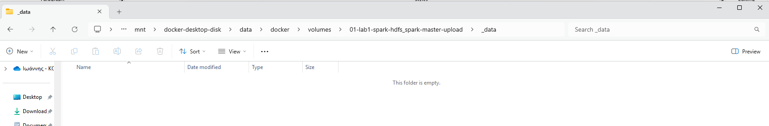
The folder is initially empty. Copy wordcount.py from ~/bigdata-dsml/docker/01-lab1-spark-hdfs/ into that _data directory.
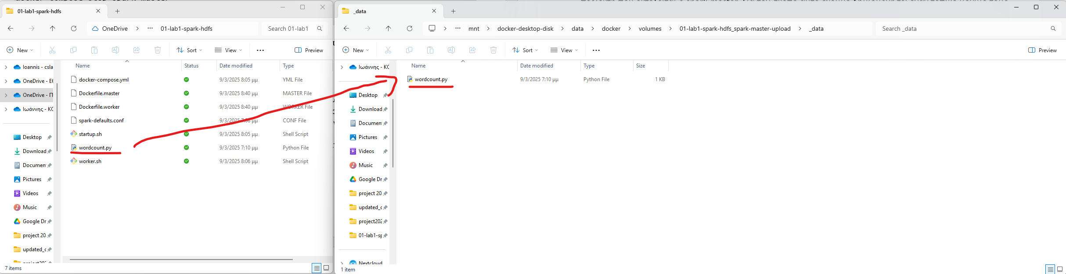
Now the spark-master container sees the file at /mnt/upload:
docker exec spark-master ls /mnt/upload
The following command prints the contents of the remote wordcount.py file as seen from inside the container:
docker exec spark-master cat /mnt/upload/wordcount.py
from pyspark import SparkConf
from pyspark.sql import SparkSession
conf = SparkConf().setAppName("Word Count example") \
.set("spark.master", "spark://spark-master:7077") \
.set("spark.executor.memory", "3g") \
.set("spark.driver.memory", "512m")
sc = SparkSession.builder.config(conf=conf).getOrCreate().sparkContext
wordcount = sc.textFile("hdfs://namenode:9000/user/root/text.txt") \
.flatMap(lambda x: x.split(" ")) \
.map(lambda x: (x, 1)) \
.reduceByKey(lambda x,y: x+y) \
.sortBy(lambda x: x[1], ascending=False)
print(wordcount.collect())
wordcount.saveAsTextFile("hdfs://namenode:9000/user/root/wordcount-output")
Any change you make to wordcount.py through the Windows file system becomes immediately visible inside the container. You do not need to re-upload it after every edit.

Uploading data files
The wordcount.py script reads a file (or directory) from HDFS and computes word frequencies. At this point, however, the HDFS file system is empty apart from the directories created earlier.
So we must upload an input data file to HDFS.
This happens in two stages:
- Place the file from your local file system into the local file system of the namenode container.
- Run hdfs dfs -put inside the namenode container to upload the file from /mnt/upload into HDFS.
For this purpose we use another persistent volume mounted into the namenode container. It is called 01-lab1-spark-hdfs_namenode-upload and is mounted at /mnt/upload (see line 16 of docker-compose.yml). Open the following folder in Explorer:
\\wsl.localhost\docker-desktop\mnt\docker-desktop-disk\data\docker\volumes\01-lab1-spark-hdfs_namenode-upload\_data
Initially the folder is empty. Copy text.txt from the 01-lab1-spark-hdfs directory into that _data folder.
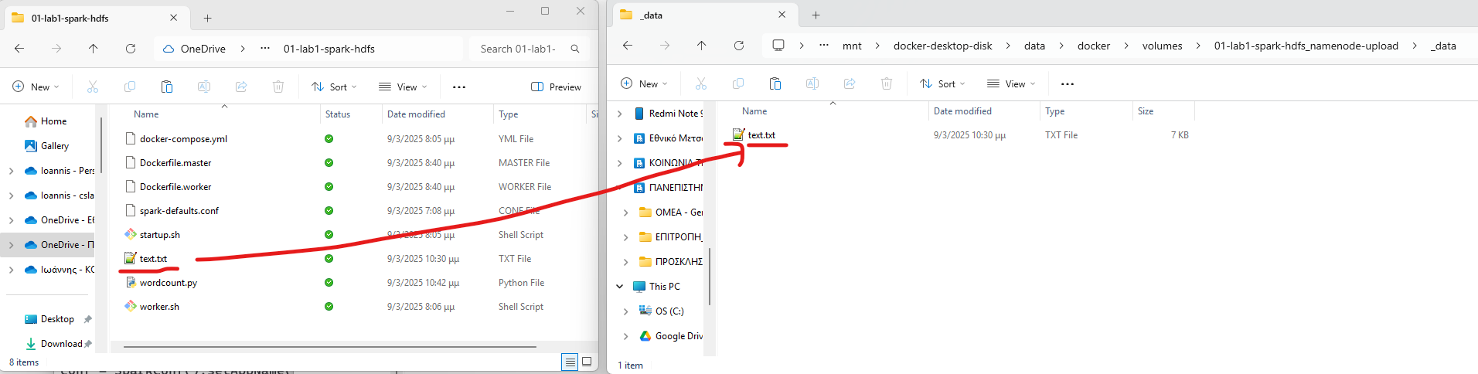
Now the namenode container sees text.txt inside /mnt/upload:
docker exec namenode ls -lah /mnt/upload
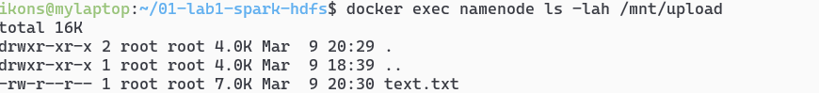
Upload the file into HDFS with:
docker exec namenode hdfs dfs -put -f /mnt/upload/text.txt /user/root/text.txt
At this point:
- the Python file to execute is available on the local file system of spark-master
- text.txt is stored in HDFS
You are ready to run the Spark program:
docker exec spark-master /opt/spark/bin/spark-submit /mnt/upload/wordcount.py

Monitoring execution
You can watch the currently running job at:
http://localhost:8080
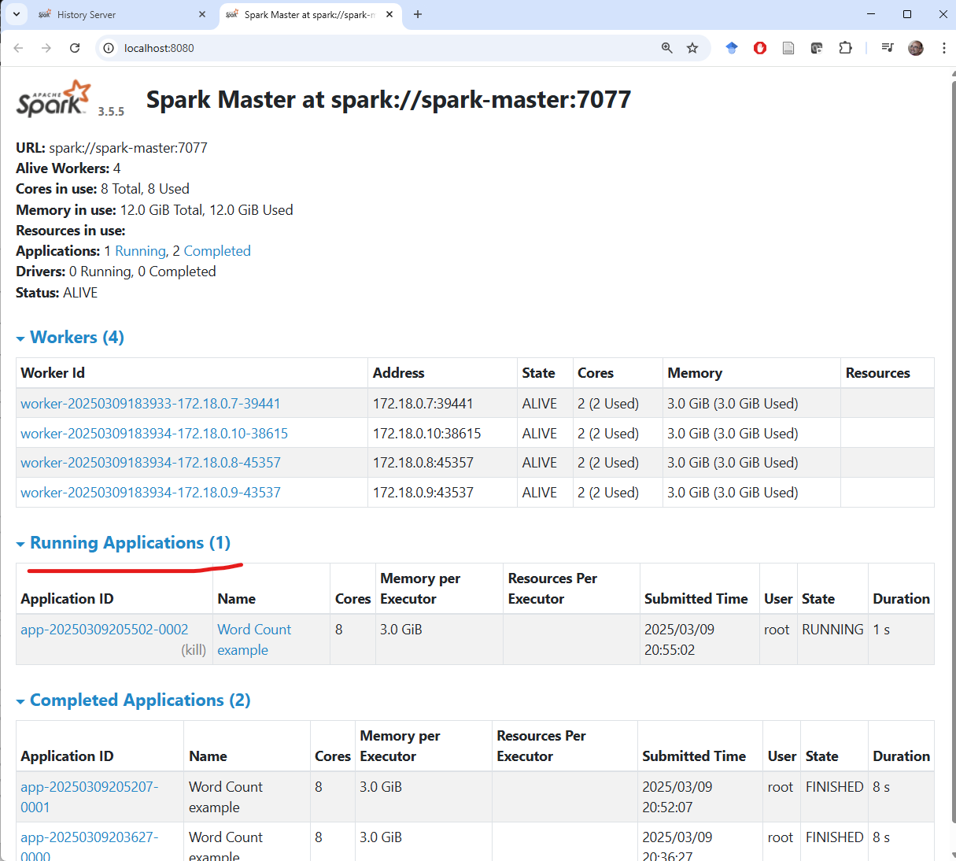

History Server
Apache Spark includes a useful service that stores log files from all submitted jobs across the master and worker nodes. This service is called the History Server and is available at:
http://localhost:8081
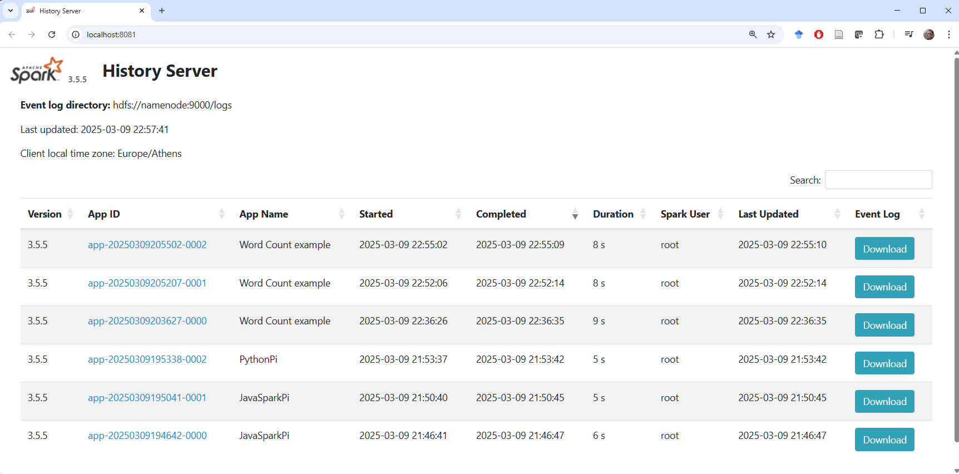
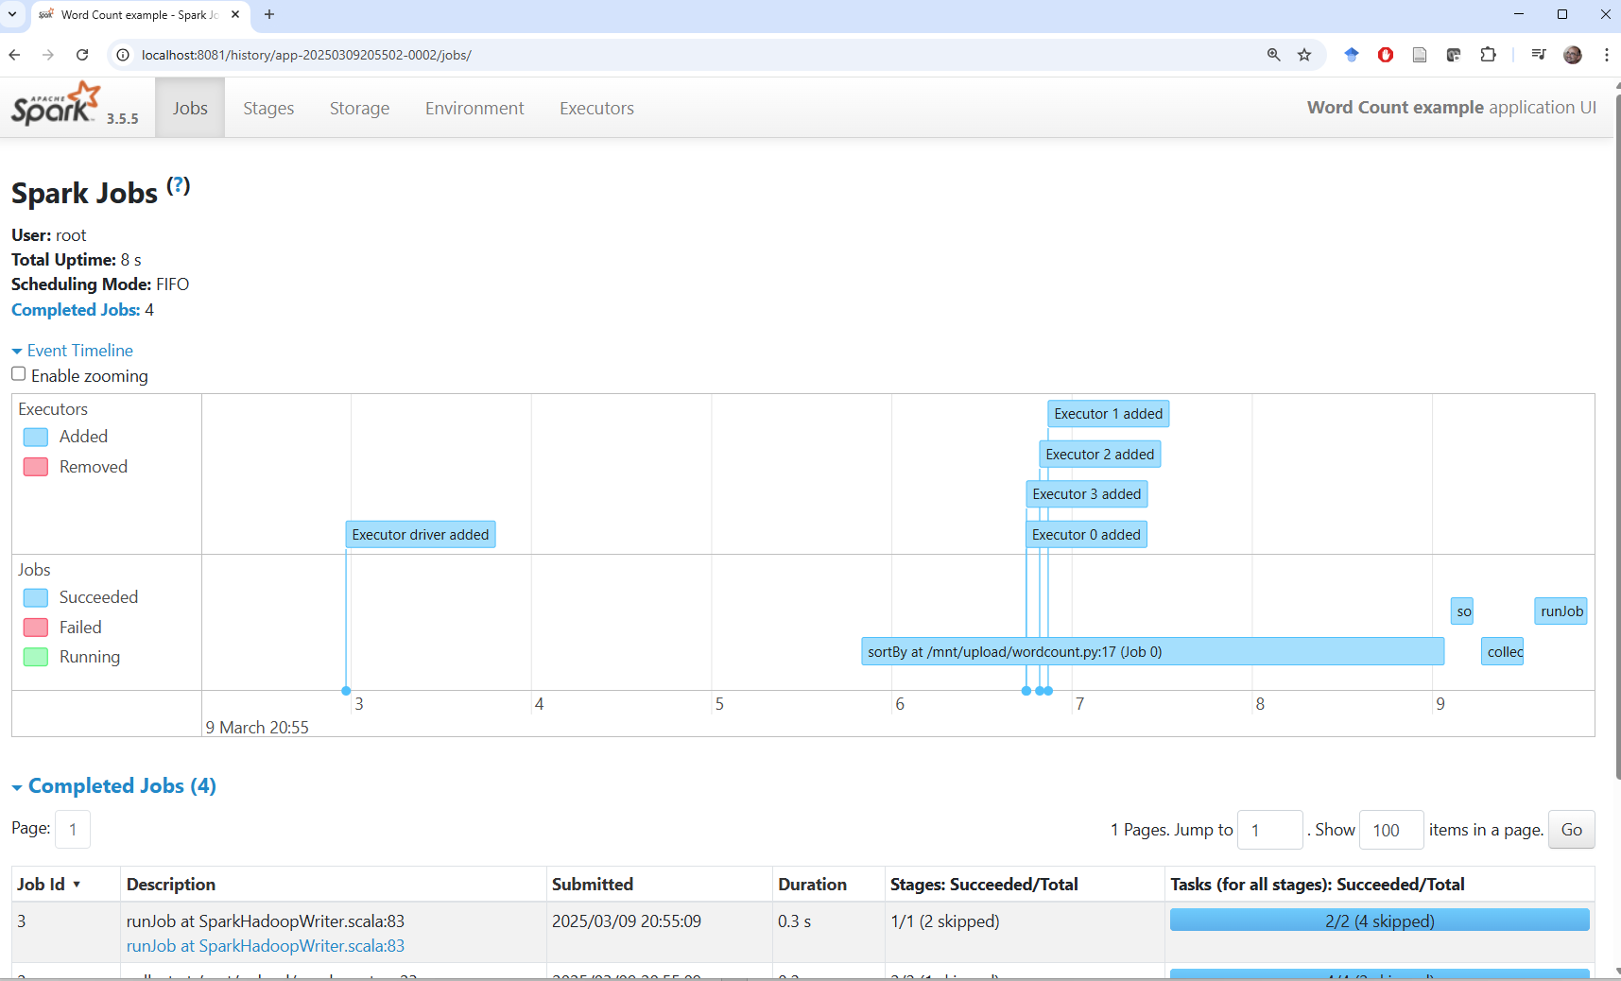

Useful Linux commands
Command | Meaning
ls | list directory contents
pwd | print the current directory
cd | change directory
cp | copy
mv | move
cat | print file contents
echo | print text to the screen
man <command> | show the manual page for <command>

Useful HDFS commands
Create a directory in HDFS:
docker exec namenode hadoop fs -mkdir -p <path>
Delete a directory in HDFS:
docker exec namenode hdfs dfs -rm -r -f <path>
Upload a file with overwrite:
docker exec namenode hdfs dfs -put -f <local-path> <hdfs-path>

Stopping the infrastructure
The following command stops the infrastructure. Files uploaded to HDFS or saved in the persistent volumes of namenode and spark-master are not deleted and remain available. As with docker-compose up, you must run it from the directory that contains docker-compose.yml.
docker-compose down

