Workstation setup (WSL + Docker)
Table of Contents
Enabling WSL and Virtual Machine Platform 1
Optional note for anyone testing the guide inside a Hyper-V VM 3
Ubuntu configuration 4
Upgrades and updates 5
Installing Docker for WSL 5
Recommended path: Docker Desktop 5
Optional advanced alternative: native Docker Engine inside WSL 10
Tools needed by the next guides 11
For the Windows / PowerShell path 11
OpenVPN client on Windows and lab access files 12
For the WSL / Ubuntu path 12
Configure VPN and kubeconfig for vdcloud 13
Next step: get the repository 13
Option A: clone in a Windows folder 14
Option B: clone inside WSL 14
What to keep in mind 14

The course includes a laboratory component in which we will use Docker containers. This guide describes the preparatory steps that should be completed before the first lab. In particular, it covers the setup of the Windows Subsystem for Linux (WSL), Ubuntu, and Docker on a personal computer.

Enabling WSL and Virtual Machine Platform
First, you need to enable WSL and the Virtual Machine Platform feature in Windows.
Open PowerShell as administrator: Right-click the Start menu and select Windows Terminal (Administrator) or PowerShell (Administrator).
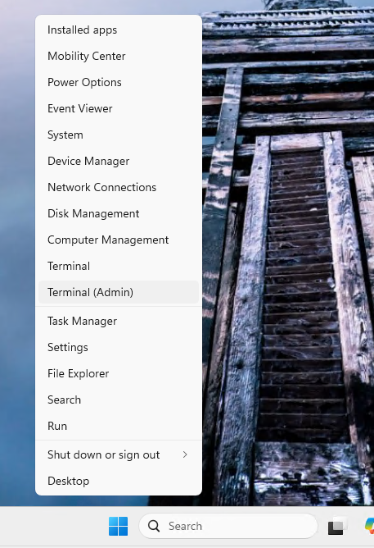
Run the following commands to enable WSL and Virtual Machine Platform. After running them, restart your computer.
wsl --install --no-distribution
dism.exe /online /enable-feature /featurename:Microsoft-Windows-Subsystem-Linux /all /norestart
dism.exe /online /enable-feature /featurename:VirtualMachinePlatform /all /norestart
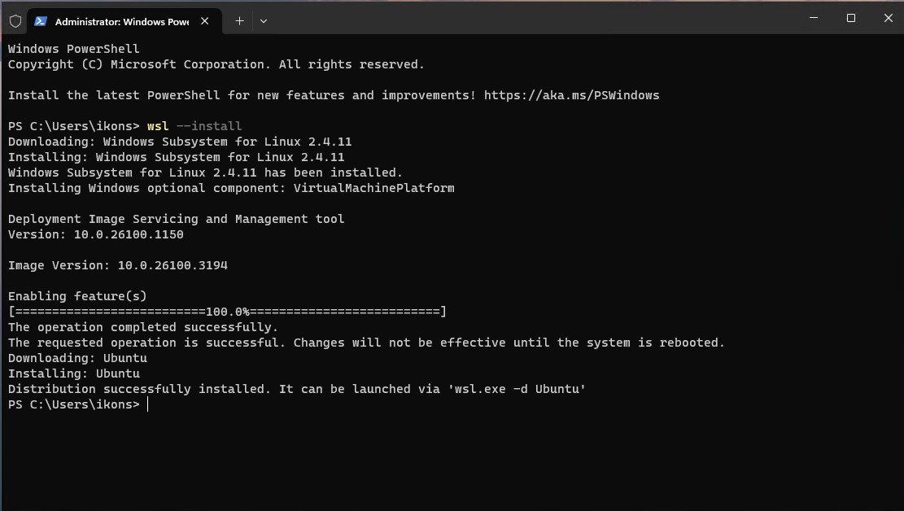
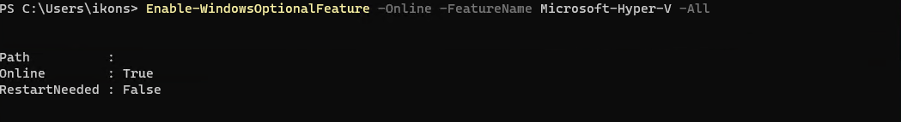
After the restart, install Ubuntu:
wsl --install -d Ubuntu

Optional note for anyone testing the guide inside a Hyper-V VM
The main course path assumes that students run this guide on a personal computer, not inside a Windows virtual machine.
If, however, you are testing the guide inside a Windows virtual machine that runs on Hyper-V, it is not enough to enable WSL2 only inside the guest operating system. The Hyper-V host must also expose nested virtualization to that VM.
If you see a message such as:
- WSL2 is not supported with your current machine configuration
- HCS_E_HYPERV_NOT_INSTALLED
then the usual cause is not the guest OS itself, but that the host has not exposed virtualization extensions to the VM.
In that case:
- shut down the VM
- on the host PowerShell as administrator run:
Stop-VM "<Your-VM-Name>"
Set-VMProcessor -VMName "<Your-VM-Name>" -ExposeVirtualizationExtensions $true
Start-VM "<Your-VM-Name>"
- inside the guest Windows, run again:
wsl --install --no-distribution
wsl --install -d Ubuntu
If the problem persists, also check:
- that virtualization is enabled in the BIOS/UEFI of the physical host
- that the VM has been fully restarted after the change
- that VirtualMachinePlatform appears as Enabled
For my own test VM, the corresponding name was Windows 11 Bigdata uth 2026, but that is not part of the general student workflow.

Ubuntu configuration
Open Ubuntu: After installation, click the Start menu and search for Ubuntu. Click it to open it.
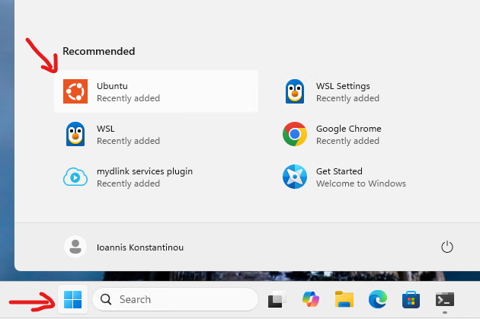
Set up a user account and password: The first time Ubuntu starts, you will be asked to create a user and set a password. This user will be the main user for your Ubuntu installation.
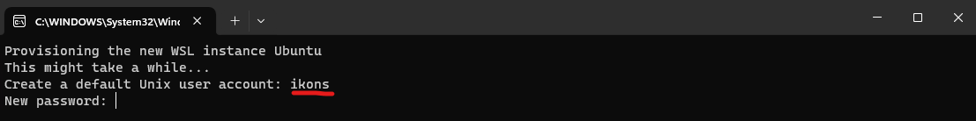

Upgrades and updates
Once Ubuntu is ready, it is a good idea to run a few commands to make sure your system is up to date.
Upgrade system packages: Run the following command to upgrade the system packages:
sudo apt update && sudo apt upgrade -y
Check the WSL status
Open PowerShell (as administrator) and run the following command:
wsl --list --verbose
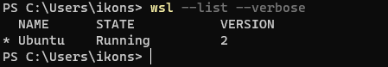
This command shows the installed Linux distributions and indicates which one is the default. If WSL has been installed correctly, you should see the Ubuntu distribution (or another distribution that you installed).
Check whether Virtual Machine Platform is enabled
To verify that Virtual Machine Platform is enabled, run the following command:
Get-WindowsOptionalFeature -Online -FeatureName VirtualMachinePlatform
If Virtual Machine Platform is enabled, the feature status should be Enabled.
Check the current WSL version
To check which WSL version (1 or 2) you are using, run the following command:
wsl --list --verbose
You will see the WSL version for each Linux distribution (for example, 2 for WSL 2 or 1 for WSL 1).
If everything is configured correctly, WSL and Virtual Machine Platform should appear as enabled, and Ubuntu or another Linux distribution should be available for use on your system.

Installing Docker for WSL
This guide supports two paths:
- Recommended and tested: Docker Desktop with WSL integration
- Optional advanced: a native Docker Engine directly inside Ubuntu on WSL
For most students, the recommended path is still Docker Desktop. The second path is useful if you prefer to work entirely from Ubuntu without a separate Docker Desktop application on Windows.

Recommended path: Docker Desktop
Go to the official Docker page and download the latest version of Docker Desktop for Windows x86_64:
https://docs.docker.com/desktop/setup/install/windows-install/
Run the installer: Double-click the installation file you downloaded and follow the installation wizard.
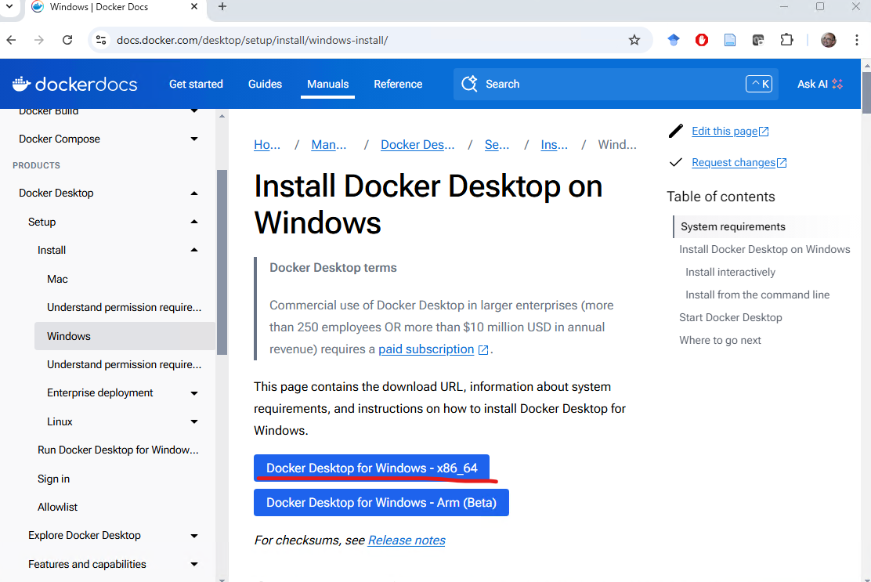
Installation options:
During installation, make sure that the Use the WSL 2 based engine option is selected.
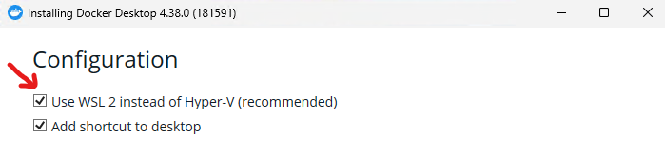
Docker Desktop will also install the Docker Desktop WSL 2 Backend, which is required in order to run Docker with WSL 2.
Complete the installation: When the installation finishes, click Finish and Docker Desktop will start automatically. The installation may take a little while. You will need to restart your computer.
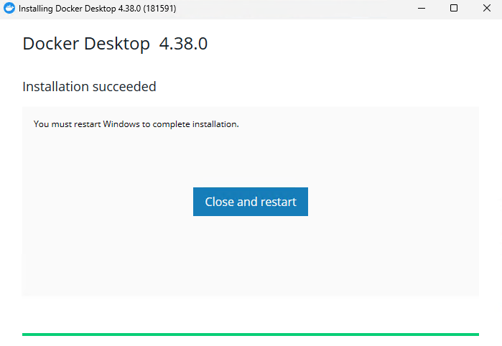
After the restart, you may be asked to create an account for the service. This is not mandatory, and you may choose Skip.
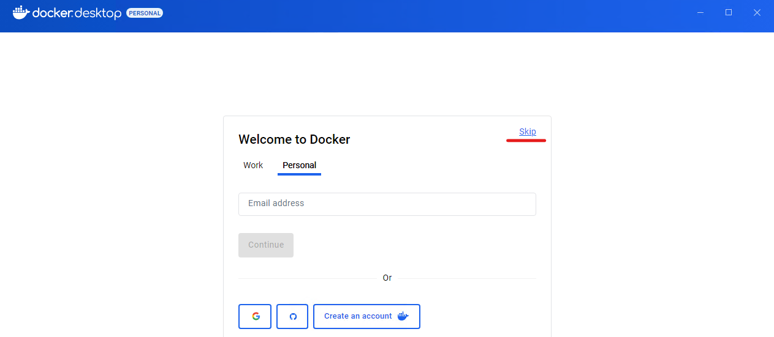
Configure Docker to use WSL 2: After installation, you can open Docker Desktop from the Start Menu.
If this is the first time you open Docker Desktop, it may guide you through enabling WSL 2.
Make sure that WSL 2 is selected as the backend in Docker Desktop. To check this, go to Settings in Docker, then to the General tab, and verify that Use the WSL 2 based engine is enabled.
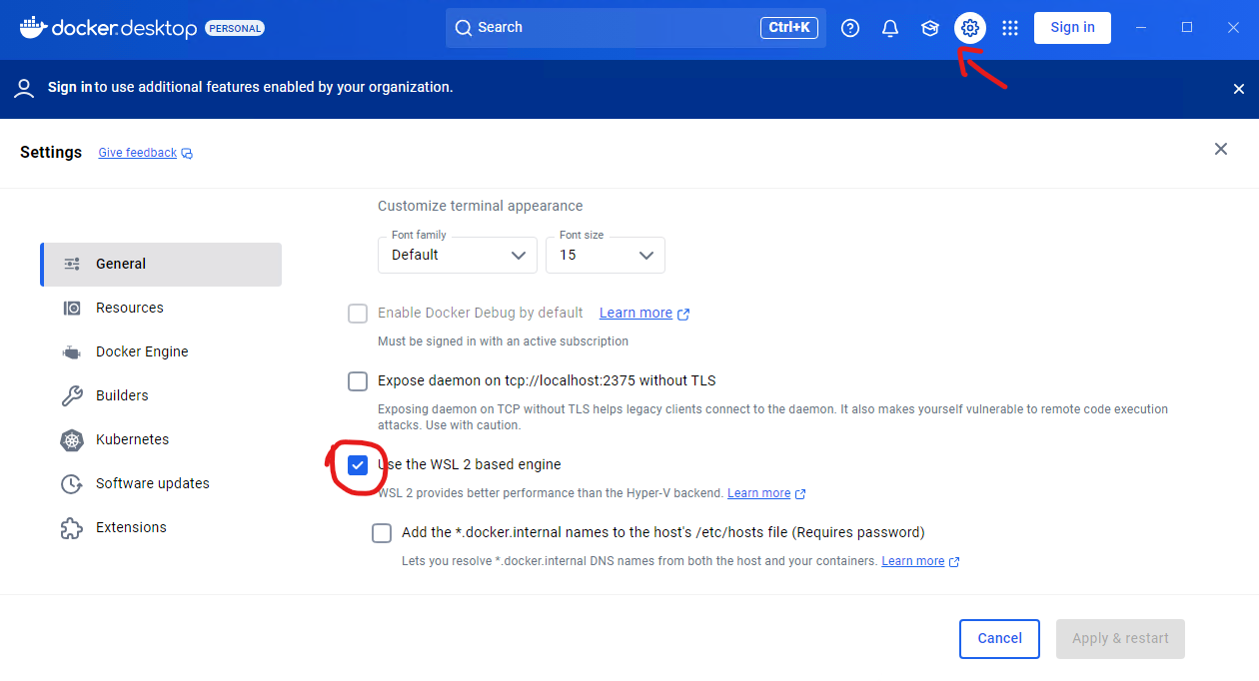
Select the WSL distribution for Docker: In the Resources tab of Docker Desktop, you can see which WSL Linux distributions are available for use with Docker. Make sure that the Ubuntu distribution (or another one you installed) is enabled for Docker.
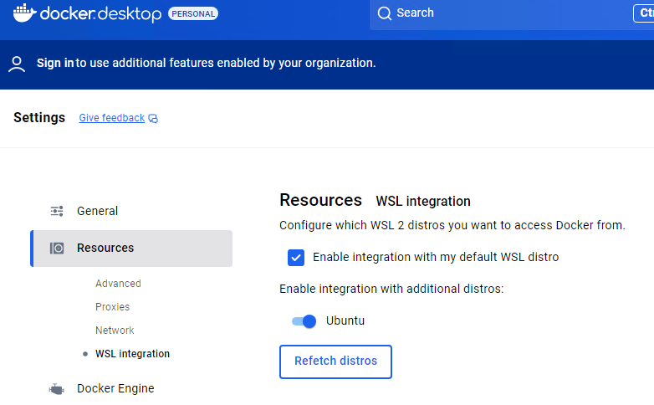
Restart Docker: If you make changes to the settings, restart Docker Desktop so that the changes take effect.
Confirm the installation
Open the Ubuntu terminal and run the following command to verify that Docker is working correctly:
docker --version
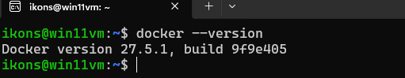
This should display the version of Docker that you installed.
Then try running the command:
docker run hello-world
This command downloads and runs a simple Docker image that prints a success message if Docker is installed and working correctly. 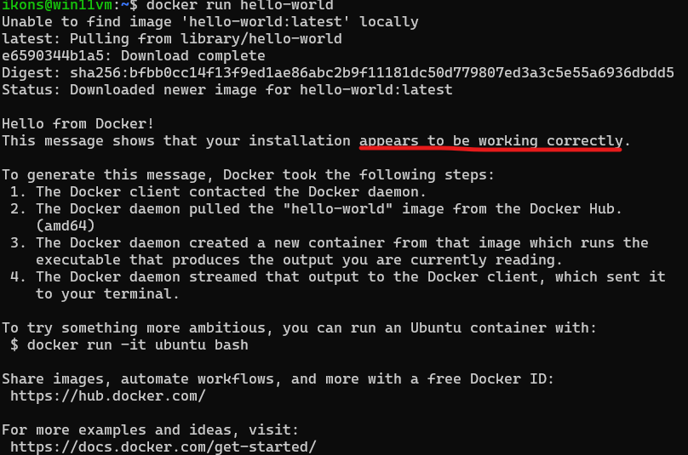
Updates and settings
Update Docker: Docker Desktop updates automatically. You can check for new versions under Settings > Updates.
Resource settings: In the Resources tab of Docker Desktop, you can configure how much CPU, memory (RAM), and disk space are available to the WSL backend.

Optional advanced alternative: native Docker Engine inside WSL
If you do not want to use Docker Desktop, you can install a standard Docker Engine directly inside Ubuntu on WSL. We tested this path and it can run the 06_local-cluster-infrastructure-docker guide, but it is a bit more demanding administratively.
Before you start, check whether your WSL shell has systemd enabled:
systemctl is-system-running
If systemd is not available, add the following to /etc/wsl.conf:
[boot]
systemd=true
and then, from Windows PowerShell, run:
wsl --shutdown
Open Ubuntu again and continue with the installation:
sudo apt update
sudo apt install -y ca-certificates curl gnupg
sudo install -m 0755 -d /etc/apt/keyrings
curl -fsSL https://download.docker.com/linux/ubuntu/gpg | sudo gpg --dearmor -o /etc/apt/keyrings/docker.gpg
sudo chmod a+r /etc/apt/keyrings/docker.gpg
echo \
"deb [arch=$(dpkg --print-architecture) signed-by=/etc/apt/keyrings/docker.gpg] https://download.docker.com/linux/ubuntu \
$(. /etc/os-release && echo \"$VERSION_CODENAME\") stable" | \
sudo tee /etc/apt/sources.list.d/docker.list > /dev/null
sudo apt update
sudo apt install -y docker-ce docker-ce-cli containerd.io docker-buildx-plugin docker-compose-plugin
sudo systemctl enable --now docker
sudo usermod -aG docker \"$USER\"
newgrp docker
docker version
docker compose version
docker run hello-world
If you use this path:
- you do not need Docker Desktop on Windows for guide 06
- the Docker daemon runs inside Ubuntu
- the Docker volumes live in the WSL file system, usually under /var/lib/docker/volumes

Tools needed by the next guides
After 01, the course splits into two kinds of paths:
- 02 and 03: can be completed either from Windows / PowerShell or from WSL / Ubuntu
- 04 and 05: run only from WSL / Ubuntu
- 06: is also documented with WSL / Ubuntu so that the shell workflow stays consistent

For the Windows / PowerShell path
Before moving to the local guides 02 and 03, make sure Windows already has:
- Python 3.11
- Git for Windows
- OpenJDK 17
The most practical and tested route in the course is to use winget.
From PowerShell:
winget install --id Python.Python.3.11 -e --source winget --accept-source-agreements --accept-package-agreements
winget install --id Git.Git -e --source winget --accept-source-agreements --accept-package-agreements
winget install --id Microsoft.OpenJDK.17 -e --source winget --accept-source-agreements --accept-package-agreements
After the installation, close the terminal, open a new PowerShell window, and verify:
python --version
git --version
java -version
The above winget identifiers were verified on my own machine:
- Python.Python.3.11
- Git.Git
- Microsoft.OpenJDK.17
An alternative also available is:
- Microsoft.OpenJDK.11
- EclipseAdoptium.Temurin.11.JDK

OpenVPN client on Windows and lab access files
After you submit the lab form, you will receive an email with two main attachments:
- vdcloud-k8s.ovpn
- config
In the course provisioning tool, these are generated and sent with exactly these names for vdcloud.
If you do not already have an OpenVPN client on Windows, install the client used by the lab. In the workflow described by the email, the client usually expects .ovpn files under:
C:\Users\<windows-username>\OpenVPN\config
In practice:
- save both attachments first under your Windows Downloads folder
- copy vdcloud-k8s.ovpn into C:\Users\<windows-username>\OpenVPN\config
- open the OpenVPN client and connect with the vdcloud-k8s.ovpn profile
Whenever the lab sends you a new vdcloud-k8s.ovpn, replace the old file and reconnect.

For the WSL / Ubuntu path
Before moving to the guides that use WSL, make sure Ubuntu already has the baseline tools:
sudo apt update
sudo apt install -y git curl tar openjdk-11-jdk python3-pip python3-venv
git --version
java -version
kubectl, Spark, and the Hadoop client are used from 04 onward. If you plan to follow the full lab path, make sure they are installed and configured before you continue to the remote execution guide.
For the course baseline, the recommended versions are:
- Spark 3.5.8
- Hadoop client 3.4.1
- Java 11
Example installation inside WSL:
cd ~
SPARK_VERSION=3.5.8
HADOOP_VERSION=3.4.1
curl -LO "https://archive.apache.org/dist/spark/spark-${SPARK_VERSION}/spark-${SPARK_VERSION}-bin-hadoop3.tgz"
tar -xzf "spark-${SPARK_VERSION}-bin-hadoop3.tgz"
curl -LO "https://archive.apache.org/dist/hadoop/common/hadoop-${HADOOP_VERSION}/hadoop-${HADOOP_VERSION}.tar.gz"
tar -xzf "hadoop-${HADOOP_VERSION}.tar.gz"
For kubectl, the simplest per-user installation in WSL is the official binary path:
cd ~
curl -LO "https://dl.k8s.io/release/$(curl -L -s https://dl.k8s.io/release/stable.txt)/bin/linux/amd64/kubectl"
chmod +x kubectl
mkdir -p ~/.local/bin
mv ./kubectl ~/.local/bin/kubectl
kubectl version --client

Configure VPN and kubeconfig for vdcloud
From the lab email, you should already have downloaded to Windows:
- vdcloud-k8s.ovpn
- the attached config
After connecting to the VPN from Windows, switch to WSL and configure kubeconfig from the attached file:
mkdir -p ~/.kube
cp /mnt/c/Users/<windows-username>/Downloads/config ~/.kube/config
chmod 600 ~/.kube/config
Then verify:
kubectl config current-context
kubectl config get-contexts
kubectl config view --minify -o jsonpath='{.clusters[0].cluster.server}{"\n"}'
kubectl -n <username>-priv get sa spark
In the configuration generated by the course provisioning tool:
- the cluster server is https://source-code-master.cluster.local:6443
- the contexts development and <username>-priv are created
- the default current context is set to <username>-priv
If kubectl does not work, first check:
- that the VPN is connected on Windows
- that config was copied correctly to ~/.kube/config
- that kubectl version --client works normally inside WSL

Next step: get the repository
Once you finish 01, the next practical step is to have the repository locally available. For the local guides 02 and 03, you can choose either a Windows path or a WSL path. For the remote guides 04 and 05, you will definitely need a WSL clone.

Option A: clone in a Windows folder
From PowerShell:
Set-Location $HOME
git clone https://github.com/ikons/bigdata-uth.git
Set-Location bigdata-uth
This option is enough for the local guides 02 and 03.

Option B: clone inside WSL
From the Ubuntu terminal:
cd ~
git clone https://github.com/ikons/bigdata-uth.git
cd bigdata-uth
This option is required for the remote guides 04 and 05, and it is also the recommended path for 06.

What to keep in mind
- For 02 and 03, you may work either from PowerShell or from WSL.
- For 04 and 05, work only from WSL.
- If you start locally on Windows, you can later create a second clone inside WSL just for the remote path.

