Local Spark + HDFS cluster with Docker Compose
Table of Contents
Docker preflight inside WSL 2
HDFS and Spark architecture 2
Basic Docker concepts 4
Installing Apache Spark and HDFS locally with Docker containers 5
How the services connect to each other 5
If you use Docker Desktop 11
If you use a native Docker Engine inside WSL 13
Running programs on the cluster 15
Running your own Spark program on the cluster 15
Uploading code 15
Uploading data files 18
Optional: Run the same reference scripts on the local cluster 19
Monitoring execution 20
History Server 21
Useful Linux commands 22
Useful HDFS commands 23
Stopping and cleaning up the infrastructure 23
Stopping the infrastructure 23
Cleaning up the infrastructure 23

In this guide, students build a small but complete Spark + HDFS cluster from scratch on their own machine with Docker Compose. The goal is not only to run prepared examples, but also to understand which pieces are required for such an environment and how they work together.
As you go through the steps, you will see the role of the NameNode, the DataNodes, the Spark master, and the Spark workers in practice, initialize HDFS, upload code and data, and execute jobs on the cluster. The commands are documented for WSL so that the workflow stays consistent and simple throughout the lab.
This guide can run with two Docker variants inside WSL:
- Recommended: Docker Desktop with WSL integration
- Optional advanced: a native Docker Engine directly inside Ubuntu
Once docker version and docker compose version work normally from the WSL terminal, the main commands of the guide are the same for both paths.

Docker preflight inside WSL
Before you continue, make sure the active Docker CLI inside WSL can talk to a working Docker daemon:
docker version
docker compose version
docker info --format '{{.ServerVersion}}'
If you use Docker Desktop, make sure the Windows application has fully started first.
If you use a native Docker Engine inside WSL, also verify:
systemctl is-active docker
which should return active.

HDFS and Spark architecture
HDFS is a distributed file system from which Spark jobs can read and write data.
Cluster node roles: 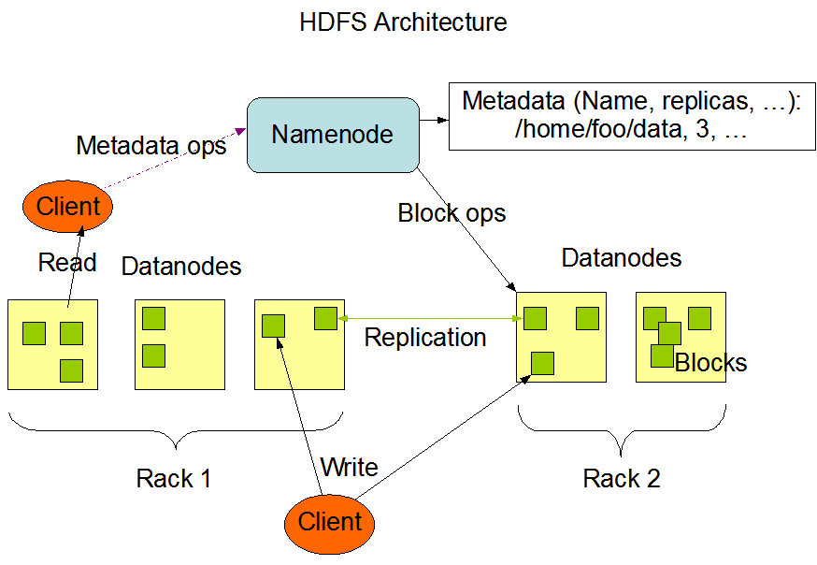
- HDFS NameNode: The NameNode is the most important HDFS node. It knows which DataNode stores each block of every file.
- HDFS DataNode: DataNodes store HDFS file blocks on their local file systems and serve those blocks when clients request them.
Spark is a unified distributed processing system for data analysis. It includes the Map/Reduce programming model as well as libraries for machine learning, SQL processing, and more.
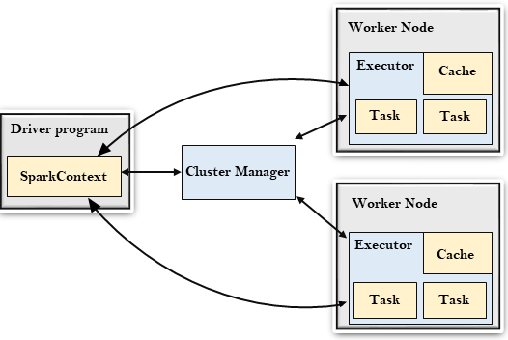
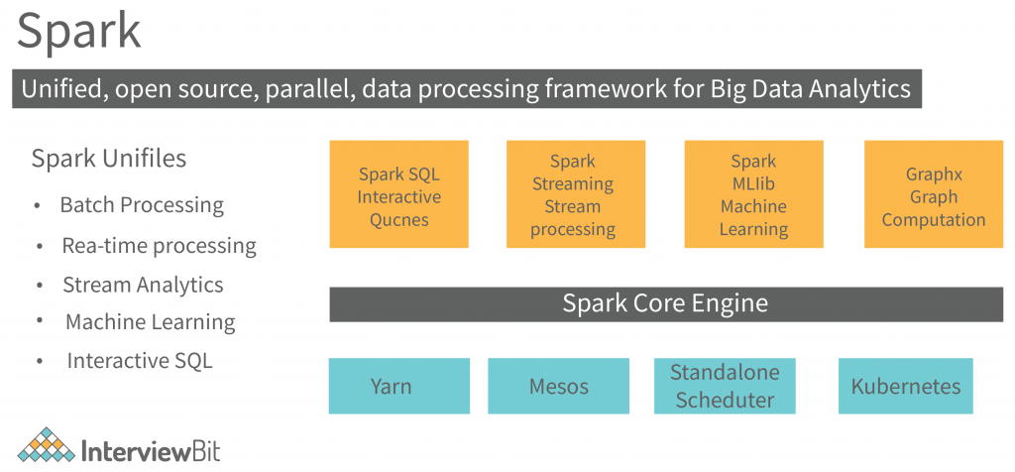
- Spark Master: The Spark Master controls the available resources and launches/manages distributed applications across the cluster.
- Spark Worker: A Worker runs on each cluster node and manages the distributed tasks assigned to that node.
- Spark Driver: The Driver acts as the controller of a Spark application and maintains its overall execution state.

Basic Docker concepts
To build the above infrastructure on a personal computer, we use Docker containers. The most important concepts are the following:
- Docker image: A static package that contains everything required to run an application, including code, dependencies, and runtime environment. To run a container, Docker first retrieves the corresponding image from an image repository. For example, the following command downloads and runs the official hello-world image:
docker run hello-world
- Dockerfile: A text file containing the instructions required to build a Docker image. It defines the base image, dependencies, and runtime configuration. The example below builds an image based on Python and runs a local app.py file.
Open the Ubuntu terminal and run:
mkdir compose-example
cd compose-example
Create a local app.py file:
nano app.py
Add the following content:
print("Hello from Docker!")
Save the file (CTRL+X, then Y, then Enter).
Now create a local Dockerfile:
nano Dockerfile
Add the following content:
FROM python:3.9
COPY app.py /app.py
CMD ["python", "/app.py"]
Save the file (CTRL+X, then Y, then Enter).
Build and run the image with the following commands:
docker build -t my-python-app .
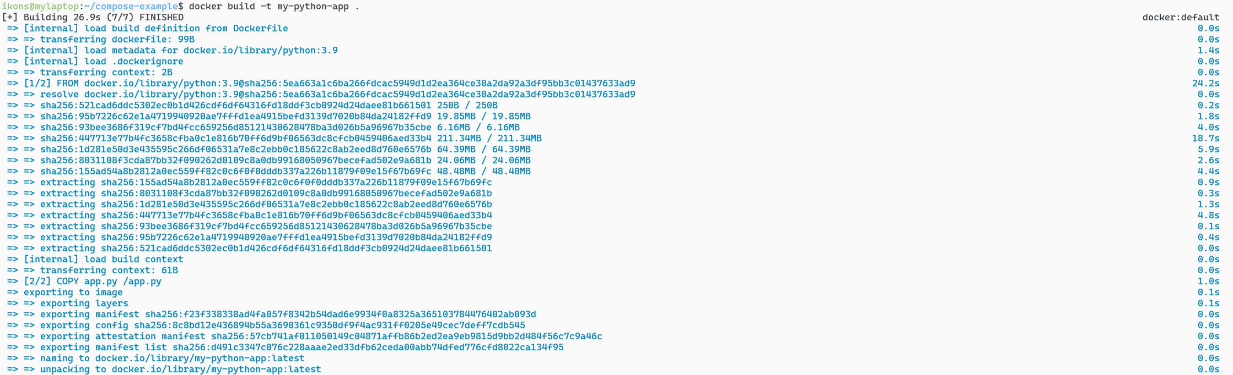
docker run my-python-app
To run the built image as a container, use the command above.
The first time you run it, Docker downloads the required dependencies. On subsequent runs, this is no longer necessary.
- Docker Compose: A tool that manages multiple containers through a Compose file, defining services, networks, and persistent storage.
- Docker containers have an ephemeral file system, so data stored only inside the container is lost when the container is removed.
- Volume: A storage mechanism that lets containers preserve data even after restart or deletion. Docker uses persistent volumes for long-term storage. Volumes can be created, named, and mounted into containers.

Installing Apache Spark and HDFS locally with Docker containers
Move to the example directory:
cd ~/bigdata-uth/docker/stacks/local-spark-hdfs/
Inside it you will find the following files:
- compose.yml: Creates a local infrastructure consisting of:
  - one HDFS cluster with one NameNode (namenode) and three DataNodes (datanode1, datanode2, datanode3)
  - one Spark cluster with one Master (spark-master) and four Workers (spark-worker1, spark-worker2, spark-worker3, spark-worker4)
  - one one-shot HDFS bootstrap service (hdfs-init)
  - one dedicated Spark History Server (spark-history)
This stack is built from shared Docker assets under the top-level docker/ directory:
- docker/images/spark-master/: reusable image for spark-master
- docker/images/spark-worker/: reusable image for Spark workers
- docker/images/spark-history/: reusable image for the dedicated History Server
- docker/shared/spark/spark-defaults.conf: shared Spark configuration of the local stack
- docker/shared/scripts/hdfs-init.sh: one-shot HDFS bootstrap script
- docker/shared/hadoop-conf/local-hdfs/: Hadoop client configuration for the local HDFS
- init-hdfs.sh: optional host-side wrapper for manually rerunning hdfs-init

How the services connect to each other
Before you start the commands, it is worth making the communication model of the local cluster explicit:
- All containers join the same Docker network, hadoop-net.
- Inside that network, the service names from compose.yml also act as hostnames.
- This means the Spark master reaches HDFS as hdfs://namenode:9000, and Spark workers reach the master as spark://spark-master:7077.
- Spark jobs are submitted from the spark-master container, but their input and output data live in the HDFS of the same stack.
- The one-shot hdfs-init service waits for HDFS and creates /user/root, /user/root/examples, and /logs automatically.
- The dedicated spark-history container reads Spark event logs from HDFS, so it can display completed applications even after the executors have finished.
- The named volumes preserve HDFS metadata, HDFS blocks, and temporary upload directories so they survive container restarts.
In other words:
- namenode and the datanodes form the HDFS subsystem
- spark-master and spark-worker1-4 form the Spark cluster
- spark-history is a dedicated monitoring service and no longer runs inside spark-master
- the shared Docker network lets those two subsystems communicate through names such as namenode and spark-master
- hdfs-init prepares the required HDFS directory structure automatically
- HDFS is the shared storage layer used both by Spark jobs and by the History Server
Starting the infrastructure: Run the following command to launch the environment. Important: you must be inside docker/stacks/local-spark-hdfs for it to work correctly.
docker compose up --build -d
In this new version of the stack, HDFS initialization is performed automatically by the hdfs-init service. The main path of the guide no longer requires a manual init-hdfs.sh step after docker compose up --build -d.
The first execution may take several minutes, especially if the Docker daemon has just started or if the larger images still need to be downloaded. If it seems slow, first confirm that docker version works from inside the WSL terminal and give the Docker daemon a little time to finish its startup sequence.
If everything works correctly, the containers will start normally. If you use Docker Desktop, you will also see the stack in the graphical application (green dot).
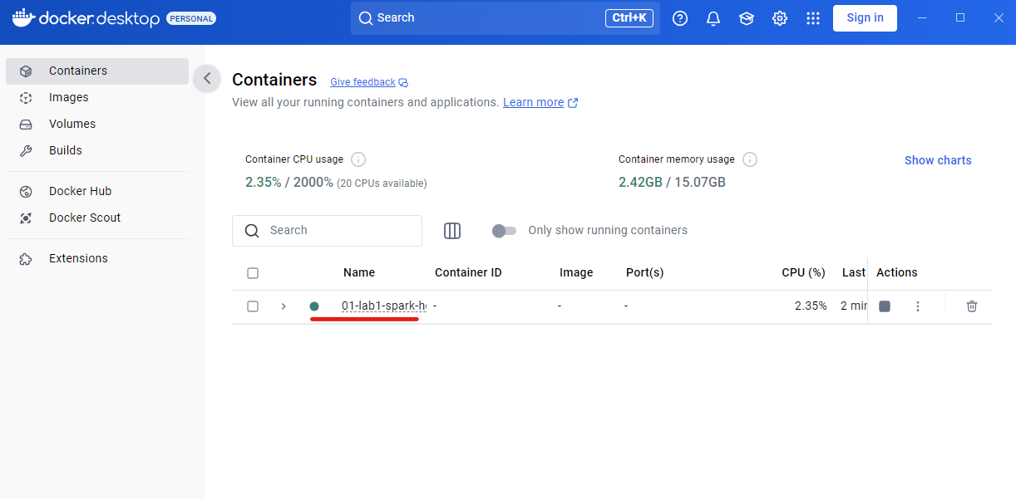
You can also list the containers from the terminal:
docker ps
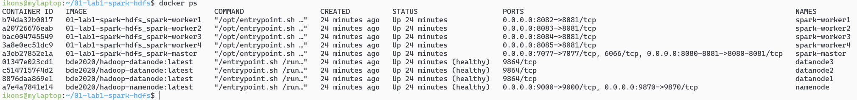
If you use Docker Desktop, click on local-spark-hdfs to see the individual containers.
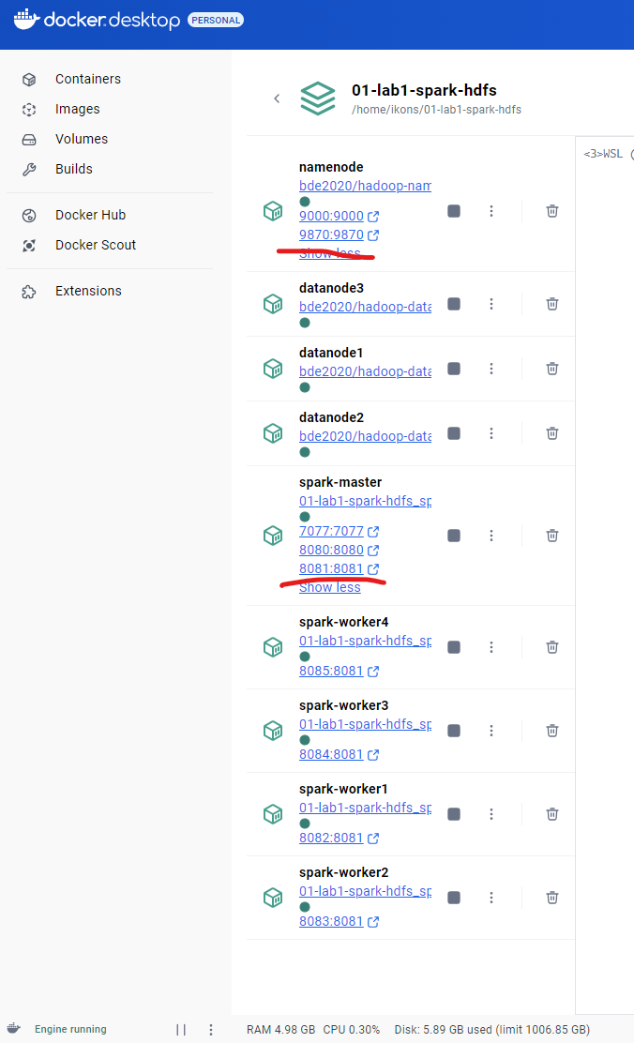
Whenever you see pairs of numbers such as 9870:9870, it means that the container exposes a service (usually an HTTP site, but not necessarily). This service is accessible from your host operating system, either by clicking the link directly or by opening it in a browser.
For example, the namenode container serves:
http://localhost:9870
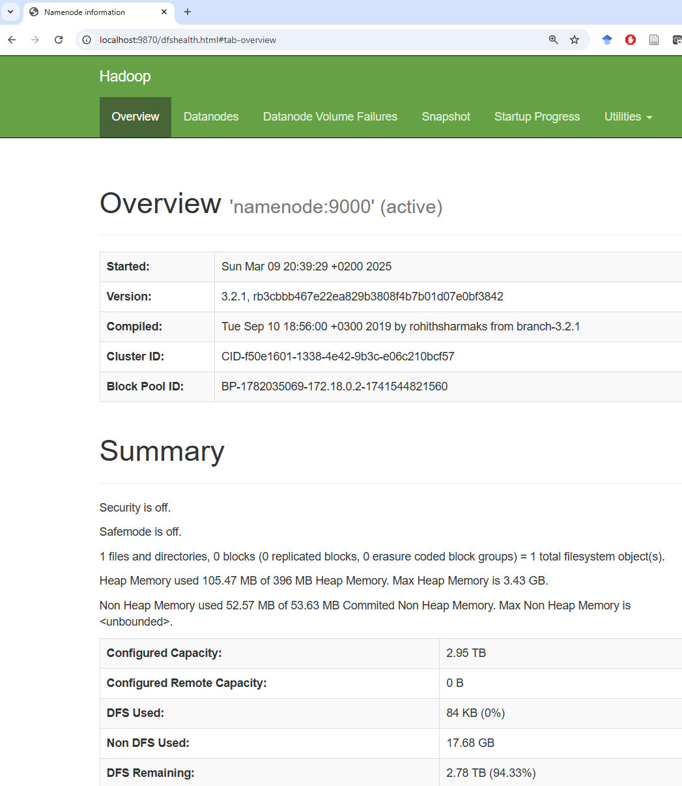
And spark-master serves the Spark UI at:
- http://localhost:18080
- http://localhost:18081 for the dedicated History Server (spark-history)
The stack uses ports 18080 and 18081 instead of 8080 and 8081, because on many Windows + WSL setups the lower ports are already reserved by the virtualization/networking stack and are not forwarded reliably to localhost.
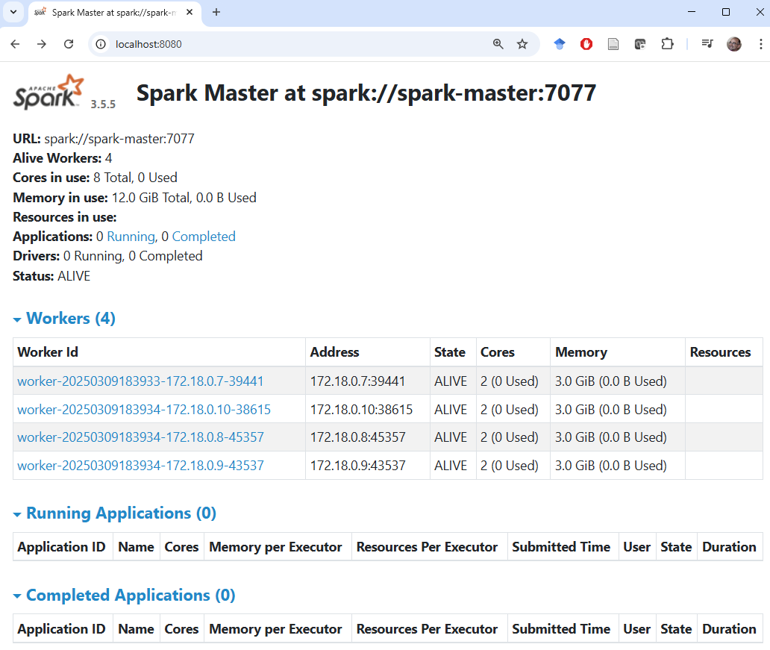
In the Volumes section you can see all persistent volumes used by the stack. These volumes are declared in compose.yml and are created automatically by docker compose up.
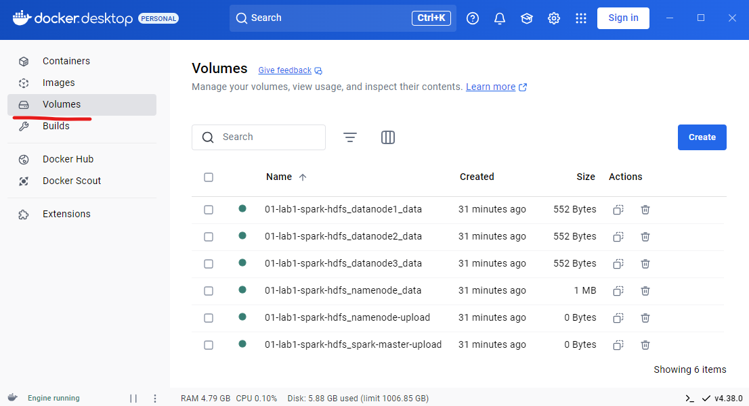
You can also list volumes from the terminal:
docker volume ls
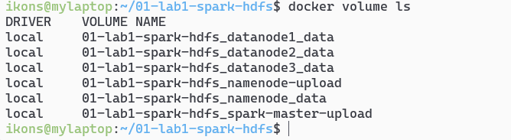
Where Docker volumes live depends on which Docker path you use.

If you use Docker Desktop
In this case, the Docker daemon does not run inside Ubuntu itself, but inside the docker-desktop infrastructure.
To see this, open a Windows terminal (right-click the Windows icon → Terminal) and run:
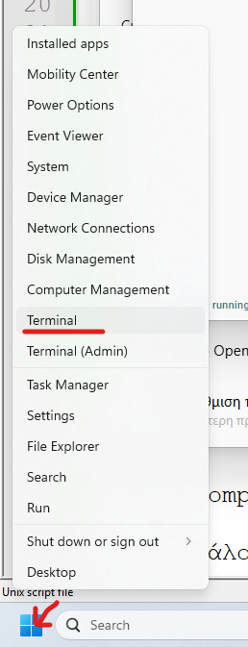
wsl -l -v
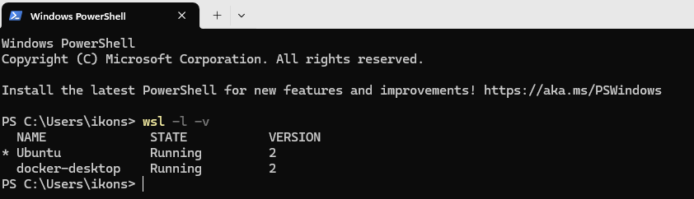
This shows that the machine runs two virtual environments: Ubuntu (where you execute the Docker commands) and docker-desktop, which runs the Docker daemon itself.
The persistent volumes live inside the file system of the docker-desktop VM.
These volumes can be accessed from the Windows host via the following folder:
\\wsl.localhost\docker-desktop\mnt\docker-desktop-disk\data\docker\volumes
Open Windows Explorer and paste the above path in the address bar. There you will see all directories used as persistent Docker volumes. Each one contains a _data subdirectory; whatever you place there becomes visible inside any container that mounts that volume.
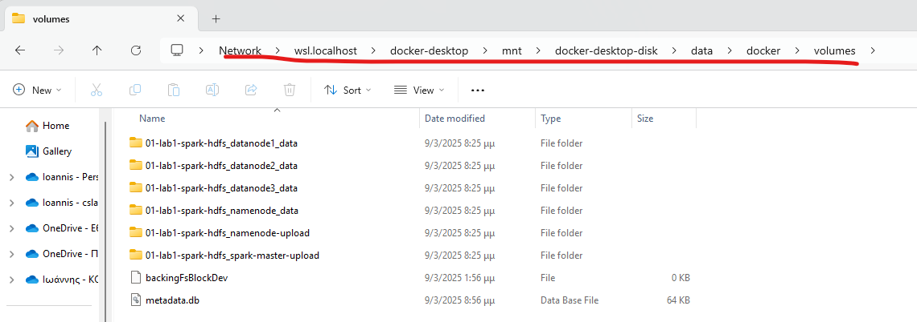

If you use a native Docker Engine inside WSL
In this case, there is no separate docker-desktop virtual machine. The Docker daemon runs inside Ubuntu itself, and the volumes live in the WSL file system, usually under:
/var/lib/docker/volumes
You can inspect them with:
sudo ls /var/lib/docker/volumes
or inspect a specific volume with:
sudo ls /var/lib/docker/volumes/<volume-name>/_data
In the lab, however, we prefer to work with docker cp and docker exec, so that the steps stay identical across both paths.
Initializing the HDFS file system: The first time you create the environment, the one-shot hdfs-init service automatically creates the required HDFS directories for file uploads and Spark event logs.
This logic is now part of the Docker Compose stack itself, so:
- the main path no longer requires a manual step after docker compose up --build -d
- the initialization is idempotent, so it can safely run again
- spark-history starts as a separate service after the HDFS bootstrap is ready
The one-shot script that performs this bootstrap is:
#!/usr/bin/env bash
set -euo pipefail
MAX_ATTEMPTS="${MAX_ATTEMPTS:-60}"
SLEEP_SECONDS="${SLEEP_SECONDS:-2}"
HDFS_URI="${HDFS_URI:-hdfs://namenode:9000}"
HDFS_BIN="${HDFS_BIN:-/opt/hadoop-3.2.1/bin/hdfs}"
hdfs_cmd() {
"${HDFS_BIN}" "$@"
}
wait_for_hdfs_rpc() {
local attempt
for attempt in $(seq 1 "$MAX_ATTEMPTS"); do
if hdfs_cmd dfsadmin -fs "${HDFS_URI}" -report >/dev/null 2>&1; then
echo "HDFS RPC endpoint is responding."
return 0
fi
echo "HDFS RPC attempt ${attempt}/${MAX_ATTEMPTS}: not ready yet"
sleep "$SLEEP_SECONDS"
done
echo "HDFS RPC endpoint did not become ready in time." >&2
return 1
}
wait_for_safe_mode_to_end() {
local attempt safe_mode_output
for attempt in $(seq 1 "$MAX_ATTEMPTS"); do
safe_mode_output="$(hdfs_cmd dfsadmin -fs "${HDFS_URI}" -safemode get 2>/dev/null || true)"
echo "safe mode attempt ${attempt}/${MAX_ATTEMPTS}: ${safe_mode_output:-unknown}"
if ! printf '%s' "$safe_mode_output" | grep -q 'Safe mode is ON'; then
return 0
fi
sleep "$SLEEP_SECONDS"
done
echo "HDFS stayed in safe mode for too long." >&2
return 1
}
echo "Waiting for the HDFS RPC endpoint to respond..."
wait_for_hdfs_rpc
# Ask HDFS to leave safe mode when it is already ready enough to accept admin commands.
# If it has already left safe mode, this is a harmless no-op.
hdfs_cmd dfsadmin -fs "${HDFS_URI}" -safemode leave >/dev/null 2>&1 || true
echo "Waiting for HDFS safe mode to end..."
wait_for_safe_mode_to_end
# -mkdir -p makes the bootstrap idempotent. Re-running it repairs the expected
# lab directories without requiring manual cleanup of the whole stack.
echo "Creating the lab directories in HDFS..."
hdfs_cmd dfs -fs "${HDFS_URI}" -mkdir -p /user/root /user/root/examples /logs
echo "HDFS bootstrap completed."
If you ever want to rerun the same bootstrap manually for recovery or diagnostics, you can still do so from the same directory:
bash ./init-hdfs.sh
The reason we create /logs in HDFS is that the History Server does not read logs from the host file system. It reads Spark event logs from the same HDFS used by the jobs.
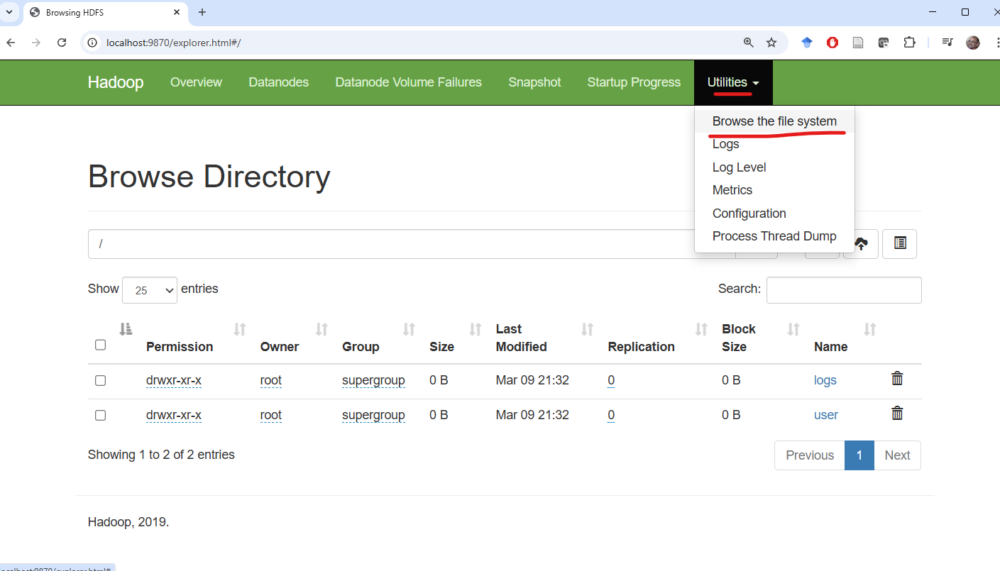

Running programs on the cluster
Run the following command to estimate π using a Monte Carlo simulation in Java:
docker exec spark-master /opt/spark/bin/spark-submit --class org.apache.spark.examples.JavaSparkPi /opt/spark/examples/jars/spark-examples.jar
If it executes correctly, you will see output similar to:
Pi is roughly 3.14638
Run the following for the equivalent Python example:
docker exec spark-master /opt/spark/bin/spark-submit /opt/spark/examples/src/main/python/pi.py

Running your own Spark program on the cluster
Now that we have an initialized HDFS file system and a working container stack, we can run our own Spark programs. To do so, we need to upload:
- code files (for example Python scripts)
- data files that will be processed (for example the input text for a word count)

Uploading code
In the repository-based workflow, the recommended path is docker cp from the cloned repo, not manual copy through volume paths. This keeps the steps identical whether you use Docker Desktop or a native Docker Engine inside WSL.
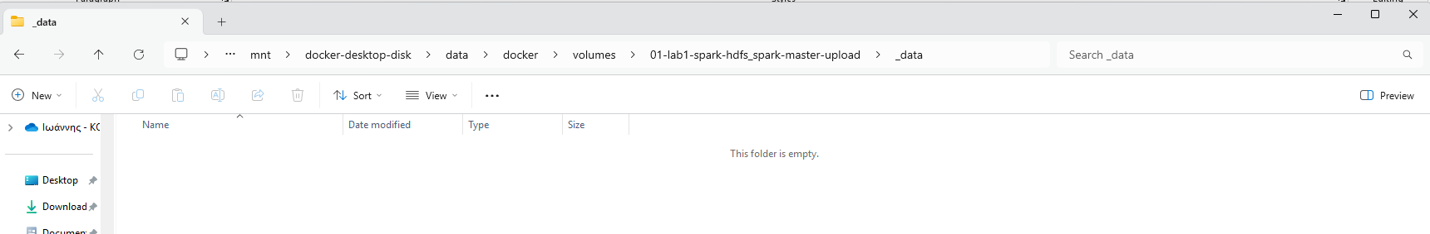
From a WSL terminal, run:
docker cp ~/bigdata-uth/code/wordcount.py spark-master:/mnt/upload/wordcount.py
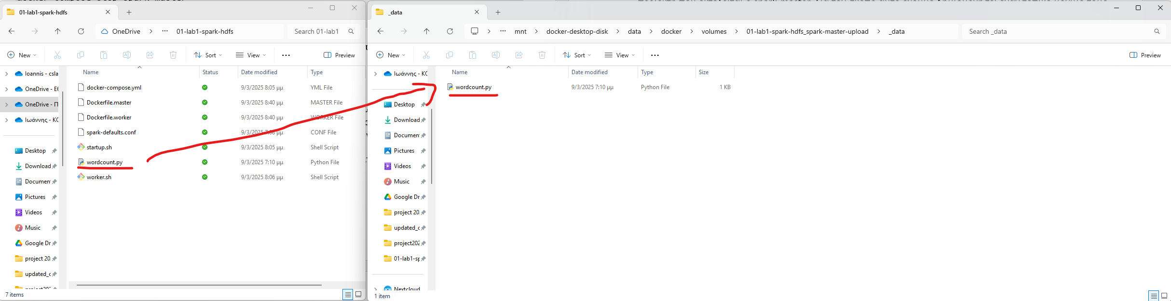
Now the spark-master container sees the file at /mnt/upload:
docker exec spark-master ls /mnt/upload
The following command prints the contents of the remote wordcount.py file as seen from inside the container:
docker exec spark-master cat /mnt/upload/wordcount.py
The script we use here is now the same shared repository script that can run either locally or on a cluster, depending on the --base-path we pass to it:
from __future__ import annotations
import argparse
import os
import sys
from pyspark.sql import SparkSession
# Keep the Python executable the same on the driver and on Spark workers.
# This avoids subtle version mismatches when the same script runs locally or on a cluster.
os.environ["PYSPARK_PYTHON"] = sys.executable
os.environ["PYSPARK_DRIVER_PYTHON"] = sys.executable
def build_path(base_path: str, relative_path: str) -> str:
return f"{base_path.rstrip('/')}/{relative_path.lstrip('/')}"
def write_local_text_output(output_path: str, lines: list[str]) -> None:
os.makedirs(output_path, exist_ok=True)
output_file = os.path.join(output_path, "part-00000")
with open(output_file, "w", encoding="utf-8") as file_handle:
for line in lines:
file_handle.write(f"{line}\n")
def parse_args() -> argparse.Namespace:
parser = argparse.ArgumentParser(
description="Count word frequencies from a text file with Spark.",
)
parser.add_argument(
"--base-path",
help="Base path that contains examples/ and where outputs should be written.",
)
parser.add_argument(
"--input",
help="Explicit input text path. Defaults to examples/text.txt locally or <base-path>/examples/text.txt remotely.",
)
parser.add_argument(
"--output",
help="Explicit output path. If omitted, local runs only print results and remote runs write under <base-path>.",
)
parser.add_argument(
"--master",
help="Optional Spark master. Local runs default to local[*] when no remote path is used.",
)
return parser.parse_args()
def main() -> None:
args = parse_args()
input_path = args.input or (
build_path(args.base_path, "examples/text.txt")
if args.base_path
else "examples/text.txt"
)
builder = SparkSession.builder.appName("wordcount example")
# Reuse the same script in two contexts:
# - local files -> start a local Spark session
# - remote URIs -> let spark-submit use the external cluster configuration
if args.master:
builder = builder.master(args.master)
if args.master.startswith("local"):
builder = builder.config("spark.submit.deployMode", "client")
elif "://" not in input_path:
builder = builder.master("local[*]").config("spark.submit.deployMode", "client")
spark = builder.getOrCreate()
sc = spark.sparkContext
sc.setLogLevel("ERROR")
output_path = args.output
if output_path is None and args.base_path:
output_path = build_path(args.base_path, f"wordcount_output_{sc.applicationId}")
wordcount = (
# textFile() gives an RDD where each element is one line from the input file.
sc.textFile(input_path)
# flatMap() is the classic "one input record -> many output records" step.
.flatMap(lambda line: line.split())
.map(lambda word: (word, 1))
# reduceByKey() is the standard RDD aggregation pattern for key-value data.
.reduceByKey(lambda left, right: left + right)
.sortBy(lambda item: (-item[1], item[0]))
)
# collect() is safe here because the lab output is intentionally small.
results = wordcount.collect()
for item in results:
print(item)
if output_path:
if "://" in output_path:
# coalesce(1) makes the lab output easier to inspect.
# For large real workloads, a single output partition would usually be a bottleneck.
wordcount.coalesce(1).saveAsTextFile(output_path)
else:
write_local_text_output(output_path, [str(item) for item in results])
print(f"Saved to: {output_path}")
spark.stop()
if __name__ == "__main__":
main()
If you change wordcount.py in the repository, rerun docker cp so the updated version is copied into the container.
The code is copied into spark-master because spark-submit runs there. The data, however, is not kept in the local file system of spark-master; it is uploaded to HDFS so it is available to the whole cluster.

Uploading data files
The wordcount.py script expects a base path that contains an examples/ subdirectory with the input files. At this point, however, the HDFS file system is empty apart from the directories created earlier.
So we must upload an input data file to HDFS.
This happens in two stages:
- Place the file from your local file system into the local file system of the namenode container.
- Run hdfs dfs -put inside the namenode container to upload the file from /mnt/upload into HDFS.
For this purpose, we again use docker cp, this time to copy the reference dataset into namenode.
From a WSL terminal, run:
docker cp ~/bigdata-uth/examples/text.txt namenode:/mnt/upload/text.txt
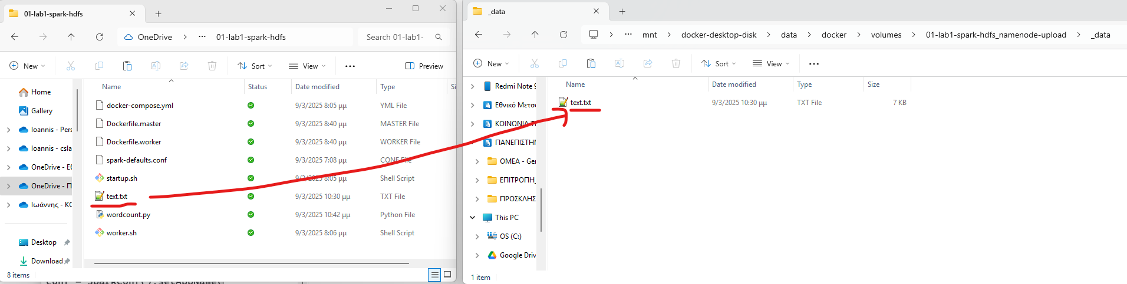
Now the namenode container sees text.txt inside /mnt/upload:
docker exec namenode ls -lah /mnt/upload
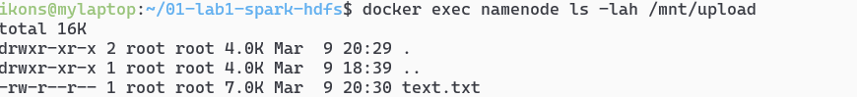
Upload the file into HDFS with the following commands. We create /user/root/examples first because that is where the script will look when we pass --base-path hdfs://namenode:9000/user/root:
docker exec namenode hdfs dfs -mkdir -p /user/root/examples
docker exec namenode hdfs dfs -put -f /mnt/upload/text.txt /user/root/examples/text.txt
At this point:
- the Python file to execute is available on the local file system of spark-master
- text.txt is stored in HDFS
You are ready to run the Spark program:
docker exec spark-master /opt/spark/bin/spark-submit /mnt/upload/wordcount.py \
--base-path hdfs://namenode:9000/user/root
In this example:
- the input is read from hdfs://namenode:9000/user/root/examples/text.txt
- the output is automatically written to a fresh directory such as hdfs://namenode:9000/user/root/wordcount_output_<app-id>
- this lets you rerun the example without manually deleting the previous output each time
At this point the execution flow is:
- the driver starts from spark-master
- spark-master assigns work to the available workers
- the workers read the input data from hdfs://namenode:9000
- the execution also writes event logs into HDFS
- the dedicated spark-history service later reads those logs to display the application history

Optional: Run the same reference scripts on the local cluster
This section is not part of the main first pass of the course. The main learning path remains:
- 03_local-spark-workbook
- 04_remote-spark-kubernetes
- 05_cluster-queries-rdd-df-sql
Use the following only as a second pass, to show that the same reference code can also run on the local Spark + HDFS cluster.
The core idea is:
- the code stays the same
- the data stays the same
- only the execution target and the HDFS base path change
From the repository root ~/bigdata-uth, upload the reference code/ directory to spark-master and the examples/ directory to namenode:
docker exec spark-master mkdir -p /mnt/upload/code
docker exec namenode mkdir -p /mnt/upload/examples
docker cp ./code/. spark-master:/mnt/upload/code/
docker cp ./examples/. namenode:/mnt/upload/examples/
docker exec namenode bash -c 'hdfs dfs -rm -r -f /user/root/examples || true; hdfs dfs -mkdir -p /user/root/examples; hdfs dfs -put -f /mnt/upload/examples/* /user/root/examples/'
In this local stack:
- the reference spark-submit script lives under /mnt/upload/code/... on spark-master
- the input datasets live under hdfs://namenode:9000/user/root/examples/...
- the --base-path is hdfs://namenode:9000/user/root
- you do not use /user/$USER, unlike the remote Kubernetes path
Start with a small portability matrix of 3 scripts:
docker exec spark-master /opt/spark/bin/spark-submit /mnt/upload/code/wordcount.py \
--base-path hdfs://namenode:9000/user/root
docker exec spark-master /opt/spark/bin/spark-submit /mnt/upload/code/DFQ1.py \
--base-path hdfs://namenode:9000/user/root
docker exec spark-master /opt/spark/bin/spark-submit /mnt/upload/code/SQLQ2.py \
--base-path hdfs://namenode:9000/user/root
After the runs, inspect the outputs in the local HDFS:
docker exec namenode hdfs dfs -ls /user/root
If everything works, the repository achieves its main portability goal:
- one shared codebase
- local execution without a cluster
- remote execution on a ready Kubernetes cluster
- and optionally execution on a local Spark + HDFS cluster as well

Monitoring execution
You can watch the currently running job at:
http://localhost:18080
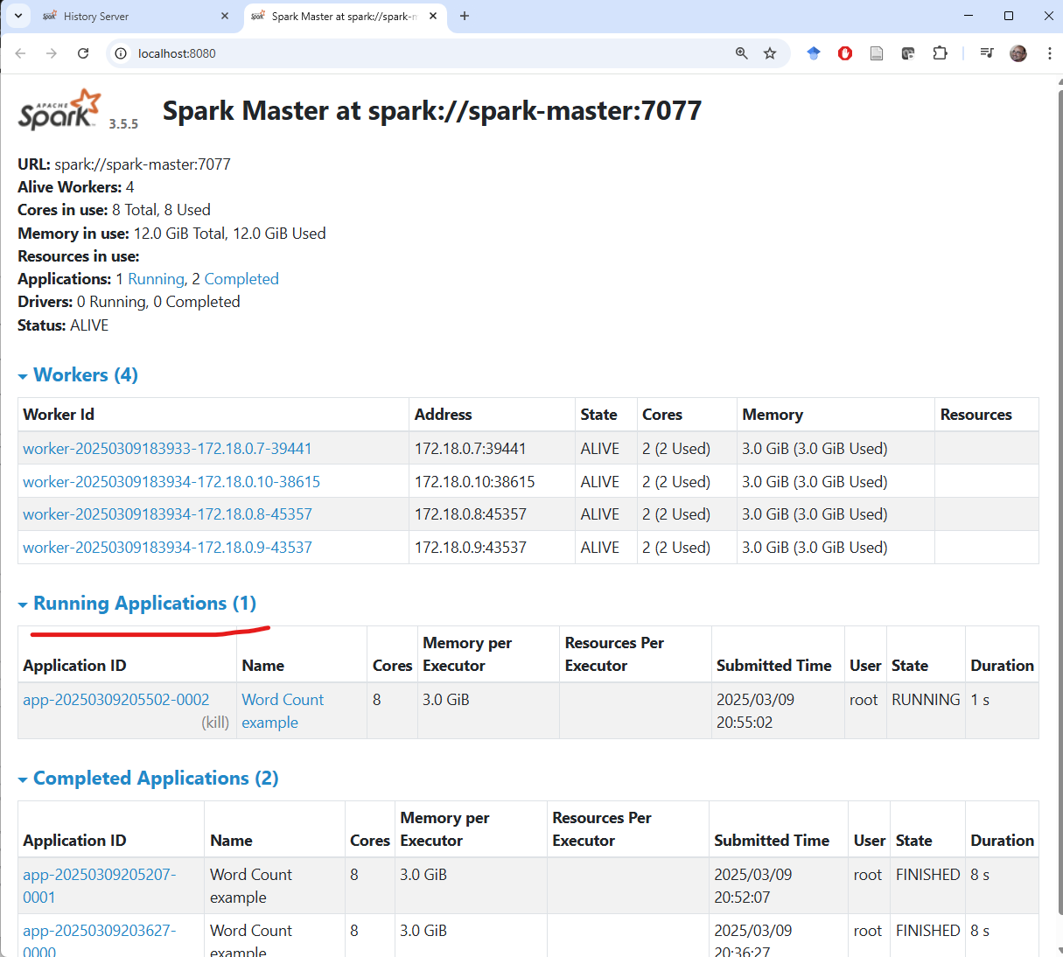

History Server
Apache Spark includes a useful service that stores log files from all submitted jobs across the master and worker nodes. In this refactored stack, the History Server runs as its own spark-history container and is available at:
http://localhost:18081
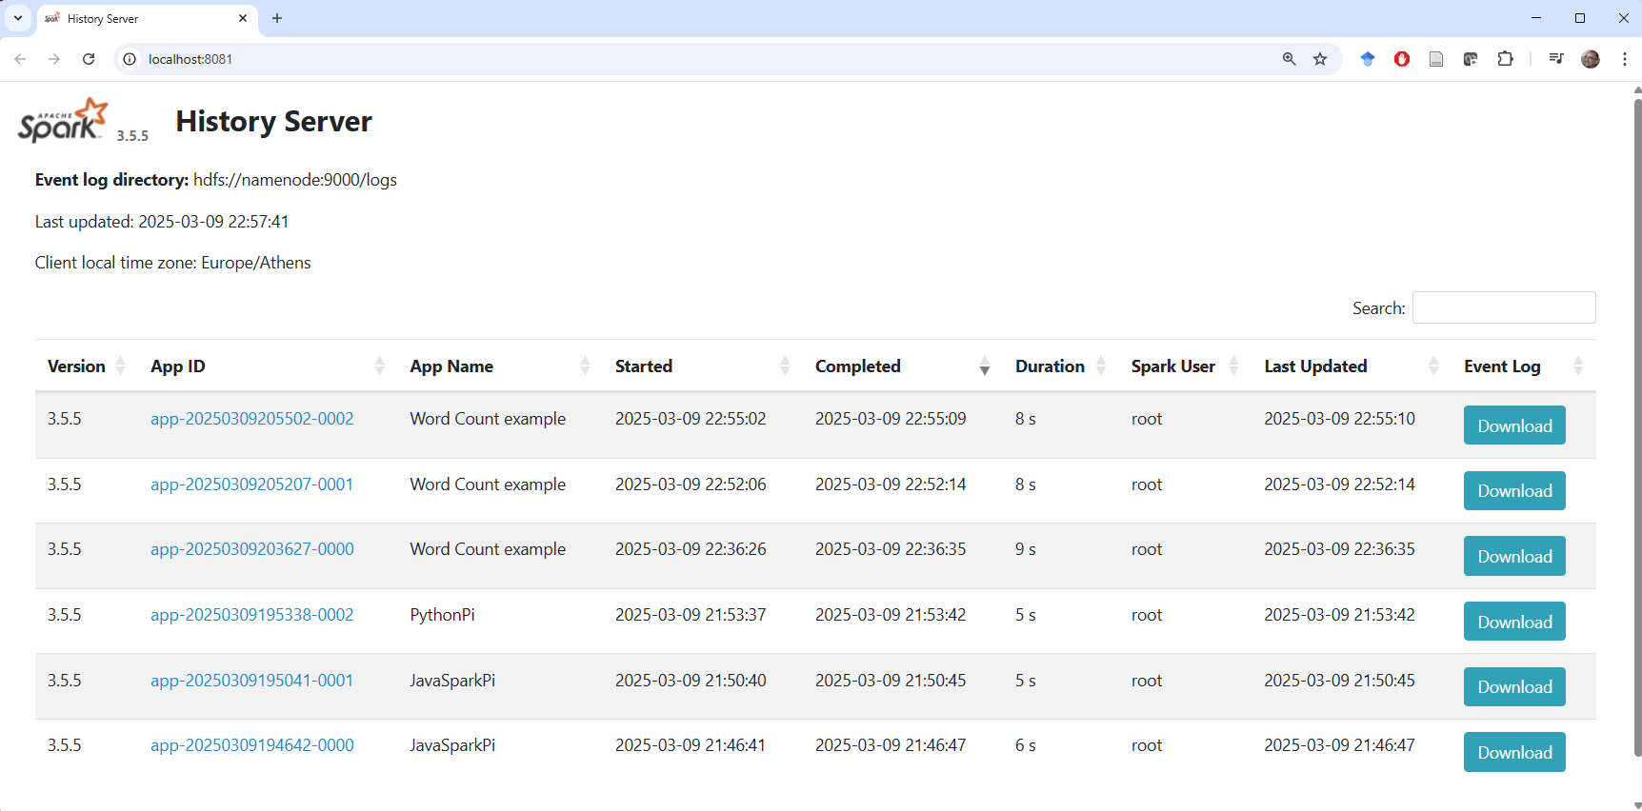
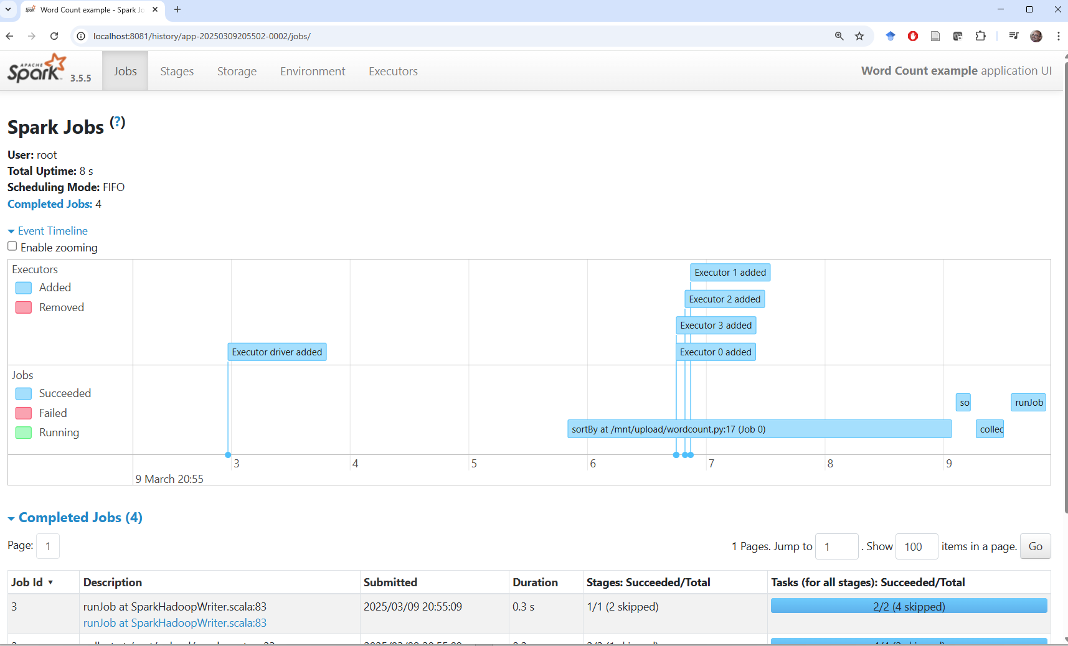

Useful Linux commands
Command | Meaning
ls | list directory contents
pwd | print the current directory
cd | change directory
cp | copy
mv | move
cat | print file contents
echo | print text to the screen
man <command> | show the manual page for <command>

Useful HDFS commands
Create a directory in HDFS:
docker exec namenode hadoop fs -mkdir -p <path>
Delete a directory in HDFS:
docker exec namenode hdfs dfs -rm -r -f <path>
Upload a file with overwrite:
docker exec namenode hdfs dfs -put -f <local-path> <hdfs-path>

Stopping and cleaning up the infrastructure

Stopping the infrastructure
The following command stops the infrastructure. Files uploaded to HDFS or saved in the persistent volumes of namenode and spark-master are not deleted and remain available. As with docker compose up, you must run it from the directory that contains compose.yml.
docker compose down

Cleaning up the infrastructure
If you want to return to a clean initial state, run:
docker compose down -v --remove-orphans
This command:
- stops and removes the containers of this lab stack
- removes the lab network
- deletes the persistent volumes, so the HDFS data, uploaded files, and execution logs are lost
The next time you run docker compose up --build -d, the environment starts fresh and you must repeat the HDFS initialization steps.

