Local Spark development with PyCharm
Table of Contents
Setting up the local environment 1
Opening the repository in PyCharm 1
Installing Python packages 4
Checking Java 4
Creating example files 5
Running and debugging in PyCharm 5
Experimenting with pyspark 6
Option 1: pyspark 6
Option 2: open the regular Python console from the terminal 6
Checking the Spark UI 7
Next local guide 7
Useful notes 8

Setting up the local environment
This is the alternative step 02 guide for local Spark development.
If you want the path that has been tested more extensively in the course, follow the VS Code guide. If PyCharm fits you better, you can use this guide and then continue to the same unified local Spark practice guide.
You can find the official Apache Spark programming guide here:
https://spark.apache.org/docs/latest/rdd-programming-guide.html
This guide assumes that you already have PyCharm Community Edition installed and that Python 3.11 is already available from 01_workstation-setup. For pyspark, Python 3.11 is the recommended baseline.
PyCharm Community Edition:
https://www.jetbrains.com/pycharm/download/

Opening the repository in PyCharm
Guide 02 supports two equivalent local paths:
- Windows / PowerShell
- WSL / Ubuntu
If you already completed 01_workstation-setup, the repository may now exist:
- either in a Windows folder, such as C:\Users\<username>\bigdata-uth
- or inside WSL, such as ~/bigdata-uth
Open PyCharm and choose the existing bigdata-uth project directory.
For the native Windows path, use the Windows project and a PowerShell terminal. For the WSL path, use the corresponding project inside WSL and a WSL terminal.
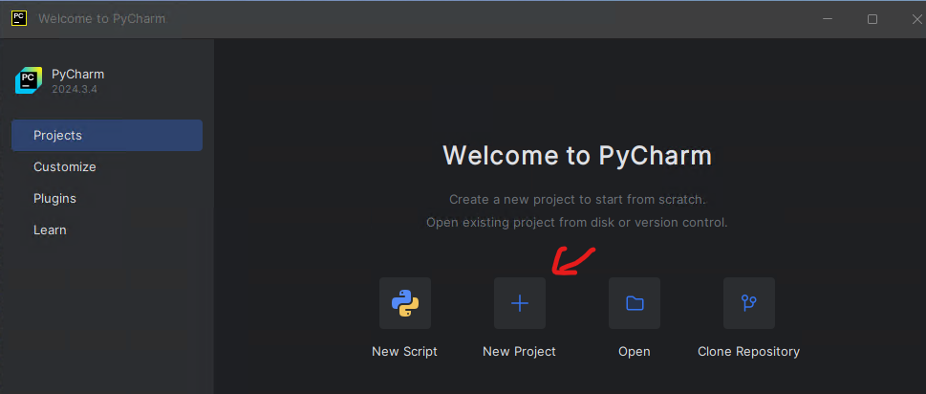
If you still decide to create a new project from scratch, then:
- choose the Pure Python project type
- give it a name such as Spark_example
- avoid spaces in file names and directory names
- in Interpreter type, choose Project venv
- as the base interpreter, choose Python 3.11
- the Create a welcome script option is optional
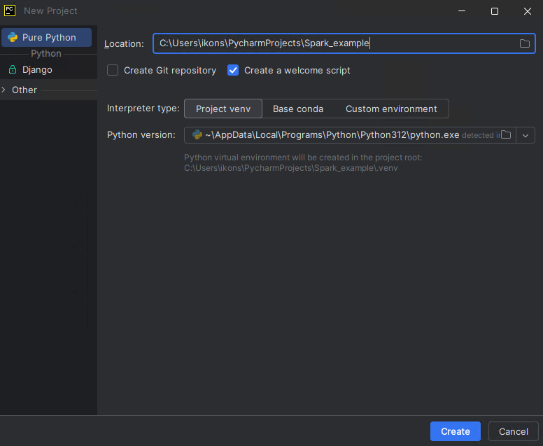
If PyCharm shows a Microsoft Defender message about folder exclusions, you may choose Exclude folders. This is not required for the example to run, but it usually helps IDE performance.
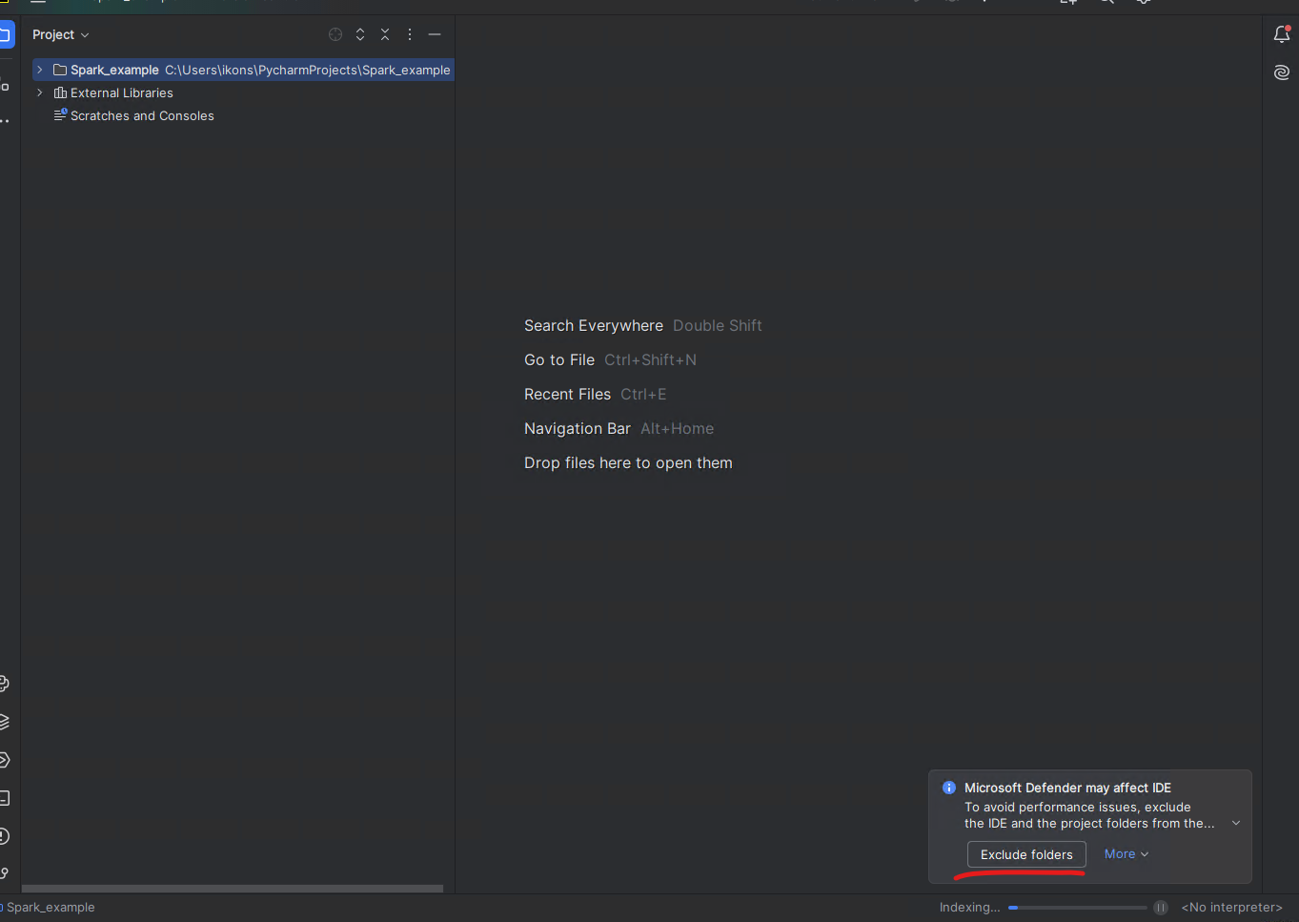

Installing Python packages
After the project is created, install the pyspark and psutil packages in the project interpreter.
You can do this either:
- from the Python Packages tool window
- from Settings | Python | Interpreter
- from the built-in PyCharm terminal with:
- python -m pip install pyspark==3.5.8 psutil
For this guide, you do not need to install Apache Spark separately on your computer. The pyspark package inside .venv and Java are enough.

Checking Java
For local PySpark execution, the course Spark 3.5.8 baseline works fine both with Java 17 on Windows and with Java 11 in WSL, following the baseline defined in 01_workstation-setup.
Check from PowerShell or WSL:
java -version
If the command does not work, go back to 01_workstation-setup first.

Creating example files
If you are following the repository-based workflow, you do not need to create a new main.py and a new text.txt. You can use the canonical files that already exist:
- code/wordcount.py
- examples/text.txt
The scratch example below remains useful only if you want to see the smallest possible Spark script from zero.
Create two files in the project directory: main.py and text.txt.
If a welcome script was created automatically, you can simply replace its contents with the following main.py.
import os
import sys
from pyspark.sql import SparkSession
os.environ["PYSPARK_PYTHON"] = sys.executable
os.environ["PYSPARK_DRIVER_PYTHON"] = sys.executable
def main() -> None:
spark = SparkSession.builder.appName("Word Count example").getOrCreate()
sc = spark.sparkContext
wordcount = (
sc.textFile("text.txt")
.flatMap(lambda line: line.split())
.map(lambda word: (word, 1))
.reduceByKey(lambda left, right: left + right)
.sortBy(lambda item: item[1], ascending=False)
)
print(wordcount.collect())
spark.stop()
if __name__ == "__main__":
main()
The two lines with sys.executable explicitly tell Spark to use the same Python interpreter that the project has selected in PyCharm. Because of that, for this first example you do not need to define PYSPARK_PYTHON and PYSPARK_DRIVER_PYTHON manually in Run Configurations.
Put the following sample content into text.txt:
spark spark data
big data spark
python spark

Running and debugging in PyCharm
Open main.py and run the program in one of the following ways:
- from the green Run icon in the gutter
- by right-clicking the file and choosing Run 'main'
- with the shortcut Shift+F10
For debugging:
- press the Debug icon in the gutter
- or right-click and choose Debug 'main'
For this simple example, you do not need to create a manual Run Configuration with environment variables. PyCharm can automatically create a temporary run/debug configuration for the current file, and that is enough.
The first time you run the program, Windows Firewall / Windows Defender may show a prompt for OpenJDK Platform binary. If it appears, choose Allow, so that Spark can open the local port it needs.
If everything is configured correctly, you should see output such as:
[('spark', 4), ('data', 2), ('big', 1), ('python', 1)]

Experimenting with pyspark
If you want to experiment interactively with Spark, you have two practical options:
- pyspark, which opens a ready-to-use shell with sc and spark already available, but on Windows it often does not provide convenient command history with the Up / Down keys
- the regular Python console that you open with python, which usually has more convenient history and editing, but requires you to create the SparkSession manually
Note: pyspark is for Python, while spark-shell is the Scala shell. The command sparkshell without a dash is not valid.

Option 1: pyspark
pyspark is the quickest option if you want to start immediately with sc and spark ready to use.
After activating .venv and confirming that java -version works, run the following in the terminal.
From PowerShell:
$env:PYSPARK_PYTHON="$PWD\.venv\Scripts\python.exe"
$env:PYSPARK_DRIVER_PYTHON=$env:PYSPARK_PYTHON
pyspark
From WSL:
export PYSPARK_PYTHON="$PWD/.venv/bin/python"
export PYSPARK_DRIVER_PYTHON="$PYSPARK_PYTHON"
pyspark
Once the shell opens, you can try commands such as:
sc.parallelize([1, 2, 3]).count()
spark.range(5).show()
To exit the shell:
exit()

Option 2: open the regular Python console from the terminal
If you prefer better command history and a more predictable terminal experience, you can first open the regular Python console:
python
and then create the Spark session manually:
import os
import sys
from pyspark.sql import SparkSession
os.environ["PYSPARK_PYTHON"] = sys.executable
os.environ["PYSPARK_DRIVER_PYTHON"] = sys.executable
spark = SparkSession.builder.appName("playground").getOrCreate()
sc = spark.sparkContext
After that, you can experiment with commands such as:
sc.parallelize([1, 2, 3]).count()
spark.range(5).show()
When you are done:
spark.stop()
exit()

Checking the Spark UI
While the program is running, you can usually monitor the Spark UI at:
http://localhost:4040
Once you stop the program, the corresponding Spark UI web server also stops.

Next local guide
After completing this basic guide, the recommended continuation is the unified local Spark practice guide:
- ../03_local-spark-workbook/README.en.md
The exact appearance of the Spark UI may differ slightly depending on the Spark version, but the general idea remains the same.
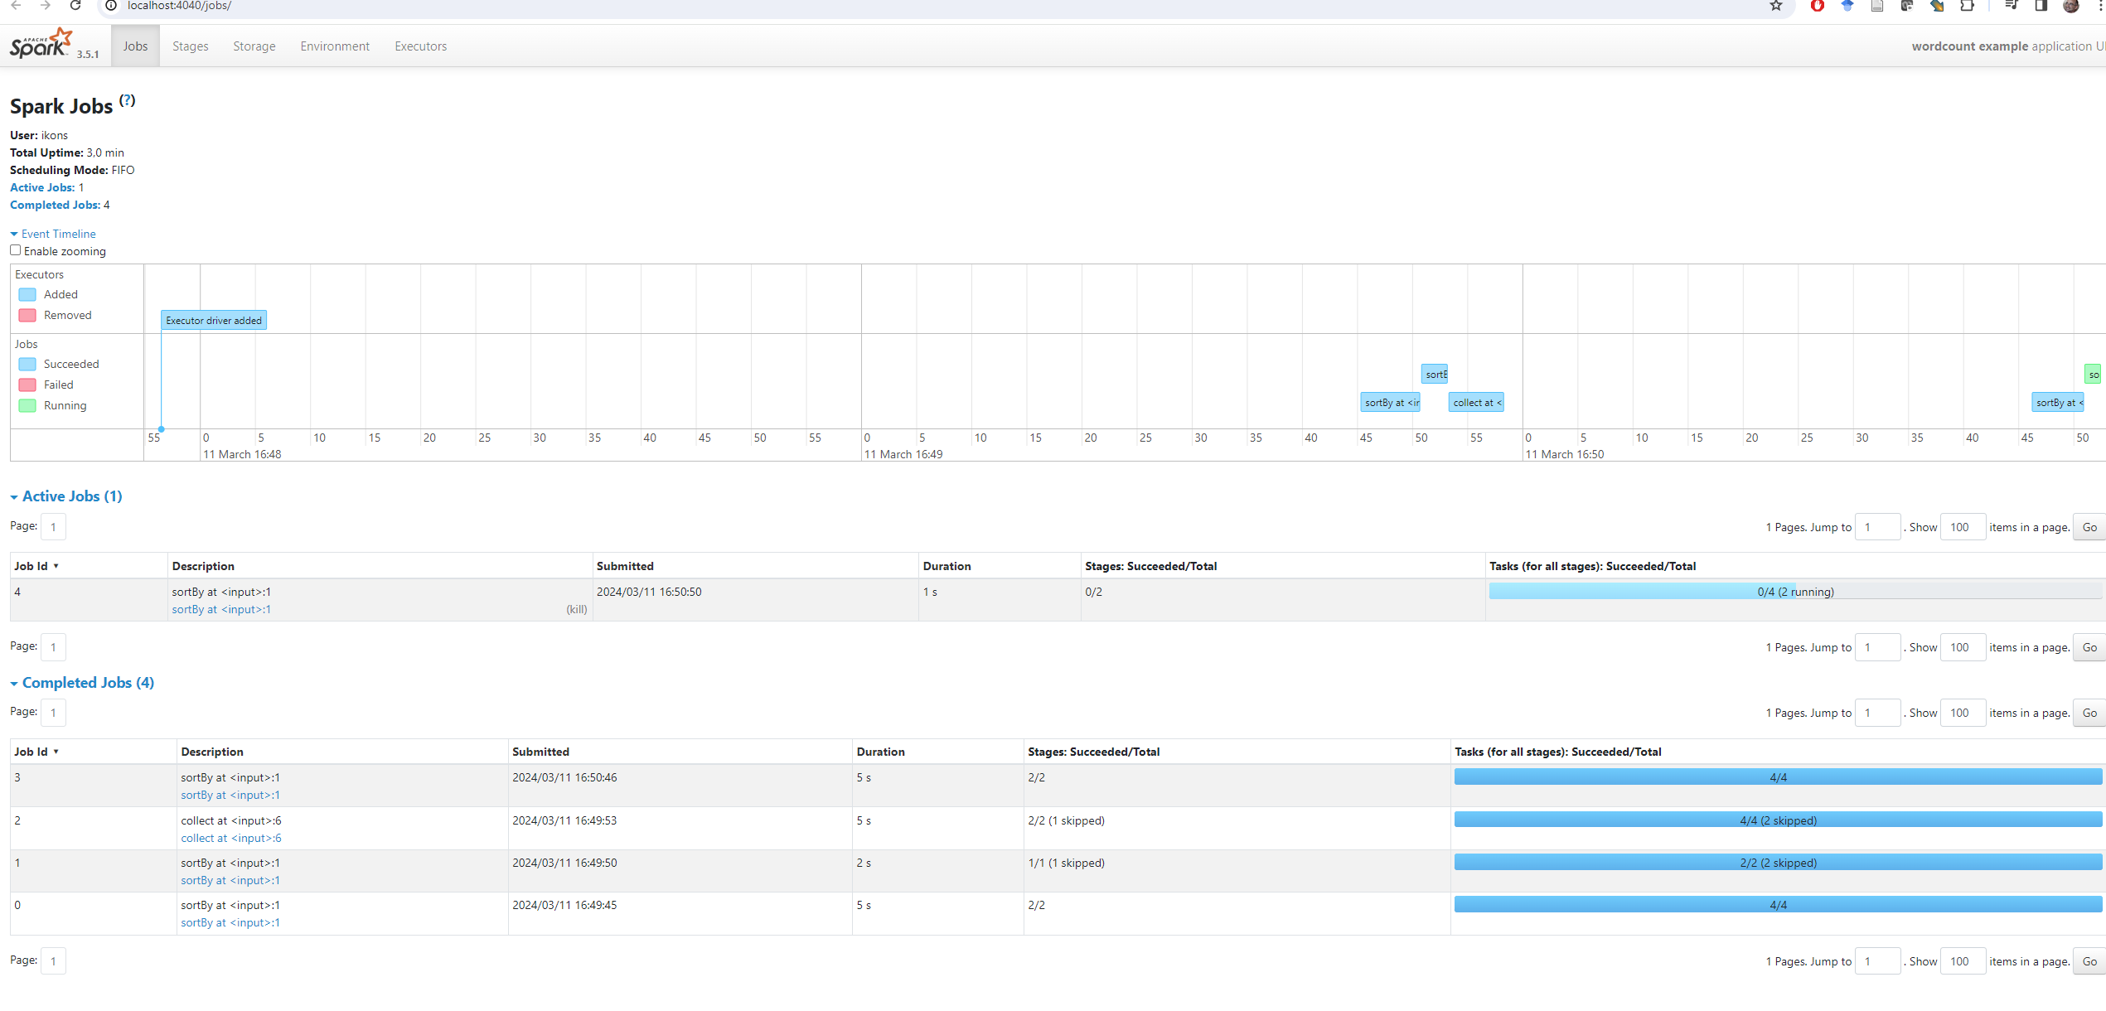

Useful notes
- If java -version does not work, close and reopen PyCharm and create a new terminal. If it still does not work, go back to 01_workstation-setup.
- If the project is not using the correct .venv, check Settings | Python | Interpreter again.
- If you see warnings about winutils.exe or NativeCodeLoader, you can ignore them for this simple local Windows example.
- If text.txt is not located in the correct directory, the program will fail because it cannot find it.
- If port 4040 is already in use, Spark may start the UI on another port such as 4041.
- PyCharm's Python Console is useful for more advanced interactive use, but it is not required for this first example.
- If you later continue to guide 04, remote execution does not happen from PowerShell but only from WSL.

