Local Spark development with VS Code
Table of Contents
Setting up the local environment 1
Opening the repository 2
Creating a virtual environment in VS Code 3
Activating the virtual environment 4
Option 1: Close and reopen the terminal 4
Option 2: Manual activation 4
Installing packages 4
If the terminal does not auto-activate .venv 5
If creating .venv gets stuck 5
What to remember 5
Checking Java 6
Creating example files 6
Running and debugging in VS Code 7
Experimenting with pyspark 8
Option 1: pyspark 8
Option 2: open the regular Python console from the terminal 8
Checking the Spark UI 9
Next local guide 9
Useful notes 10

Setting up the local environment
You can find the official Apache Spark programming guide here:
https://spark.apache.org/docs/latest/rdd-programming-guide.html
This guide assumes that you already have a recent version of Visual Studio Code installed on your computer.
This is the recommended and tested workflow for local development in the course. If you prefer another IDE, there is also the alternative PyCharm guide, but the path that is validated most consistently in the course is VS Code.
https://code.visualstudio.com/
This guide assumes that Python 3.11 has already been installed through 01_workstation-setup. In this course we use a simple local environment with venv, so Python 3.11 is the recommended baseline.
For Python development in VS Code, you should install at least the following extensions:
- Python
- Pylance
- optionally Jupyter
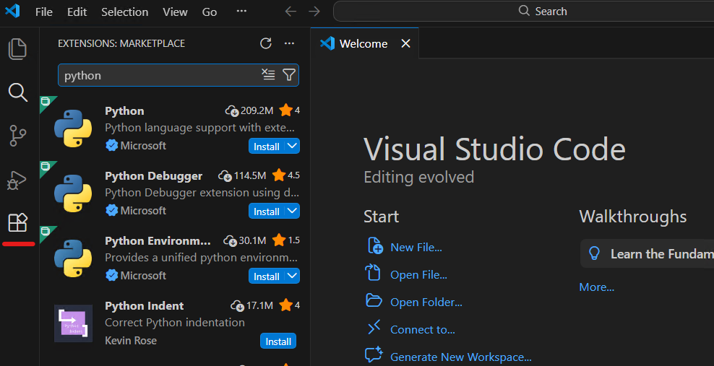

Opening the repository
Guide 02 supports two equivalent local paths:
- Windows / PowerShell
- WSL / Ubuntu
If you already completed 01_workstation-setup, the repository may now exist:
- either in a Windows folder, such as C:\Users\<username>\bigdata-uth
- or inside WSL, such as ~/bigdata-uth
In VS Code, open the folder that matches the path you chose:
- for the native Windows path, open the normal Windows folder and use a PowerShell terminal
- for the WSL path, open the repo through WSL integration and use a WSL terminal
In this guide, every step that differs is shown for both environments.
When VS Code runs for the first time, if it asks whether you trust the folder, choose Yes, I trust the authors.
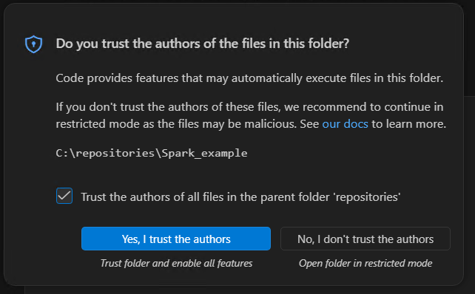

Creating a virtual environment in VS Code
A virtual environment is an isolated Python space for a specific project.
Inside that space, you install only the packages needed by that particular assignment, without affecting the rest of your computer or other projects.
In practice, this gives three main benefits:
- it keeps each assignment's dependencies separate
- it avoids conflicts between different package versions
- it makes the run/debug environment in VS Code more predictable
For this course it is recommended to use a local virtual environment with venv inside each project. This is the cleanest and most practical approach because:
- each assignment has its own packages
- conflicts between different projects are avoided
- VS Code usually detects the project's .venv automatically
Open the bigdata-uth folder in VS Code.
Open a terminal inside VS Code (Terminal -> New Terminal) and create the virtual environment.
From PowerShell:
py -3.11 -m venv .venv
From WSL:
python3 -m venv .venv
The command above creates a .venv directory inside your project.

Activating the virtual environment
After creating .venv, you have two simple options:

Option 1: Close and reopen the terminal
In many cases it is enough to close the terminal and open a new terminal inside VS Code.
VS Code will usually detect .venv automatically and activate it by itself.

Option 2: Manual activation
If you want, you can also activate it manually.
From PowerShell:
.venv\Scripts\Activate.ps1
If PowerShell blocks local scripts from the virtual environment, run this first:
Set-ExecutionPolicy -Scope Process Bypass
.venv\Scripts\Activate.ps1
From WSL:
source .venv/bin/activate
If everything worked correctly, you will usually see (.venv) at the beginning of the terminal prompt.
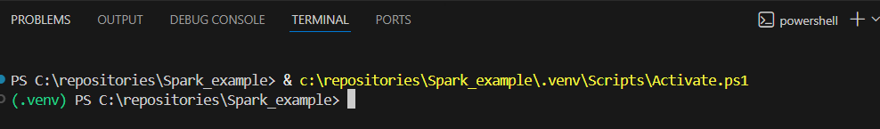

Installing packages
After the virtual environment is activated, install the required packages with:
python -m pip install pyspark==3.5.8 psutil
You can view the installed packages with:
python -m pip list
We prefer the python -m pip form instead of plain pip, because this makes it explicit that the installation targets the Python interpreter used by the project.
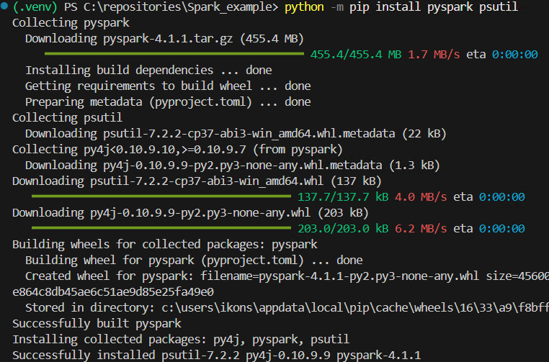

If the terminal does not auto-activate .venv
From PowerShell:
.venv\Scripts\Activate.ps1
From WSL:
source .venv/bin/activate

If creating .venv gets stuck
On some machines, creating .venv may be slow or appear to hang at the step where pip is installed.
From PowerShell:
py -3.11 -m venv --without-pip .venv
.venv\Scripts\python.exe -m ensurepip --upgrade
From WSL:
python3 -m venv --without-pip .venv
.venv/bin/python -m ensurepip --upgrade
This way, the virtual environment is created first and pip is installed in a second step.

What to remember
For this course, the recommended workflow is the following:
- create .venv
- choose Python: Select Interpreter
- install packages with python -m pip
- run or debug from VS Code
Manual activation is optional and is mainly useful when you work directly from a terminal.

Checking Java
For local PySpark execution, the course Spark 3.5.8 baseline works fine both with Java 17 on Windows and with Java 11 in WSL, following the baseline defined in 01_workstation-setup. You do not need to install Apache Spark separately on your computer. For this guide, the pyspark package inside .venv and the Java installation from 01_workstation-setup are enough.
Check from PowerShell or WSL:
java -version
If the command does not work, go back to 01_workstation-setup first.

Creating example files
If you are following the repository-based workflow, you do not need to create a new main.py and a new text.txt. You can use the canonical files that already exist:
- code/wordcount.py
- examples/text.txt
The small standalone example below remains useful only if you want to see the smallest possible Spark script from zero.
Create two files in your project directory: main.py and text.txt.
Put the following code into main.py:
import os
import sys
from pyspark.sql import SparkSession
os.environ["PYSPARK_PYTHON"] = sys.executable
os.environ["PYSPARK_DRIVER_PYTHON"] = sys.executable
def main() -> None:
spark = SparkSession.builder.appName("Word Count example").getOrCreate()
sc = spark.sparkContext
wordcount = (
sc.textFile("text.txt")
.flatMap(lambda line: line.split())
.map(lambda word: (word, 1))
.reduceByKey(lambda left, right: left + right)
.sortBy(lambda item: item[1], ascending=False)
)
print(wordcount.collect())
spark.stop()
if __name__ == "__main__":
main()
The two lines using sys.executable explicitly tell Spark to use the same Python interpreter that the project has selected in VS Code. Because of that, this first example does not require a separate launch.json.
Put the following sample content into text.txt:
spark spark data
big data spark
python spark

Running and debugging in VS Code
After you have already selected the interpreter from .venv, open main.py and run the program in one of the following ways:
- from the Run Python File button
- from the integrated terminal, with .venv active, by using python main.py
For debugging:
- open Run and Debug
- if VS Code asks you for a debug configuration type, choose Python Debugger: Current File
- then press F5
For this simple example, that is enough. You do not need to write launch.json manually. If VS Code automatically creates a simple launch.json during the first debug run, you can keep the default configuration.
The first time you run the program, Windows Firewall / Windows Defender may show a prompt for OpenJDK Platform binary. If it appears, choose Allow, so that Spark can open the local port it needs.
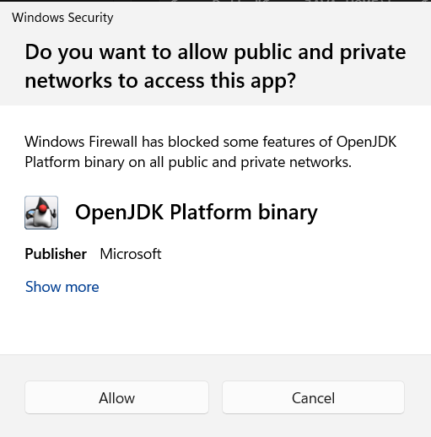
If everything is configured correctly, you should see output such as:
[('spark', 4), ('data', 2), ('big', 1), ('python', 1)]

Experimenting with pyspark
If you want to experiment interactively with Spark, you have two practical options:
- pyspark, which opens a ready-to-use shell with sc and spark already available, but on Windows it often does not provide convenient command history with the Up / Down keys
- the regular Python console that you open with python, which usually has more convenient history and editing, but requires you to create the SparkSession manually
Note: pyspark is for Python, while spark-shell is the Scala shell. The command sparkshell without a dash is not valid.

Option 1: pyspark
pyspark is the quickest option if you want to start immediately with sc and spark ready to use.
After activating .venv and confirming that java -version works, run the following in the terminal.
From PowerShell:
$env:PYSPARK_PYTHON="$PWD\.venv\Scripts\python.exe"
$env:PYSPARK_DRIVER_PYTHON=$env:PYSPARK_PYTHON
pyspark
From WSL:
export PYSPARK_PYTHON="$PWD/.venv/bin/python"
export PYSPARK_DRIVER_PYTHON="$PYSPARK_PYTHON"
pyspark
Once the shell opens, you can try commands such as:
sc.parallelize([1, 2, 3]).count()
spark.range(5).show()
To exit the shell:
exit()

Option 2: open the regular Python console from the terminal
If you prefer better command history and a more predictable terminal experience, you can first open the regular Python console:
python
and then create the Spark session manually:
import os
import sys
from pyspark.sql import SparkSession
os.environ["PYSPARK_PYTHON"] = sys.executable
os.environ["PYSPARK_DRIVER_PYTHON"] = sys.executable
spark = SparkSession.builder.appName("playground").getOrCreate()
sc = spark.sparkContext
After that, you can experiment with commands such as:
sc.parallelize([1, 2, 3]).count()
spark.range(5).show()
When you are done:
spark.stop()
exit()

Checking the Spark UI
Another useful way to monitor what is happening is through the URL where the Spark UI runs. During local execution, it usually appears at:
http://localhost:4040
Once you stop the program, the corresponding Spark UI web server also stops.
The exact appearance of the Spark UI may differ slightly depending on the Spark version, but the general idea remains the same.
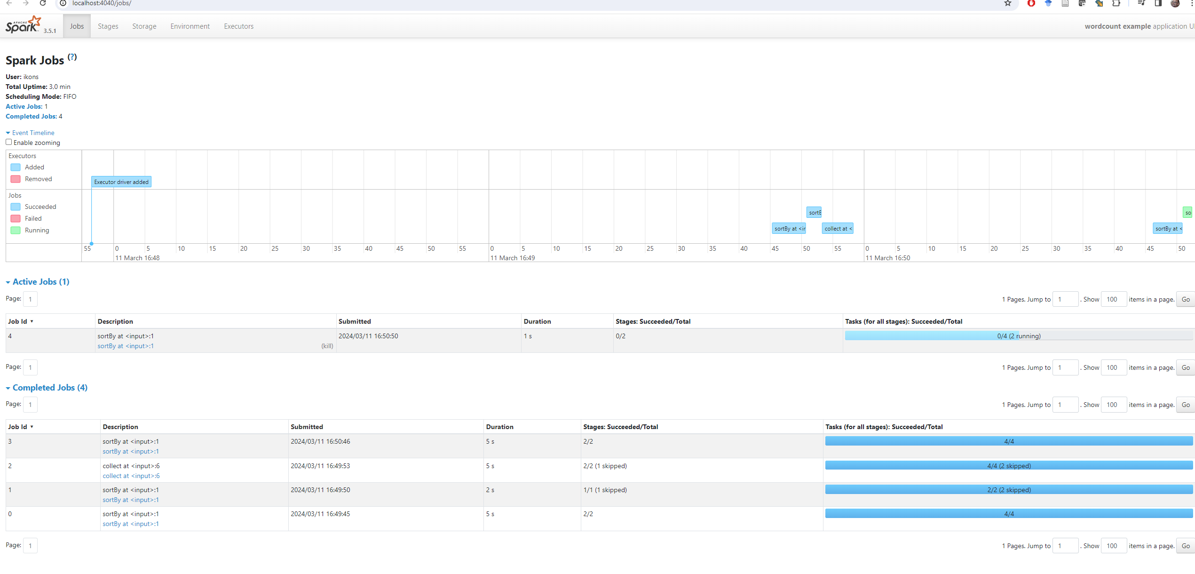

Next local guide
After completing this basic guide, the recommended continuation is the unified local Spark practice guide:
- ../03_local-spark-workbook/README.en.md
That guide now contains together:
- the small local examples with the RDD API
- the local examples with DataFrames and Spark SQL
- the bridge toward remote execution on Kubernetes from WSL

Useful notes
- If java -version does not work, close and reopen VS Code and create a new terminal. If it still does not work, go back to 01_workstation-setup.
- If VS Code does not detect .venv correctly, run Python: Select Interpreter again.
- If you see warnings about winutils.exe or NativeCodeLoader, you can ignore them for this simple local Windows example.
- If text.txt is not located in the correct directory, the program will fail because it cannot find it.
- If port 4040 is already in use, Spark may start the UI on another port such as 4041.
- If you later continue to guide 04, remote execution does not happen from PowerShell but only from WSL.

