Guide for connecting to the vdcloud lab Kubernetes environment and running Apache Spark

Introduction
This guide provides detailed instructions for connecting to the VDCLOUD lab infrastructure through VPN, installing the required tools, preparing a local workstation, and running Apache Spark jobs on Kubernetes (k8s).
You will also receive an email containing two configuration files and the username assigned to you in the infrastructure. In the guide below, whenever you see testuser, replace it with the username you received by email.

Installing the OpenVPN client
To connect to the infrastructure, install the OpenVPN client from the following link:
https://openvpn.net/community-downloads/
After installing the client, import the .ovpn file that was sent to you by email and connect.

Checking infrastructure connectivity from WSL Ubuntu
After connecting to the VPN, access from Windows usually works without issues. On some WSL Linux installations, however, DNS settings may not be updated automatically. Open your WSL Linux environment and run:
ping source-code-master.cluster.local
If it is not configured correctly, the command will hang and return no output because hostname resolution is not working. In that case, do the following.
Open /etc/resolv.conf with:
sudo nano /etc/resolv.conf
Replace:
nameserver 10.255.255.254
with:
nameserver 10.42.0.1
Also make sure the following line exists:
search default.svc.cluster.local
Save the file and exit (Ctrl+X, then Y).
Run the ping command again:
ping source-code-master.cluster.local
You should now get output similar to the following (stop it with Ctrl+C, otherwise it keeps running):
PING source-code-master.cluster.local (10.42.0.1) 56(84) bytes of data.
64 bytes from source-code-master.cluster.local (10.42.0.1): icmp_seq=1 ttl=63 time=9.34 ms
64 bytes from source-code-master.cluster.local (10.42.0.1): icmp_seq=2 ttl=63 time=9.33 ms
64 bytes from source-code-master.cluster.local (10.42.0.1): icmp_seq=3 ttl=63 time=52.2 ms
64 bytes from source-code-master.cluster.local (10.42.0.1): icmp_seq=4 ttl=63 time=10.9 ms
64 bytes from source-code-master.cluster.local (10.42.0.1): icmp_seq=5 ttl=63 time=10.9 ms
^C
--- source-code-master ping statistics ---
5 packets transmitted, 5 received, 0% packet loss, time 4180ms
rtt min/avg/max/mdev = 9.325/18.530/52.237/16.867 ms
Unfortunately, you may need to repeat this DNS adjustment every time you reconnect to the VPN.

Installing kubectl
kubectl is the command-line tool used to manage Kubernetes clusters. Install it on a Linux machine or VM with the following commands:
# Install basic packages required for HTTPS repositories
sudo apt-get install -y apt-transport-https ca-certificates curl gnupg
# Download and store the public key for the Kubernetes repository
curl -fsSL https://pkgs.k8s.io/core:/stable:/v1.32/deb/Release.key | sudo gpg --dearmor -o /etc/apt/keyrings/kubernetes-apt-keyring.gpg
# Set the correct permissions on the key
sudo chmod 644 /etc/apt/keyrings/kubernetes-apt-keyring.gpg
# Add the Kubernetes repository to apt sources
echo 'deb [signed-by=/etc/apt/keyrings/kubernetes-apt-keyring.gpg] https://pkgs.k8s.io/core:/stable:/v1.32/deb/ /' | sudo tee /etc/apt/sources.list.d/kubernetes.list
# Set the correct permissions on the sources file
sudo chmod 644 /etc/apt/sources.list.d/kubernetes.list
# Update apt package lists
sudo apt-get update
# Install kubectl
sudo apt-get install -y kubectl
# Create ~/.kube where the config file will be stored
mkdir ~/.kube
Copy the config file you received by email to ~/.kube/config, so that kubectl can connect to the k8s infrastructure.
If you initially downloaded the file on Windows, you need to copy it from the Windows host file system into your WSL Linux home directory. Suppose the file is in the Windows user’s Downloads folder.
Run the following commands in WSL Linux. Replace ikons with your own Windows username.
# Move to the user's home directory
cd
# Create the .kube directory if it does not exist
mkdir .kube
# Copy the config file from the Windows file system to WSL
# ⚠️ Replace ikons with your own Windows username
cp /mnt/c/Users/ikons/Downloads/config ~/.kube/config
An alternative is to use Windows Explorer and browse to the Linux folder directly.
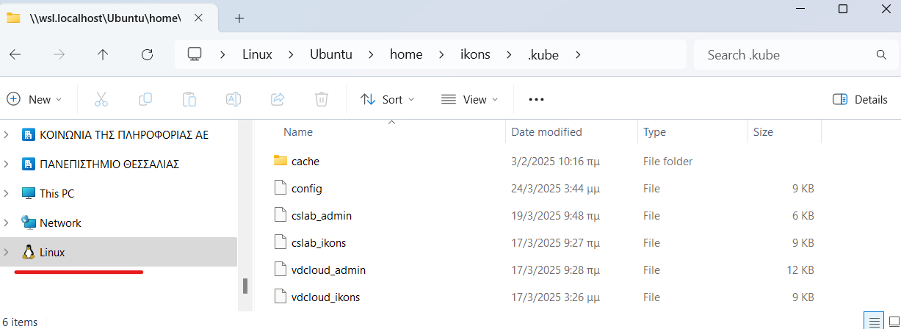
Figure 1

Installing k9s
k9s is a terminal tool for monitoring and managing Kubernetes clusters.
# Download the k9s .deb package from GitHub
wget https://github.com/derailed/k9s/releases/download/v0.40.10/k9s_linux_amd64.deb
# Install the package with dpkg
sudo dpkg -i k9s_linux_amd64.deb
# Set nano as the default editor for k9s (and generally for kubectl)
echo "export KUBE_EDITOR=nano" >> ~/.bashrc
k9s uses the same ~/.kube/config file.

Installing Hadoop and Spark clients
Install Hadoop and Spark locally on your Linux machine / WSL environment so that you can connect to the remote infrastructure and interact with HDFS and Spark.
# Move to the home directory
cd ~
# Install Java Development Kit 8 (required by Hadoop/Spark)
sudo apt-get install -y openjdk-8-jdk
# Download Spark 3.5.5 with Hadoop 3 support
wget https://downloads.apache.org/spark/spark-3.5.5/spark-3.5.5-bin-hadoop3.tgz
# Extract Spark
tar -xzf spark-3.5.5-bin-hadoop3.tgz
# Download Hadoop 3.4.1
wget https://dlcdn.apache.org/hadoop/common/hadoop-3.4.1/hadoop-3.4.1.tar.gz
# Extract Hadoop
tar -xzf hadoop-3.4.1.tar.gz
Add the following environment variables to your shell configuration file. Replace testuser with your own username.
export JAVA_HOME=/usr/lib/jvm/java-8-openjdk-amd64
export SPARK_HOME=$HOME/spark-3.5.5-bin-hadoop3
export PATH=$HOME/spark-3.5.5-bin-hadoop3/bin:$HOME/hadoop-3.4.1/bin:$PATH
# ⚠️ Replace testuser with your own username
export HADOOP_USER_NAME=testuser
Save the file and then load the new settings:
. ~/.bashrc

Configuring the HDFS client
Create core-site.xml:
nano hadoop-3.4.1/etc/hadoop/core-site.xml
<configuration>
<property>
<name>fs.default.name</name>
<value>hdfs://hdfs-namenode:9000</value>
</property>
</configuration>
If everything is configured correctly, open the following page on your computer:
http://hdfs-namenode:9870/
Then choose Utilities → Browse the file system and enter the path /user/username. There you will be able to see the outputs of your jobs.
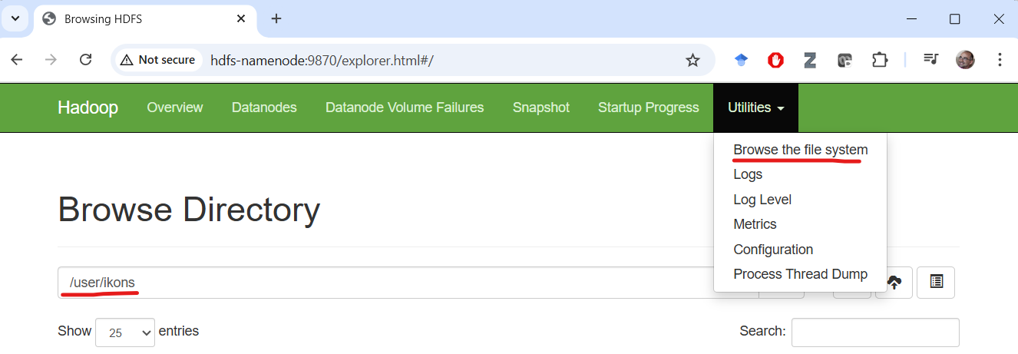
Figure 2

Running a test WordCount program
Create a Python file named wordcount_localdir.py with the following content:
from pyspark import SparkContext
# Initialize SparkContext
sc = SparkContext(appName="WordCount")
input_dir = "hdfs://hdfs-namenode:9000/user/ikons/examples/text.txt"
# Get the application ID (job ID) from the Spark context
job_id = sc.applicationId
# Create the dynamic output directory by appending the job ID
output_dir = f"hdfs://hdfs-namenode:9000/user/ikons/wordcount_output_{job_id}"
# Perform the word count operation
text_files = sc.textFile(input_dir)
#sampled_text = text_files.sample(withReplacement=False, fraction=0.001, seed=42)
# Split lines into words, map them to (word, 1) pairs, then reduce by key
word_count = text_files.flatMap(lambda line: line.split(" ")) \
.map(lambda word: (word, 1)) \
.reduceByKey(lambda a, b: a + b)
# Sort the results by occurrences in decreasing order
sorted_word_count = word_count.map(lambda x: (x[1], x[0])) \
.sortByKey(ascending=False) \
.map(lambda x: (x[1], x[0]))
# Save the sorted results directly to HDFS in a single output file
sorted_word_count.coalesce(1).saveAsTextFile(output_dir)
✅ Note: Replace ikons in the file with the username you received.
Copy the required files into HDFS:
# Create a sample input text file
echo "this is a text file, with text document, to be used as input for the wordcount example" > ~/text.txt
# Copy the Python file into your home directory
cp wordcount_localdir.py ~/wordcount_localdir.py
# Upload the text file to HDFS (the user/<username> directory must already exist)
hdfs dfs -put -f ~/text.txt
# Upload the Python script to HDFS
hdfs dfs -put -f ~/wordcount_localdir.py
📂 The -put -f option overwrites the file in HDFS if it already exists.

Running Spark on Kubernetes
The wordcount_localdir.py file must be stored in HDFS so that it is accessible to Spark executors during execution. The HDFS location of the file is the final argument of spark-submit.
Run the following command:
spark-submit \
--master k8s://https://10.42.0.1:6443 \
--deploy-mode cluster \
--name wordcount \
--conf spark.hadoop.fs.permissions.umask-mode=000 \
--conf spark.kubernetes.authenticate.driver.serviceAccountName=spark \
--conf spark.kubernetes.namespace=testuser-priv \
--conf spark.executor.instances=5 \
--conf spark.kubernetes.container.image=apache/spark \
--conf spark.kubernetes.submission.waitAppCompletion=false \
--conf spark.eventLog.enabled=true \
--conf spark.eventLog.dir=hdfs://hdfs-namenode:9000/user/testuser/logs \
--conf spark.history.fs.logDirectory=hdfs://hdfs-namenode:9000/user/testuser/logs \
hdfs://hdfs-namenode:9000/user/testuser/wordcount_localdir.py
Replace testuser with the username you received by email.
This command submits a Spark job to a Kubernetes cluster. The main parameters are:
- --master k8s://https://10.42.0.1:6443: the Kubernetes API endpoint.
- --deploy-mode cluster: run the application inside the cluster rather than on the local computer.
- --name wordcount: the name of the Spark application.
- --conf spark.hadoop.fs.permissions.umask-mode=000: Hadoop file permission settings.
- --conf spark.kubernetes.authenticate.driver.serviceAccountName=spark: service account used by the Spark driver.
- --conf spark.kubernetes.namespace=testuser-priv: namespace where the job will run.
- --conf spark.executor.instances=5: create 5 executors.
- --conf spark.kubernetes.container.image=apache/spark: the container image used by Spark.
- --conf spark.kubernetes.submission.waitAppCompletion=false: submit the job without waiting for completion.
- --conf spark.eventLog.enabled=true: enable Spark event logging.
- --conf spark.eventLog.dir=...: where the Spark event logs will be stored in HDFS.
- --conf spark.history.fs.logDirectory=...: where the History Server will later read the logs from.
- hdfs://.../wordcount_localdir.py: the Python file to execute.
All tunable Spark parameters are documented here:
https://spark.apache.org/docs/latest/configuration.html
Other useful options include:
- --conf spark.log.level=DEBUG: emit more debug output.
- --conf spark.executor.memory=2g: allocate more memory per executor if your jobs need it.

Storing default Spark parameters
To avoid rewriting the full parameter list every time you run Spark, you can place the defaults into a Spark configuration file. Replace testuser with your own username.
# ⚠️ Replace testuser with your own username
USERNAME=testuser
Then run:
cat > ~/spark-3.5.5-bin-hadoop3/conf/spark-defaults.conf <<EOF
spark.master k8s://https://10.42.0.1:6443
spark.submit.deployMode cluster
spark.hadoop.fs.permissions.umask-mode 000
spark.kubernetes.authenticate.driver.serviceAccountName spark
spark.kubernetes.namespace $USERNAME-priv
spark.executor.instances 5
spark.executor.memory 1500m
spark.driver.memory 512m
spark.kubernetes.container.image=apache/spark
spark.kubernetes.submission.waitAppCompletion false
spark.eventLog.enabled true
spark.eventLog.dir hdfs://hdfs-namenode:9000/user/$USERNAME/logs
spark.history.fs.logDirectory hdfs://hdfs-namenode:9000/user/$USERNAME/logs
EOF
Now you can execute the previous example more simply:
spark-submit hdfs://hdfs-namenode:9000/user/testuser/wordcount_localdir.py

Monitoring execution with k9s
Start k9s:
k9s
Examples:
Show pods:
:pods
Show logs for a pod:
l
Inspect the status/details of a pod:
d

Useful HDFS commands
List the contents of <path>:
hadoop fs -ls <path>
Create a directory including parent directories:
hadoop fs -mkdir -p <path>
Upload a file from <localpath> to <hdfspath>:
hadoop fs -put <localpath> <hdfspath>
Delete a remote HDFS directory recursively:
hadoop fs -rm -r <hdfspath>

Useful Linux commands
ls
pwd
cd
cp
mv
cat
echo
man
Using the nano editor:
Ctrl+X: Exit
y/n: save or not
Enter: Save using the same file name/path

Running Spark locally, either interactively or via a Python file
As discussed in theory, Spark can also run locally on your own computer, either interactively through a shell or by executing a Python file with spark-submit.

Interactive execution through the shell
Open a Spark shell with:
pyspark --deploy-mode client --master local[*]
You can read and write files directly from the lab HDFS. Spark executors will run on your own computer, using its memory and CPU resources. Depending on your hardware, you may need to tune spark.executor.instances and spark.executor.memory in ~/spark-3.5.5-bin-hadoop3/conf/spark-defaults.conf so that the requested resources do not exceed what your machine can provide.
You can monitor the running jobs at:
http://localhost:4040/
To exit the shell, press Ctrl+D.

Running a local Python file for testing
You can also test a local .py file before uploading it to the k8s cluster:
spark-submit --deploy-mode client --master local[*] wordcount_localdir.py
A Python file executed in this way can still read from and write to the remote HDFS cluster of the lab. The execution resources, however, are taken from your local machine. As before, make sure the configured CPU and memory requirements do not exceed the resources available on your computer. In this case, you do not need to upload the .py file to HDFS before running it.

