Apache Spark Development with VS Code
Table of Contents
Installing pyspark in VS Code with a venv environment 1
Creating a new working folder 2
Creating a virtual environment in VS Code 3
Activating the virtual environment 3
Option 1: Close and reopen the terminal 3
Option 2: Manual activation 3
Installing packages 3
If PowerShell does not allow activation 4
If creating .venv gets stuck 4
What to remember 4
Installing Java on your computer 5
Creating example files 5
Running and debugging in VS Code 6
Experimenting with pyspark 7
Option 1: pyspark 7
Option 2: open the regular Python console from the terminal 8
Checking the Spark UI 8
Useful notes 9

Installing pyspark in VS Code with a venv environment
You can find the official Apache Spark programming guide here:
https://spark.apache.org/docs/latest/rdd-programming-guide.html
This guide assumes that you already have a recent version of Visual Studio Code installed on your computer. Instead of VS Code, you may also use any Python IDE/editor of your choice.
https://code.visualstudio.com/
It is recommended to install Python 3.11 on your computer. In this course we use a simple local environment with venv, so Python 3.11 is a safe and practical choice.
https://www.python.org/downloads/
For Python development in VS Code, you should install at least the following extensions:
Python
Pylance
optionally Jupyter
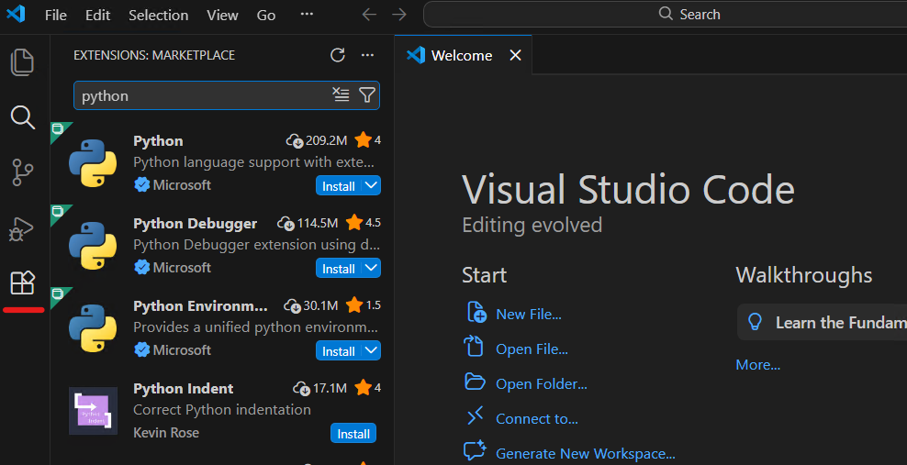

Creating a new working folder
Create a new directory for your project, for example Spark_example under a path such as C:\repositories. It is important that file names and directory names do not contain spaces.
Open the folder in VS Code with File -> Open Folder.
When VS Code runs for the first time, if it asks whether you trust the folder, choose Yes, I trust the authors.
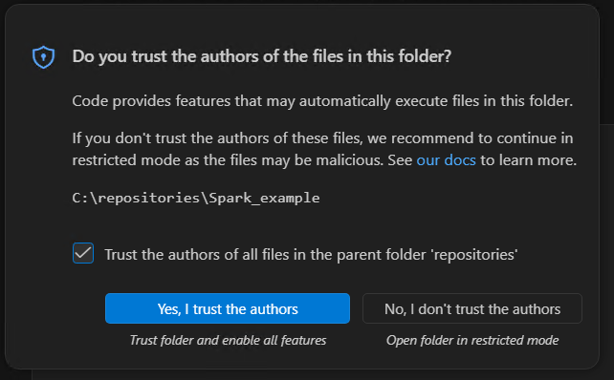

Creating a virtual environment in VS Code
For this course it is recommended to use a local virtual environment with venv inside each project. This is the cleanest and most practical approach because:
each assignment has its own packages
conflicts between different projects are avoided
VS Code usually detects the project's .venv automatically
Open your project folder in VS Code.
Open a terminal inside VS Code (Terminal -> New Terminal) and create the virtual environment:
python -m venv .venv
The command above creates a .venv directory inside your project.

Activating the virtual environment
After creating .venv, you have two simple options:

Option 1: Close and reopen the terminal
In many cases it is enough to close the terminal and open a new terminal inside VS Code.
VS Code will usually detect .venv automatically and activate it by itself.

Option 2: Manual activation
If you want, you can also activate it manually from the terminal.
In Windows cmd.exe:
.venv\Scripts\activate.bat
In Windows PowerShell:
.\.venv\Scripts\Activate.ps1
If everything worked correctly, you will usually see (.venv) at the beginning of the terminal prompt.
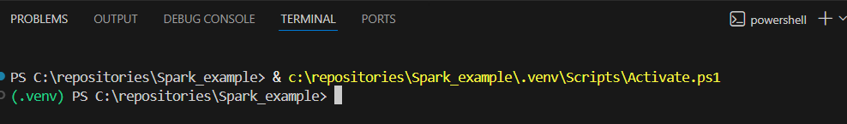

Installing packages
After the virtual environment is activated, install the required packages with:
python -m pip install pyspark psutil
You can view the installed packages with:
python -m pip list
We prefer the python -m pip form instead of plain pip, because this makes it explicit that the installation targets the Python interpreter used by the project.
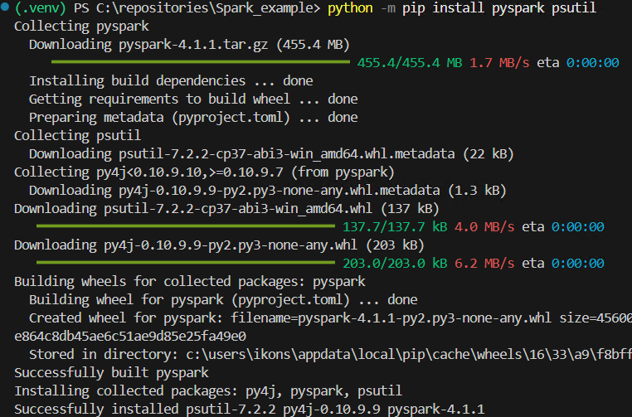

If PowerShell does not allow activation
On some Windows machines, PowerShell may not allow the execution of Activate.ps1.
In that case you can either:
use cmd.exe with:
- .venv\Scripts\activate.bat
or run once:
- Set-ExecutionPolicy -ExecutionPolicy RemoteSigned -Scope CurrentUser

If creating .venv gets stuck
On some machines, the command:
python -m venv .venv
may be slow or appear to hang at the step where pip is installed inside the virtual environment.
In that case, try the following alternative:
python -m venv --without-pip .venv
.\.venv\Scripts\python.exe -m ensurepip --upgrade
This way, the virtual environment is created first and pip is installed in a second step.

What to remember
For this course, the recommended workflow is the following:
create .venv
choose Python: Select Interpreter
install packages with python -m pip
run or debug from VS Code
Manual activation is optional and is mainly useful when you work directly from a terminal.

Installing Java on your computer
JDK 17 is required for local PySpark execution. You do not need to install Apache Spark separately on your computer. For this guide, the pyspark package installed inside .venv plus Java is enough.
On Windows, the simplest approach is to open a PowerShell terminal and run:
winget install --id Microsoft.OpenJDK.17 --accept-source-agreements --accept-package-agreements
This command installs Java and configures the required system environment variables.
During installation, Windows may show a prompt asking to run the installer with administrator privileges. In that case, choose Yes to continue.
If winget is not available on your machine, install any JDK 17 manually and make sure that:
JAVA_HOME points to the Java installation directory
the java command is available in PATH
If Java was installed while VS Code was already open, close and reopen all VS Code windows and create a new terminal, so that the new environment variables are loaded. Normally, a full computer restart is not required. Then verify that everything works correctly:
java -version

Creating example files
Create two files in your project directory: main.py and text.txt.
Put the following code into main.py:
import os
import sys
from pyspark.sql import SparkSession
os.environ["PYSPARK_PYTHON"] = sys.executable
os.environ["PYSPARK_DRIVER_PYTHON"] = sys.executable
def main() -> None:
spark = SparkSession.builder.appName("Word Count example").getOrCreate()
sc = spark.sparkContext
wordcount = (
sc.textFile("text.txt")
.flatMap(lambda line: line.split())
.map(lambda word: (word, 1))
.reduceByKey(lambda left, right: left + right)
.sortBy(lambda item: item[1], ascending=False)
)
print(wordcount.collect())
spark.stop()
if __name__ == "__main__":
main()
The two lines using sys.executable explicitly tell Spark to use the same Python interpreter that the project has selected in VS Code. Because of that, this first example does not require a separate launch.json.
Put the following sample content into text.txt:
spark spark data
big data spark
python spark

Running and debugging in VS Code
After you have already selected the interpreter from .venv, open main.py and run the program in one of the following ways:
from the Run Python File button
from the integrated terminal, with .venv active, by using python main.py
For debugging:
open Run and Debug
if VS Code asks you for a debug configuration type, choose Python Debugger: Current File
then press F5
For this simple example, that is enough. You do not need to write launch.json manually. If VS Code automatically creates a simple launch.json during the first debug run, you can keep the default configuration.
The first time you run the program, Windows Firewall / Windows Defender may show a prompt for OpenJDK Platform binary. If it appears, choose Allow, so that Spark can open the local port it needs.
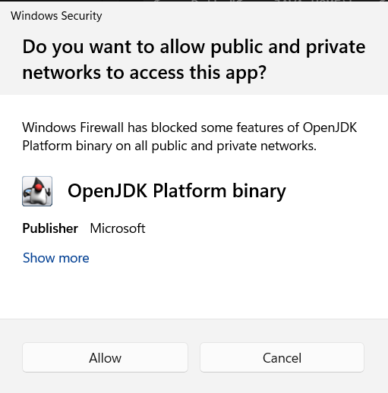
If everything is configured correctly, you should see output such as:
[('spark', 4), ('data', 2), ('big', 1), ('python', 1)]

Experimenting with pyspark
If you want to experiment interactively with Spark, you have two practical options:
pyspark, which opens a ready-to-use shell with sc and spark already available, but on Windows it often does not provide convenient command history with the Up / Down keys
the regular Python console that you open with python, which usually has more convenient history and editing, but requires you to create the SparkSession manually
Note: pyspark is for Python, while spark-shell is the Scala shell. The command sparkshell without a dash is not valid.

Option 1: pyspark
pyspark is the quickest option if you want to start immediately with sc and spark ready to use.
After activating .venv and confirming that java -version works, run the following in the terminal:
$env:PYSPARK_PYTHON = (Resolve-Path .\.venv\Scripts\python.exe).Path
$env:PYSPARK_DRIVER_PYTHON = $env:PYSPARK_PYTHON
pyspark
Once the shell opens, you can try commands such as:
sc.parallelize([1, 2, 3]).count()
spark.range(5).show()
To exit the shell:
exit()

Option 2: open the regular Python console from the terminal
If you prefer better command history and a more predictable terminal experience, you can first open the regular Python console:
python
and then create the Spark session manually:
import os
import sys
from pyspark.sql import SparkSession
os.environ["PYSPARK_PYTHON"] = sys.executable
os.environ["PYSPARK_DRIVER_PYTHON"] = sys.executable
spark = SparkSession.builder.appName("playground").getOrCreate()
sc = spark.sparkContext
After that, you can experiment with commands such as:
sc.parallelize([1, 2, 3]).count()
spark.range(5).show()
When you are done:
spark.stop()
exit()

Checking the Spark UI
Another useful way to monitor what is happening is through the URL where the Spark UI runs. During local execution, it usually appears at:
http://localhost:4040
Once you stop the program, the corresponding Spark UI web server also stops.
The exact appearance of the Spark UI may differ slightly depending on the Spark version, but the general idea remains the same.
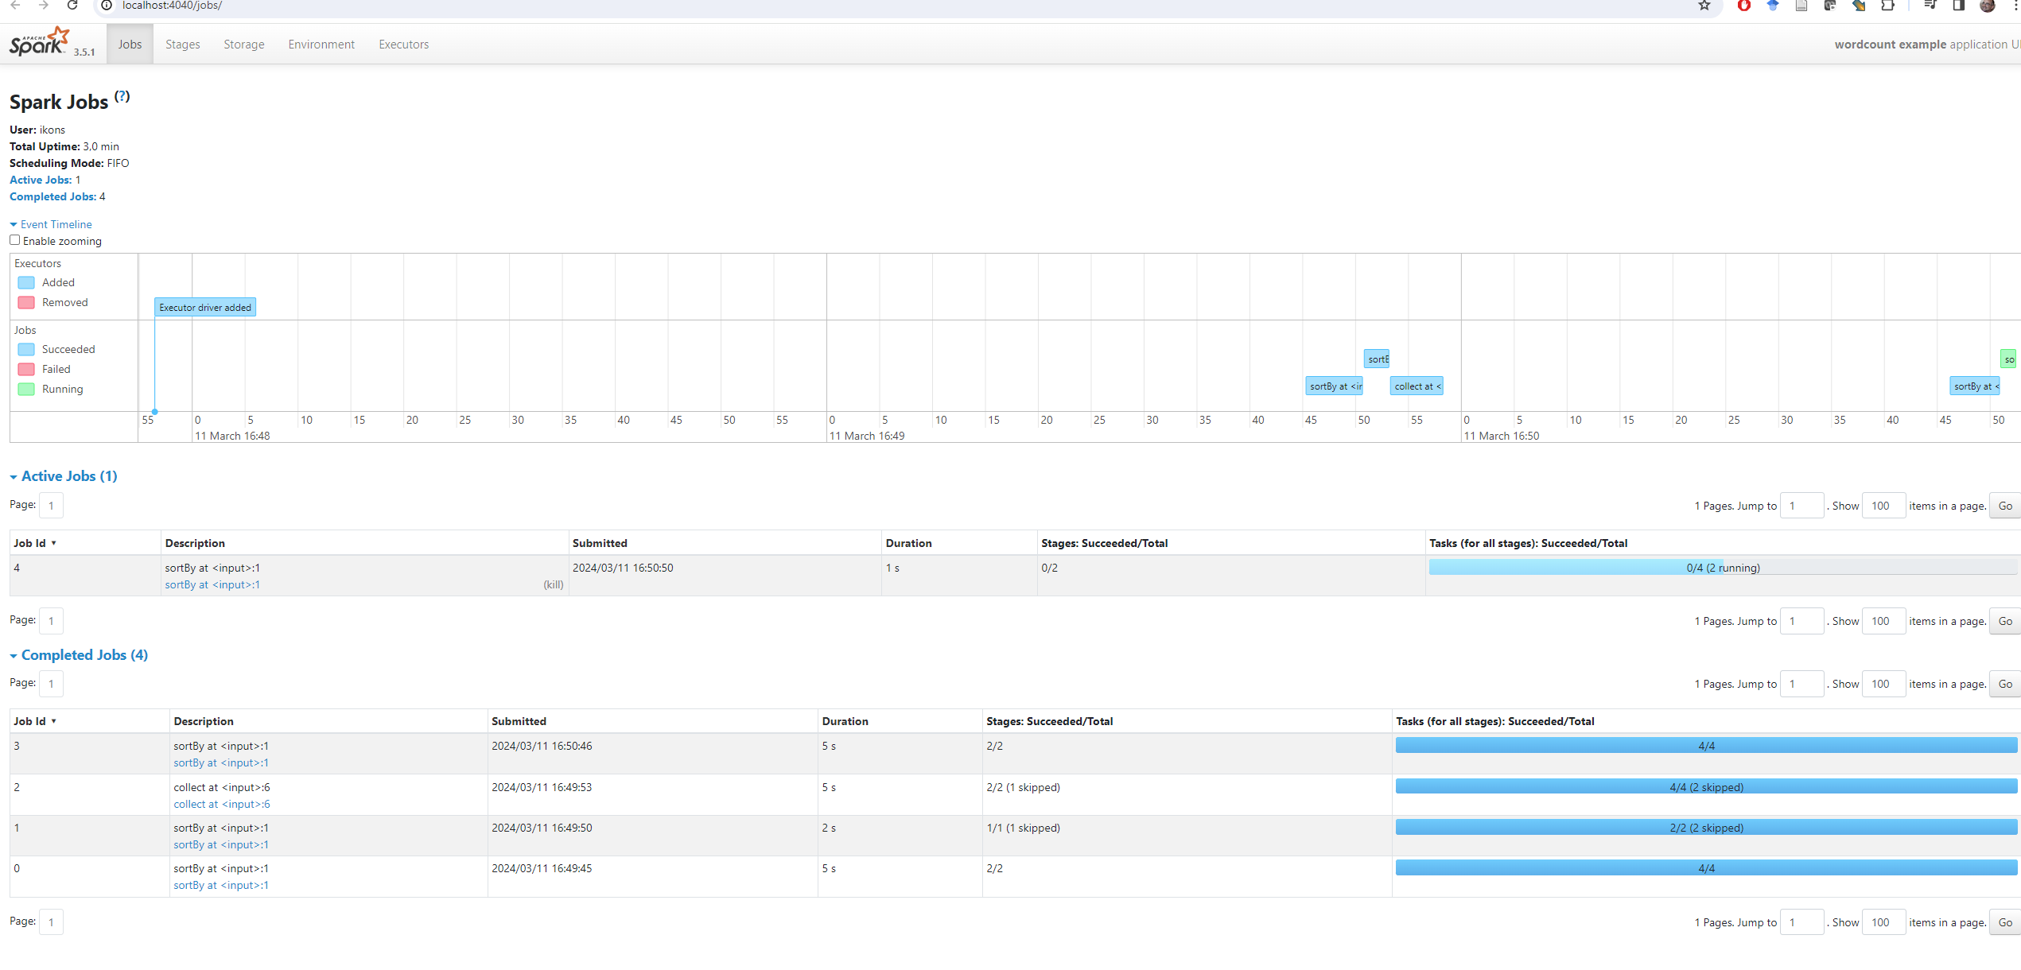

Useful notes
If java -version does not work immediately after installation, close and reopen VS Code and create a new terminal.
If VS Code does not detect .venv correctly, run Python: Select Interpreter again.
If you see warnings about winutils.exe or NativeCodeLoader, you can ignore them for this simple local Windows example.
If text.txt is not located in the correct directory, the program will fail because it cannot find it.
If port 4040 is already in use, Spark may start the UI on another port such as 4041.

