Workstation setup (WSL + Docker)
Table of Contents
Preparation structure 1
01. WSL and Ubuntu 2
enable-wsl.ps1 3
install-ubuntu.ps1 3
ubuntu-first-update.sh 4
check-wsl.ps1 4
02. Docker Desktop with WSL integration 5
verify-docker-desktop.sh 7
03. Native Docker Engine inside WSL 8
wsl.conf.example 8
restart-wsl.ps1 8
install-docker-engine.sh 8
verify-docker.sh 9
04. Final validation and local clone 9
clone-cloud-uth.sh 9
verify-workstation.sh 9
What counts as complete 10

The laboratory part of the course assumes that each student can work from an Ubuntu environment inside WSL and execute Docker commands from that same shell. This guide covers only that preparatory phase. When it is complete, the workstation will be ready for the Docker guide and for the Kubernetes onboarding material.
The canonical code and helper files of the preparatory workflow now live under code/00_workstation-setup. If you are reading this material before creating your first local clone, treat the snippets below as the authoritative execution steps and continue to step 04, where the repository clone is also created.

Preparation structure
# | Directory | Goal
01 | code/00_workstation-setup/01_wsl-bootstrap | Enable WSL2, install Ubuntu, and prepare the baseline tools
02 | code/00_workstation-setup/02_docker-desktop-wsl | Recommended setup with Docker Desktop and WSL integration
03 | code/00_workstation-setup/03_native-docker-engine | Optional setup with a native Docker Engine inside WSL
04 | code/00_workstation-setup/04_validation | Final validation and local repository clone

01. WSL and Ubuntu
Before using Docker, Windows must provide a working WSL2 environment and an Ubuntu distribution. This step enables the required Windows features, installs Ubuntu, and prepares the shell with the minimum tools needed immediately afterward.
Open PowerShell as administrator from the Start menu.
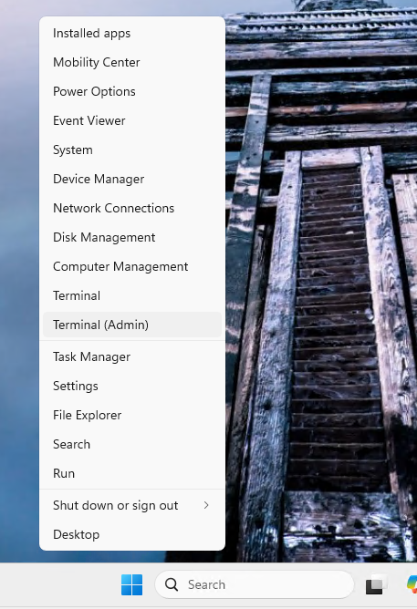

enable-wsl.ps1
Run the following contents first from an elevated PowerShell session. A Windows restart is required afterward.
# Run this script from an elevated PowerShell window.
wsl --install --no-distribution
dism.exe /online /enable-feature /featurename:Microsoft-Windows-Subsystem-Linux /all /norestart
dism.exe /online /enable-feature /featurename:VirtualMachinePlatform /all /norestart
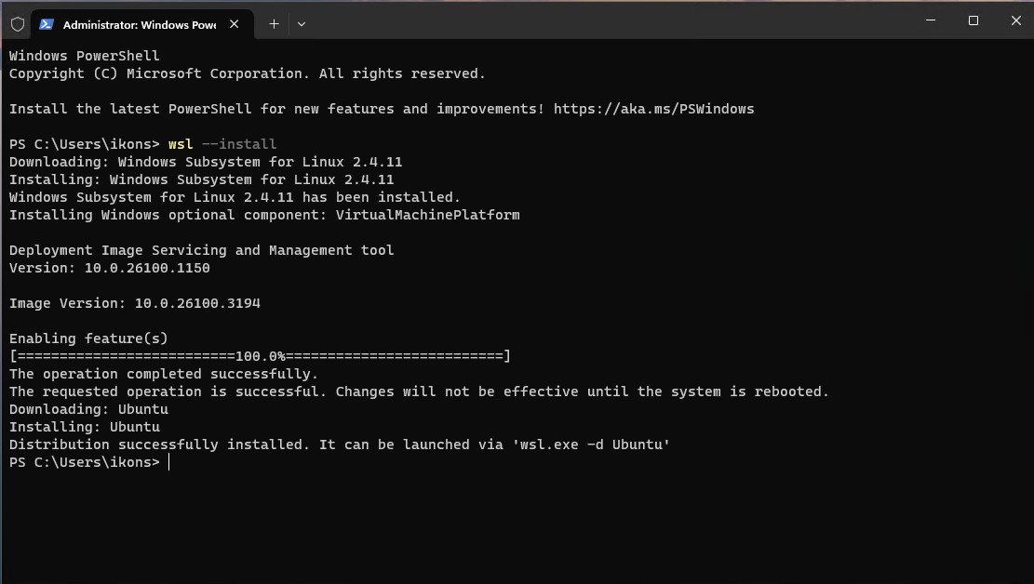
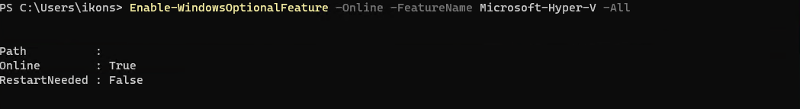

install-ubuntu.ps1
After the restart, complete the Ubuntu installation.
# Install Ubuntu after the first restart.
wsl --install -d Ubuntu
Then open Ubuntu from the Start menu and create the WSL user account.
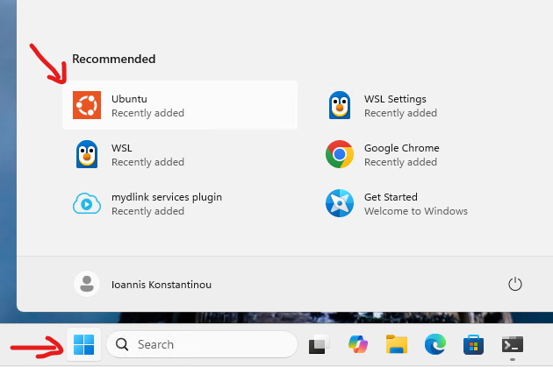
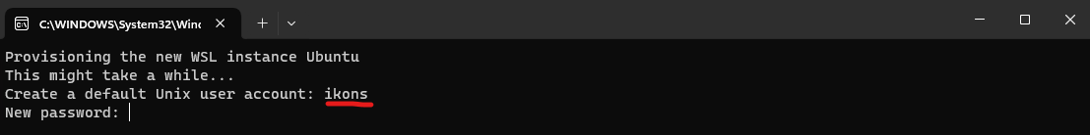

ubuntu-first-update.sh
From the Ubuntu terminal, update the system and install the first required tools. Having git available already at this stage is useful because the local repository clone can then happen immediately without an extra preparatory step.
#!/usr/bin/env bash
set -euo pipefail
sudo apt update
sudo apt upgrade -y
sudo apt install -y git curl ca-certificates
git --version
curl --version

check-wsl.ps1
Finally, return to PowerShell to verify that WSL and VirtualMachinePlatform are configured correctly.
# Show the installed distributions and their WSL versions.
wsl --list --verbose
# Confirm that the Virtual Machine Platform feature is enabled.
Get-WindowsOptionalFeature -Online -FeatureName VirtualMachinePlatform
If the installation completed correctly, Ubuntu appears with version 2 and VirtualMachinePlatform appears as Enabled.

02. Docker Desktop with WSL integration
For most students, this is the recommended path. The Docker daemon remains managed by Docker Desktop, while everyday work is performed from the Ubuntu terminal inside WSL, which is also the shell environment used by the following guides.
Download Docker Desktop from the official Docker page for Windows x86_64:
https://docs.docker.com/desktop/setup/install/windows-install/
During installation, make sure that Use the WSL 2 based engine remains enabled.
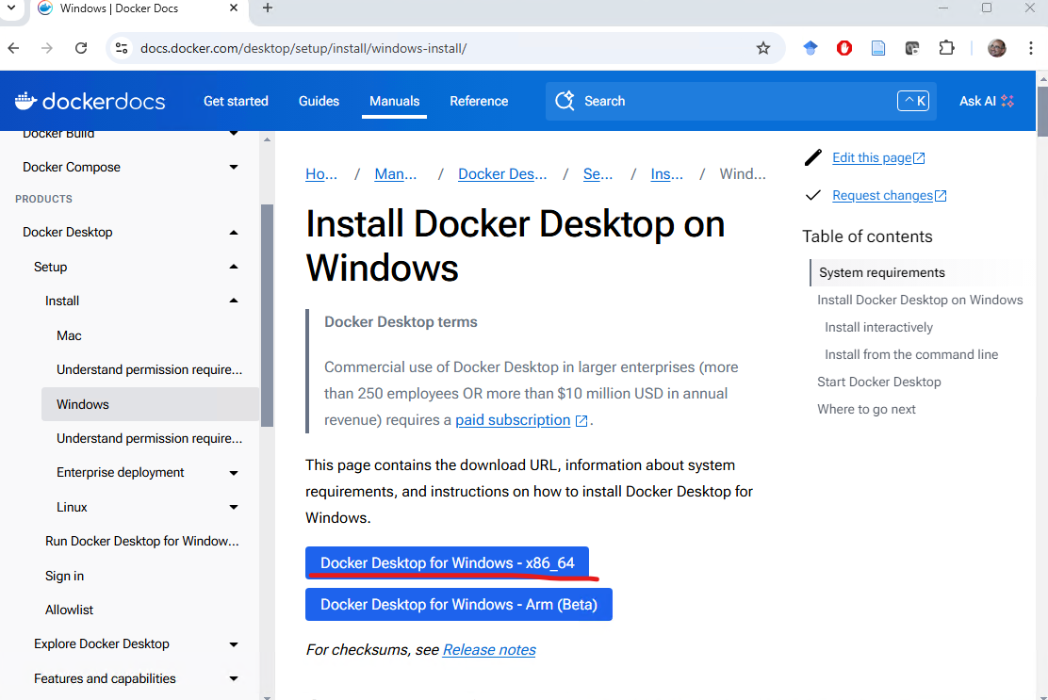
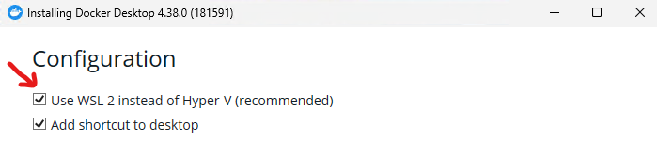
After installation, open Docker Desktop, confirm that the WSL 2 based engine is still enabled, and enable the Ubuntu distribution under Resources -> WSL Integration.
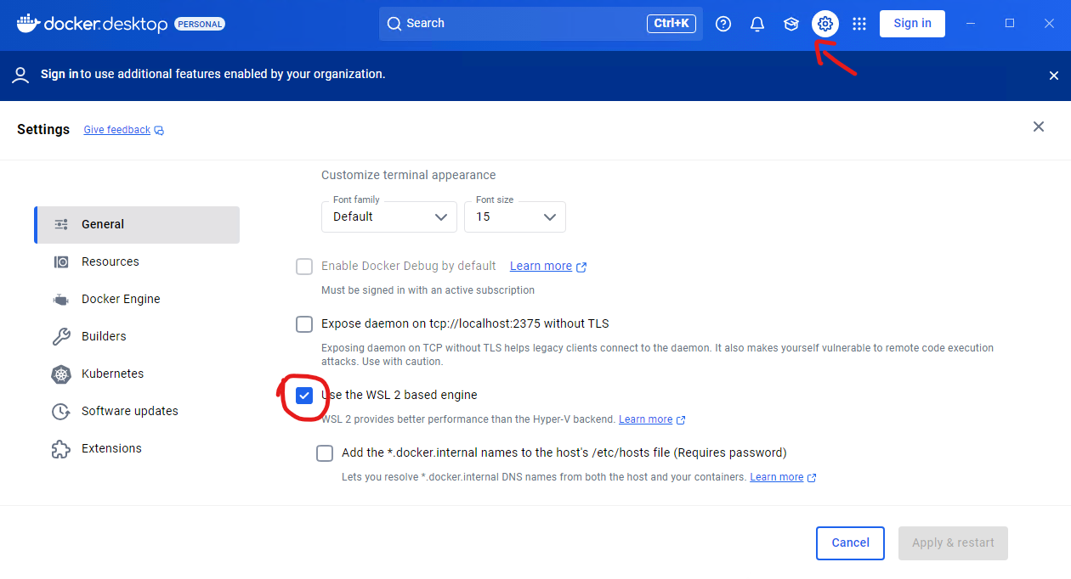
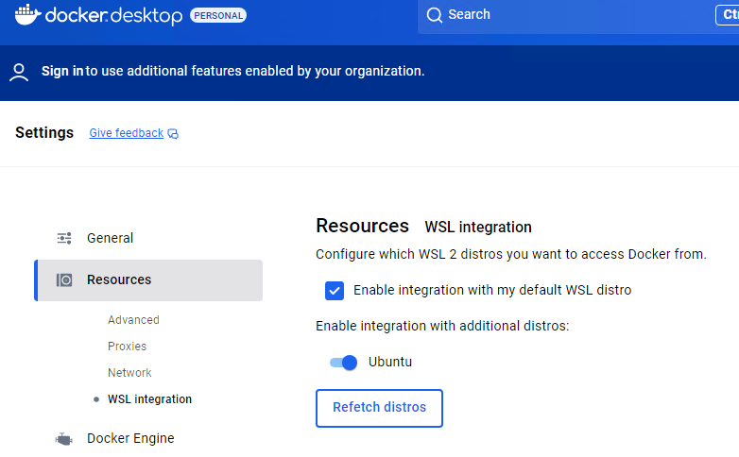
If Docker Desktop asks for an account, you may skip that step.
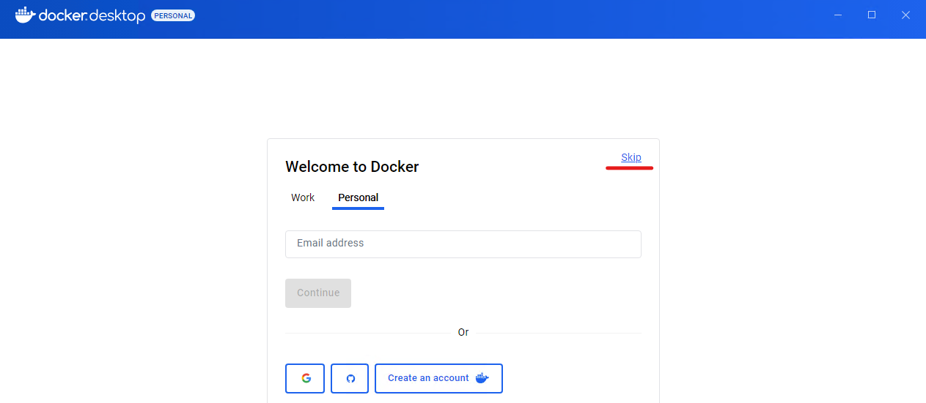

verify-docker-desktop.sh
Once Docker Desktop is ready, open a new Ubuntu terminal and run the following validation.
#!/usr/bin/env bash
set -euo pipefail
docker version
docker compose version
docker run --rm hello-world
The successful execution of hello-world shows that the integration between Docker Desktop and WSL is working normally.
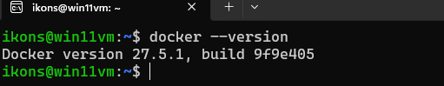
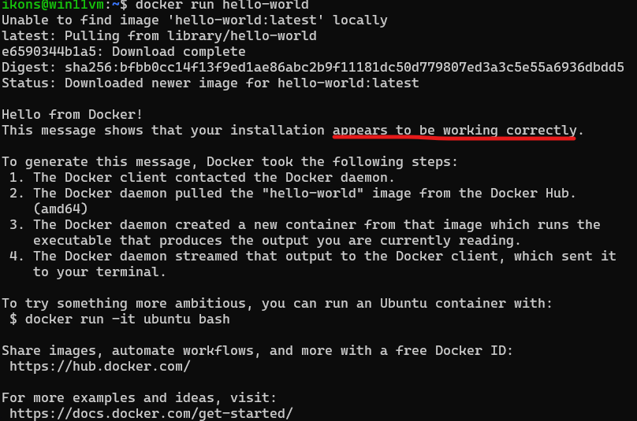

03. Native Docker Engine inside WSL
This path is optional and is intended for students who prefer to work entirely from Ubuntu without Docker Desktop on Windows. The course supports it, but it requires slightly more careful local environment management.
Before installation, check whether the Ubuntu shell already runs with systemd enabled by executing:
systemctl is-system-running
If you need to enable systemd, use the following contents in /etc/wsl.conf.

wsl.conf.example
[boot]
systemd=true
After the change, restart WSL from PowerShell.

restart-wsl.ps1
# Restart WSL after editing /etc/wsl.conf.
wsl --shutdown
Open Ubuntu again and continue with the Docker Engine installation.

install-docker-engine.sh
#!/usr/bin/env bash
set -euo pipefail
sudo apt update
sudo apt install -y ca-certificates curl gnupg
sudo install -m 0755 -d /etc/apt/keyrings
curl -fsSL https://download.docker.com/linux/ubuntu/gpg | sudo gpg --dearmor -o /etc/apt/keyrings/docker.gpg
sudo chmod a+r /etc/apt/keyrings/docker.gpg
echo \
"deb [arch=$(dpkg --print-architecture) signed-by=/etc/apt/keyrings/docker.gpg] https://download.docker.com/linux/ubuntu \
$(. /etc/os-release && echo \"$VERSION_CODENAME\") stable" | \
sudo tee /etc/apt/sources.list.d/docker.list > /dev/null
sudo apt update
sudo apt install -y docker-ce docker-ce-cli containerd.io docker-buildx-plugin docker-compose-plugin
sudo systemctl enable --now docker
sudo usermod -aG docker "$USER"
After the script completes, close and reopen the Ubuntu terminal or run newgrp docker once so that the new group membership becomes active.

verify-docker.sh
#!/usr/bin/env bash
set -euo pipefail
docker version
docker compose version
docker run --rm hello-world
If this validation completes without sudo, then the native installation is ready for the Docker guide.

04. Final validation and local clone
Once docker version, docker compose version, and docker run --rm hello-world work, the workstation preparation is essentially complete. The final step is to ensure that the repository also exists as a local clone inside WSL so that the examples from the guides can be executed directly.

clone-cloud-uth.sh
#!/usr/bin/env bash
set -euo pipefail
cd ~
if [ ! -d cloud-uth/.git ]; then
git clone https://github.com/ikons/cloud-uth.git
fi
cd cloud-uth

verify-workstation.sh
#!/usr/bin/env bash
set -euo pipefail
cd ~/cloud-uth
git rev-parse --show-toplevel
docker version
docker compose version
docker run --rm hello-world
After this check succeeds, you can continue to docs/01_lab1-docker/README.en.md.

What counts as complete
- WSL2 and Ubuntu work normally.
- One of the two Docker paths has been completed and the docker / docker compose commands work from the Ubuntu shell.
- The repository exists locally at ~/cloud-uth.
- The environment is ready for the examples under code/01_docker and for the Kubernetes onboarding material that follows.

