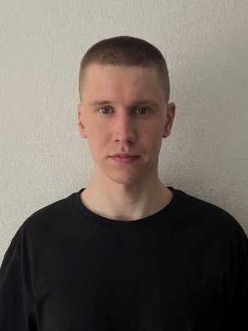
Konstantin Isakov
Engineer / back-end developer

Mirny, Russia | +79115779513 | drahmin5@icloud.com

Launch operations engineer with 4 years of experience in space hardware testing and back-end development. Specialized in space hardware testing, Java (Spring Boot) and Python, with deep expertise in SQL and NoSQL databases. Experienced in propulsion system testing for a space launch vehicles, optimizing microservice architecture and implementing CI/CD pipelines.
Graduated with Honors from A.F.Mozhaisky Military Space Academy
Seeking to apply my dual expertise in space hardware testing and backend development to build reliable, high-performance systems. Passionate about writing clean code and solving complex engineering challenges in the aerospace tech sector.

Key Competences

Java (Spring Boot) | Python (FastAPI) | SQL (PostgreSQL, MySQL) | Docker | REST API | Apache Kafka | Git, CI/CD (GitHub CI) | Microservices | English B2

COMPETENCE 1: Space Launch Operations & Propulsion Testing
- Conducted qualification and acceptance testing of over 30 propulsion systems for space launch vehicles, ensuring 100% mission readiness and compliance with strict military standards.
- Executed more than 20 successful “Soyuz” rocket launches as part of the launch operations team, contributing to a 100% launch success rate during tenure.
- Supported the deployment of over 50 military and dual-purpose satellites into target orbits, directly enabling critical national security and civilian infrastructure missions.

COMPETENCE 2: Backend Development & Database Design
- Developed a full-stack e-commerce application as part of intensive training, implementing user authentication, product catalog, and order management using Java (Spring Boot) and PostgreSQL.
- Collaborated in a team of 3 to build a finance tracker application, focusing on backend logic, RESTful API design, and database integration (Python (FastAPI), PostgreSQL).
- Performed in-depth database analysis and optimization for an academic project, writing complex SQL queries, creating indexes, and normalizing data to improve query performance by 30%.

Work Experience

Department of Defense| Senior Engineer, Propulsion Systems Division 2022 – now

Education

A.F.Mozhaisky Military Space Academy, City 2022
Major: Launch operations engineer, Specialist Degree

Moscow Institute of Physics and Technology (MIPT), Moscow 2027 (Expected)
Major: Back-end developer, Master’s Degree

