Getting Started

1. Install HAXM if not yet installed
2. Start Android Studio and create a new project
   1. Choose API 21 : Android 5.0
   2. Empty Activity
   3. Wait for the Android Studio to finish building the Gradle, etc…
3. Before writing your first code, run the default Android project (just to make sure the emulator is working)
   1. Let’s create a new virtual device

|  |  |
| --- | --- |
| Step 1: Click |  |
| Step 2: Click |  |
| Step 3: Select | Then click Next |
| Step 4: Select tab | Then find the corresponding Image below    You might have to download. You only need to this once.  Click Next then Finish |
| Step 5: Run the emulator |  |

1. The very least – the default Hello World should be running before you continue.
2. Try to create the layout first before writing the code that references the UI
3. Who is **R** ?

Go to **yourProjectFolder**\app\build\generated\source\r\debug\**yourProject\nameOfYourProject**

yourProject => \com\example\ (just an example)

You can open the R.java using any text editor. Look only … don’t modify

The contents of R.java are automatically generated by Android Studio.

Make sure you CLOSE the R.java file and the folder where it resides. Otherwise, you will have a possible build error (Typically, an I/O exception)

Program

1. Change the layout to LinearLayout (easier to work with). Take note of the highlighted portion

<**LinearLayout xmlns:android="http://schemas.android.com/apk/res/android"  
 xmlns:app="http://schemas.android.com/apk/res-auto"  
 xmlns:tools="http://schemas.android.com/tools"  
 android:layout_width="match_parent"  
 android:layout_height="match_parent"  
 tools:context="com.example.w3_companion.MainActivity"  
 android:orientation="vertical"**>

1. Changing the theme of the App

Reference: <https://developer.android.com/studio/write/theme-editor.html>

|  |  |
| --- | --- |
| Go to |  |
| Select | Usually, it’s located somewhere on the upper right |
| Changing the color | Double click the “color” button on the left  Pick the color you like to experiment with.  Mine 😊    Go to the layout xml to see the change you made |

1. Creating the labels. Go to strings.xml and create the following

<**string name="app_name"**>Tuition</**string**>  
<**string-array name="Semester"**>  
 <**item** >Spring</**item**>  
 <**item** >Fall</**item**>  
 <**item** >Summer</**item**>  
</**string-array**>  
<**string name="College"**>Select Semester</**string**>

1. Creating the UI

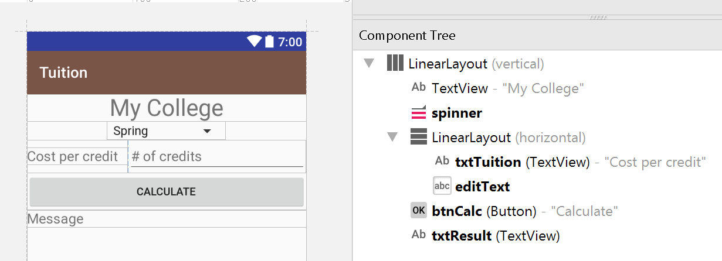

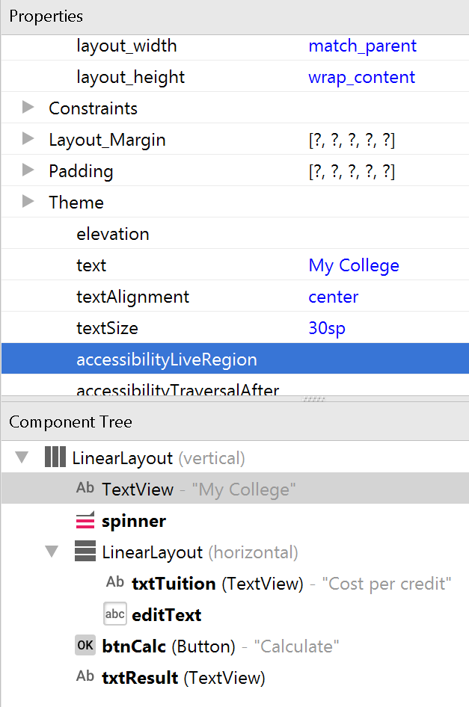

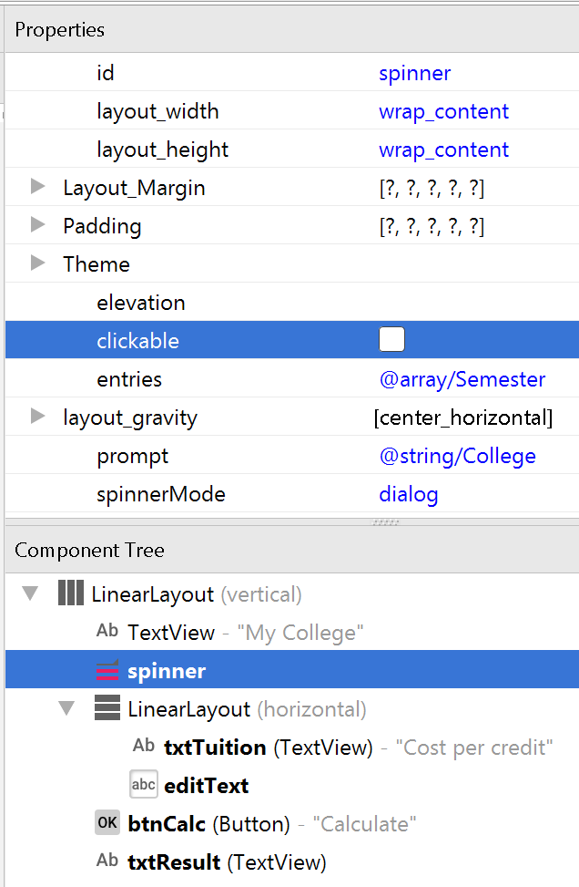

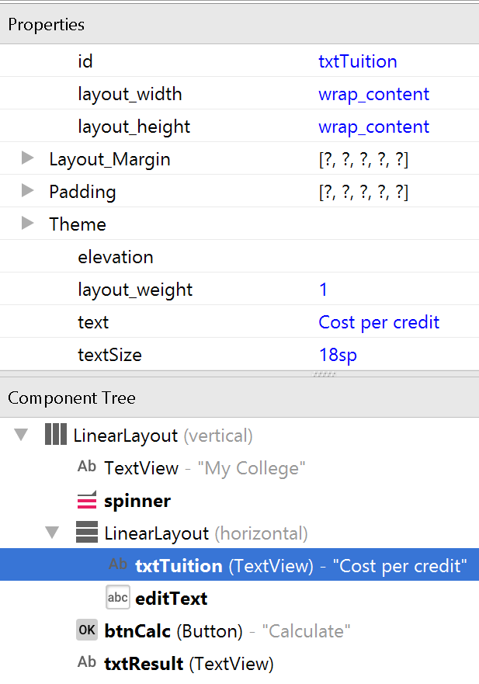

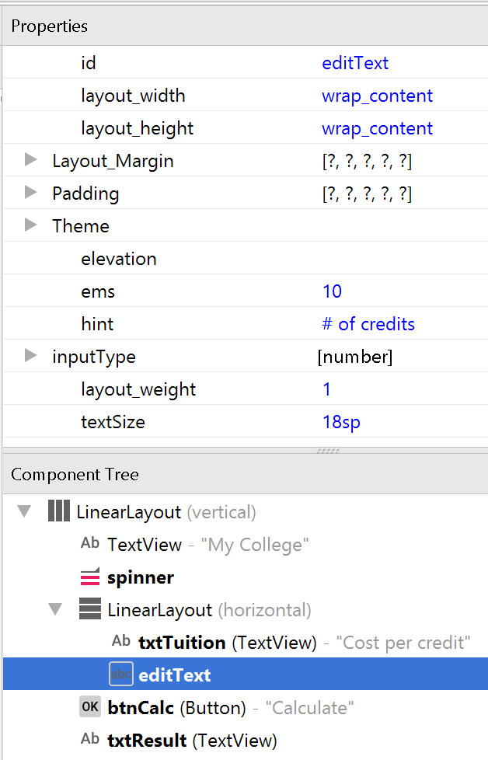

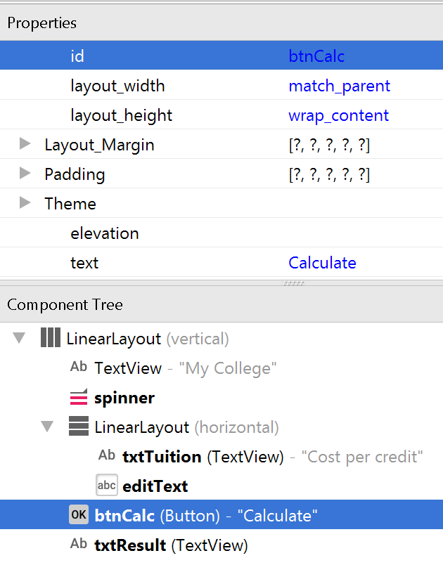

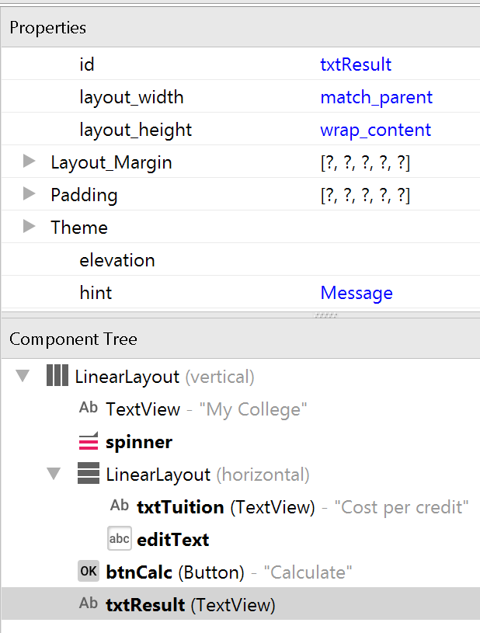

1. Run the application (before writing the code).
2. The Code (MainActivity.java)

**private double** []**prices** = {200,300,350};  
**private double cost**;  
@Override  
**protected void** onCreate(Bundle savedInstanceState) {  
 **super**.onCreate(savedInstanceState);  
 setContentView(R.layout.***activity_main***);  
 **final** TextView feePerCredit = (TextView) findViewById(R.id.***txtTuition***);  
 **final** EditText nCredits = (EditText) findViewById(R.id.***editText***);  
 **final** TextView msg = (TextView) findViewById(R.id.***txtResult***);  
 **final** DecimalFormat currency = **new** DecimalFormat(**"$###,###.##"**);  
  
 **final** Spinner sp = (Spinner) findViewById(R.id.***spinner***);  
 sp.setOnItemSelectedListener(**new** AdapterView.OnItemSelectedListener() {  
 @Override  
 **public void** onItemSelected(AdapterView<?> parent, View view, **int** position, **long** id) {  
 feePerCredit.setText(currency.format(**prices**[position]));  
 }  
  
 @Override  
 **public void** onNothingSelected(AdapterView<?> parent) {  
  
 }  
 });  
  
 Button btn = (Button) findViewById(R.id.***btnCalc***);  
 btn.setOnClickListener(**new** View.OnClickListener() {  
 @Override  
 **public void** onClick(View v) {  
 **int** credits;  
 **try** {  
 credits = Integer.*parseInt*(nCredits.getText().toString());  
 String semester = sp.getSelectedItem().toString();  
  
 **int** index = sp.getSelectedItemPosition();  
 **double** calc = credits * **prices**[index];  
 msg.setText(semester + **" semester tuition is "** + currency.format(calc));  
 } **catch** (Exception ex) {  
 msg.setText(**"Calculation problem"**);  
 }  
 }  
 });  
  
  
}