Something to remember

1. Run intel haxm
2. Save your project on your desktop (easy to find)
3. Application Name: YourLastname_Problem#
4. Use API 21 Android 5.0



1. Remove Backward compatibility. All other Activity you want to create or call via Intent should have the same configuration

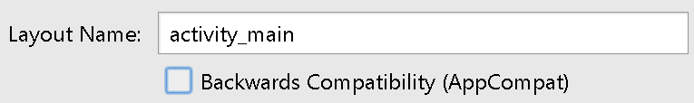

1. Before writing any codes, run the default “Hello World” app just to make sure your emulator is working.
2. When changing the property value, do not forget to press the “enter key”
3. Try Rebuilt Project if certain changes you made are not “seen” by the Android studio

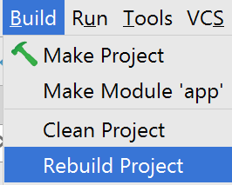

1. Try to do incremental testing
   1. Run your app after making “few” changes.

To earn credits

Problem – Airline Reservation System

A very small airline has asked you to develop a new system. You’re to write an app to assign seats on each flight of the airline’s only plane (capacity: 10 seats).

This application will only run on one device, yours. So, don’t worry about database and/or multiple users accessing a central server.

A user can select First class or Economy. Seats are randomly assigned.

First Class is from seats 1 to 5 while Economy is from 6 to 10. Your app should never assign a seat that has already been assigned. If there are no more seats available, inform the user.

Example output (You can re-design to make it look better)

|  |  |  |
| --- | --- | --- |
| When it starts | When “First Class” was chosen | When “Economy” was chosen |
|  |  |  |

Some guidance

1. If you want to retrieve the Views (GUI objects) added to a LinearLayout, you can do it dynamically.

LinearLayout l1 = (LinearLayout) findViewById(R.id.***L1***); // get the reference

// assuming you have 10 TextView added to the LinearLayout during design time

// you can write a code to reference all of it using this approach

**private** TextView []**txt**; // single dimensional array

**txt = new TextView[10];**

**for** (**int** i = 0 ; i < l1.getChildCount() ; i++) { //getChildCount() returns the # of Obj

**txt**[i] = (TextView) l1.getChildAt(i);

}

1. If you want to change background color, find the property

**txt**[0].setBackgroundColor(Color.***GREEN***);