Something to remember

1. Run intel haxm
2. Save your project on your desktop (easy to find)
3. Application Name: YourLastname_Problem#
4. Use API 21 Android 5.0



1. Remove Backward compatibility. All other Activity you want to create or call via Intent should have the same configuration



1. Before writing any codes, run the default “Hello World” app just to make sure your emulator is working.
2. When changing the property value, do not forget to press the “enter key”
3. Try Rebuilt Project if certain changes you made are not “seen” by the Android studio

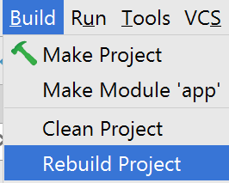

1. Try to do incremental testing
   1. Run your app after making “few” changes.

To earn credits

1. Solve at least one of the problems.
2. Show your working app to the instructor
3. Upload your final work

Problem 1 – 6/49 Number Picker

Write an application that would generate four sets of 6/49 numbers for the user to choose from.

Each set should have 6 numbers ranging from 1 to 49 (no duplicates).

Example Output (you can re-design to make it more appealing)

|  |  |  |
| --- | --- | --- |
| When the app starts | When the Generate Number is clicked | When certain numbers are selected, and Pick button was clicked |
|  |  |  |

Some guidance

1. You can create a separate Java class with a method that generates the random numbers. This method can then be used in your MainActivity each time you need a series of numbers.
2. Android programming is basically Java coding with extra GUI libraries. The fundamentals are still the same. Therefore, you can actually create an array of CheckBox. Each element points to a specific CheckBox. This would then allow you to reference the different checkboxes via index and loop.
3. Sometimes, you will find similarities in features and/or concept. Example: JLabel and TextView