**The GUI**

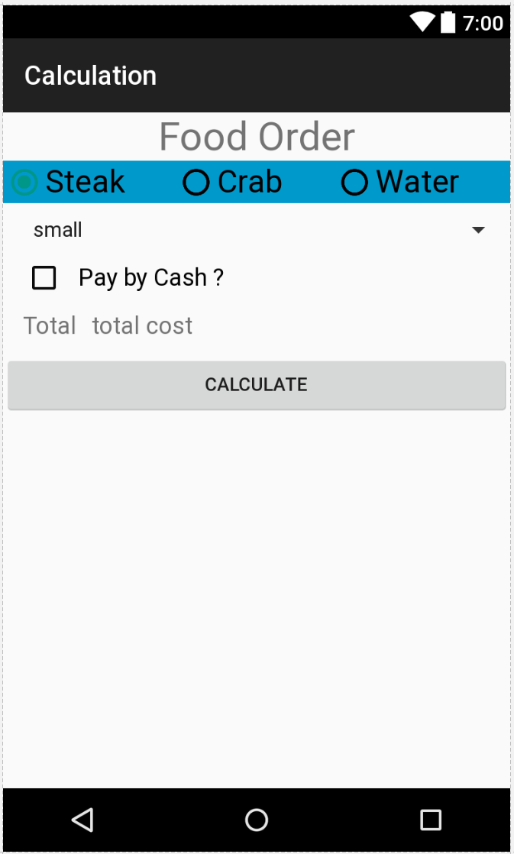

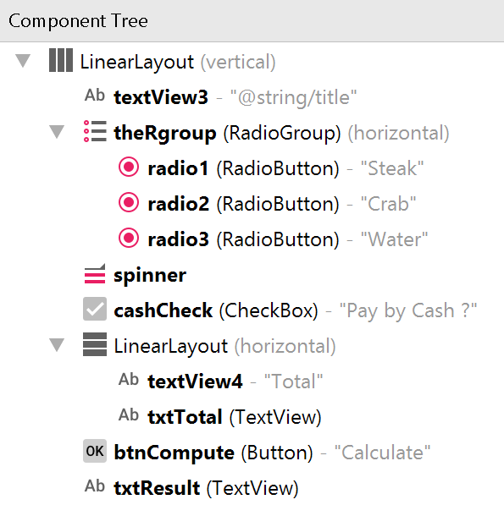

**strings.xml**

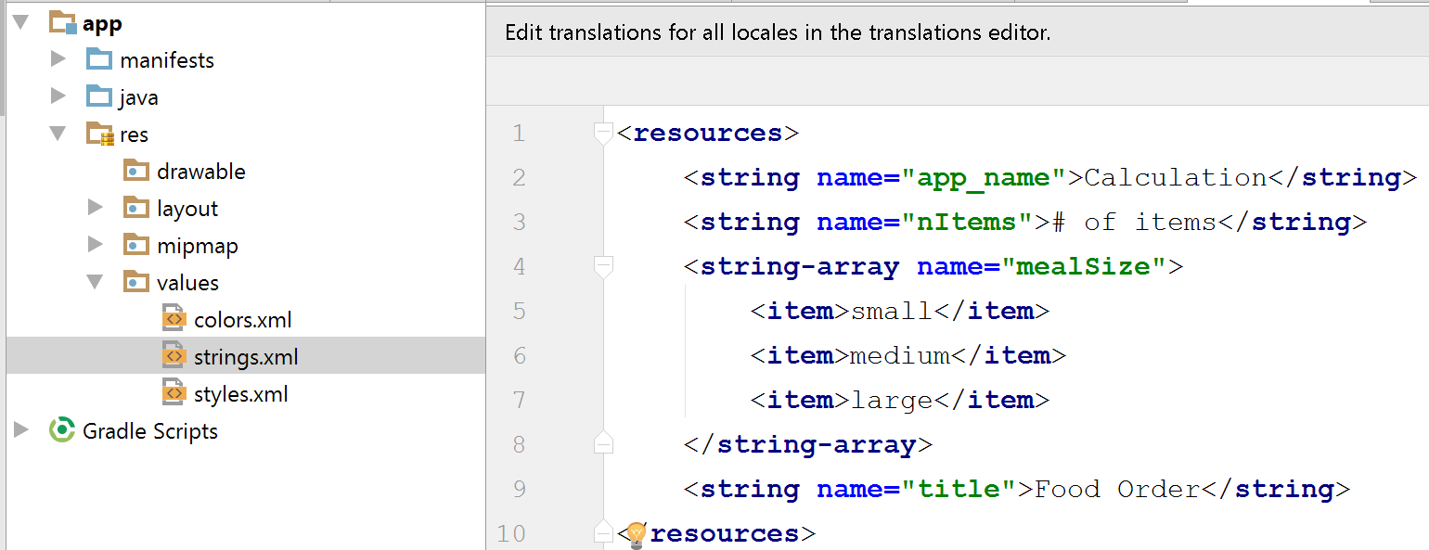

**Individual Components: TextView**

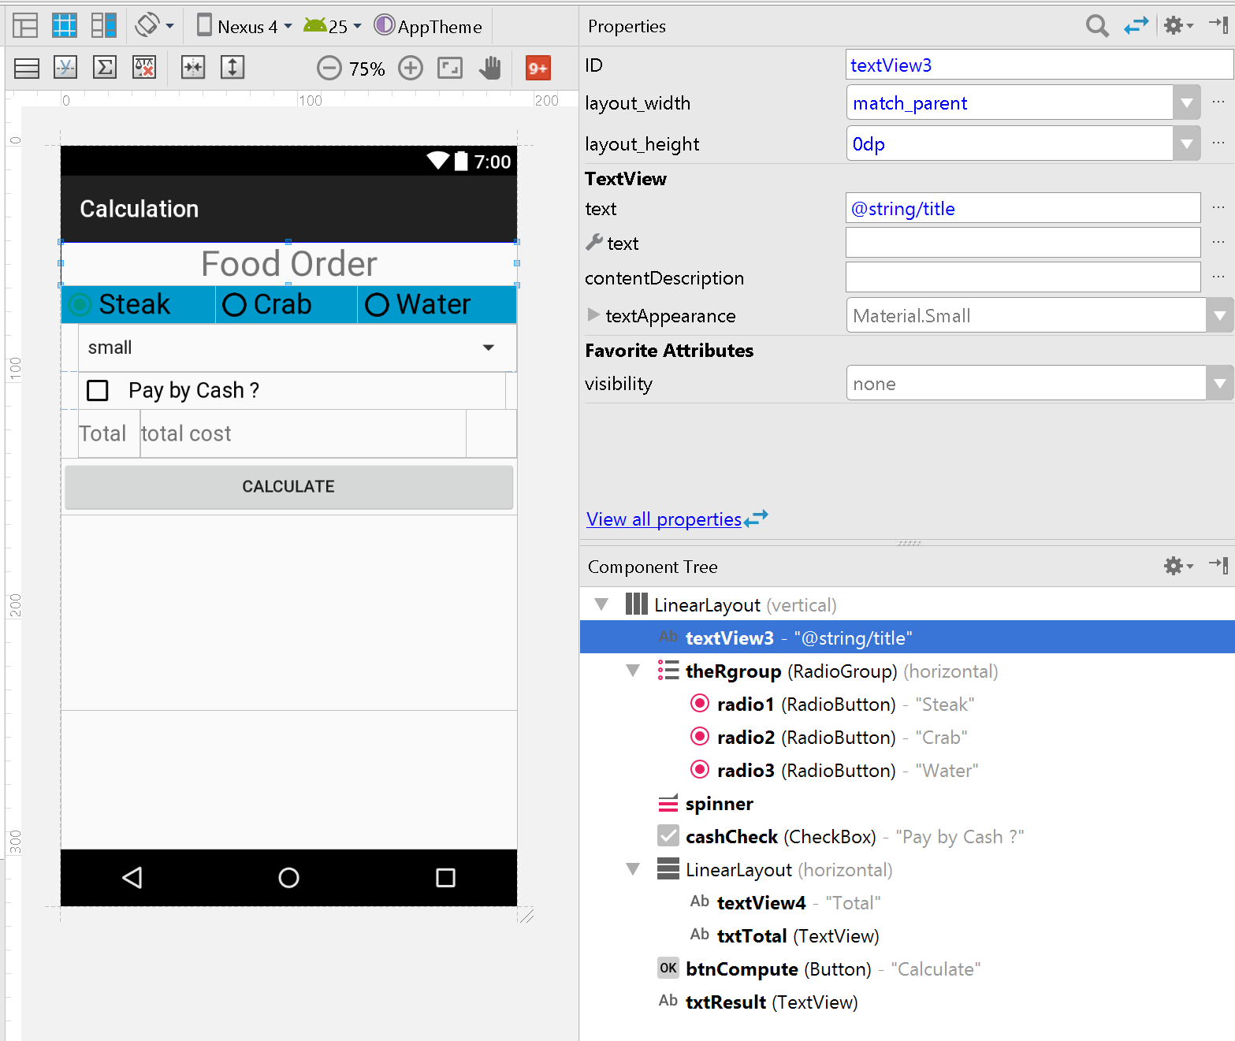

**Individual Components: RadioGroup w/ RadioButtons**

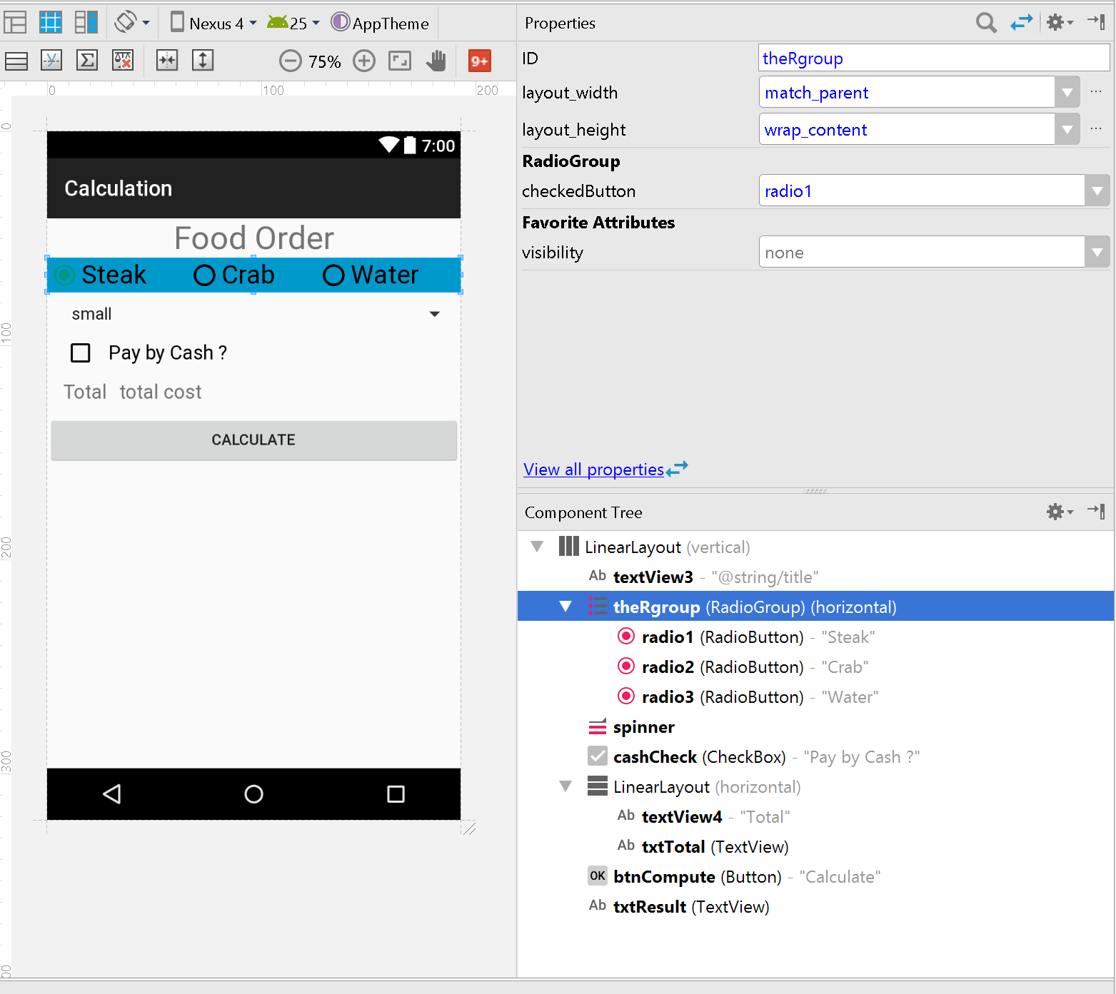

|  |  |
| --- | --- |
|  |  |
|  |  |
|  |  |

**Individual Components: Spinner**

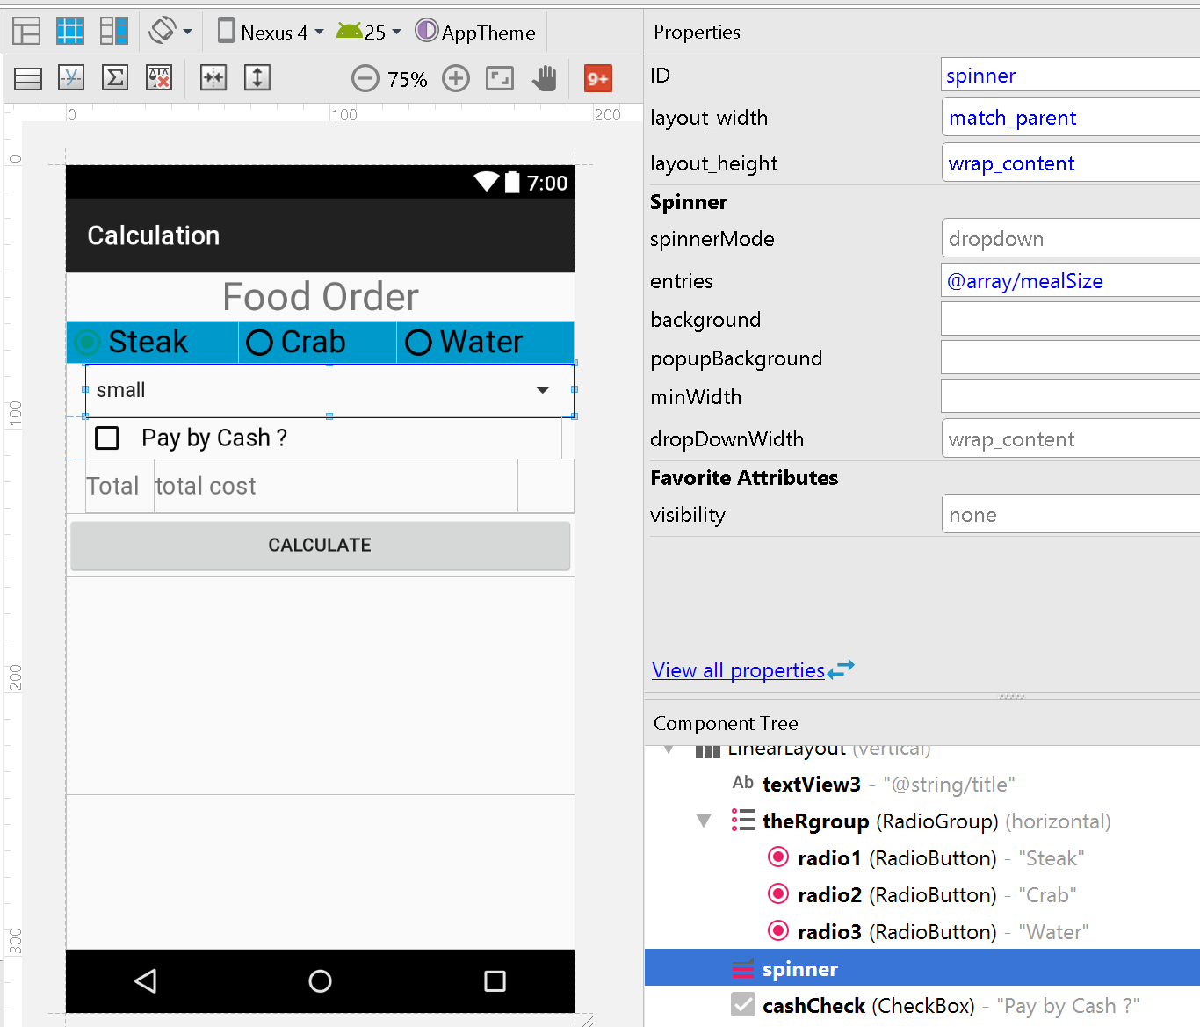

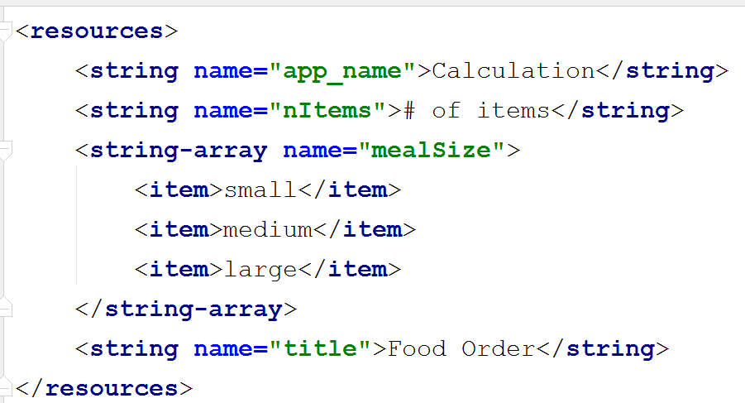

**Individual Components: CheckBox**

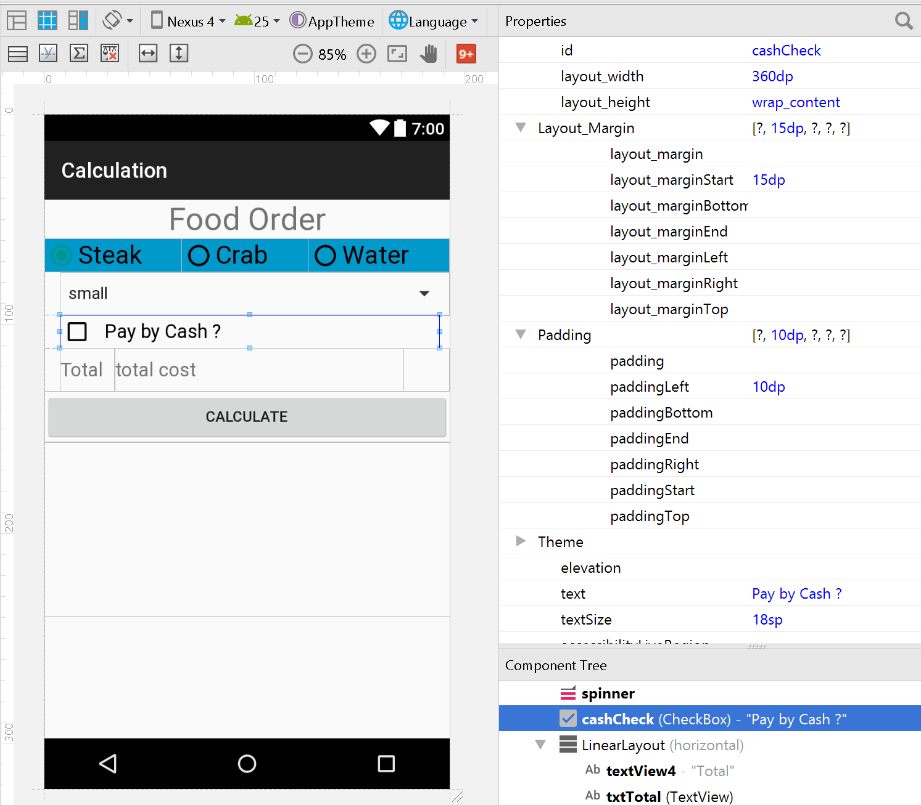

**Individual Components: another LinearLayout (Horizontal)**

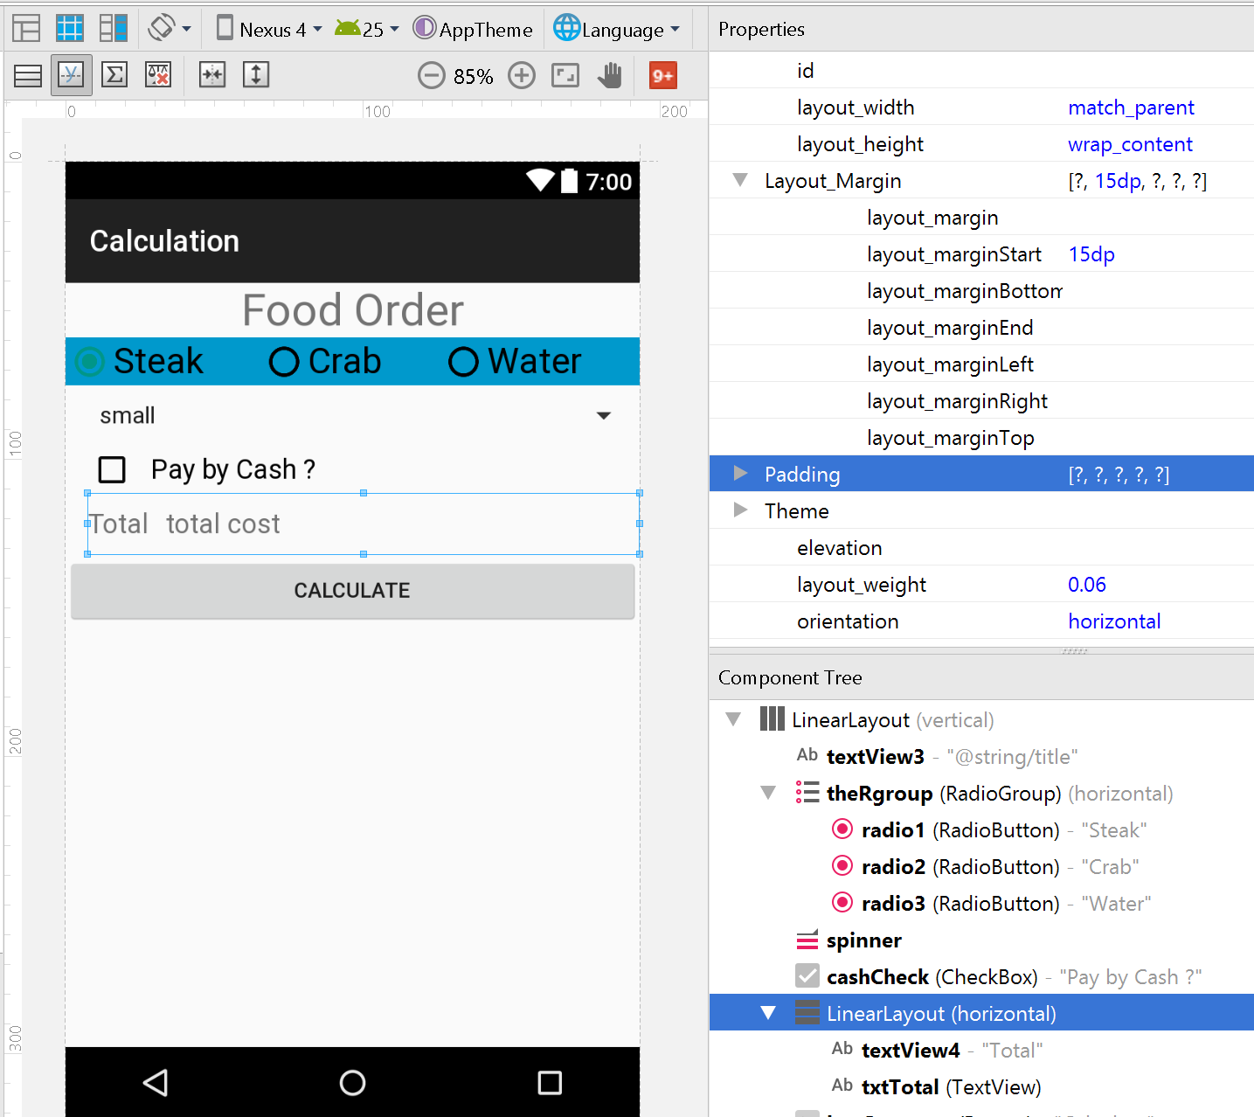

|  |  |
| --- | --- |
|  |  |
|  |  |

* About layout_weight : <https://blog.stylingandroid.com/layout-weights-part-1/>

**Individual Components: Button**

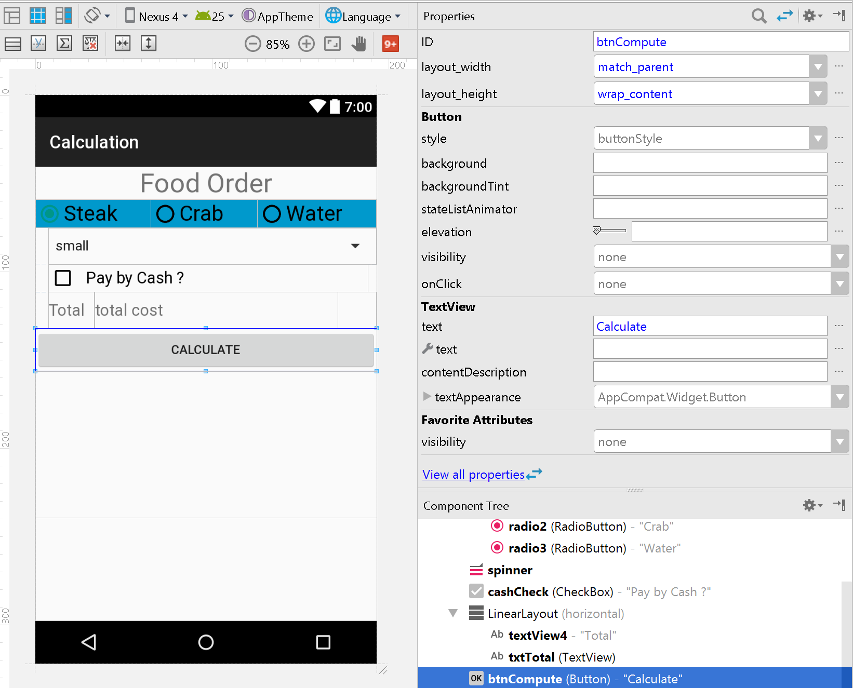

**Individual Components: TextView**

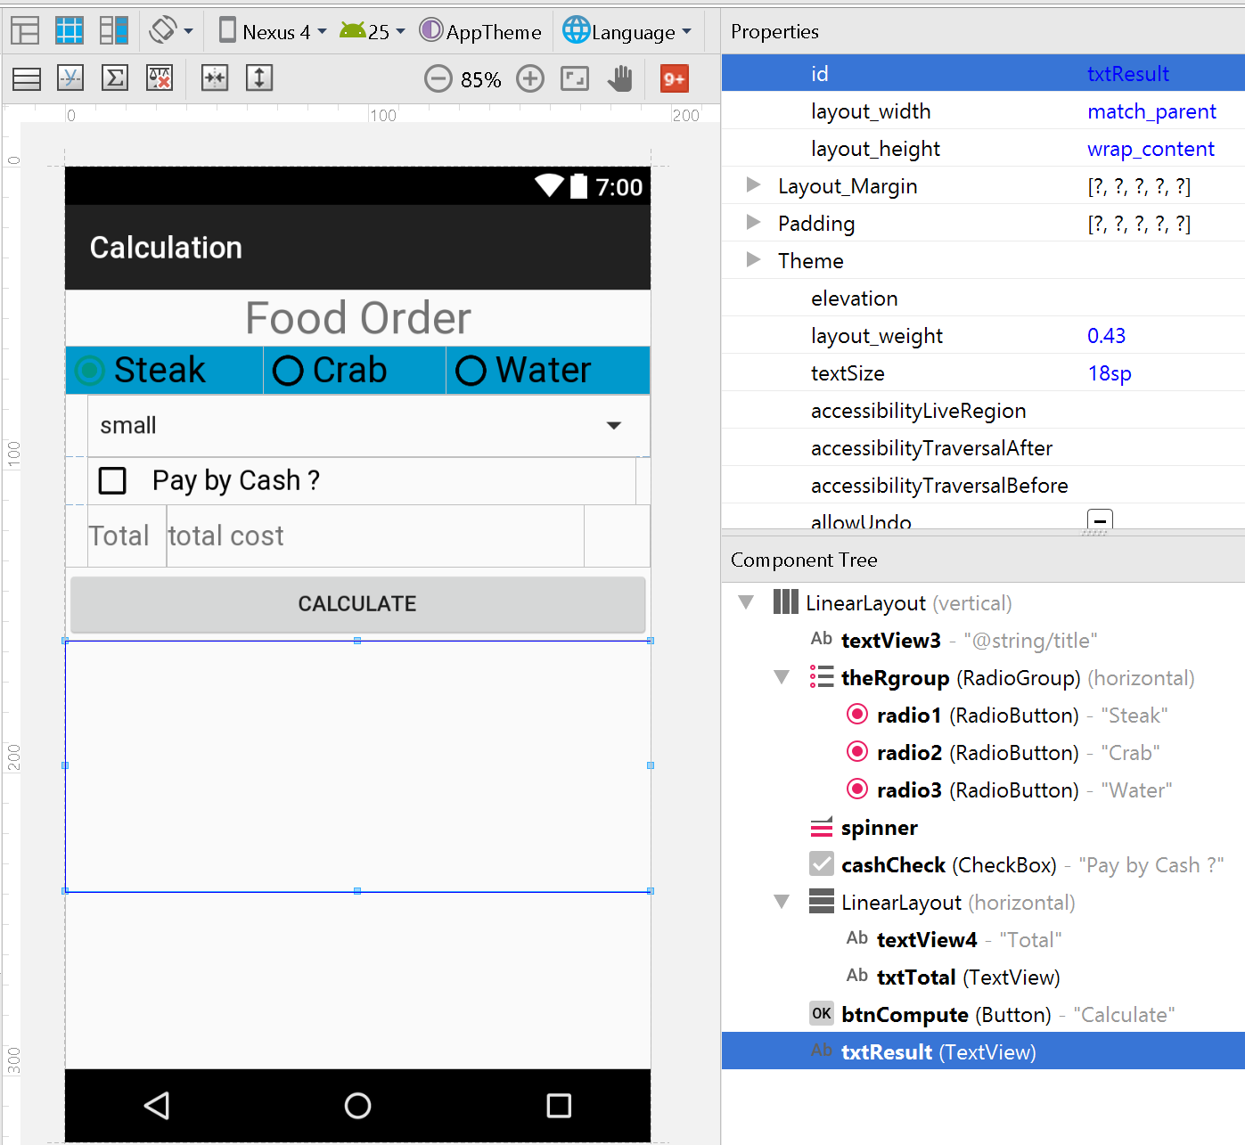

**The Code in MainActivity.java**

