Part 1 – Volume Calculation App

Formulae

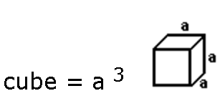

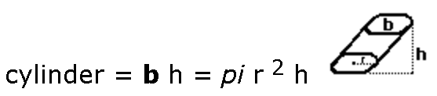

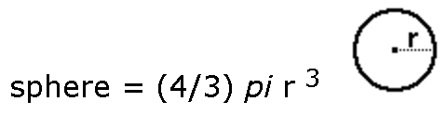

Write an application that would allow the user to do volume computation. Avoid putting all the calculations in one activity.

To submit: Compress the project folder and upload to the designated submission box

Project name: Yourname_VolCalc

API 21

Don’t select backward compatibility. This will give you more flexibility with the theme