Compute my grades

Given: 20% labs, 20% Project, 30% midterm, 30% final exam

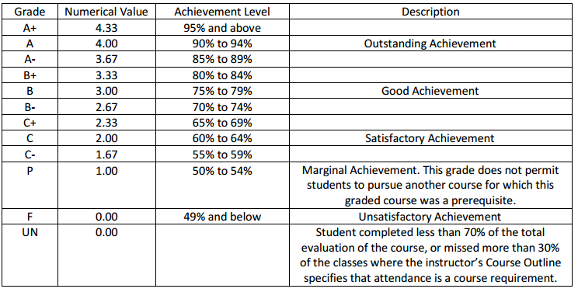

Write an application that would allow the user to enter his/her grades (labs, projects, and midterm) and the desire grade letter (e.g. A). Based on the data given by the user, calculate the minimum grade the student should get in the final exam.

To submit: Compress the project folder and upload to the designated submission box

Project name: Yourname_Grades

API 21

Don’t select backward compatibility. This will give you more flexibility with the theme