60 DAYS OF NETWORKING | DAY 04

VLAN Segmentation and
802.1Q Trunking
  - Configuration, verification and troubleshooting record
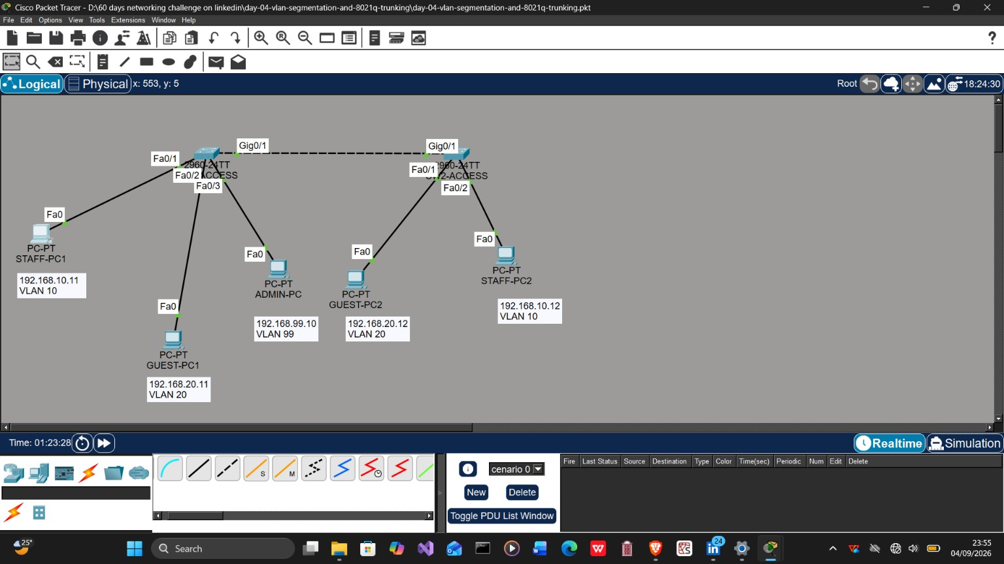
Final labelled topology: VLANs 10, 20, 99 and 999 across two access switches
Core lesson: When the configuration looks correct, verify the physical port and follow the MAC address.
Completed 5 September 2026 | Status: Verified

1. Project Summary
This lab demonstrates how VLANs divide one physical switched network into separate Layer 2 broadcast domains. Two Cisco 2960 switches carry VLAN 10 (STAFF), VLAN 20 (GUEST), VLAN 99 (MANAGEMENT) and VLAN 999 (NATIVE-BLACKHOLE) across an 802.1Q trunk. No router or multilayer switch is present, so inter-VLAN communication is intentionally unavailable.

Objectives
- Create and name the four VLANs on both switches.
- Assign user-facing interfaces as static access ports.
- Restrict the inter-switch trunk to VLANs 10, 20, 99 and 999.
- Use VLAN 999 as the native VLAN and parking VLAN for unused ports.
- Configure management SVIs and verify SSH access.
- Prove same-VLAN connectivity and cross-VLAN isolation.
- Diagnose accidental and controlled faults with switch verification commands.

VLAN Plan
VLAN | Name | Network / purpose | Active access ports
10 | STAFF | 192.168.10.0/24 - staff endpoints | SW1 Fa0/1; SW2 Fa0/1
20 | GUEST | 192.168.20.0/24 - guest endpoints | SW1 Fa0/2; SW2 Fa0/2
99 | MANAGEMENT | 192.168.99.0/24 - switch administration | SW1 Fa0/3; both SVIs
999 | NATIVE-BLACKHOLE | Native VLAN and unused ports | Unused ports

Addressing
Device | IPv4 address | VLAN | Role
STAFF-PC1 | 192.168.10.11/24 | 10 | Staff endpoint on SW1
STAFF-PC2 | 192.168.10.12/24 | 10 | Staff endpoint on SW2
GUEST-PC1 | 192.168.20.11/24 | 20 | Guest endpoint on SW1
GUEST-PC2 | 192.168.20.12/24 | 20 | Guest endpoint on SW2
ADMIN-PC | 192.168.99.10/24 | 99 | Management workstation
SW1-ACCESS | 192.168.99.2/24 | 99 | Management SVI
SW2-ACCESS | 192.168.99.3/24 | 99 | Management SVI
Default gateways were not required for the successful tests because each path remained within one subnet and VLAN.

2. Core Configuration and Verification
The complete reusable configurations are stored in the configs folder. Password values are represented by the placeholder <LAB_PASSWORD>; the Packet Tracer lab password is intentionally not reproduced in this report.

Inter-switch Trunk
interface gigabitEthernet0/1
switchport mode trunk
switchport trunk native vlan 999
switchport trunk allowed vlan 10,20,99,999
The trunk and detailed switchport state were verified with:
show interfaces trunk
show interfaces gigabitEthernet0/1 switchport

Final Connectivity Results
Test | Expected | Observed
STAFF-PC1 to STAFF-PC2 | Success in VLAN 10 | Successful
GUEST-PC1 to GUEST-PC2 | Success in VLAN 20 | Successful after cable correction
ADMIN-PC to 192.168.99.2 | Success in VLAN 99 | Successful
ADMIN-PC to 192.168.99.3 | Success across trunk | Successful
STAFF VLAN to GUEST VLAN | Failure without routing | Failed as designed

Verification Commands
show vlan brief
show interfaces status
show interfaces trunk
show interfaces gigabitEthernet0/1 switchport
show ip interface brief
show mac address-table dynamic
ping <destination-ip>

3. The Unexpected Issue and How We Fixed It
Symptom: GUEST-PC1 (192.168.20.11) could not ping GUEST-PC2 (192.168.20.12); all four requests timed out.
The IP addresses and subnet masks were correct. VLAN 20 existed on both switches and was allowed across the operational trunk. Because the devices were in the same subnet, a default gateway was not part of this path.

Investigation Sequence
- Verified the guest IP addresses and /24 subnet masks.
- Ran show vlan brief to confirm VLAN 20 existed on both switches.
- Ran show interfaces trunk to confirm VLAN 20 was allowed and forwarding over Gi0/1.
- Ran show mac address-table dynamic on SW2 to locate GUEST-PC2 at Layer 2.

The Decisive Evidence
Vlan Mac Address Type Ports
10 00e0.8f2e.99e3 DYNAMIC Fa0/1
The MAC address belonged to GUEST-PC2, but it was learned on SW2 Fa0/1 in VLAN 10. That port was reserved for STAFF-PC2, so the evidence pointed to a physical connection problem rather than a trunk problem.
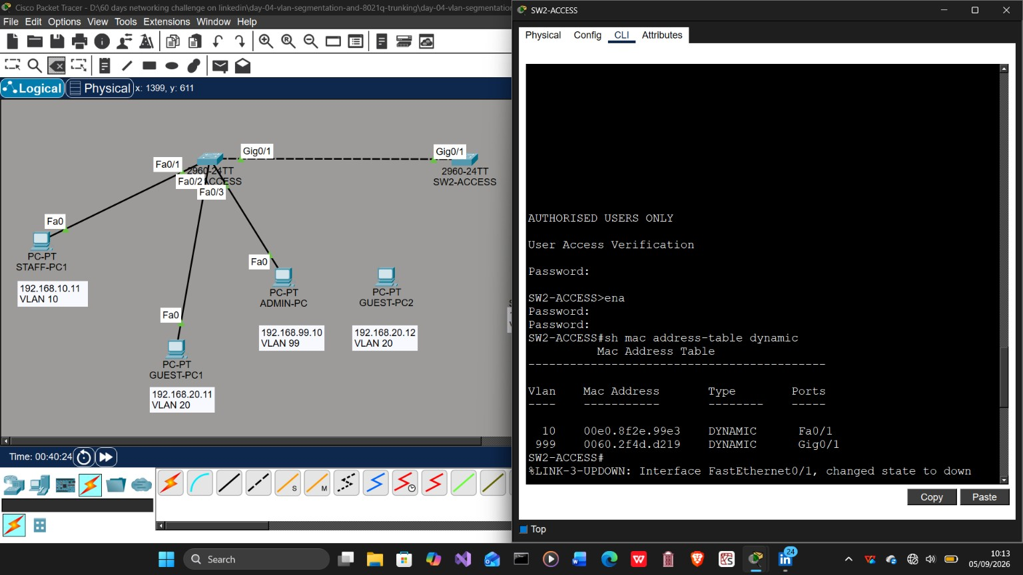
MAC-table diagnosis: GUEST-PC2 was learned on the VLAN 10 staff port

Root Cause
GUEST-PC2 had been connected to SW2 Fa0/1, a static access port in VLAN 10, instead of SW2 Fa0/2, the intended VLAN 20 guest port. An access switch assigns an untagged frame to the VLAN configured on its ingress port; the host's 192.168.20.12 address does not determine its Layer 2 VLAN.

Correction
Endpoint | Correct SW2 port | Access VLAN
STAFF-PC2 | Fa0/1 | 10 - STAFF
GUEST-PC2 | Fa0/2 | 20 - GUEST
After reconnecting the endpoints and allowing the interfaces to return to up/up, the guest ping was repeated. All four ICMP echo requests received replies, producing 0% packet loss.
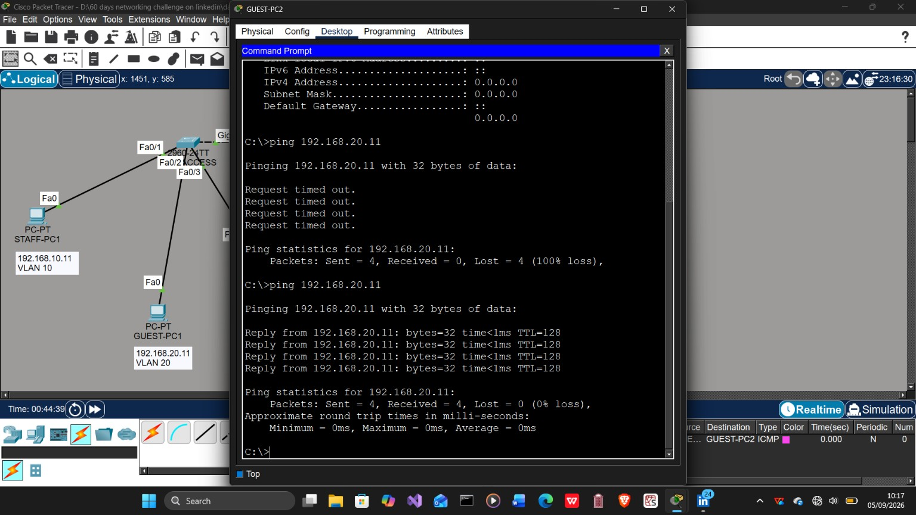
Verification: GUEST-PC2 reached GUEST-PC1 successfully after the cable was moved to Fa0/2
Lesson: When the logical configuration checks out, verify the actual cabling and use the MAC table to connect an endpoint to its physical port and VLAN.

4. Controlled Break-and-Fix Tests
After the accidental cabling issue was resolved, two faults were introduced deliberately to test the troubleshooting workflow.

Test 1 - Incorrect Staff Access VLAN
SW2 Fa0/1 was moved from VLAN 10 to VLAN 20. STAFF-PC1 and STAFF-PC2 kept addresses in 192.168.10.0/24, but their frames entered different Layer 2 broadcast domains and the ping failed.
show interfaces fastEthernet0/1 switchport
The output exposed Access Mode VLAN: 20 (GUEST). The port was restored with:
configure terminal
interface fastEthernet0/1
switchport access vlan 10
end
Evidence: screenshots 18-20 show the failure, the incorrect switchport state and the restored ping.

Test 2 - VLAN 20 Removed From the Trunk
VLAN 20 was removed from the SW1 trunk allow-list. Guest traffic failed across the switches while staff traffic continued to work. The trunk remained up/up, proving that an operational trunk can still have a VLAN-specific forwarding problem.
interface gigabitEthernet0/1
switchport trunk allowed vlan 10,99,999
The required list was restored with:
interface gigabitEthernet0/1
switchport trunk allowed vlan 10,20,99,999
Evidence: screenshots 21-22 show the guest failure and the staff VLAN remaining operational during the fault.

Troubleshooting Takeaways
- VLAN membership follows the ingress switchport, not the endpoint's IP subnet.
- Two hosts can share an IP subnet and still fail when their access ports belong to different VLANs.
- An up/up trunk does not prove that every required VLAN is allowed across it.
- Compare one failing VLAN with one working VLAN to narrow the fault domain quickly.
- Always repeat the original test after a correction and record the verified final state.

5. Screenshot Rename Map
The folder contains 24 descriptive PNG screenshots. JPEG photographs, duplicate captures and the three optional screenshots previously marked to skip were not included.
No. | Original upload | New filename | Evidence
1 | Screenshot (142).png | 01-final-labelled-topology.png | Completed topology with device, port, IP and VLAN labels
2 | Screenshot (143).png | 02-sw1-sw2-vlan-brief.png | VLAN database and access-port membership on both switches
3 | Screenshot (150).png | 03-vlan-port-assignments-full-verification.png | Full VLAN and parked-port verification
4 | 1001821171.png | 04-sw1-sw2-access-port-verification.png | Interface status, access VLANs and disabled unused ports
5 | Screenshot (148).png | 05-sw1-sw2-management-svi-verification.png | VLAN 99 management SVI addresses and operational status
6 | Screenshot (149).png | 06-sw1-sw2-8021q-trunk-status.png | Operational trunk, VLAN allow-list and native VLAN 999
7 | Screenshot (146).png | 07-8021q-trunk-switchport-details.png | Detailed trunk switchport settings
8 | Screenshot (175).png | 08-guest-vlan20-same-vlan-ping.png | Successful guest VLAN 20 connectivity across the trunk
9 | Screenshot (176).png | 09-admin-management-svi-pings.png | ADMIN-PC connectivity to both management SVIs
10 | Screenshot (177).png | 10-ssh-access-to-sw1.png | SSH session to SW1-ACCESS
11 | Screenshot (178).png | 11-ssh-access-to-sw2.png | SSH session to SW2-ACCESS
12 | Screenshot (156).png | 12-wrong-port-mac-address-diagnosis.png | MAC-table evidence of GUEST-PC2 on SW2 Fa0/1 in VLAN 10

5. Screenshot Rename Map (continued)
No. | Original upload | New filename | Evidence
13 | Screenshot (157).png | 13-guest-pc2-connectivity-restored.png | GUEST-PC2 ping recovery after correcting the cable
14 | Screenshot (158).png | 14-guest-pc1-connectivity-restored.png | GUEST-PC1 ping recovery after correcting the cable
15 | Screenshot (159).png | 15-failed-guest-pdu-during-cabling-fault.png | Failed guest ICMP PDU during the cabling fault
16 | Screenshot (160).png | 16-guest-pc1-ping-failure-during-cabling-fault.png | Guest ping failure before the physical correction
17 | Screenshot (161).png | 17-guest-pc2-ping-failure-and-recovery.png | Before-and-after guest connectivity evidence
18 | Screenshot (162).png | 18-staff-ping-failure-after-wrong-access-vlan.png | Staff failure after the remote port was moved to VLAN 20
19 | Screenshot (164).png | 19-wrong-access-vlan-identified.png | Switchport output identifying VLAN 20 on SW2 Fa0/1
20 | Screenshot (165).png | 20-access-vlan-restored-and-ping-verified.png | Staff port restored to VLAN 10 and ping verified
21 | Screenshot (179).png | 21-guest-vlan-failure-after-vlan20-removed-from-trunk.png | Guest failure after VLAN 20 was removed from the trunk
22 | Screenshot (180).png | 22-staff-vlan-remains-operational-during-trunk-fault.png | VLAN 10 remains operational during the VLAN 20 trunk fault
23 | Screenshot (183).png | 23-simulation-icmp-crosses-trunk.png | ICMP packet crossing the inter-switch trunk
24 | Screenshot (184).png | 24-simulation-cross-vlan-isolation.png | Same-VLAN success and cross-VLAN failure in Simulation mode

6. LinkedIn Post Draft
This version folds the unexpected cabling issue and the troubleshooting process into the Day 4 learning story.
Day 4/60 - VLAN Segmentation and 802.1Q Trunking
Today I built a two-switch network using VLAN 10 for STAFF, VLAN 20 for GUEST, VLAN 99 for MANAGEMENT and VLAN 999 as the native/black-hole VLAN.
I configured the access ports, restricted the 802.1Q trunk to the required VLANs, assigned management SVIs and verified SSH access.
The most valuable part was troubleshooting an unexpected fault. GUEST-PC1 and GUEST-PC2 could not communicate even though their IP addressing, VLAN database and trunk configuration appeared correct.
The SW2 MAC address table showed GUEST-PC2 being learned on Fa0/1 in VLAN 10. I had connected the guest PC to the staff access port. After moving GUEST-PC2 to Fa0/2 in VLAN 20 and placing STAFF-PC2 on Fa0/1 in VLAN 10, the guest ping succeeded with 0% packet loss.
I also introduced two controlled faults: assigning the staff port to the wrong VLAN and removing VLAN 20 from the trunk allow-list. This confirmed that an operational trunk can still have a VLAN-specific forwarding problem.
Key lesson: when the configuration looks correct, verify the physical port and follow the MAC address.
Build. Break. Investigate. Fix. Verify.
GitHub: [ADD DAY 4 GITHUB LINK]
#60DaysOfNetworking #NetworkEngineering #CiscoPacketTracer #CCNA #VLAN #8021Q #Troubleshooting #LearningInPublic
Before posting: Replace [ADD DAY 4 GITHUB LINK] with the repository URL after uploading the folder.

7. Package Contents
- README.md - GitHub-ready project narrative and verification summary.
- Day-04-Lab-Documentation.docx - this polished lab report.
- day-04-vlan-segmentation-and-8021q-trunking.pkt - working Packet Tracer lab.
- configs/ - reusable SW1 and SW2 configurations with password placeholders.
- notes/troubleshooting.md - detailed incident and break-fix record.
- screenshots/ - 24 numbered PNG screenshots plus the rename map.
- social/linkedin-post.md - editable LinkedIn story.

Delivery Check
Check | Result
Relabelled screenshots | 24 genuine PNG files
JPEG/JPG files | None included
Packet Tracer source | Included and non-empty
Troubleshooting record | Included in Word and Markdown formats
LinkedIn story | Included as an editable Markdown draft
Final status: The Day 4 lab package is organised, documented and ready for repository upload. Replace the GitHub placeholder in the social post after publishing.

