PriceWatch
Competitor price monitoring for marketplace sellers and online shops in Uzbekistan

Client guide
What the service does, what you can do with it, how to try the demo, and what a production launch includes.
Version 1.0 · October 2026

Contents
1. What is PriceWatch 3
The problem it solves 3
What PriceWatch does instead 3
Who it is for 3
2. Features 4
Dashboard 4
Products and price history 4
Recommended price 5
Alerts in Telegram 6
Morning digest 6
Telegram bot commands 6
Import and export (Excel) 7
Scraper health 7
Team and access rights 8
Convenience 8
3. How PriceWatch collects prices 9
4. How to test the demo 10
Logging in 10
A 15-minute test plan 10
Testing Telegram alerts 11
What the demo does not show 11
5. Getting started with your products 12
Free 14-day pilot 12
What we need from you 12
Plans 12
6. Production: running PriceWatch for your business 13
How a launch works 13
Reliability and security in production 13
7. Frequently asked questions 15

If the contents list looks empty, right-click it in Word and choose Update Field.

1. What is PriceWatch
PriceWatch is an online service that watches your competitors' prices for you and tells you, in Telegram, the moment something important changes — so you can react in minutes instead of days.

The problem it solves
On Uzum Market and in online shops, customers compare prices in seconds. A competitor who lowers a price by a few percent can take your sales the same afternoon. Today most sellers check competitors by hand: a manager opens dozens of pages, copies prices into Excel, and still misses the discount that started at 2 p.m.

What PriceWatch does instead
- You add your products — name, your price and (optionally) your purchase cost.
- For each product you add links to the same product at your competitors (Uzum Market and other online shops).
- The service checks those pages automatically, day and night, and records price, old (crossed-out) price and stock.
- When something changes, you get a Telegram message: a competitor lowered the price, became cheaper than you, ran out of stock, or is back in stock.
- PriceWatch suggests the price to set — for example 1 000 sum below the cheapest competitor, but never below your minimum profit — and you can apply it with one tap.
- Every morning you receive a short summary of the last 24 hours.

Who it is for
- Uzum Market sellers with 20–2 000 products in competitive categories: smartphones and accessories, appliances, cosmetics, kids' goods.
- Online shops of electronics and home appliances, where prices change daily.
- Distributors and brands that want to see which resellers sell below the recommended retail price.

In one sentence
You stop checking competitors by hand. PriceWatch checks them for you and tells you what to do.

2. Features

Dashboard
The first screen shows the state of your market at a glance:
- Products tracked and the number of competitor links.
- Where I'm more expensive — how many of your products cost more than the cheapest competitor.
- Changes in 24 hours — how many competitor prices moved.
- Scraper health — whether all competitor shops are being read normally.
- A live feed of the latest price changes (green ▼ = cheaper, red ▲ = more expensive) and the latest alerts. The feed refreshes itself every minute.
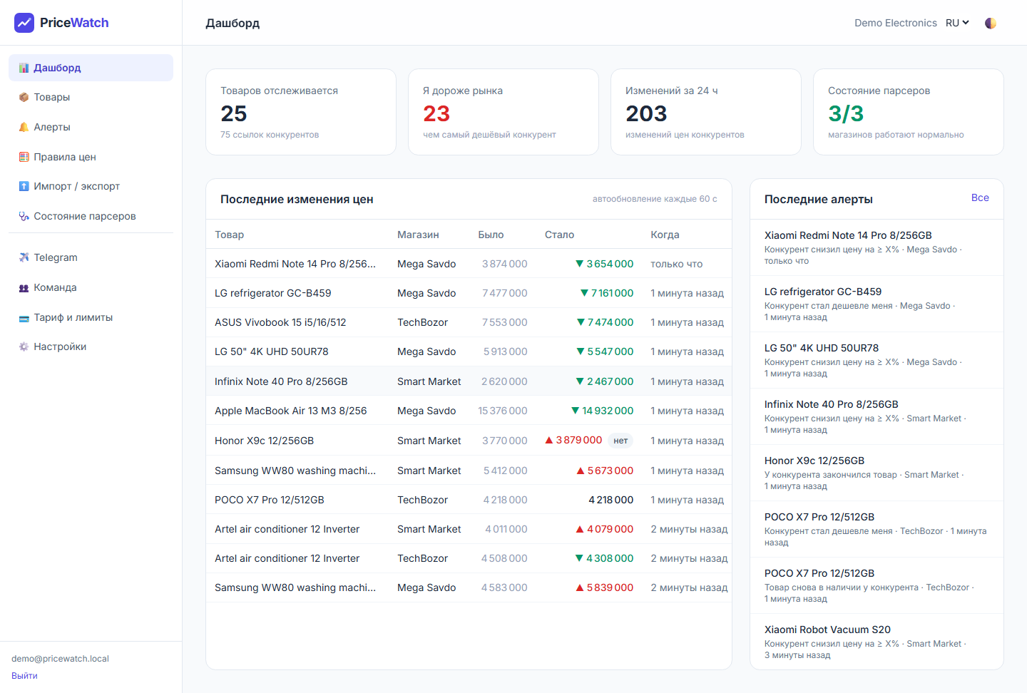
Dashboard: key numbers, latest competitor price changes and alerts

Products and price history
The product list shows your price, the cheapest competitor price and the difference in percent. Use the filters I'm more expensive, I'm cheapest or No competitor links, search by name or SKU, and filter by category.
Open any product to see:
- A price chart for 7, 30 or 90 days — your price as a dashed line and each competitor in its own colour.
- Every competitor with current price, old price, stock, and when it was last checked.
- The full history of recorded prices.
- A Check now button for an immediate, out-of-schedule check.
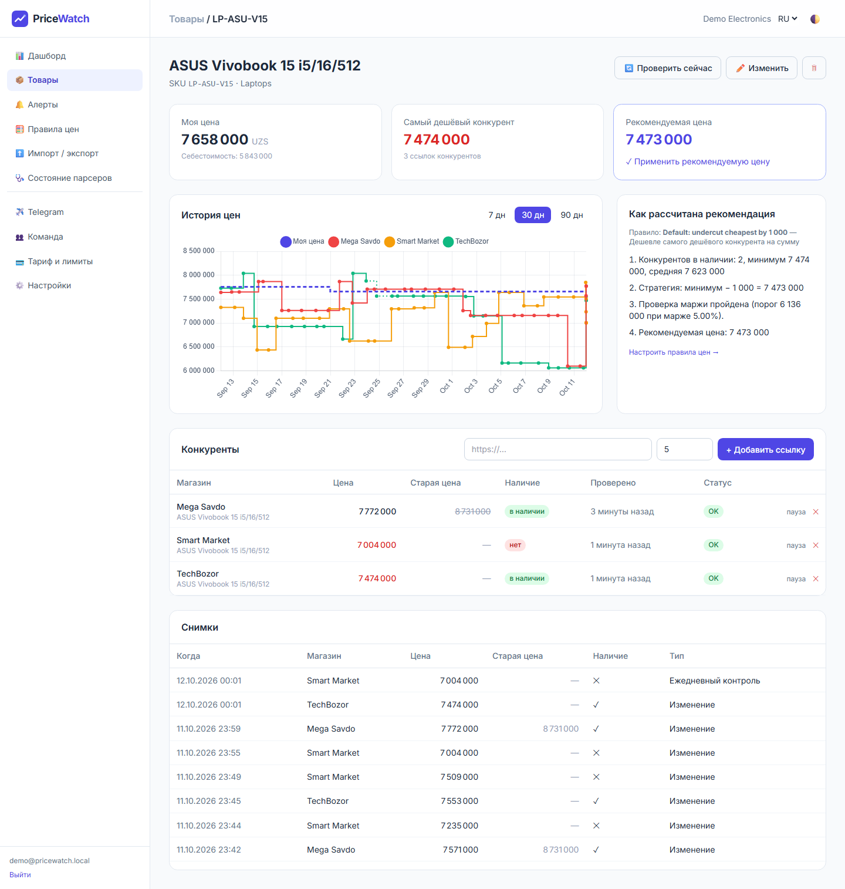
Product page: price chart, competitors and the recommended price with its explanation

Recommended price
For every product PriceWatch calculates the price to set, and explains the calculation step by step so you always understand why. You choose the strategy:
Strategy | Example
Undercut the cheapest by an amount | Cheapest competitor 1 199 000 → recommended 1 198 000
Undercut the cheapest by a percent | 1% below the cheapest competitor
Match the cheapest | Same price as the cheapest competitor
Market average | Average of all competitors that have the product in stock

Two safety rules always apply: the price is never below your cost plus your minimum margin (for example cost + 5%), and it is rounded to a clean number (for example to the nearest 1 000 sum). Competitors who are out of stock are ignored. Rules can apply to all products, to a category, or to one product.
PriceWatch never changes your prices on its own — it only recommends. You apply a price with one click on the website or one tap in Telegram.

Alerts in Telegram
Choose which events matter to you:
Alert | When it fires
Competitor dropped the price by ≥ X% | A competitor lowered the price by at least the percent you set (5% by default)
Competitor became cheaper than me | A competitor's price fell below yours
Competitor ran out of stock | A good moment to raise your price or push sales
Competitor is back in stock | Competition returns for this product
Any price change | Every price move, for products you watch closely

Each message shows the product, the old and new price, your price and the recommended price, with buttons Open product, Apply recommended price and Mute this alert. Alerts are grouped: you get at most one message per product every 30 minutes, so there is no spam. Alerts can also be sent by e-mail.
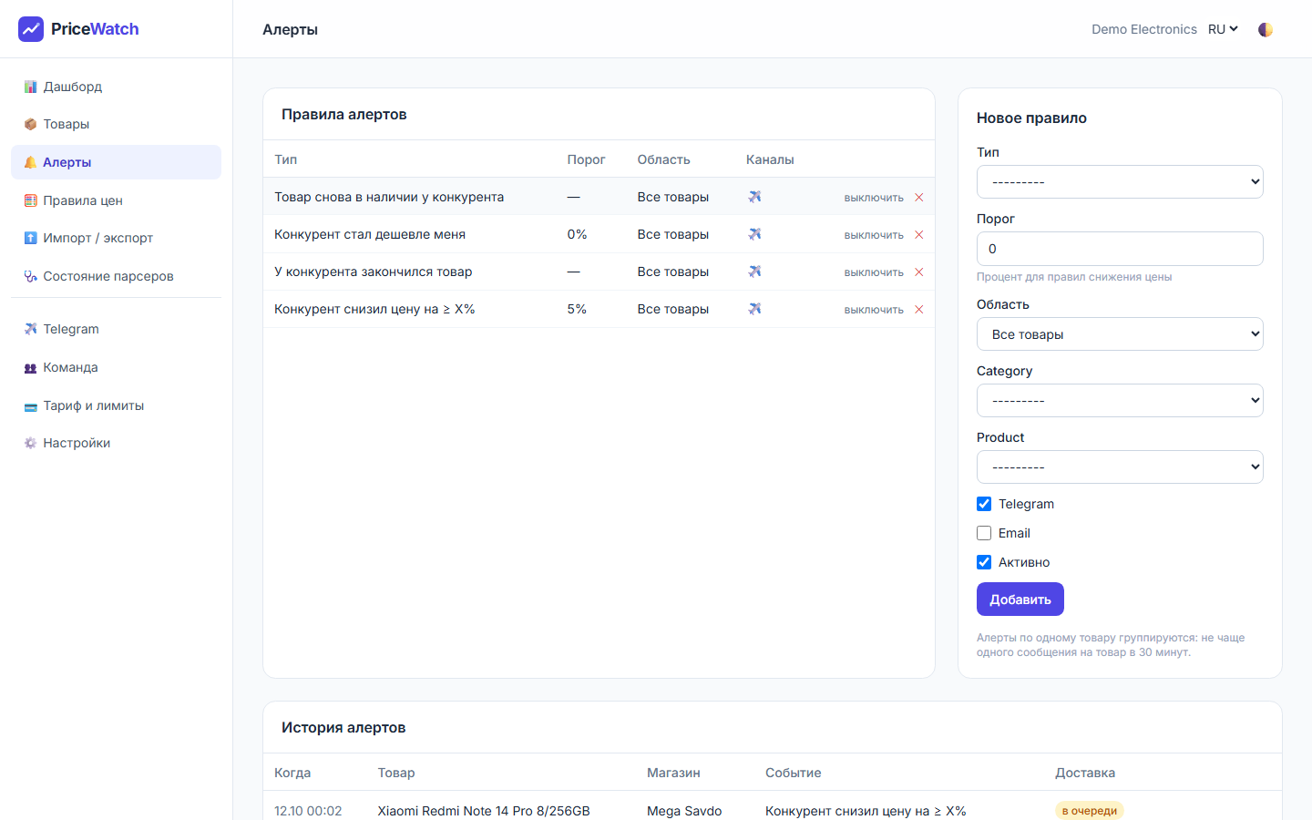
Alert rules and the history of alerts

Morning digest
Every day at 09:00 Tashkent time (the time can be changed) PriceWatch sends a summary: price changes in the last 24 hours, the products where you are more expensive than the market, and what your competitors ran out of.

Telegram bot commands
Command | What it does
/products | Your products with your price and the cheapest competitor price
/check SKU | Checks one product right now and replies with fresh prices
/report | The daily summary, right now
/lang | Switch the bot language: Russian, Uzbek or English

Import and export (Excel)
- Import: download the Excel or CSV template, fill in your products and competitor links, and upload it. You get a report: how many products were created or updated, how many links were added, and exactly which rows had errors and why.
- Export: download a formatted Excel report — your price against every competitor, market minimum and average, the recommended price. Rows where you are more expensive are highlighted in red.
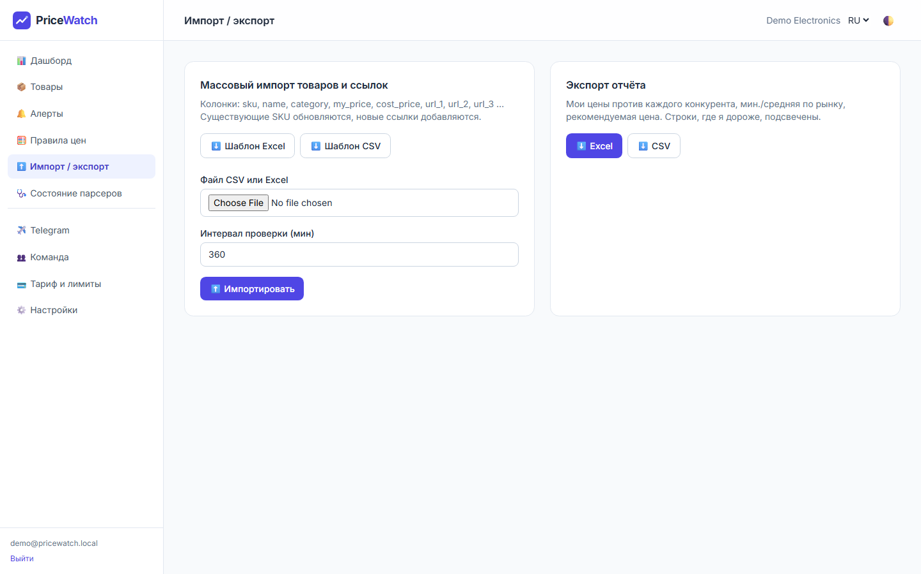
Import with error report and Excel export

Scraper health
A dedicated page shows, for every competitor shop, how many checks succeeded in the last hour, which links have problems (for example the product was removed from the competitor's site), and when each shop was last read. If a shop changes its website and checks start failing, our team is notified automatically and fixes it.
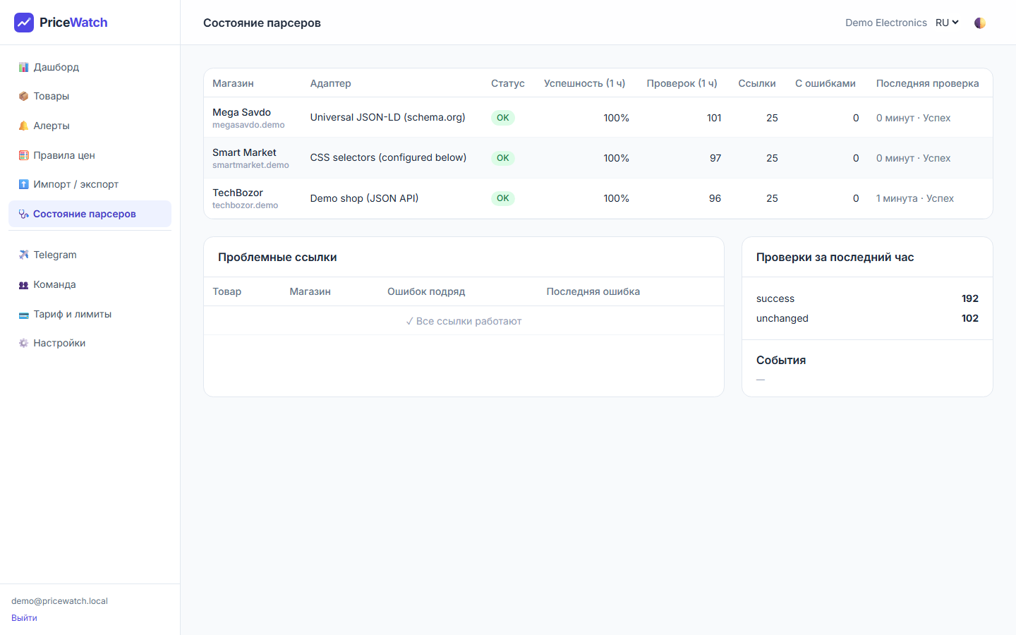
Scraper health: success rate per shop and problem links

Team and access rights
Role | Can do
Owner | Everything, including inviting colleagues, plan and company settings
Manager | Add and edit products, links, alert and pricing rules, apply prices
Viewer | See everything, change nothing — for owners, accountants, partners

Invite colleagues by e-mail. Each company sees only its own data; nobody else can see your products, prices or rules.

Convenience
- Three languages: Russian, Uzbek and English — for the website and the bot.
- Works on a phone as well as on a computer.
- Dark mode with one click.
- For larger clients: a documented API to connect PriceWatch to your own accounting or ERP system (Business plan).

3. How PriceWatch collects prices
PriceWatch reads the same public product pages that any shopper sees. It does not log in to anyone's account and does not use your Uzum seller account in any way.
- Only public information is collected: price, crossed-out price, stock and product name.
- Each website's rules for automated visitors (robots.txt) are respected.
- Visits to every shop are spaced out and limited, so we never overload anyone's website.
- Protection systems such as captchas are never bypassed.
- Suspicious values are double-checked: if a price suddenly jumps 5 times or shows 0, PriceWatch re-checks it 10 minutes later and alerts you only if it is confirmed.
- History is kept compactly: a new record is stored when something changes, plus one control record per day.

Is it legal?
PriceWatch uses only information that is publicly available to any visitor, follows each website's crawling rules and keeps request rates low. Decisions about prices are always yours — the service is informational.

4. How to test the demo
The demo is a working copy of PriceWatch filled with sample data: 25 products, 3 competitor shops and 30 days of price history. The three demo shops (TechBozor, Mega Savdo, Smart Market) are built-in test shops whose prices change by themselves every couple of minutes — so you will see real new changes and alerts while you explore.

Logging in
Item | Value
Address | The demo link we sent you (it ends with .onrender.com)
E-mail | demo@pricewatch.local
Password | demo12345

Note about the demo
The demo runs on free hosting that falls asleep after 15 minutes without visitors. The first opening after a pause can take about a minute — this is normal and does not happen in production.
Other people may be testing the same demo account at the same time, so data can change while you look.

A 15-minute test plan
- Dashboard. Look at the four numbers at the top. Note how many changes there were in 24 hours. Wait 2–5 minutes — new rows appear in “Latest price changes” without reloading the page.
- Products. Choose the filter “I'm more expensive” and open any product.
- Price chart. Switch between 7, 30 and 90 days. Hover over the lines to see exact prices.
- Recommended price. Read the explanation on the right, then click “Apply recommended price”. Your price changes and the chart shows the new value.
- Check now. Click “Check now” on the product page, wait a minute and reload — the “Checked” column shows a fresh time.
- Add your own product. Products → “+ Product”: enter a code (SKU), a name and a price, save. On the product page paste a competitor link and click “Add link”.
- Pricing rules. Add a rule with strategy “Market average”, then reopen a product — the recommended price and its explanation change.
- Alerts. Open “Alerts”: see the rules and the history of alerts that already fired. Add a rule, for example “Any price change”.
- Excel. On “Import / export” download the Excel report and open it — rows where you are more expensive are red. Download the import template and look at the format.
- Scraper health. Check that all three shops show a high success rate.
- Languages, phone, dark mode. Switch RU / UZ / EN at the top, press 🌓 for dark mode, and open the demo on your phone.
- Plan and limits. Open “Plan & limits” to see the plans and how much of the limit is used.

Testing Telegram alerts
If the demo has a Telegram bot connected (we will tell you the bot name):
- On the website open the “Telegram” page — you will see a code.
- Open the bot in Telegram and send /start and the code, for example /start A1B2C3.
- Send /products and /report. Within a few minutes the first alerts arrive with the “Apply” button.
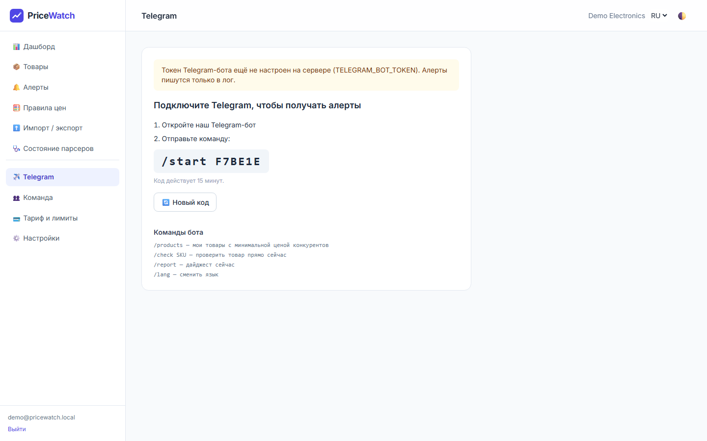
Connecting Telegram with a one-time code

What the demo does not show
- Real Uzum Market checks: they need a more powerful server than the free demo hosting. They work in production — we have tested them on live Uzum product pages.
- Your own products and competitors — that is what the free pilot is for (next section).

5. Getting started with your products

Free 14-day pilot
- You send us your 20–50 most important products (or we take them from your Uzum shop).
- Together we choose 3–5 main competitors and collect links to the same products.
- We connect your Telegram and set up alerts and the morning digest.
- After 7 days we meet for 20 minutes: what changed, where you were more expensive, how often you used the recommendations.
- Before the 14 days end you choose a plan — or simply stop, at no cost.

What we need from you
Information | Required | Comment
Product code (SKU) | Yes | Your internal code or Uzum article
Product name | Yes
Your current price | Yes | In sum
Purchase cost | Recommended | Needed so the recommended price never goes below your minimum profit
Category | Optional | For filters and rules by category
Competitor links | Yes | Links to exactly the same product (model, memory, colour, set)

Collecting links takes about 1 hour for 20 products with 3 competitors and 4–6 hours for 100 products. We can do it for you as part of the setup service.

Plans
Plan | Price per month | Links | Checks | Included
Free trial | 0 (14 days) | up to 20 | every 6 hours | Telegram alerts, dashboard, CSV
Start | 300 000 – 500 000 sum | up to 200 | every 2 hours | Alerts, digest, recommended price, 2 users
Business | 800 000 – 1 500 000 sum | up to 2 000 | every 30 min | + Excel reports, API, up to 10 users
Enterprise | from 2 500 000 sum | individual | from 5 min | Custom shops, dedicated server, guaranteed response time

One-time setup (connecting your specific competitors, importing your catalogue, training your team): from $300 to $800, depending on the number of products and shops. Discounts: 15% for 3 months, 25% for 12 months paid in advance.

6. Production: running PriceWatch for your business
The demo shows what PriceWatch can do. A production launch is the real, permanent service for your company. Here is what changes.
 | Demo | Production
Availability | Falls asleep after 15 minutes without visitors | Always on, 24/7 — checks run day and night
Address | Temporary …onrender.com link | Your own address, e.g. prices.yourshop.uz, with a secure HTTPS connection
Data | Shared sample data, deleted after 30 days | Your own private data, kept permanently
Uzum Market | Not available | Fully supported (real browser checks)
Backups | None | Automatic daily backups stored outside the server, with regular restore tests
Monitoring | None | 24/7 availability monitoring, automatic error reports, instant alerts to our team
Check frequency | Demo shops every few minutes | According to your plan (every 6 h … every 5 min)
Support | — | Fixes when a competitor changes its website, help with new shops

How a launch works
- Agreement and plan. We agree on the plan, the number of products and shops, and sign the offer agreement.
- Server and address. We set up a dedicated cloud server and connect your address (domain) with HTTPS. Typical server: 4 processor cores, 8 GB memory — enough for about 5 000 links.
- Your data. We import your catalogue, connect your competitors, and test every shop.
- Team and Telegram. We create accounts for your team, connect Telegram and configure alerts, pricing rules and the morning digest.
- Training. A one-hour online session for your managers.
- Go live. Usually 3–5 working days from receiving your product list.

Reliability and security in production
- Secure HTTPS connection; passwords are stored encrypted; admin tools are hidden and protected against password guessing.
- Each company's data is fully separated from other companies.
- Daily backups stored in a separate location; restores are tested every month.
- Every part of the system is continuously health-checked and restarts automatically if something fails.
- If a competitor's website changes and checks start failing, our team is alerted automatically. Typical fix time: within one working day (4 hours on Enterprise).
- Updates are installed without stopping the service.
- The system grows with you: more products and more frequent checks are handled by adding server capacity.

Your data
Your catalogue, prices and settings belong to you. You can export everything to Excel at any time, and on request we delete all your data.

7. Frequently asked questions
Can Uzum block my seller account because of PriceWatch?
No. PriceWatch does not use your seller account at all — it only reads public product pages, like any shopper.
Does PriceWatch change my prices automatically?
No. It recommends a price and explains why. You decide and apply it with one click.
How quickly will I learn about a competitor's discount?
Depending on your plan, from 5 minutes (Enterprise) to 30 minutes (Business) or 2 hours (Start), plus up to a minute for the Telegram message.
What if the competitor sells a slightly different model?
Compare only identical products (model, memory, colour, set). We help you choose correct links during setup.
What if a competitor removes the product?
The link is marked as a problem on the Scraper health page, and we let you know so you can replace it.
Can several employees use one account?
Yes — invite colleagues as Manager (can edit) or Viewer (read-only). The number of users depends on the plan.
Which shops are supported?
Uzum Market and most online shops in Uzbekistan. Many work immediately; others we connect during setup, usually within a day.
Can I try it on my own products before paying?
Yes — the free 14-day pilot on your real products.
Will I get too many messages?
No. Messages for one product are grouped — at most one every 30 minutes — and you choose which events you want.

Next step
Send us 20 of your key products and the names of your main competitors — we will set up your free 14-day pilot.

