SMART GREEN NURSERY: AI-ENABLED GARDENING & PLANT CARE PLATFORM

PROJECT PROPOSAL



Program: BSCS Session: 2022 – 2026 Shift: Evening

Supervisor
Dr. Shahzadi Tayyaba (Associate Professor)

Submitted By
- Ikram Ali, bsf2201577
- Abdul Wahab, bsf2201585
- Muhammad Raza, bsf2201546

UNIVERSITY OF EDUCATION, LAHORE

October 22, 2025

Declaration

This is to certify that, I am Ikram Ali S/O Muhammad Iqbal, group leader of FYP under registration no 22-UE-02285 at Department of Information Sciences University of Education Lahore. I declare that our FYP “Smart Green Nursery: AI-Enabled Gardening & Plant Care Platform” proposal is the result of our own research and development. We have not copied the proposal from anywhere. I declare that my FYP proposal is checked by my supervisor and the similarity index is less than 20%.

Submission Date: 22-09-2025_ Name of Group Leader: Ikram Ali Signature: ________

Name of Supervisor: Dr. Shahzadi Tayyaba
Designation: Associate Professor
Signature: __________________________

Table of Contents
- Introduction ........................................................................................ 4
- Related Work ...................................................................................... 4
- Problem Description........................................................................... 5
- Aims and Objectives.......................................................................... 5
- Domain of the Project ........................................................................ 5
- Project Scope ..................................................................................... 6
- Methodology....................................................................................... 6
- Tools and Technology ........................................................................ 8
- Milestones (Gantt chart)..................................................................... 8
- References ......................................................................................... 9

1. Introduction
Today, more and more people enjoy having plants, but it is not always easy to care for them properly. Lifestyle and work schedules make it difficult to give attention to plants, and many people do not have enough gardening knowledge to do it properly, or there may be diseases that the plants get. For both the novice gardener and nursery owners, gardening is a difficult task. Most existing nursery websites are strictly for online supplying. Gardening apps are available, but they mostly provide generic care tips that are not tailored to each user or plant. The goal of our project, Smart Green Nursery: AI-Enabled Gardening & Plant Care Platform, is to address these issues. The platform, Smart Green Nursery, will have two main functions. It will not simply be an online plant business, but will also provide a user's with smart, intelligent, and AI-based care, which may include watering schedules, fertilizer recommendations, and sunlight recommendations for their plants, trees, and/or shrubs. Users can upload images for plant disease identification, and the platform will provide possible solutions. It will also have a smart way for nursery owners to inventory their plants/shrubs/trees/etc., providing notifications when items are running low. Finally, it will have a community forum for buyers and sellers, to share tips, moments in plant and gardening joy or struggles, and knowledge. A platform like Smart Green Nursery, in conjunction with AI, site design and gardening experiences, has the potential to make gardening easier, smarter, and ultimately more sustainable. In this way, we can assist the plant-lover user, and also assist the nursery business owner with managing their business.
2. Related Work
While thinking about this project, we noticed that many researchers have already work on applying artificial intelligence and smart technologies in agriculture and plant care. For example, many researchers have worked on using deep learning and computer vision for detecting plant diseases. These studies show that with the help of images, AI models like convolutional neural networks can identify different plant diseases with high accuracy. This proves that AI has a strong role in improving plant health and making gardening more reliable.
Another area of research is focused on making AI models lighter so they can run on mobile devices. A recent study introduced a hybrid Vision Transformer model that can detect plant diseases quickly and still work on low-resource devices like smartphones. This is very important because most users want simple mobile solutions instead of complex setups.
From this related work, we learned that a lot of progress has been made in disease detection and smart monitoring. However, most systems only focus on one part, like either selling plants, detecting diseases, or monitoring with sensors. None of them combine all these features into one complete platform. Our project, Smart Green Nursery: AI-Enabled Gardening & Plant Care Platform, is different because it brings together plant selling, AI-based care tips, disease detection, inventory management, and a gardening community forum in a single system
3. Problem Description
The main problem we observed is that most nurseries and gardening platforms are either very basic or only focus on selling plants. They do not guide users on how to take care of plants after purchase. Mobile apps that exist for gardening usually provide general tips, but they are not personalized. For example, every plant has different water, sunlight, and fertilizer needs, but users usually get the same advice for all plants. This creates difficulty for beginners who do not know much about plant care.
One of the problems is plant diseases. Most people cannot easily recognize what is wrong with a plant just by looking at it leaves or overall condition. Because of this, treatment often starts late and many plants end up dying. Nursery owners also face difficulties in keeping track of stock and refilling it on time, which sometimes results in financial loss.
Our project aims to cover these issues by creating a platform that is simple to use but also smart in its features. It will support users with AI-Based disease detection, give personalized care suggestions, and help nursery owners with an inventory system that shows alerts when the stock is low. We also plan to add a forum where buyers, sellers and plant lovers can interact and share useful experiences.
This project is meaningful because it brings plant selling, plant care and nursery management together in one system. With the help of artificial intelligence and modern technology, gardening can become easier, more reliable and more eco-friendly for everyone.
4. Aims and Objectives
The main goal of our project is to build a smart and easy to use platform that brings together an online plant store, AI-based plants care, and nursery management in one place. The core features of our project include giving users personalized advice for plant care, using AI to identify plant through images, and helping nursery businesses manage their stock with an inventory system. Along with these, our project also has a secondary goal of providing a community forum where buyers, sellers and plant enthusiasts can connect, share ideas and support each other in improving their gardening experience.
5. Domain of Project
The scope of our project mainly lies in artificial intelligence, web development, and smart agriculture. It is basically web based platform that uses AI and data to guide users in plant care and to identify plant diseases from images. The project also covers e-commerce since it allows nurseries to manage their stock and sell plants online. Simply put, my project is where technology and agriculture come together to make plant care easier and nursery management more efficient.

6. Project Scope
The scope of our project is limited to the development of a web-based platform that provides AI-based plant care guidance, plant disease detection through image uploads, nursery stock management, and an online plant selling feature. The system will also have a community forum where users can share tips and experiences.
Some areas are not included in this project, such as advanced greenhouse automation, hardware-based environmental monitoring, and large-scale enterprise-level inventory systems. The focus will remain on software features that can directly help nursery owners and plant lovers.
For assumptions, we are considering that users will have internet access, basic knowledge of using web platforms, and good quality images of plants for disease detection. These assumptions are important because the performance of the system depends on the quality of user input and the availability of online access.
In short, the project scope is to design and develop a smart but simple platform that combines plant selling, plant care, and nursery management without going into complex hardware or large-scale industrial setups.
7. Methodology
To complete our project, we planned to follow a simple step-by-step process. we will begin reviewing different nursery systems and gardening apps that already exists. From there, we will note down their weak point and use them to define the requirement for our own system. After that, we will design the system’s overall structure and create a user interface that is simple and easy for both nursery owners and customers to use.
In the next stage, we will apply artificial intelligence to handle two main tasks: Identifying plant diseases and giving care suggestions. For this, we will use machine learning models analyze plant images and provide recommendations based on the results. Alongside this, we will also work on modules for online plant sales, stock management and a community forum.
Once the development is complete, our focus will be on testing. We will use different plant images and datasets to check how accurate, reliable, and user-friendly the system is. Any bugs or issues we found during this stage will be fixed before final launch.
By following this structured approach, we can move smoothly from requirement gathering to design, implementation, and testing. The ultimate of a project is to create a smart and dependable platform that improves the way plant care and nursery management are done compare to traditional methods.

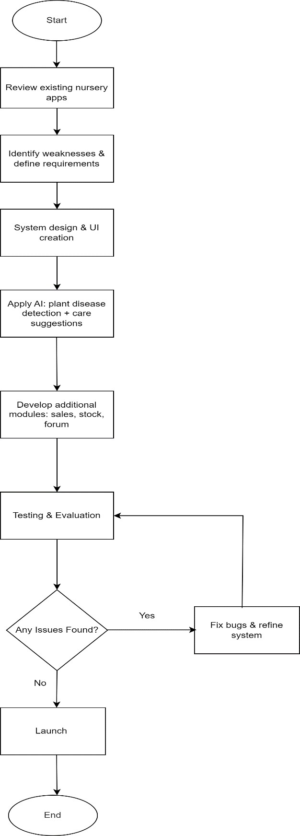

Fig1: Flowchart Diagram

8. Tools and Technology
For our project, we will need both software and hardware tools.
Software Tools:
- Frontend: We will use React.js to design a simple and interactive web interface.
- Backend: D jango web API will be used to manage server-side functions and connect the frontend with the database.
- Database: SQL Server (or any relational SQL database) will store user accounts, plants details, inventory data, and forum content.
- AI and ML: Python will be used with libraries like TensorFlow or PyTorch to train plant disease detection models, while OpenCV will help in processing plant images.
- Development Tools: We will work with Visual Studio, Visual Studio code,and Jupyter Notebook for writing and testing code.
Hardware Tools:
- A personal computer or laptop with atleast 8GB RAM and fast processor.
- Stable Internet connection for running system online and training AI models.
- Enough storage space to keep datasets, images, and Application files.
With these tools and technologies, we will be able to design, build and test the Smart Green Nursery Platform successfully

9. Milestones (Gantt chart)
We planned our project in the form of milestones. Each milestone includes a few tasks that, when completed one after another, will help me smoothly towards the final result.
Milestones and Tasks:
- Requirement Gathering & Planning
  - Study existing nursery systems and gardening apps.
  - Note down limitations and user needs.
  - Finalize project requirements and features.
- System Design
  - Create system architecture.
  - Design database structure (SQL).
  - Prepare UI/UX mockups for frontend.
- Backend Development (ASP.NET Core Web API)
  - Set up backend framework.
  - Develop APIs for user management, plant data, and inventory.
  - Connect APIs with SQL database.
- Frontend Development (React.js)
  - Build user interface for plant browsing and purchasing.
  - Integrate AI care tips and disease detection modules.
  - Connect frontend with backend APIs.
- AI Integration
  - Train and test AI model for plant disease detection.
  - Connect AI service with the platform.
  - Test accuracy of care suggestions.
- Testing & Debugging
  - Test each module separately (unit testing).
  - Perform integration testing of the whole system.
  - Fix bugs and performance issues.
- Deployment & Documentation
  - Deploy system on server.
  - Write final report and user manual.
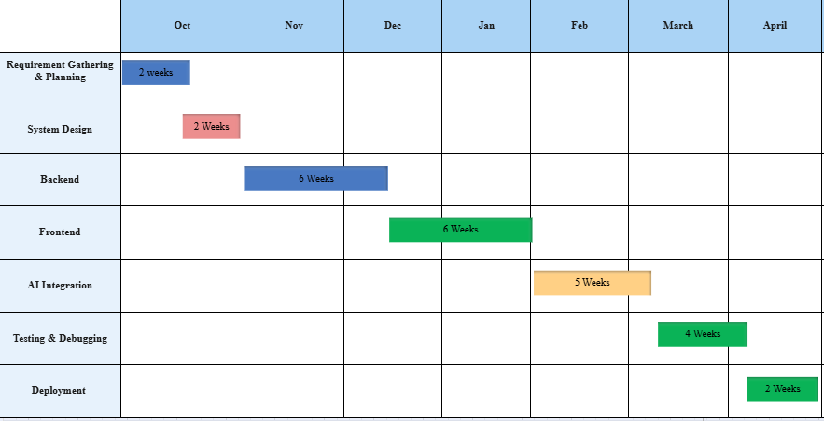

Fig2: Gantt chart

10. References
1. Wang, H., Shang, S., Wang, D., He, X., Feng, K., & Zhu, H. (2022). Plant Disease Detection and Classification Method Based on the Optimized Lightweight YOLOv5 Model. Agriculture, 12(7), 931. https://doi.org/10.3390/agriculture1207093
2. Shoaib, M., et al. (2023). An Advanced Deep Learning Models-Based Plant Disease Detection: Review of Current Techniques and Challenges. Journal of Plant Pathology.
3. Sinamenye, J. H., et al. (2025). Potato Plant Disease Detection: Leveraging Hybrid Deep Learning Model EfficientNetV2B3 + ViT. BMC Plant Biology.
4. Zubair, F., et al. (2025). A Robust Ensemble Model for Plant Disease Detection. MDPI Agronomy.
5. “Artificial Intelligence in Horticulture” (2025). The Journal of Horticultural Science & Biotechnology.

