Lab Assignment: Hybrid Parallel Sorting Using OpenMP and MPI

Explanation of implementation approach:
The program sorts a large array of numbers in parallel, meaning it splits the work between multiple processes (using MPI) and within each process, it uses threads (using OpenMP). This makes the sorting much faster compared to doing it sequentially.

How It Works
1-Set Up MPI
MPI is initialized, and all the processes (think of them as team members) are set up.
Each process knows its role: the master process (rank 0) is in charge of dividing the array and merging the results, while the other processes handle sorting chunks of the array.
2-Divide the Work (MPI Scatter)
The master process splits the array into smaller pieces and sends each piece to a process.
For example, if the array has 16 numbers and there are 4 processes, each process gets 4 numbers to work on.
3-Sort Each Chunk (OpenMP)
Inside each process, OpenMP is used to sort the chunk of the array in parallel using a technique called "merge sort."
OpenMP helps break the sorting task into smaller pieces so multiple threads can work on it simultaneously.
4-Collect the Results (MPI Gather)
After sorting, each process sends its sorted chunk back to the master process.
The master collects all the sorted chunks.
5-Merge the Sorted Chunks (OpenMP)
The master process merges the sorted chunks into one big sorted array.
It uses OpenMP again to speed up this merging process by running parts of it in parallel.

Measuring Time
The program measures how long it takes for the different parts to run:
MPI Time: How long it takes to divide the array, send the pieces to processes, and collect the results.
OpenMP Time: How long it takes to sort the chunks within each process.
Total Time: The combined time for everything.
At the end, the program prints:
The original array (before sorting).
The sorted array (after everything is done).
How much time each phase took.
This program is a great example of teamwork in computing:
MPI handles communication between processes.
OpenMP handles parallel work inside each process.
By combining MPI and OpenMP, the program takes advantage of both distributed and shared memory systems, making it much faster to sort large arrays.

Comparison of performance for pure MPI and hybrid models:

With 16 population:
hybrid models:
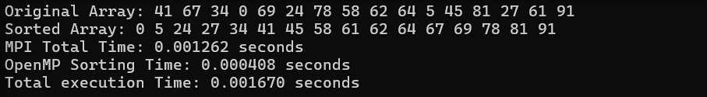
With Pure MPI :
Analysis:
The hybrid model is slightly faster than the pure MPI model for a small population size due to OpenMP accelerating sorting within each chunk.

With 10^6 population size:
hybrid models:
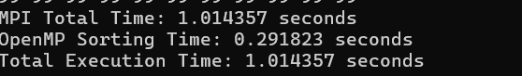
(could not show all the output array because it is so large )
With Pure MPI :

Analysis:
- The hybrid model significantly outperforms pure MPI. OpenMP reduces the intra-process sorting time, decreasing the overall execution time
With 10^8 population size:
hybrid models:
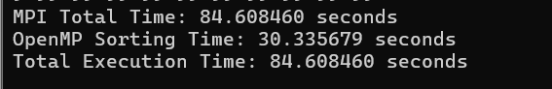
With Pure MPI :

Analysis:
For large population sizes, the hybrid model is considerably faster. OpenMP enables better utilization of multi-threading within each process, while MPI handles inter-process communication effectively.

Conclusion:
For small population sizes: The difference between hybrid and pure MPI models is negligible due to the low computational demand.
For larger population sizes: The hybrid model shows clear superiority. OpenMP accelerates intra-process sorting, and the combination with MPI minimizes inter-process communication overhead.
Overall: The hybrid model is more efficient, especially as the population size increases, leveraging the strengths of both MPI and OpenMP for distributed and parallel computation.

