**Curriculum vitae**

Personal Info:

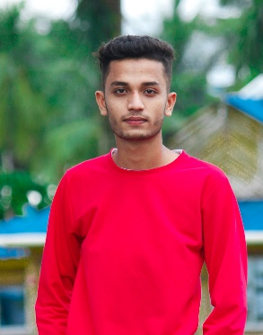**Name:** Ikramul Molla

**Nationality:** Indian

**Religion:** Muslim

**Age:** 17 years

**Marital Status:** Unmarried

**Father’s Name:** Afsar Molla

**Address:** Vill+Post-Chandi, Pol-Bishnupur, Dist-South 24 Pgs, West Bengal, 743503

**Contact info:**

**Phone number:** 6291300688

**Email address:** [ikramulmolla61@gmail.com](mailto:ikramulmolla61@gmail.com)

**Academic qualifications:**

|  |  |  |  |  |
| --- | --- | --- | --- | --- |
| **Name of board** | **Name of the institute** | **Name of the exam** | **Year of passing** | **Marks obtained** |
| WBBSE/CISCE | Udairampur pallisree sikshayatan(H.S) | Madhyamik | 2019 | 65% |
| WBSCTE | BBIT | Polytechnic | 2023 | 8.1 (DGPA) |

**Career Objective:**

Seeking a suitable job in the IT sector in accordance with my competencies,education and experience.

**Professional Experience:**

1. I worked on a project on Hospital management at XYZ company using java/python.
2. Created a movies website for download the movies and a website for our school.

I hereby agree that all the information listed above is true to the best of my knowledge

Signature: Ikramul Molla

Date: 01/12/2021