
CHRIST (Deemed to be University)
BANGALORE, INDIA
Department of Statistics

A Mini Project Report on
Application of Correlation and Linear Regression Techniques
(Reading Score and Writing Score)
Submitted in partial fulfilment of the requirements for
CIA 3 – Component 1 of Descriptive Statistics (STA101-1)

Submitted by:  Krish Gupta  Register No.: 2640227  Class: 1BScCS  Programme: B.Sc. Computer Science, Statistics | Submitted to:  Department of Statistics  CHRIST (Deemed to be University)

September 2026

1. INTRODUCTION
College lab PC, Tuesday afternoon, Kaggle open in one tab and a blank Excel workbook in the other. I needed a public dataset for correlation and simple linear regression, something I could finish in Excel without spending the viva translating domain jargon. Housing prices looked fine until I started naming columns. Square footage, year built, neighbourhood codes. That conversation eats half the slot before anyone asks about Pearson r.
Research question: How strongly are reading and writing exam scores associated in this public dataset, and what simple linear regression equation estimates writing score from reading score?
I switched to Students Performance in Exams, uploaded by spscientist on Kaggle. Reading and writing scores, same students, both out of 100. That was enough of a reason.
Dataset URL: https://www.kaggle.com/datasets/spscientist/students-performance-in-exams
The CSV has 1000 rows. Eight columns if you count everything: gender, race/ethnicity, parental level of education, lunch, test preparation course, maths, reading, writing. I only needed the last two for the model. Reading as X, writing as Y.
Correlation asks whether they move together. Regression fits a straight line so writing can be estimated from reading. Both are on the syllabus. Both are fine in Excel once ToolPak is on.
I did skim a housing sample first. The scatter was fine. I still dropped it because units keep hijacking the discussion. Reading and writing being language scores on the same scale made the chart readable in about ten seconds. Insert > Charts > Scatter on those two columns showed a clear bottom-left to top-right cloud, so I locked the pair and stopped browsing.
Every coefficient in this report comes from analysis.xlsx and matches analysis_summary.json. One predictor. Excel ToolPak. Residual checks a viva panel can point at.

2. DATA DESCRIPTION
Source is the Kaggle file above. Public CSV, which is what the assignment asked for.
Raw shape: 1000 rows, 8 columns. Working pair:
Independent variable (X): Reading Score
Dependent variable (Y): Writing Score
Mean reading score = 69.169 (SD 14.600). Mean writing score = 68.054 (SD 15.196). The averages sit within about one mark of each other. That does not prove a linear link on its own. It just matches the direction the correlation later shows.
Cleaning was light. No missing cells in reading or writing, nothing outside 0 to 100. I renamed headers in Excel so spaces would not break range names when I typed formulas. No log transform. No rescaling. One writing score sits near 10. Lowest reading score in the file is 17. I kept both. Cutting the low writing point would tidy Figure 1 and nudge R² a little, and it would also change n for no good reason. Final n = 1000.
Gender, lunch type, parental education, and test preparation are still on the raw sheet. I left them out of the fitted model. Syllabus examples for this mini project were mostly single-predictor problems, and one X keeps the ToolPak output short enough to talk through cell by cell.
I did run a quick side check of maths versus writing. Correlation was high. Still lower than reading versus writing. Reading and writing are both language measures, so that pair carried a clearer story for a short report.
Sampling note I keep coming back to: Kaggle hosts the file, but the listing does not say how these 1000 rows were drawn. No school list, no board, no year, no sampling design. Every coefficient below describes this file. I am not pretending it describes every exam system.

3. OBJECTIVE
I wanted Karl Pearson’s correlation coefficient and Spearman’s rank correlation between reading and writing, stated in plain language. Then a fitted line in Excel: Writing Score = a + b × Reading Score. Then the ToolPak numbers I would actually be asked about: slope, intercept, R², adjusted R², and the main p-values.
I also needed the scatter with a trendline, plus residual plots I could defend if someone asked whether a straight line was a bad idea for this sample. The click path had to be written down so I could rebuild analysis.xlsx the night before the viva without guessing.
Causation is outside the design. Multiple regression too. This is a one-predictor Excel walkthrough.

4. METHODOLOGY
Full analysis ran in MS Excel. Analysis ToolPak handled Correlation and Regression.
First snag: on the college lab PC, ToolPak was off by default. Data Analysis was missing from the Data tab until I flipped it on. Path: File > Options > Add-ins > Manage: Excel Add-ins > Go > tick Analysis ToolPak > OK. After that, Data Analysis showed up where the syllabus screenshots said it would.
Workbook layout in analysis.xlsx is a bit messy on purpose.
RawData is the untouched Kaggle dump. CleanData is where I actually work: reading_score in column A, writing_score in column B, then maths and gender parked to the right for side checks. After Regression finished I stuck predicted_writing and residual in columns E and F on that same sheet so I could chart them without hopping around. Correlation holds the Pearson matrix plus Rank_R / Rank_W. Regression is the raw ToolPak dump. Interpretation is a scratch sheet with three lines I wrote to myself about the intercept p-value.
How the clicks went:
Scatter first. Select the two score columns, Insert > Charts > Scatter, reading on the horizontal axis, writing on the vertical. The cloud runs upward. No obvious bend that would force a curve as the first model.
Pearson next. I typed =CORREL on CleanData. First attempt used the wrong writing range (one row short at the bottom). The number came back a little off from what I expected after looking at the scatter, which is how I caught it. Fixed the range, re-ran, then confirmed with Data > Data Analysis > Correlation on the same full ranges.
Spearman: Rank_R and Rank_W with =RANK.AVG on each score column. Copy those rank columns and Paste Special > Values right away so a later sort cannot move them. Then =CORREL on the two rank columns. I also ran Correlation via Data Analysis on the ranks as a second check.
Regression: Data > Data Analysis > Regression. Input Y Range = writing scores, Input X Range = reading scores, Residuals ticked, output on its own sheet. From the summary table I recorded intercept, slope, R², adjusted R², F, and the p-values.
Charts after that. Linear trendline on the scatter with equation and R² displayed. Residuals plotted against fitted writing scores. Residual histogram and residual Q-Q plot saved for the figures folder.
Excel detail that cost time: RANK.AVG with relative references will drift if you sort the sheet afterward. Paste values immediately. I also re-ran Regression after sorting CleanData in a different order. Slope and intercept did not change. Good.
Figures in this report:
Figure 1. Scatter plot of Reading Score vs Writing Score with fitted linear trendline.
Figure 2. Residual plot (residuals against fitted writing scores).
Figure 3. Comparison of Pearson r and Spearman rho.
Figure 4. Histogram of residuals.
Figure 5. Q-Q plot of residuals.
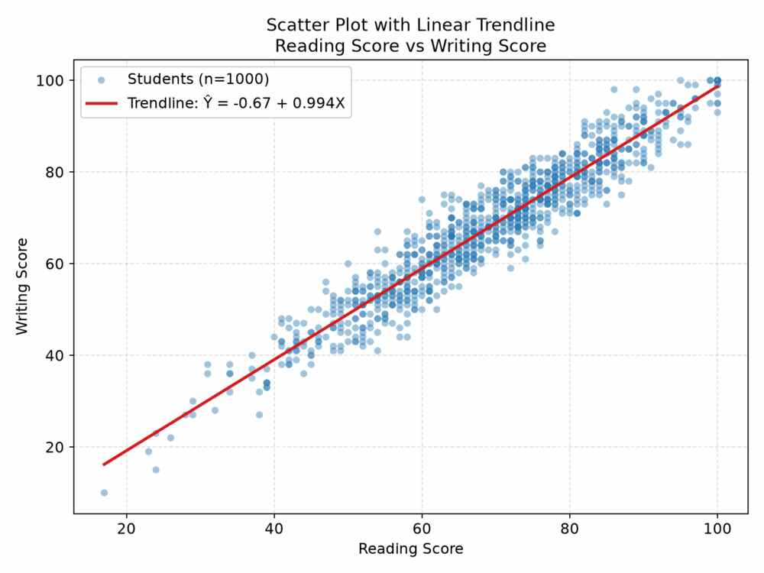
Figure 1. Scatter plot of Reading Score vs Writing Score with fitted linear trendline.
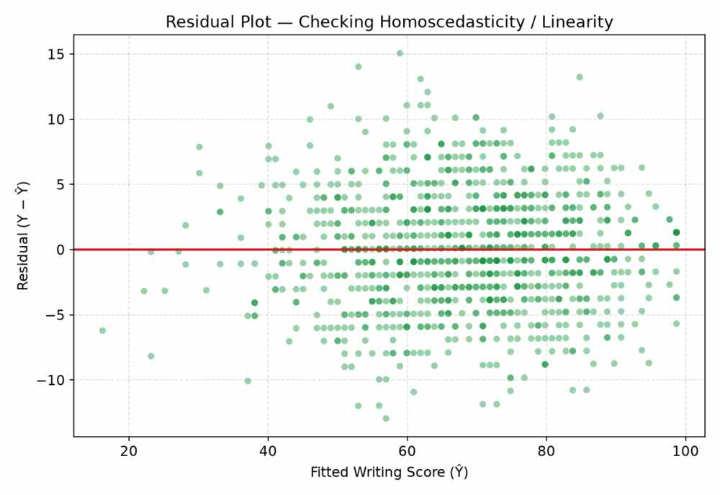
Figure 2. Residual plot (residuals against fitted writing scores).
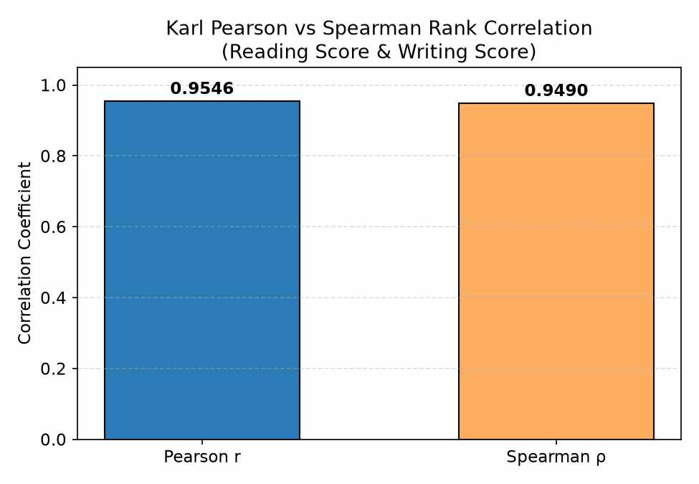
Figure 3. Comparison of Pearson r and Spearman rho.
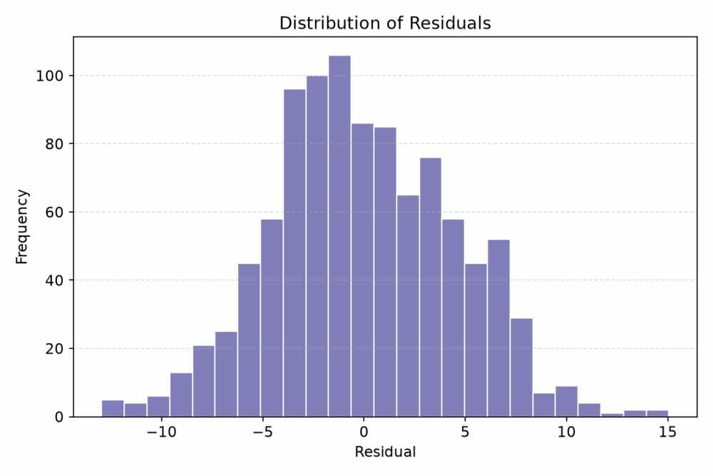
Figure 4. Histogram of residuals.
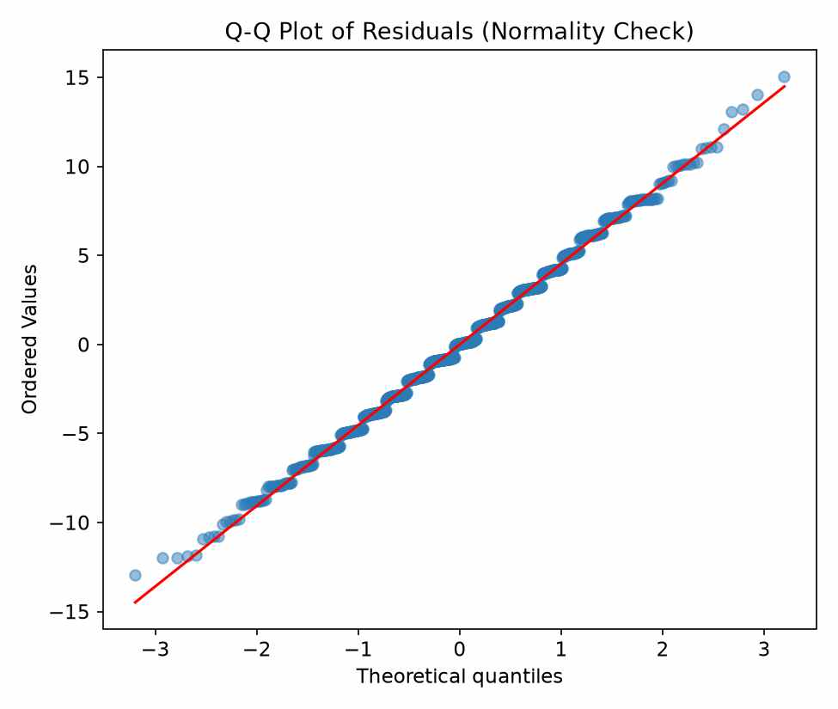
Figure 5. Q-Q plot of residuals.

5. ANALYSIS AND INTERPRETATION
Pearson r = 0.9546. ToolPak reports the p-value as essentially 0. The null of no linear association is rejected at ordinary levels. Direction is positive. Strength is very strong. Figure 1 shows the same thing without numbers: higher reading scores sit with higher writing scores, and the fitted line tracks the cloud.
Spearman ρ = 0.9490, also with p essentially 0. Close to Pearson. When those two stay near each other, a handful of extreme ranks are unlikely to be driving everything. If Spearman had fallen well below Pearson I would have gone hunting outliers next. The gap here was small, so I left the sample alone.
Fitted equation:
Writing Score = -0.6676 + 0.9935 × Reading Score
Slope = 0.9935. In this sample, a one-mark rise in reading is associated with about a one-mark rise in writing, on average.
I double-checked that against analysis_summary.json before locking the report. The JSON has slope 0.993531..., se_slope 0.009814..., t_slope 101.2325.... ToolPak on the Regression sheet matches those once you round. p-value for the slope is essentially 0.
Intercept = -0.6676. Negative intercept looks strange until you notice reading score = 0 never appears in the file. Lowest reading score = 17, so the intercept is an extrapolation outside the observed X range. p-value for the intercept = 0.3362, not significant at 5%. For the report and for viva answers I quote the slope and treat the intercept as a mathematical constant of the fitted line. I would not call it a meaningful writing score at reading = 0.
R² = 0.9113. Adjusted R² = 0.9112. About 91% of the writing-score variation in this sample is accounted for by reading score. The leftover 9% is everything one predictor cannot cover.
F on the ANOVA block is about 10248 (JSON lists 10248.019...). p essentially 0. The regression as a whole clears the usual significance bar in ToolPak.
Residual checks from the figures:
Figure 2: residuals fan around zero. No clear smile or frown shape across fitted values.
Figure 4: residual histogram piles near zero.
Figure 5: Q-Q plot looks acceptable through the middle and a bit off in the tails.
That is enough for a syllabus mini project. The linear fit does not look obviously wrong. Perfect normality of errors is not required here, and nothing in the plots forces me to switch to a curve.
One thing I am still slightly nervous about for the viva is explaining Figure 5 if someone zooms in on the tails. The middle of the Q-Q looks fine. The ends wander a bit. My plan is to say that and stop, rather than invent a story about a different model I did not fit.
A few points sit well below the line. They stay in the sample. Dropping them only to lift R² would misrepresent the 1000-row file Kaggle actually provides.
Quick plug-ins with the equation (rounded):
Reading 70 → predicted writing ≈ 68.9
Reading 85 → predicted writing ≈ 83.8
Reading 50 → predicted writing ≈ 49.0
Those land in a sensible band for the middle of the data. Near the extremes I would treat predictions more carefully. Fewer points there, and the intercept itself is poorly estimated.
Table 1. Correlation results (n = 1000)
Measure | Coefficient | p-value | Interpretation
Karl Pearson r | 0.9546 | ≈ 0 | very strong positive linear association
Spearman ρ | 0.9490 | ≈ 0 | very strong positive monotonic association

Table 2. Simple linear regression summary
Term | Estimate | Std. Error | p-value
Intercept (a) | -0.6676 | 0.6938 | 0.3362
Slope (b) | 0.9935 | 0.0098 | ≈ 0
R² = 0.9113 | Adj R² = 0.9112 | F ≈ 10248 (p ≈ 0)

Equation: Writing Score = -0.6676 + 0.9935 × Reading Score
Figure 3 is mostly for the viva slide. Pearson and Spearman look almost the same on it, which matches the 0.9546 vs 0.9490 gap being tiny.
I also re-opened the Regression dialog once because a near-unit slope made me wonder if I had pointed Y at writing and X at writing by mistake. I had not. Reading in, writing out. The two language scores in this file really do track that tightly.

6. CONCLUSIONS AND RECOMMENDATIONS
Reading and writing move together strongly in this sample. Pearson r = 0.9546. Spearman ρ = 0.9490. The line is Writing Score = -0.6676 + 0.9935 × Reading Score. R² = 0.9113, adjusted R² = 0.9112.
If I quote one number in practice, it is the slope. The intercept (p = 0.3362) is not significant and sits outside the observed reading range, so I leave it alone in interpretation.
Scatter looks linear enough. Residuals do not push me toward a different curve for this assignment.
What I would use this for next is mostly practice. The association is visible on the scatter, and ToolPak tables are easy to read aloud in a viva. If the goal later shifts from demonstration to prediction, columns like test preparation or background factors would need to come in, and models would need comparing. One predictor is enough for the syllabus demo. It is thin as a forecasting tool.
I am keeping the causal claim off the page. An association of this size in these 1000 rows does not mean that raising reading by one mark raises writing by 0.99 for every student in every school.
Main limitation stays the sampling frame. Kaggle does not publish how these rows were drawn. No documented population, no school list, no sampling probability attached to the CSV. I cannot honestly export the same strength to my college, another board, or another country. The numbers describe this file.
If the project continued I would split the regression by test-preparation status and check whether the slope changes across those groups. That step is not part of this submission.
Note: This submission is individual (faculty-confirmed), not a group of 4.

8. AI DISCLOSURE
Drafting and editing assistance was used via AI writing tools during preparation of this report. All statistical analysis was run by the student in MS Excel (Analysis ToolPak) on the Kaggle dataset. All numerical results were verified against the Excel workbook. The student takes full responsibility for the interpretation and the final text.

7. REFERENCES (APA)
Kaggle. (n.d.). Students performance in exams [Data set]. https://www.kaggle.com/datasets/spscientist/students-performance-in-exams
Gupta, S. C., & Kapoor, V. K. (2002). Fundamentals of mathematical statistics (11th ed.). Sultan Chand & Sons.
Triola, M. F. (2018). Elementary statistics (13th ed.). Pearson.
Microsoft. (n.d.). Use the Analysis ToolPak to perform complex data analysis. https://support.microsoft.com/office/use-the-analysis-toolpak-to-perform-complex-data-analysis-6c67ccf0-f4a9-487c-8dec-bdb5a2cefab6
Zar, J. H. (2010). Biostatistical analysis (5th ed.). Pearson Prentice Hall.

