CIA-II AUGUST 2026
COURSE NAME: COMPUTATIONAL STATISTICS
PROGRAM NAME: BSCCS
REGISTER NUMBER: 2640227

OBJECTIVE: Utilise concepts studied in the first half of the first semester to clean up a dataset.

STEPS:
- Import dataset / Open dataset in Excel
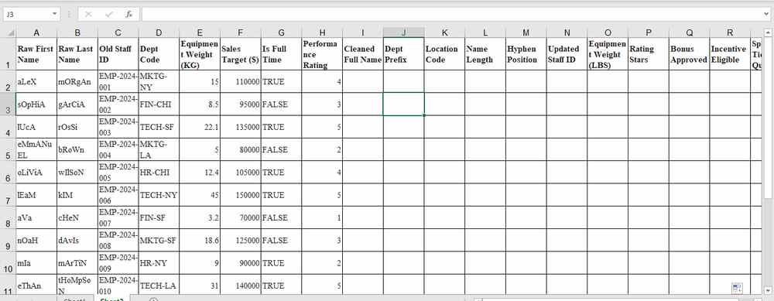
- A) To create Clean Full Name, we first use =TRIM(A2) function to remove any extra spaces from the raw name, then we wrap it inside a PROPER function to change the case, =PROPER(TRIM(A2)), now we repeat the same for raw last name, =PROPER(TRIM(B2)), finally combine them with CONCAT function, =CONCAT(PROPER(TRIM(A2)), " ", PROPER(TRIM(B2))), finally let’s trim it again to remove extra space added if only first name is provided. =TRIM(CONCAT(PROPER(TRIM(A2)), " ", PROPER(TRIM(B2))))
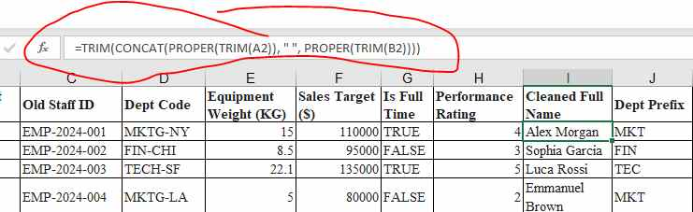
We can also use =TEXTJOIN(“ “, TRUE, PROPER(TRIM(A2)), " ", PROPER(TRIM(B2))) for the same result

B) To extract first 3 letters of dept code, use LEFT function.
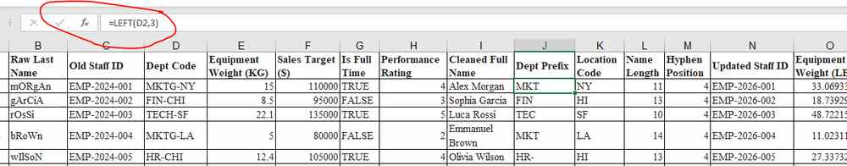

C) To extract last 2 letters of dept code, use RIGHT function
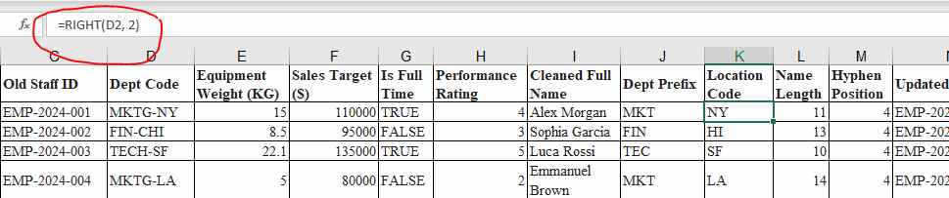
D) To find length of name, we will use the LEN function
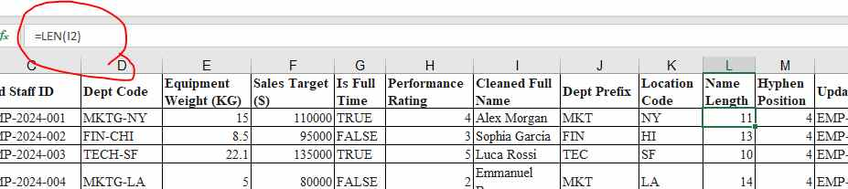

E) To find position of `-` in old staff id we will use SEARCH function
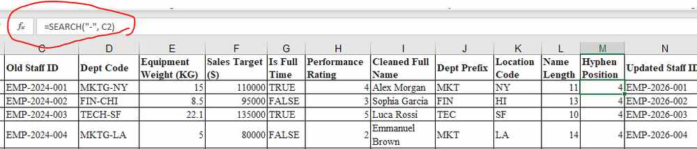

- To replace outdated year code, we will use SUBSITUTE function
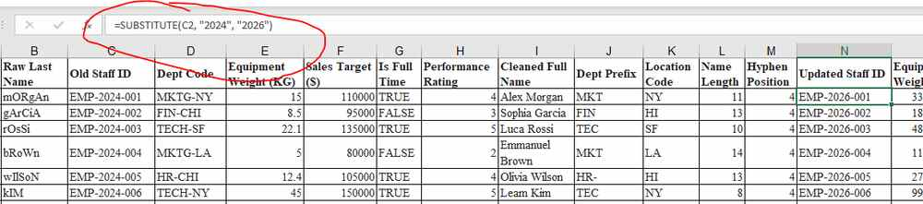

To convert from KGS to Pounds, we use the CONVERT function
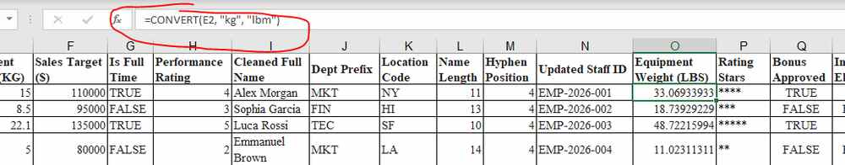

- To create * indicator from rating stars, we will use the REPT function
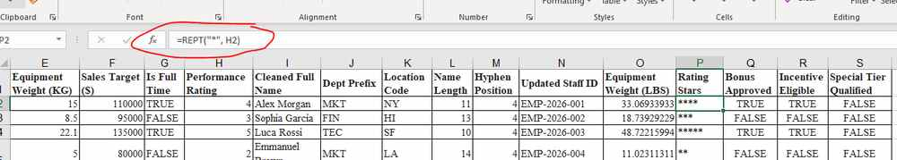

- A) We will use AND function to combine greater than logic condition and the value in FULL TIME
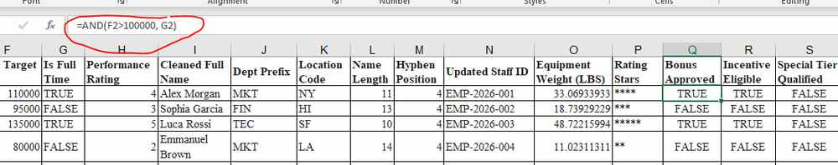

B) We will use OR function to utilise either greater than logic condition or the value in FULL TIME
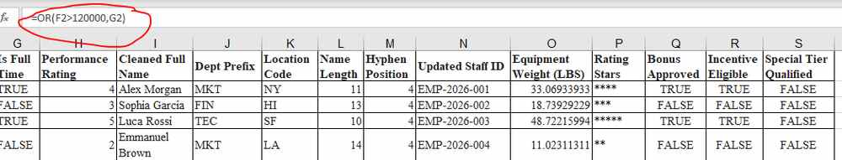

C) We will use XOR function to utilise either greater than logic condition or the value in FULL TIME, but not both at the same time
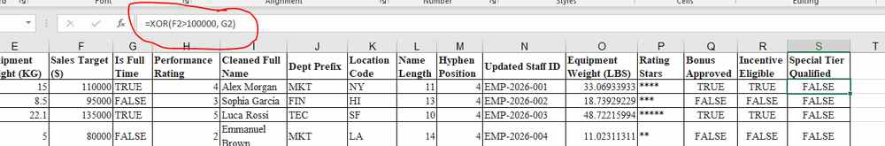
Note: Utilise flash fill for each column…
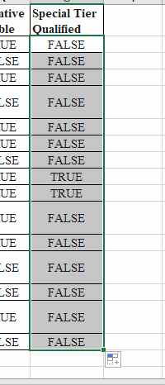
BEFORE:
RESULT:

