ESE Computational Statistics
Register: 2640227

AIM: Clean, analyse and represent data set of a sales division in a company.

A1)
To remove duplicate data, select full dataset and then go to Data -> Remove Duplicates
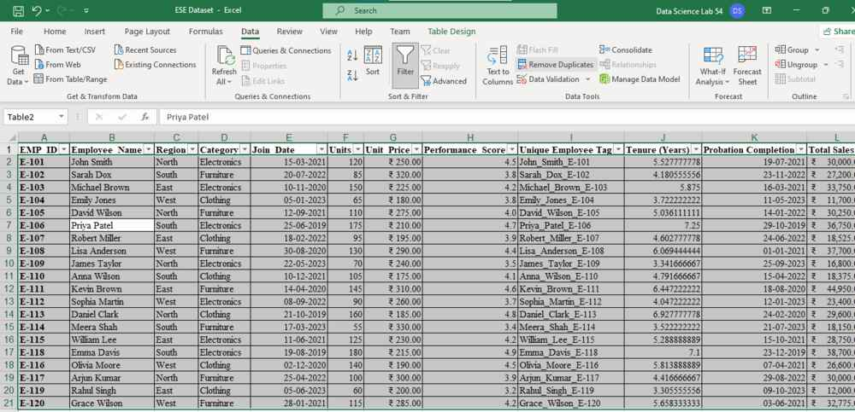

To format data in column, select column, go to home and select the desired formatting type
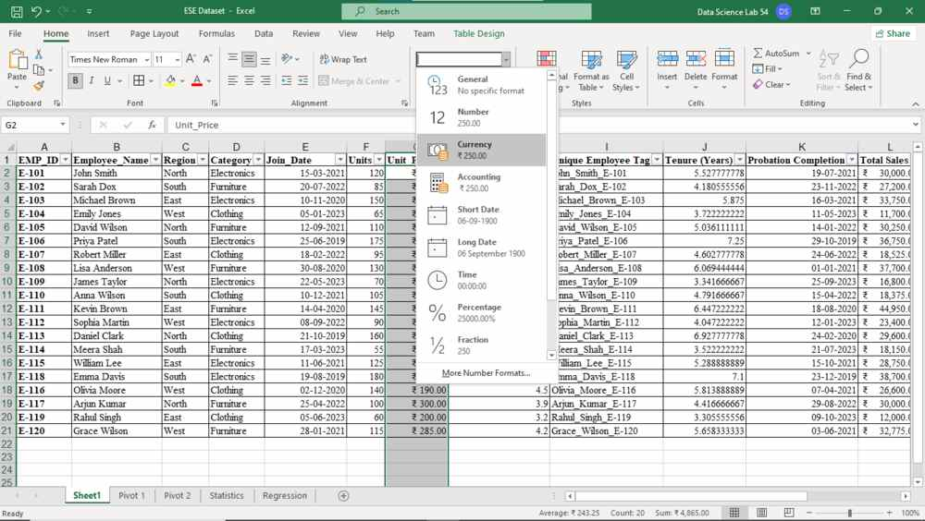

To create UNIQUE Employee Tag, use formula:
=TEXTJOIN("_",TRUE, SUBSTITUTE(B2, " ", "_"), A2)
And then flash fill the column
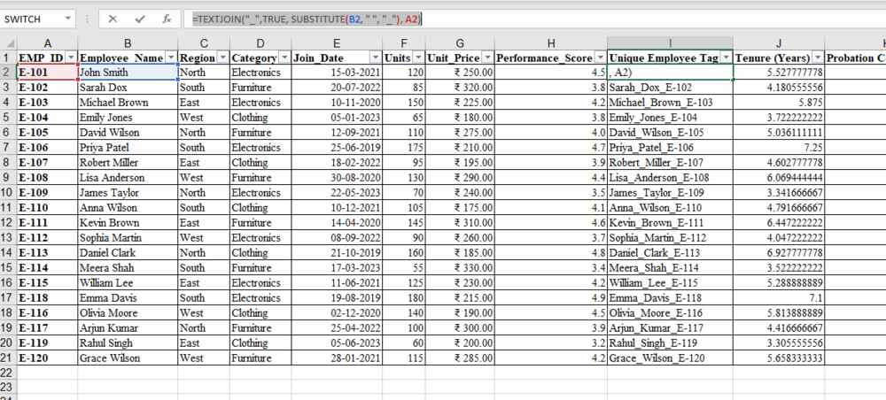

A2)
To calculate Tenure in years, you can use the =YEARFRAC function. Give it the start date and keep end date as TODAY()
=YEARFRAC(E2,TODAY()) and flash-fill
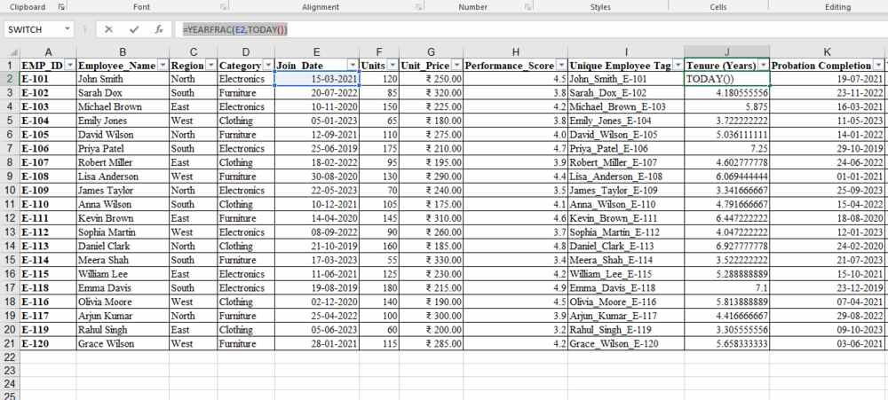
For probation completion date, use =WORKDAY(E2, 90), it takes start dates and adds 90 days, skipping any non working days and then set display format to date
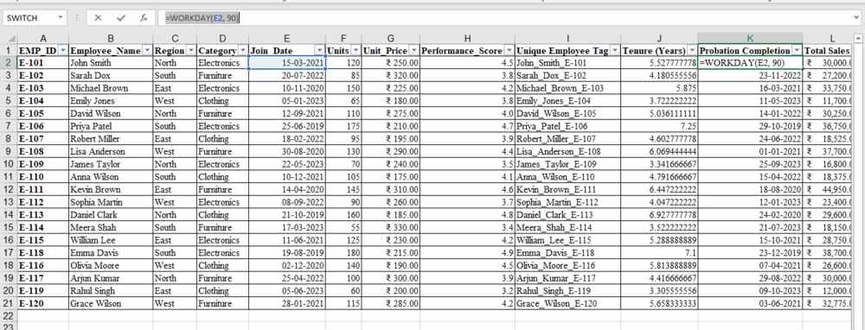
Total Sales is a production of Units and Unit Price
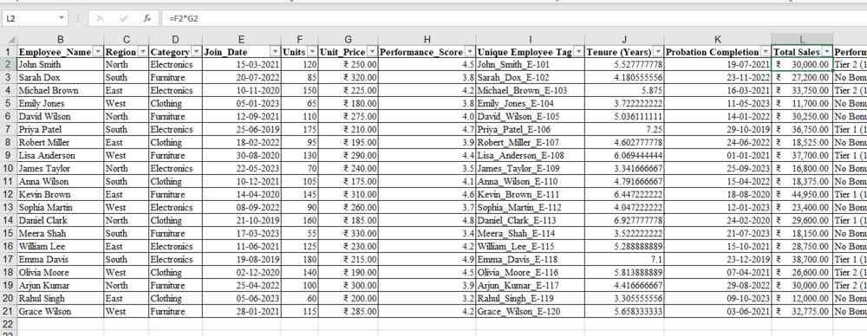
For classification of the tiers based on Total Sales, Tenure and Performance Score, a coefficient is derived:
=[@[Tenure (Years)]]*[@[Performance_Score]]*[@[Total Sales]]
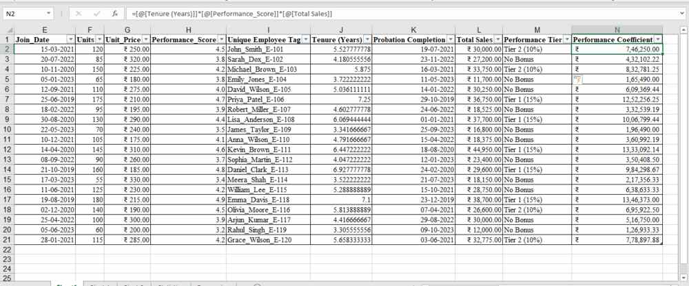
Then performance tier is given Tier 1 if you are higher than the 3rd Quartile of the coefficient series, Tier 2 if you are above average in the coefficient series and No Bonus if neither is met
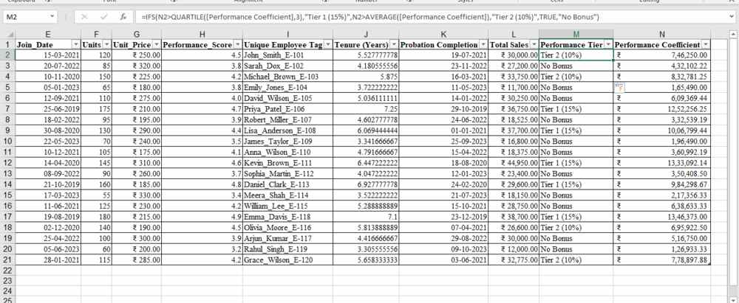

A3)
Click on Insert Pivot Chart drop down, Insert Pivot Chart and Table: 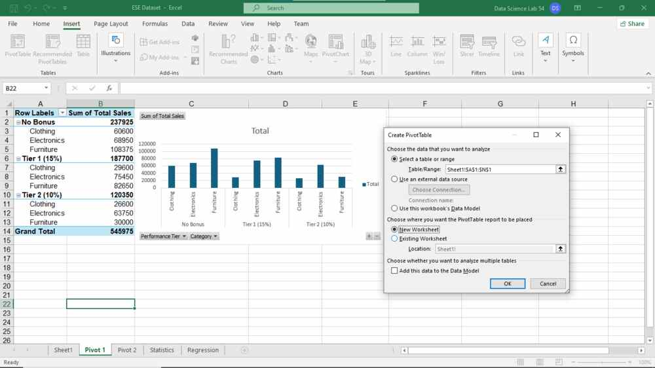
Select the range of the table, and the location of the pivot.
An empty pivot will be created. Then choose columns, rows and values in the pivot settings
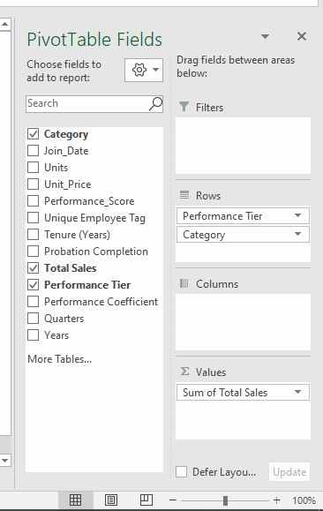

Two pivot tables and charts have been created:
One that divides sales between tiers and categories:
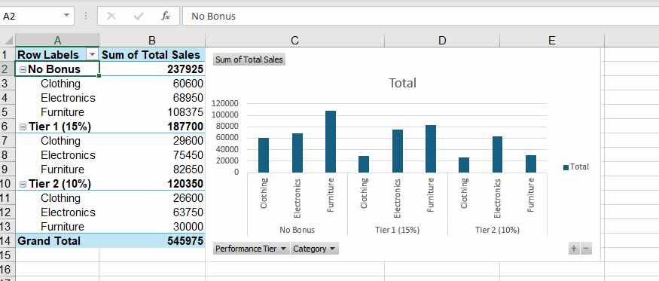
Second that distributes sales between regions
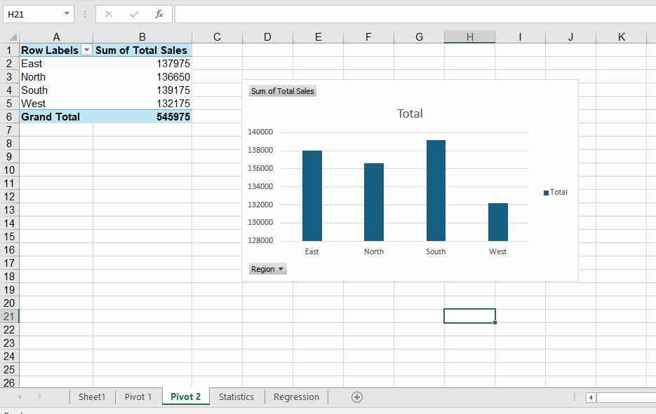

A4)
To define MEAN, MEDIAN, MODE, Standard Deviation, Variance, Q1, Q3, IQR, we can use the following formulae:

MEAN: =AVERAGE(Table2[Total Sales])
MEDIAN: =MEDIAN(Table2[Total Sales])
MODE: =MODE.SNGL(Table2[Total Sales])
Sample Standard Deviation: =STDEV.S(Table2[Total Sales])
Variance: =VAR(Table2[Total Sales])
Q1: =QUARTILE(Table2[Total Sales], 1)
Q3: =QUARTILE(Table2[Total Sales], 3)
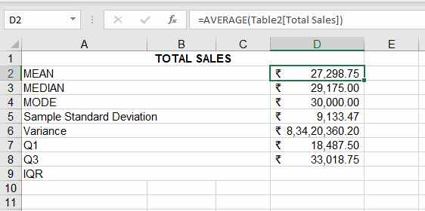
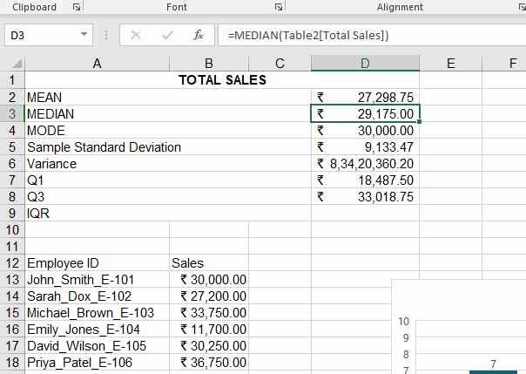
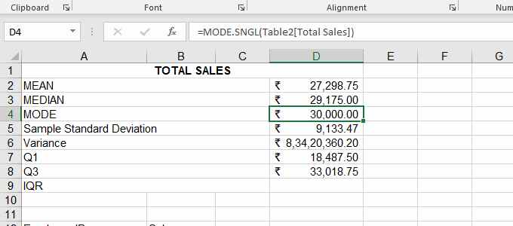
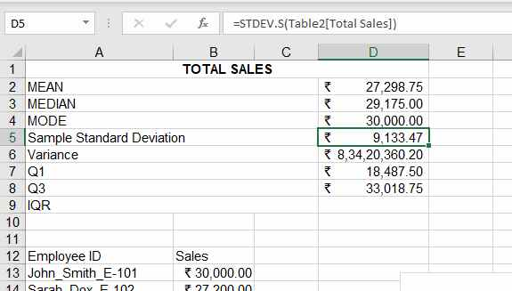
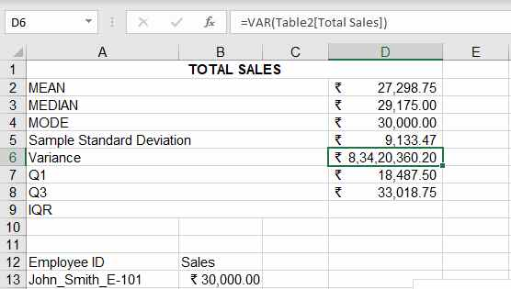
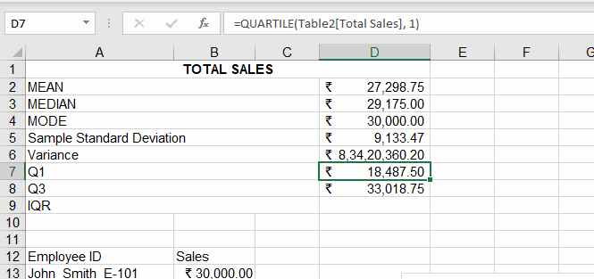
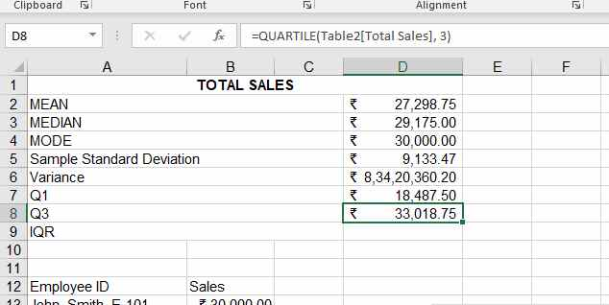

To create Histogram, first isolate data that you want to put in histogram:
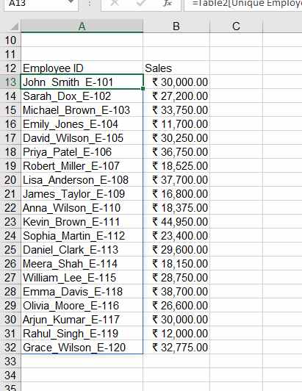

Then click on Insert -> Insert Chart -> Histogram:
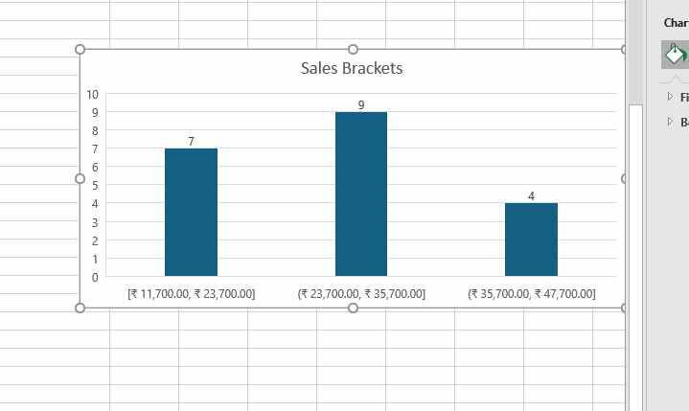
A5)
For regression, again isolate Units & Total Sales
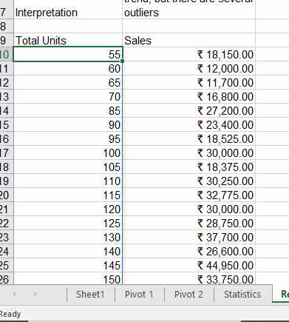
Use functions:
Correlation: =CORREL
Slope: =SLOPE
Intercept: =Intercept

Provide them with the X & Y we isolated: 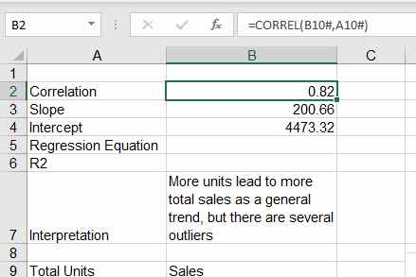
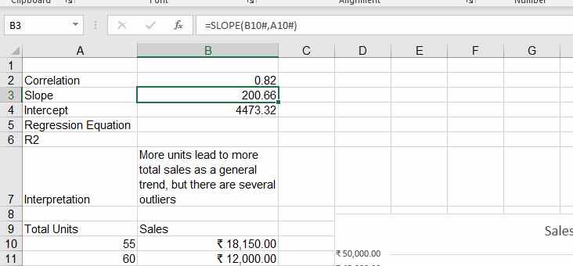
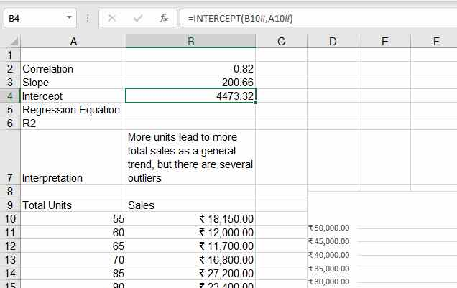

Finally add a two line small interpretation. You can also add a graph:
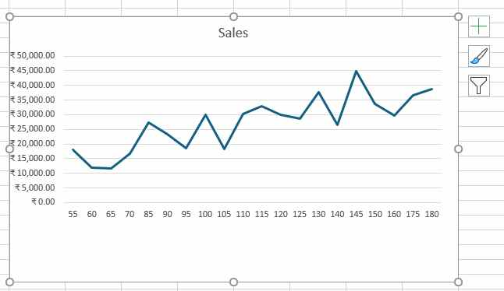
AIM: Workbook submitted on Google Classroom

