Assignment – 1
Objective: Explain File Types, Name Box, Active Cell & Range of Cells, Formula Bar, Font Group, Number Group, Alignment Group, Styles Group, Cells Group

- File Types
File types dictate the format/type of content stored inside a file. For example, a .xlsx file will hold a spreadsheet from Excel, while .docx will hold word files. There are many file types for various different purposes…
PNG, JPG, WEBP, AVIF, GIF: Images
MOV, MP4, MKV: Videos
MP3, M4A, WAV: Audio
Etc.

- Name Box
Name Box shows the name of the current active cell. If select the cell on the D column in the row 7, it will show D7, the columns are letters and rows are numbers. The name of the cell is ${COLUMN}${ROW} so D col, row 7 makes D7. The name box will display the name of the active (selected) cell.
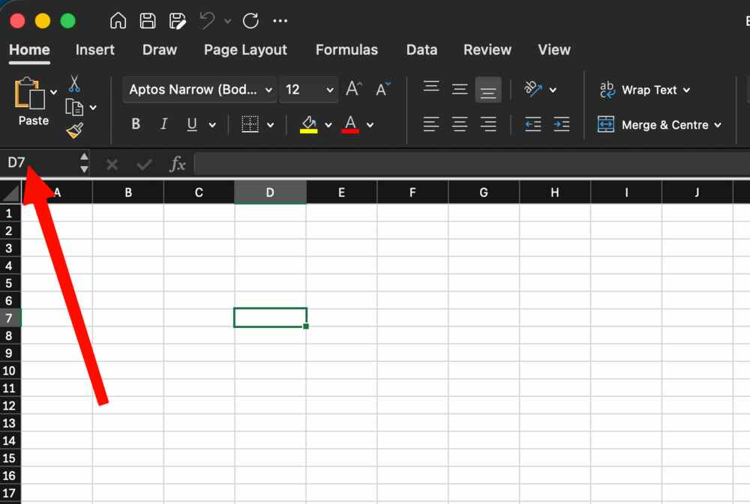

- Active Cell & Range of Cells
Active Cell is the cell that you have selected. The active cell is what will change. It will have a green outline around it and if you type anything it will go inside this cell. Similarly all formatting will be applied to this cell as well.
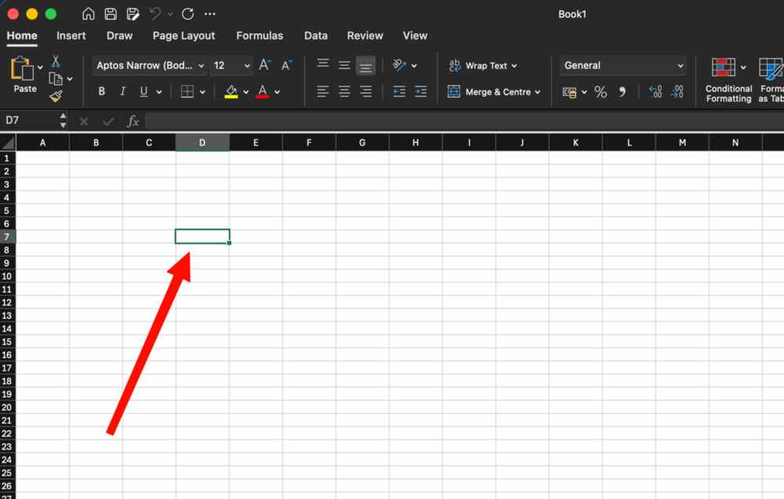
Range of cells is a collection of cells. You enter the starting cell name and then : and then the ending cell name to reference it. Eg. D7:J18 here. You can select a cell range to format it, or change its properties, or even reference it to run formulae.
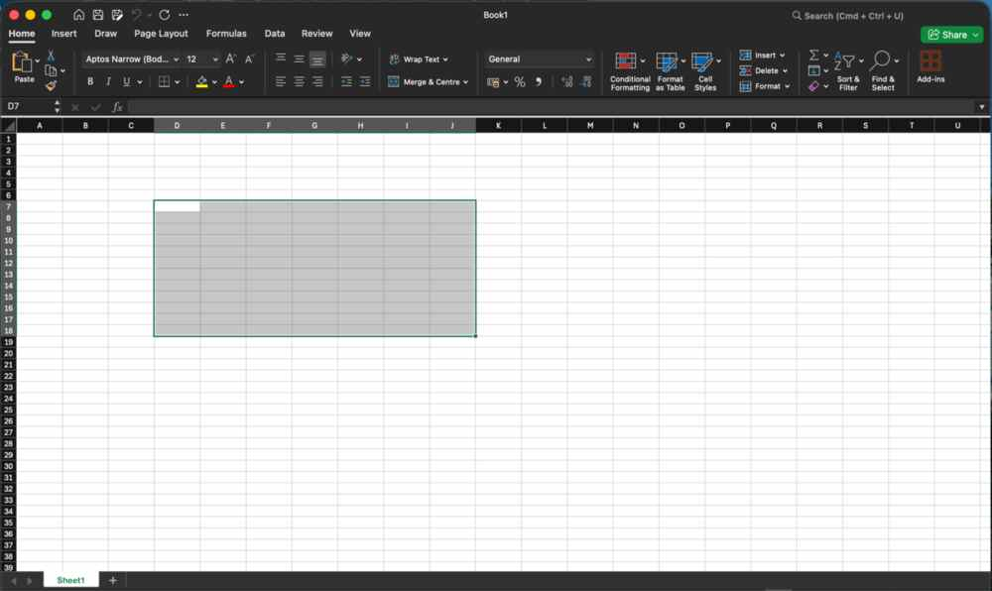

- Formula Bar
The formula bar is used to enter a formula that is executed by Excel, you can run mathematical equations or use functions here.
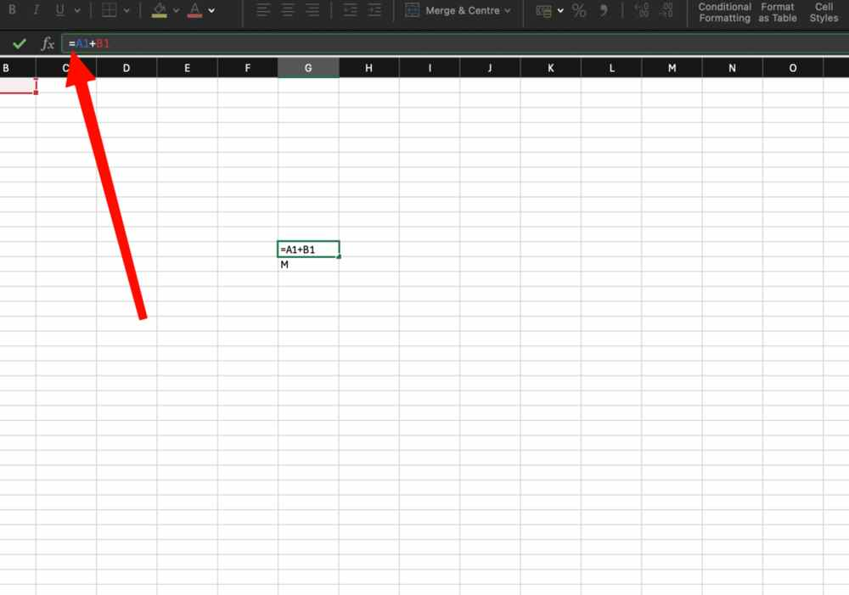
- Font Group
Font group is used to change the font formatting of the content of cell(s). You can change font name, weight, size. You can also highlight the font or change its colour.
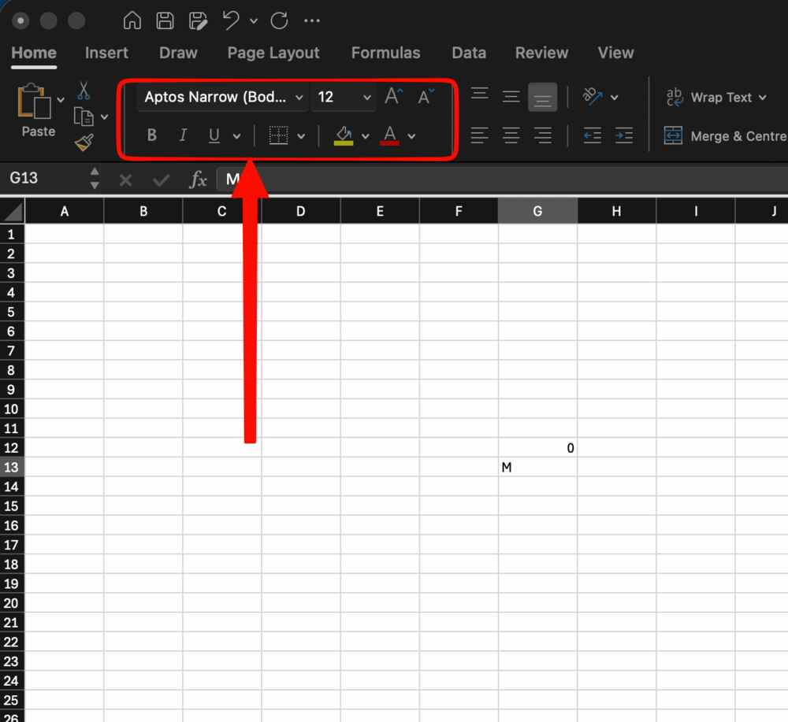
- Number Group
Similar to font group, it has options to customize the font display. Including number formatting, percentage and decimals.
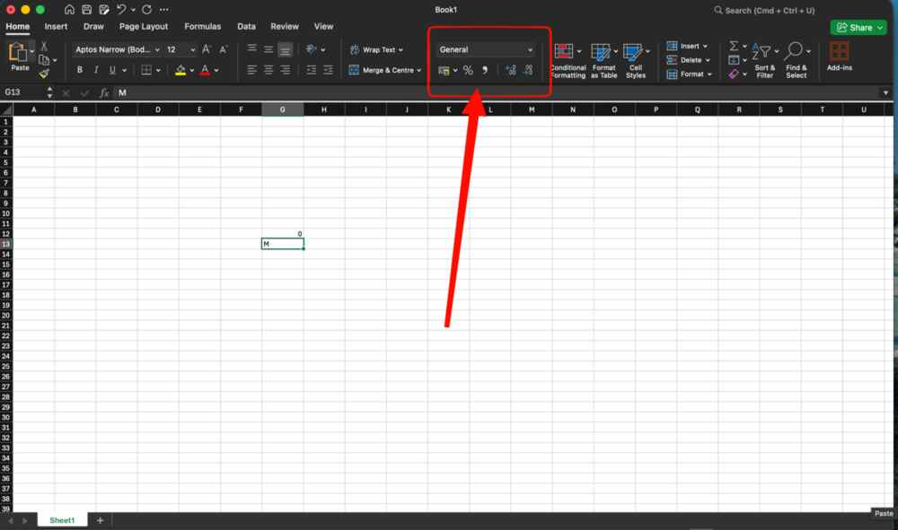

- Alignment Group
Similar to Font and Number groups, this group contains options to change the alignment of the text. You can centre, right, left, or justify align. You can also change vertical alignment and indentation. You can also angle the text.
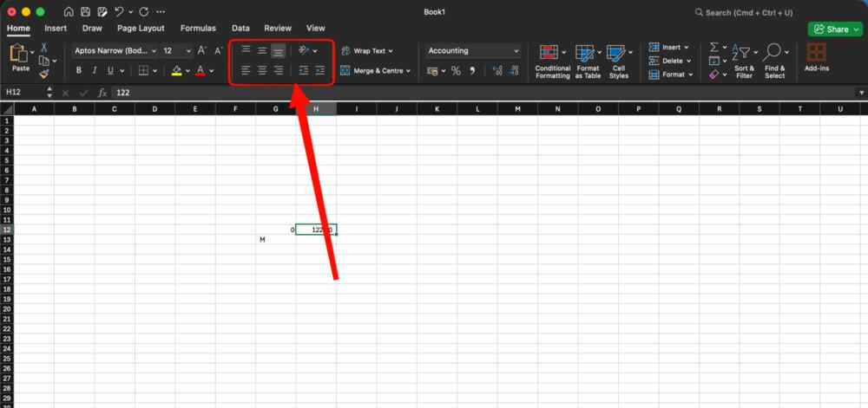

- Styles Group
The styles group is used to style/design the cell. You can style it as table, do conditional formatting or change the style of the cell itself.
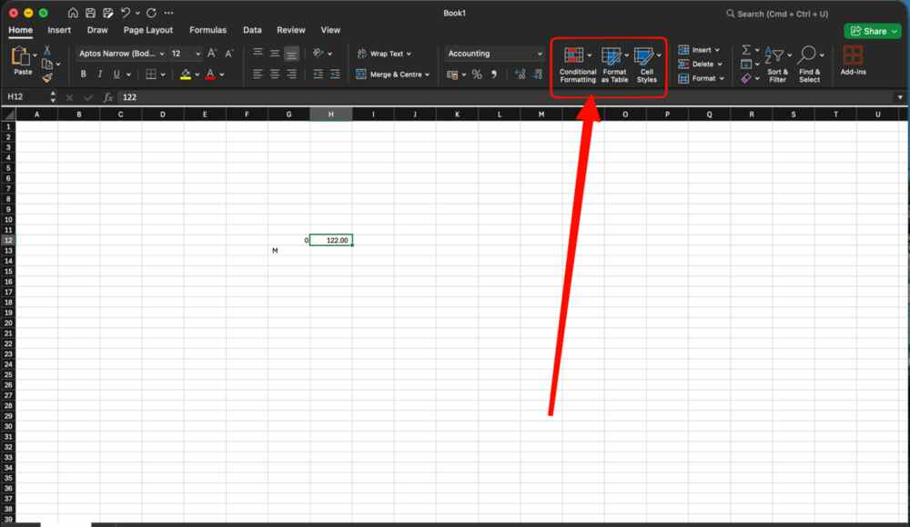

- Cells Group
This has the options to insert columns/rows (cells) etc. into the spreadsheet. It also look at cell deletion and the height/width of columns/rows (cells).


