Assignment – 2
Objective: Assignment – 2
- Create the above dataset in a new Microsoft Excel worksheet.

Typing out the whole dataset by hand is unnecessary, we will import the dataset, however the data does not have delimiters or fixed width, we will fix the inconsistency by hand.

  - Copy Pasted Data in Text file
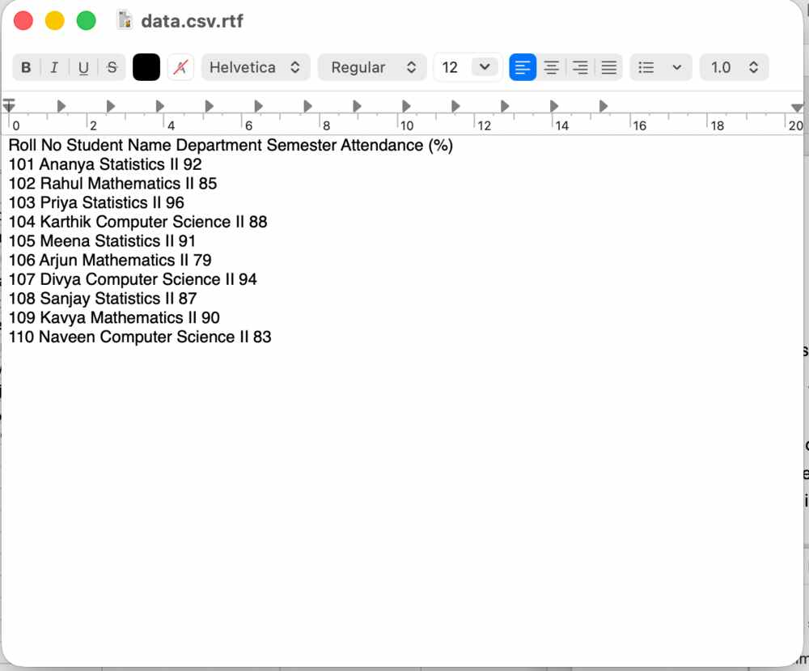
  - Import wizard
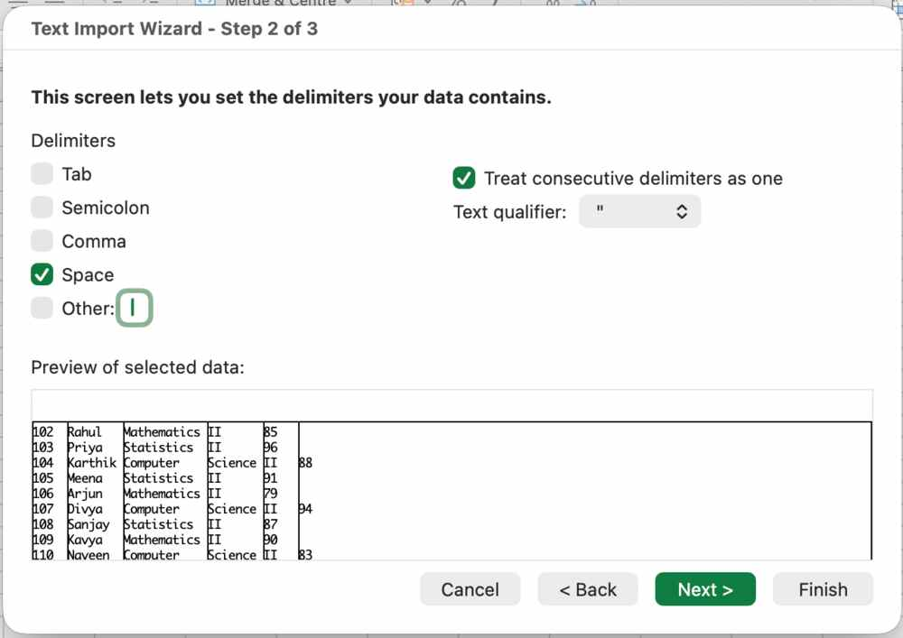

  - Imported data set
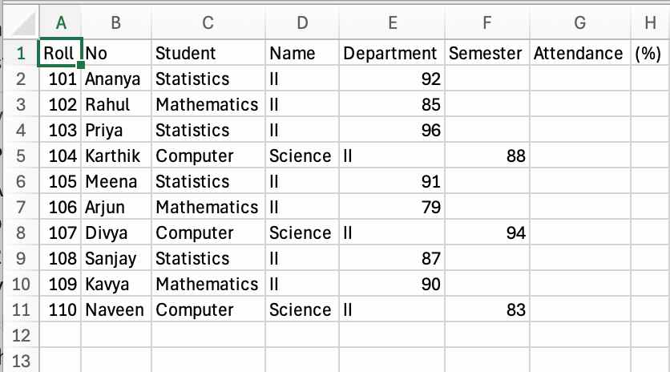
  - Fix the discrepancies
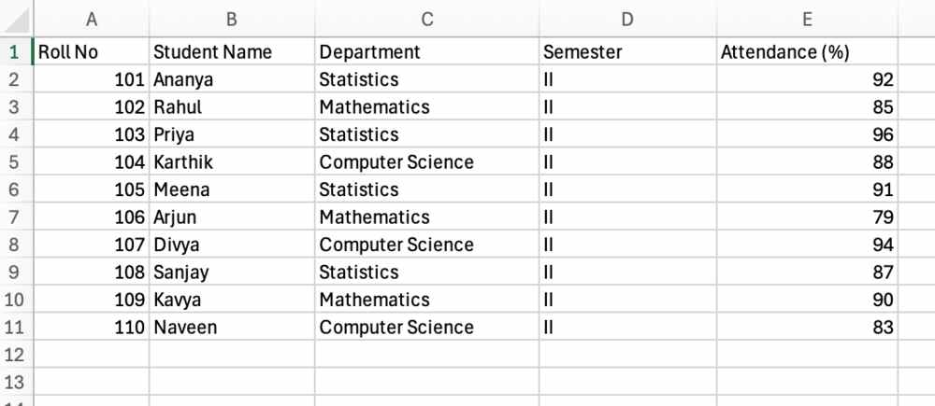
- Rename the worksheet as Student Attendance.
Double click on the sheet name and type
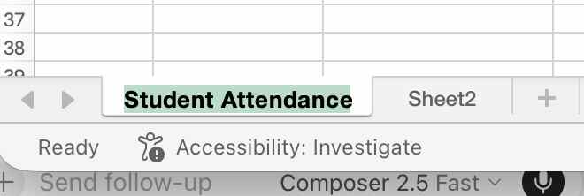

- Using the Home tab, format the worksheet by performing the following:
  - Make the heading row Bold.
    - Select the heading row
    - Either click the B icon or press CTRL B
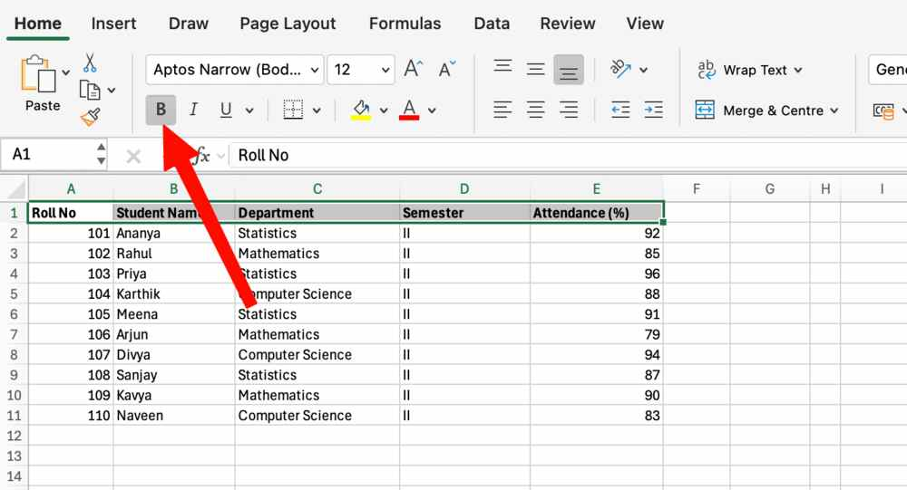
  - Change the heading font size to 16.
    - Select the heading row
    - In the home tab click on font
    - Select 16
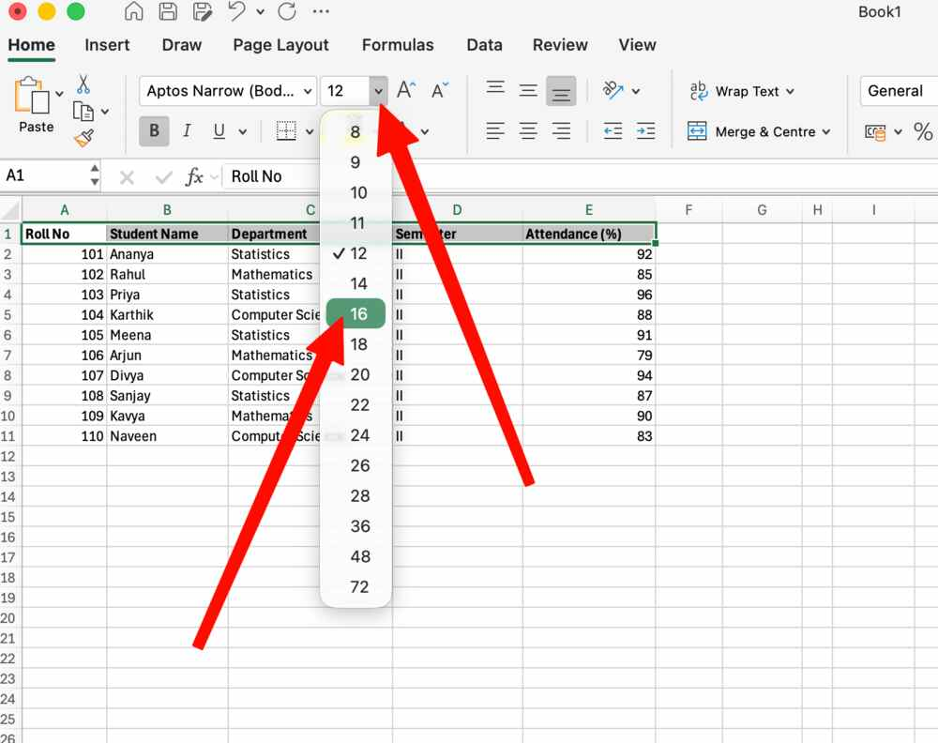

  - Apply a suitable background color to the heading row.
    - Select the heading row
    - Click the bucket icon in the home tab
    - Choose a suitable colour
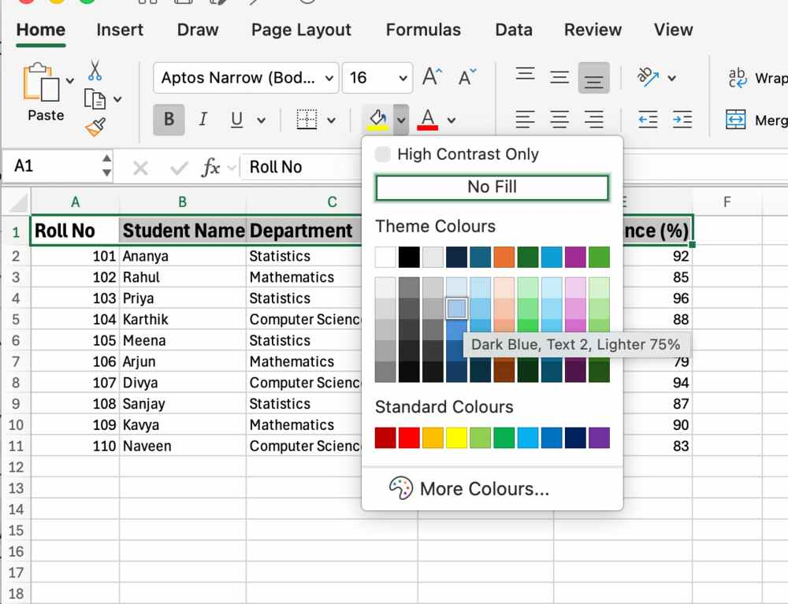
  - Center-align all column headings.
    - Select the heading row
    - Click the align to middle icon to center align
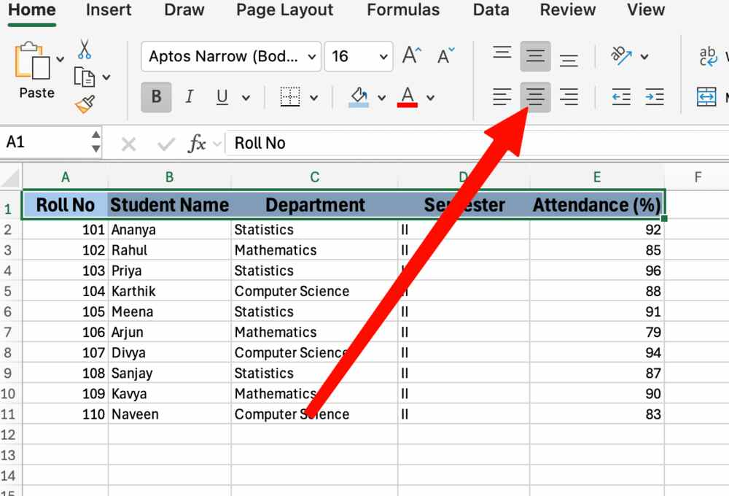

  - Apply All Borders to the entire dataset.
    - Select the dataset
    - Click the border icon
    - Click on All borders
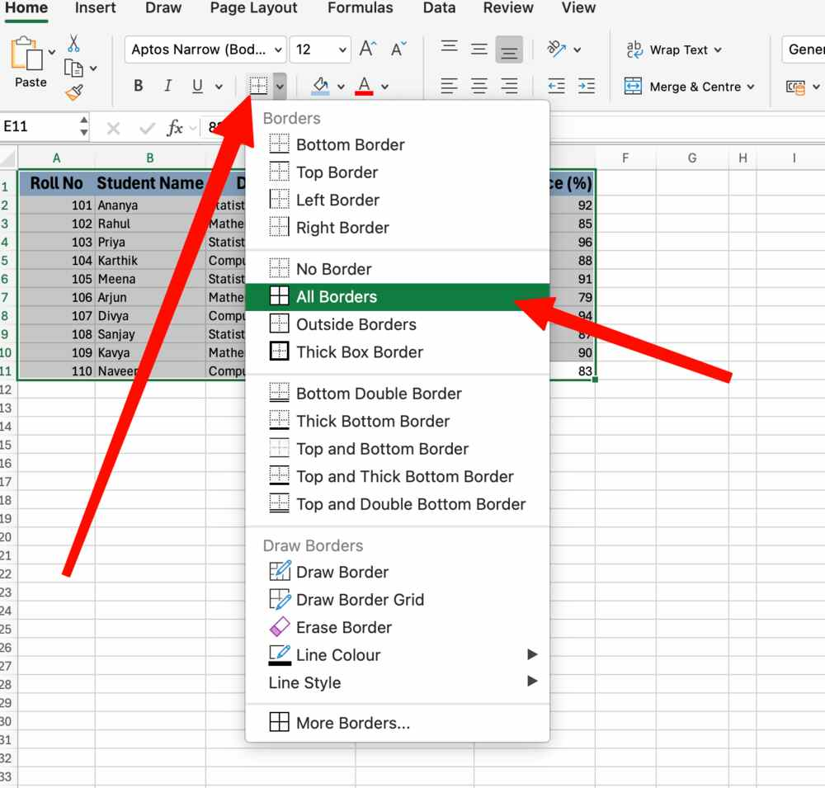
- Using the Mini Toolbar, change the font style and font color of the Student Name column
Mini Toolbar Not available in MacOS, changed without it.
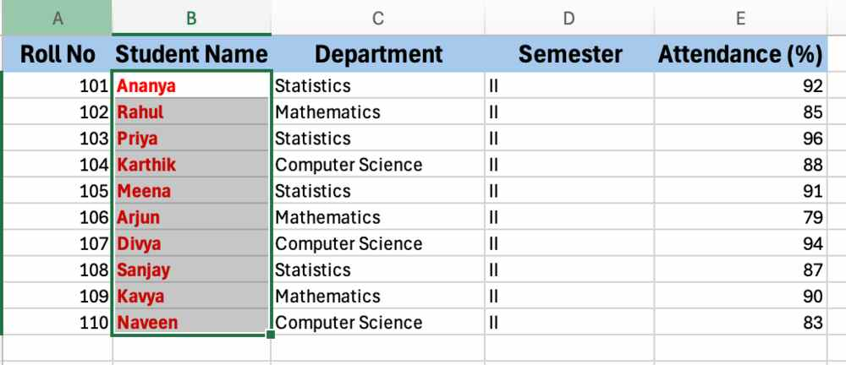
- Sort the dataset in ascending order of Student Name.
  - After selecting the dataset
  - Click on Sort in Data tab
  - Select the column name “Student Name”
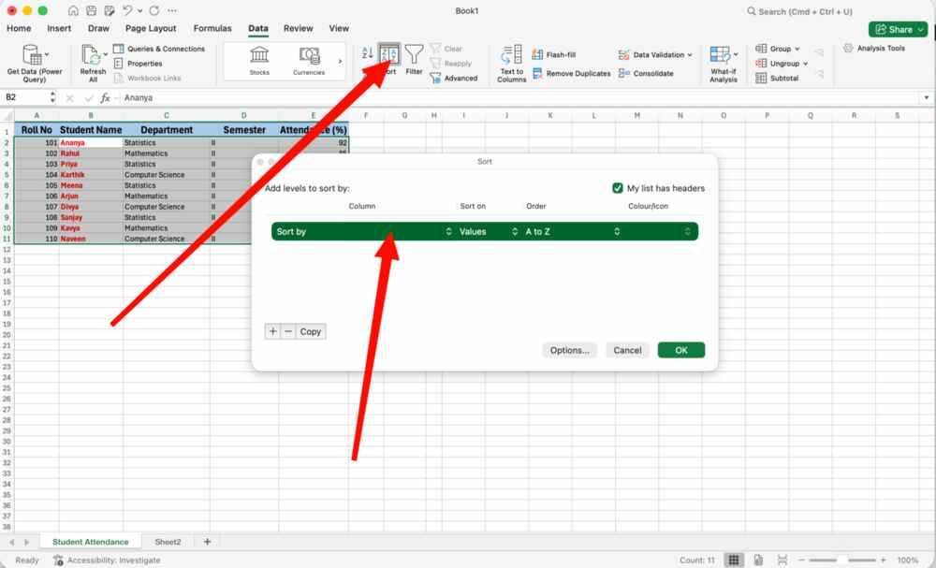
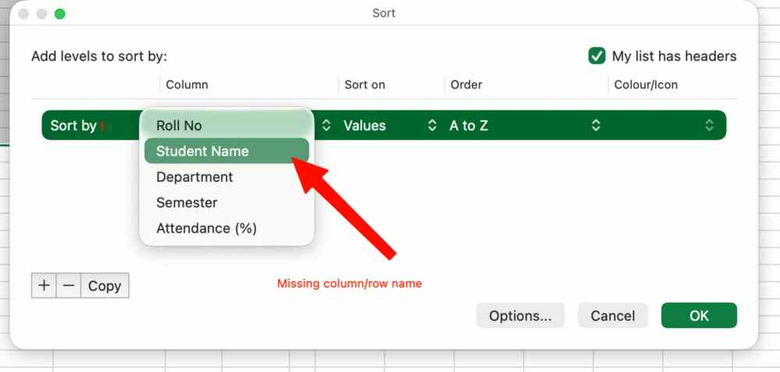
- Customize the Quick Access Toolbar by adding the New, Save, and Undo commands.
Show the customized Quick Access Toolbar to the faculty.
Quick Assess Toolbar cannot be customized on MacOS


