Assignment – 3
Introduction: Excel provides various tools to manage datasets, generate data and cleanup datasets.
Objective: Import dataset, split contact info, format the dataset, generate email addresses, remove duplicates and present dataset.
- Import the dataset
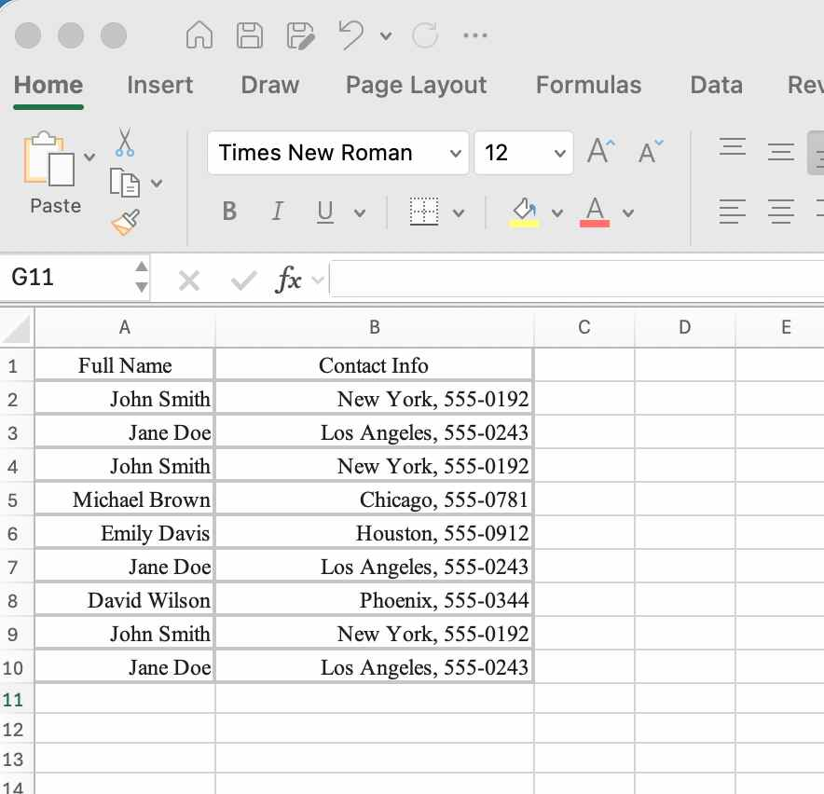
- Using the Home tab, format the worksheet by performing the following:
- Make the heading row Bold and Italic.
  - Select the heading row
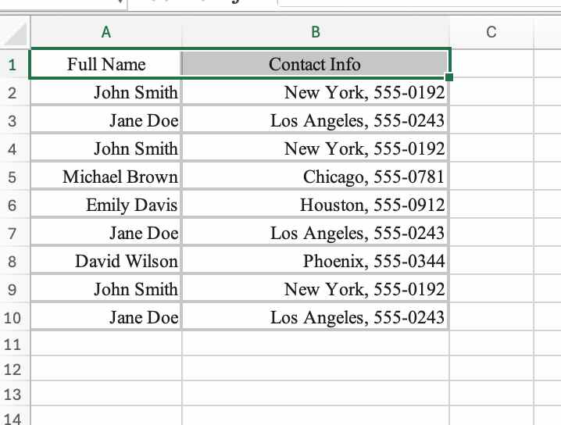
  - Click on the Bold button
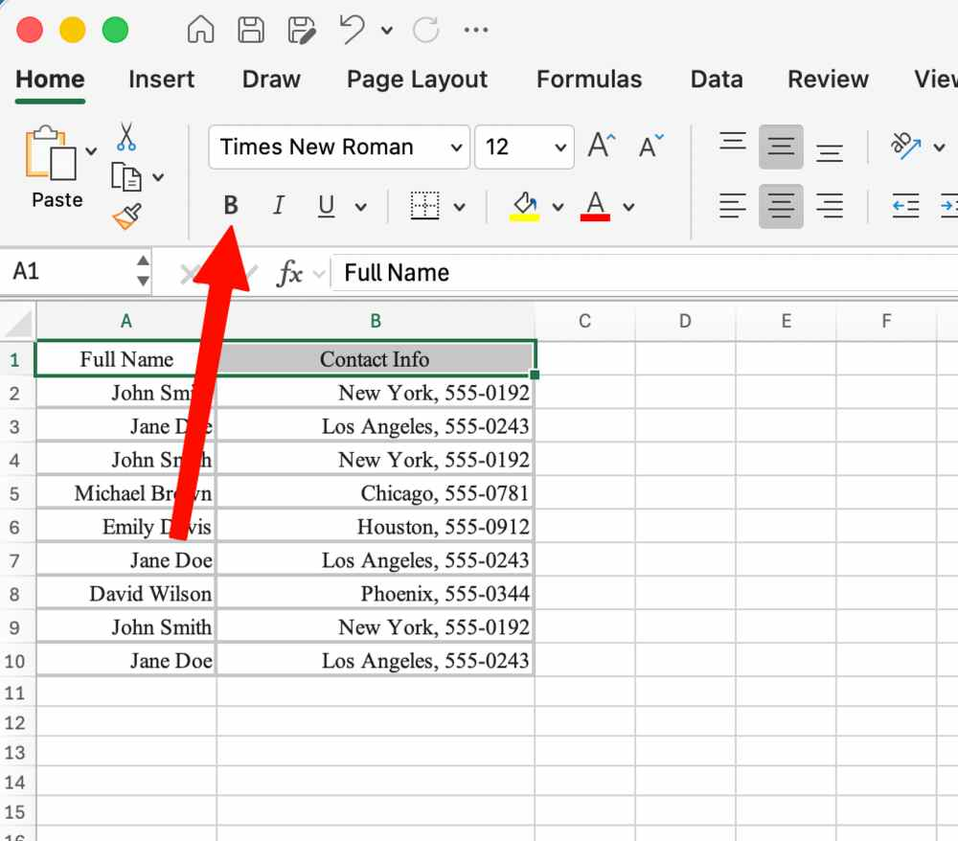
- Change the heading font size to 14.
With the heading row selected, click on the fontsize select and click on 14
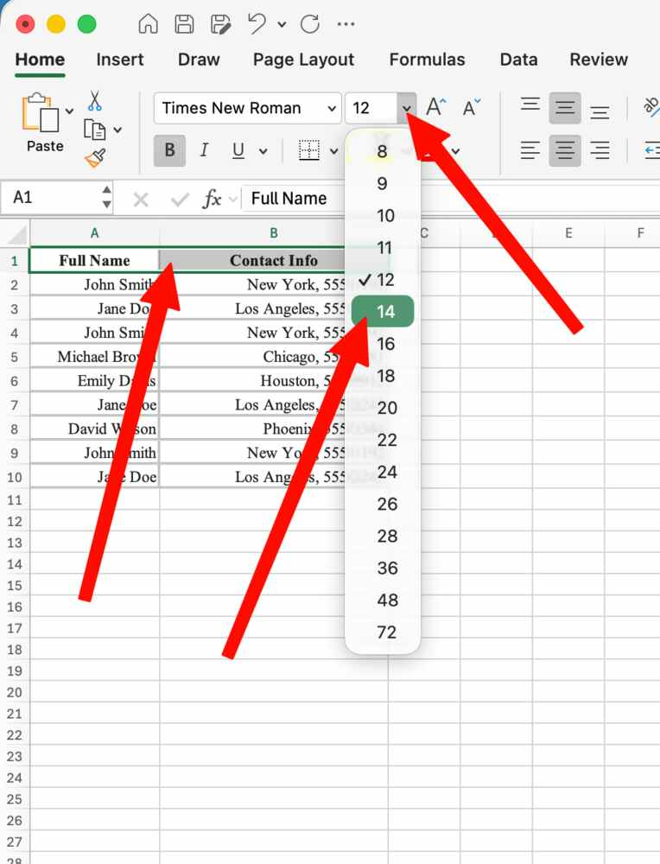
- Apply a Light Green background color to the heading row.
With the heading row selected, click on the fill bucket (background color) and then select light green.
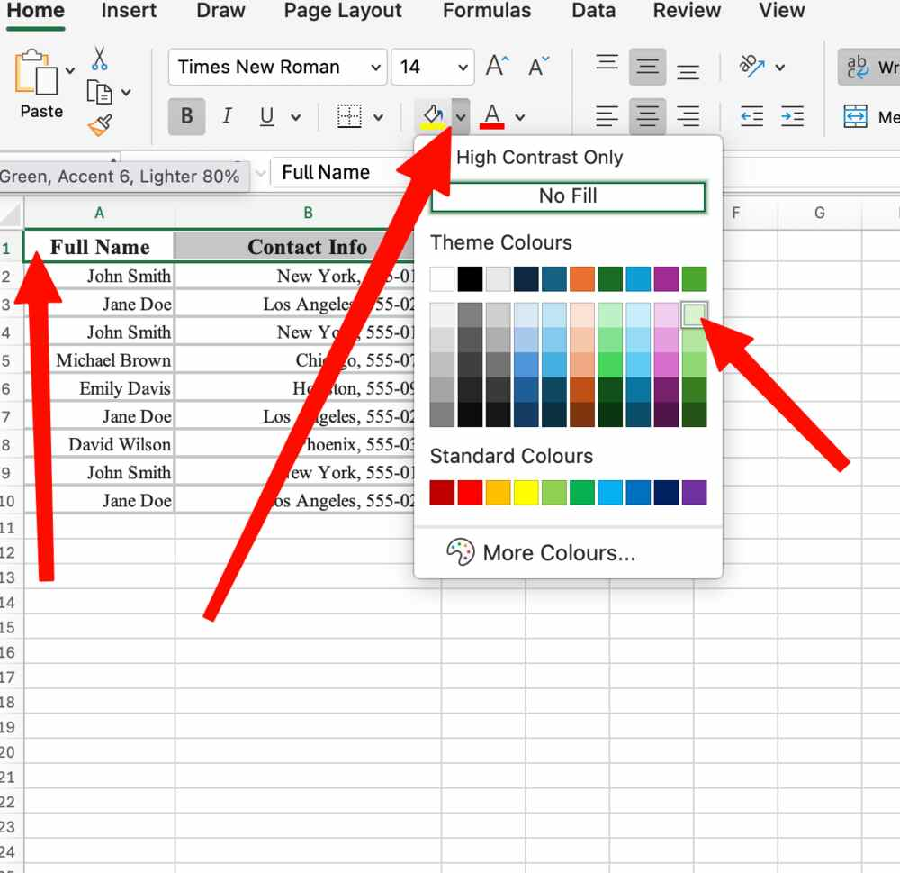
- Left-align all text columns.
Click the arrow to select all and then click on the left align icon
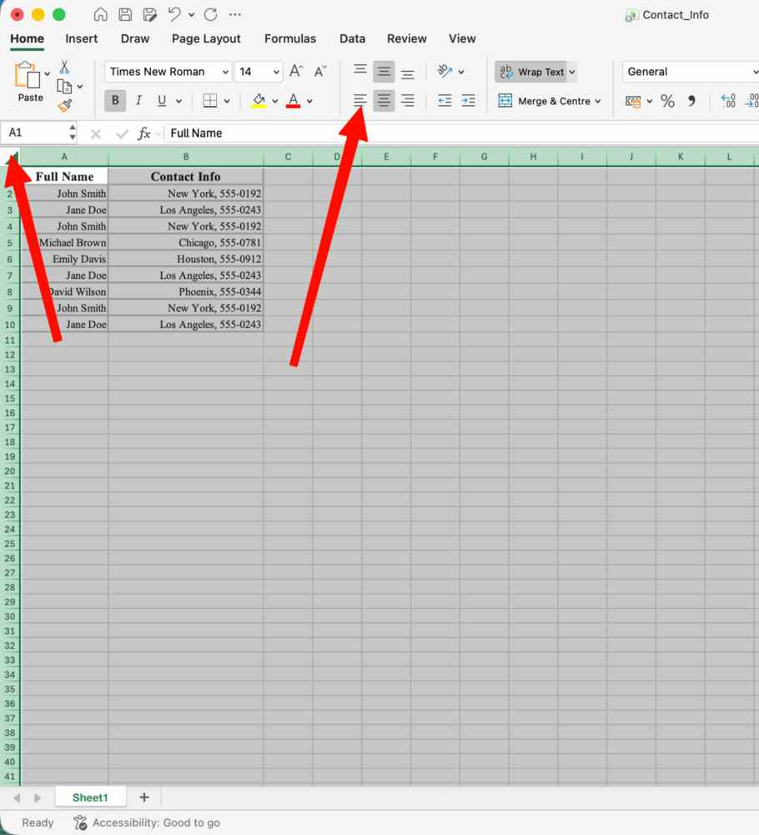
- Apply All Borders to the entire dataset.
With the Dataset selected, click on borders and then all borders.
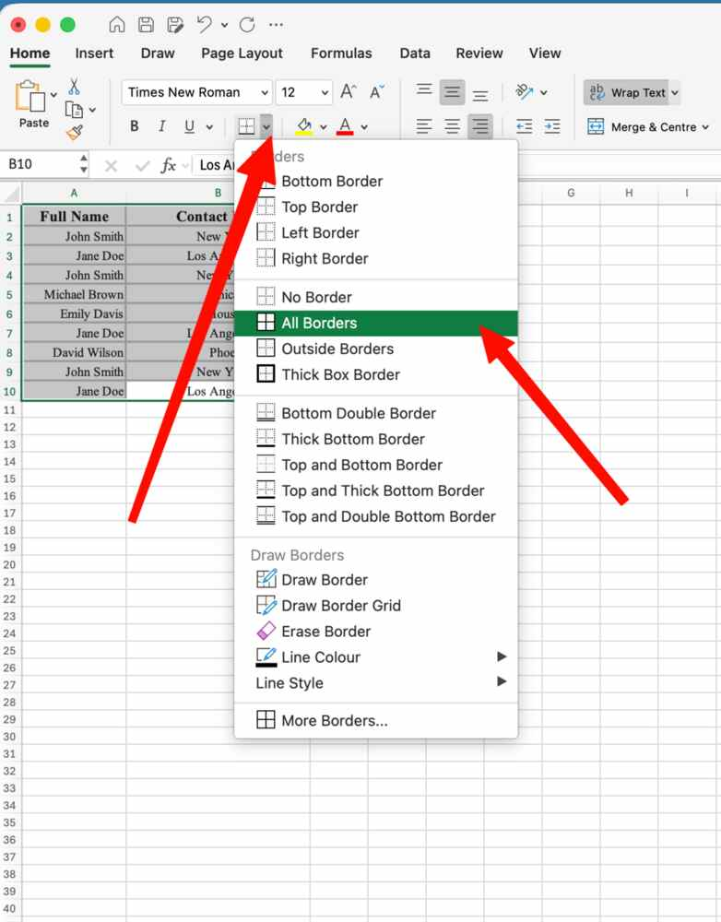
- Select the formatted dataset, use the Copy as Picture feature, and paste the resulting image into the report.
Make selection, click on copy dropdown and click on copy as picture.
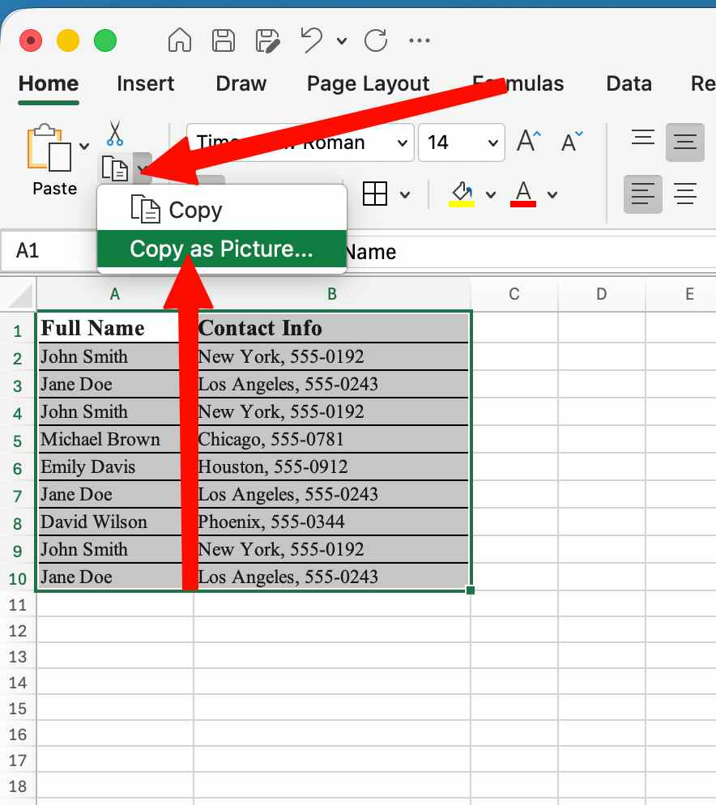

The result will be…
- Select Column B, navigate to the Data tab, use the Text to Columns wizard to split the city and phone number into two separate columns using the Comma delimiter.
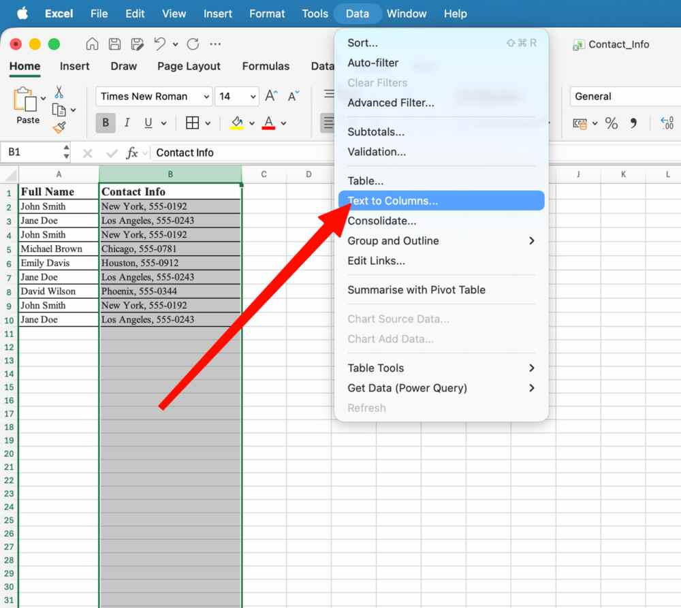
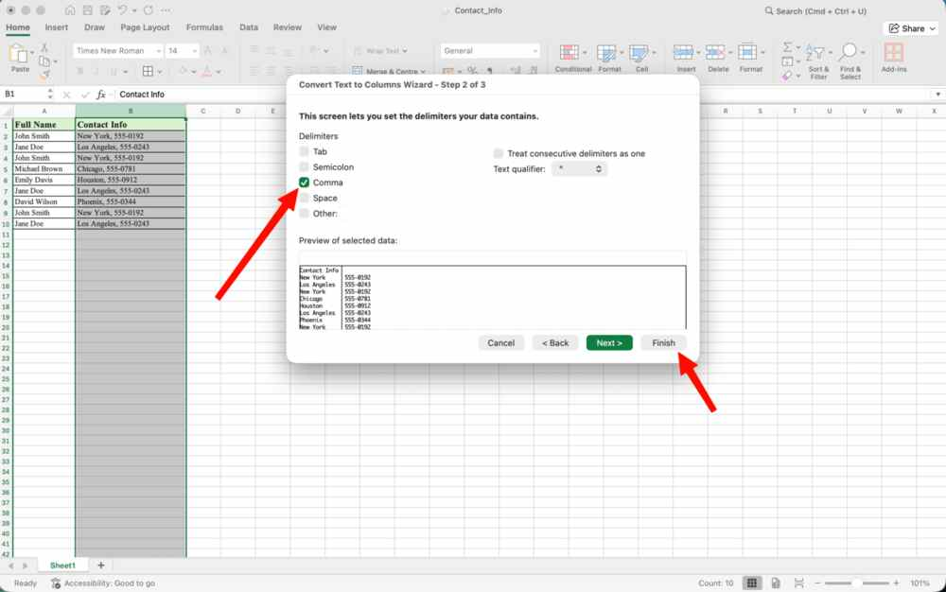
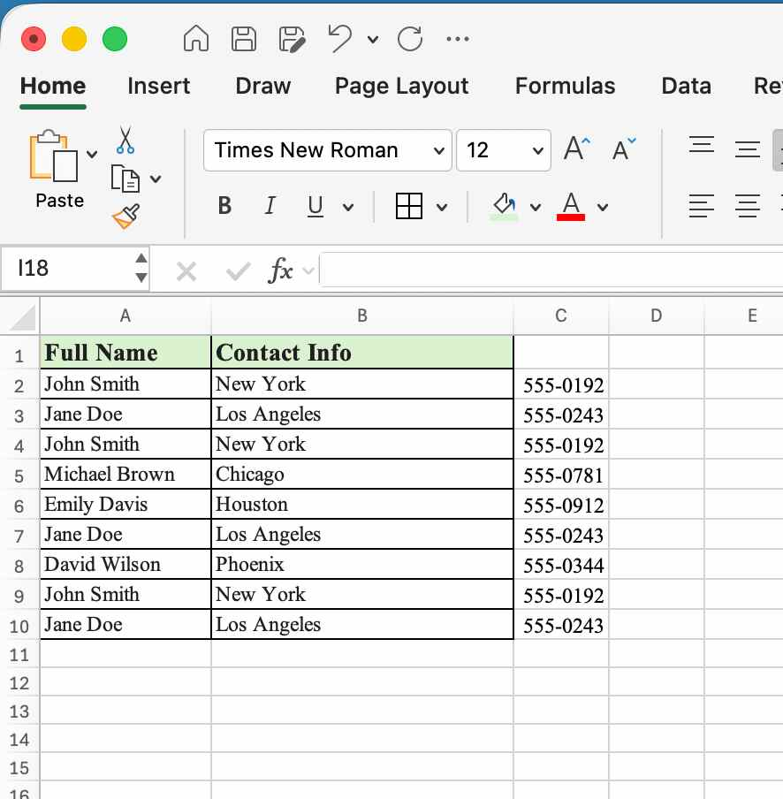

- Create a new Column (Email Output), type the first student’s email manually based on their name (e.g., john.smith@school.com). Use Flash Fill to automatically generate email addresses for the remaining rows.
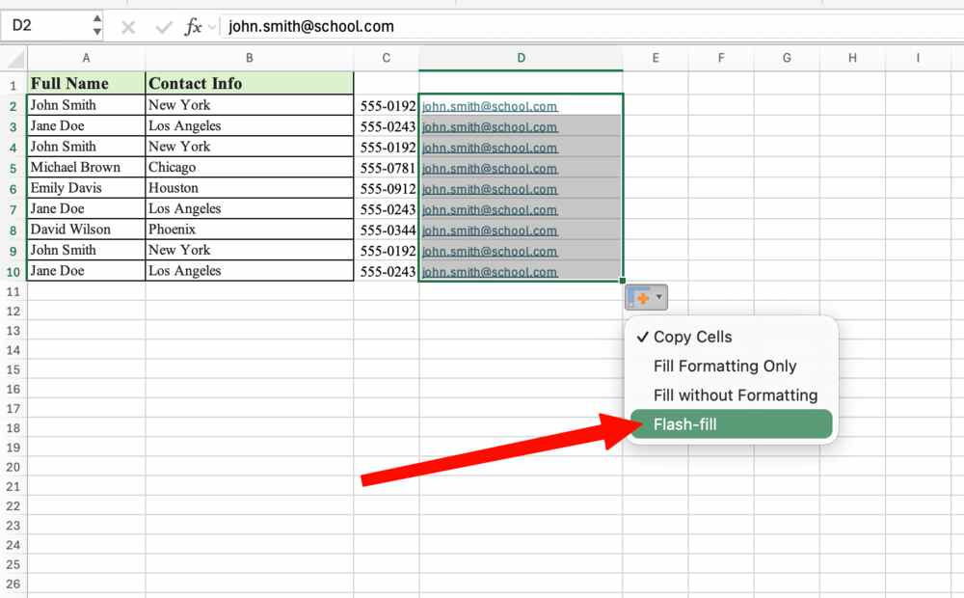
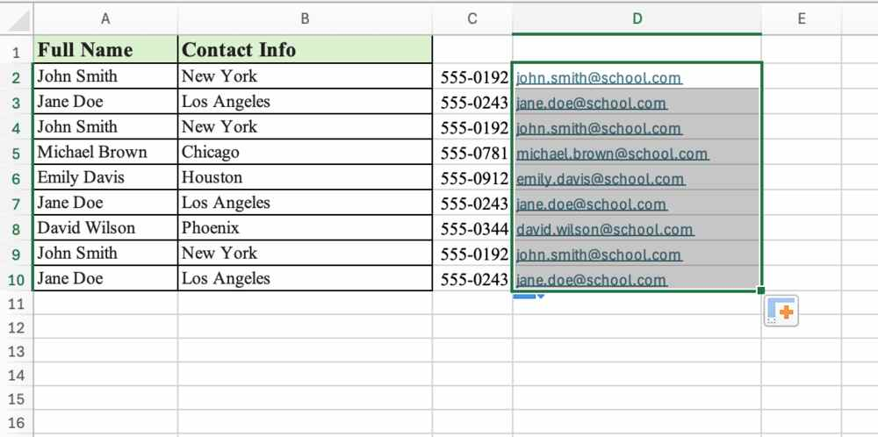
- Select the entire dataset, use the Remove Duplicates tool to delete the redundant identical rows, and show the final, cleaned dataset.
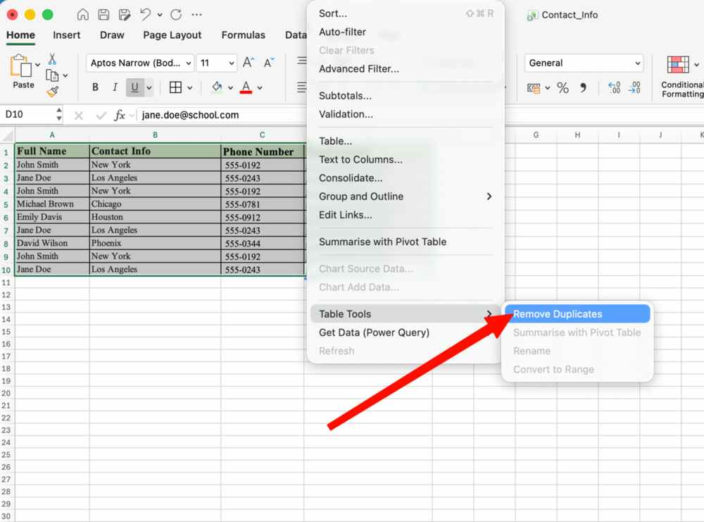
Final dataset…

Result

