Assignment – 4
Introduction: Excel has various functions for text manipulation. They can be used to clean/optimise the text data in datasets.
Objective: Utilise text manipulation functions in Excel to cleanup data in two datasets.
- Import the Customer Dataset provided into a new Microsoft Excel worksheet.
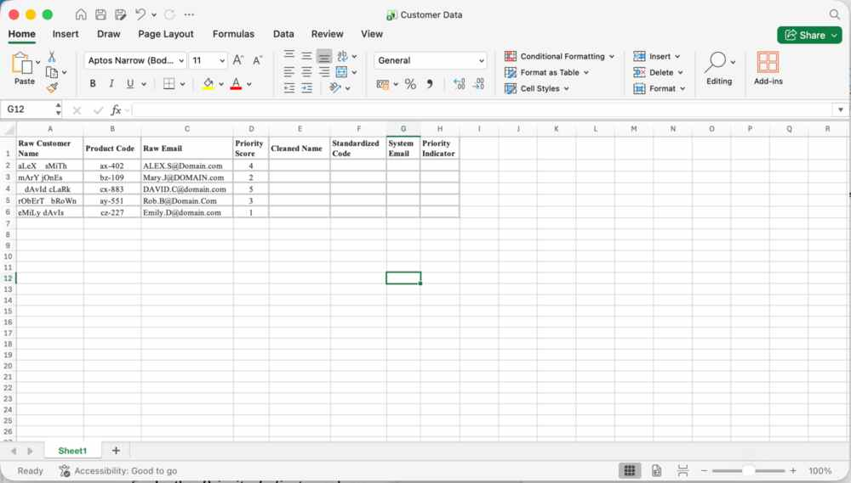
- In the Cleaned Name column, use a combination of the TRIM and PROPER functions to remove the irregular spacing and correct the capitalization of the names in Column A
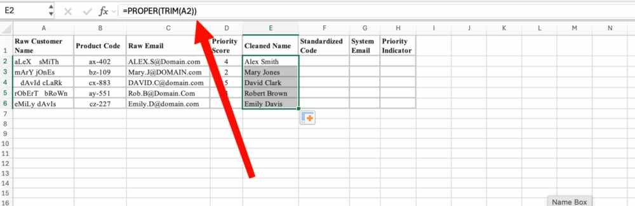
- In the Standardized Code column, use the UPPER function to convert the product codes to all uppercase letters.
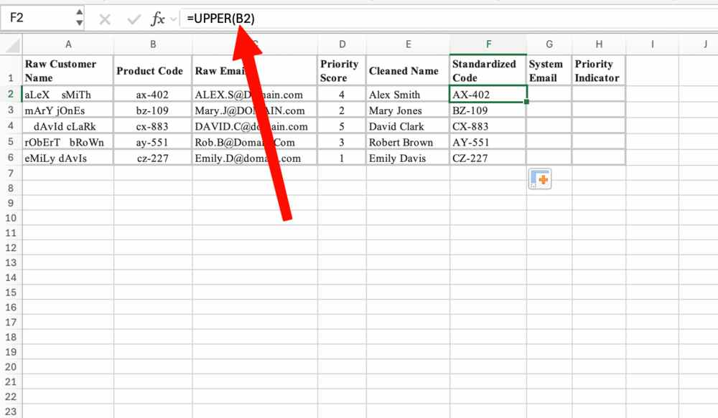
- In the System Email column, use the LOWER function to convert the raw emails to all lowercase letters.
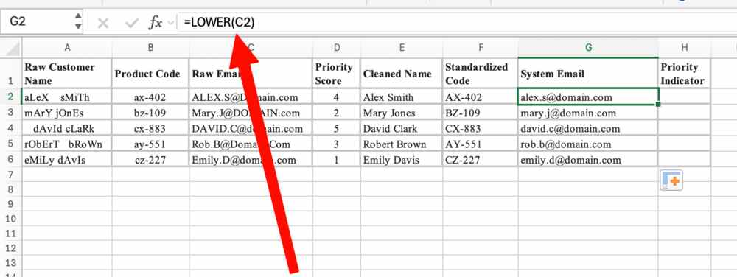
- In the Priority Indicator column, use the REPT function to visually repeat a star symbol “*” (or a character of your choice) based on the number provided in the Priority Score column. Show the fully cleaned and formatted table to the faculty.
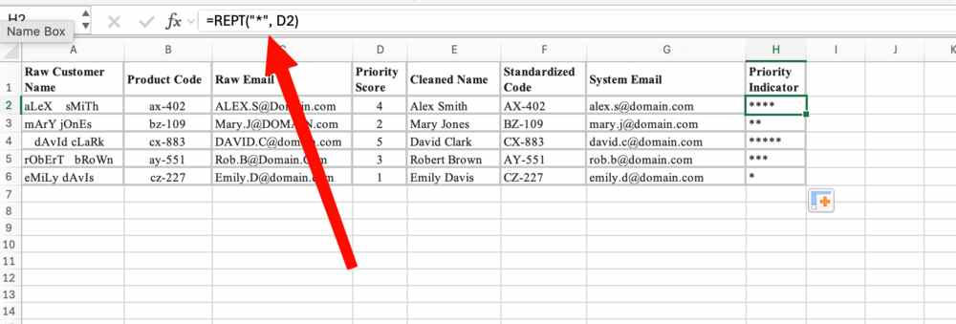
- Import the Employee Directory Update Dataset provided into a new Microsoft Excel worksheet.
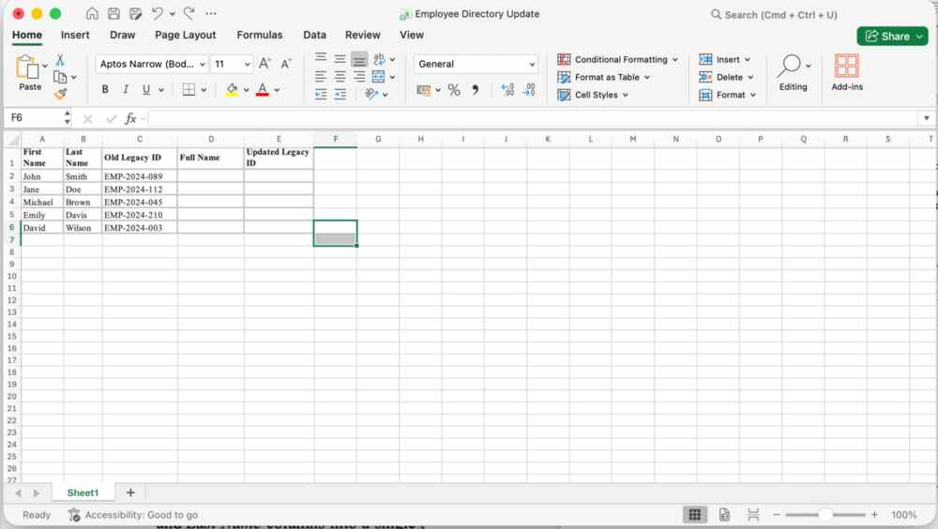
- In the Full Name column, use the CONCATENATE function to merge the First Name and Last Name columns into a single string, ensuring you include a blank space (“ ”) between the names.
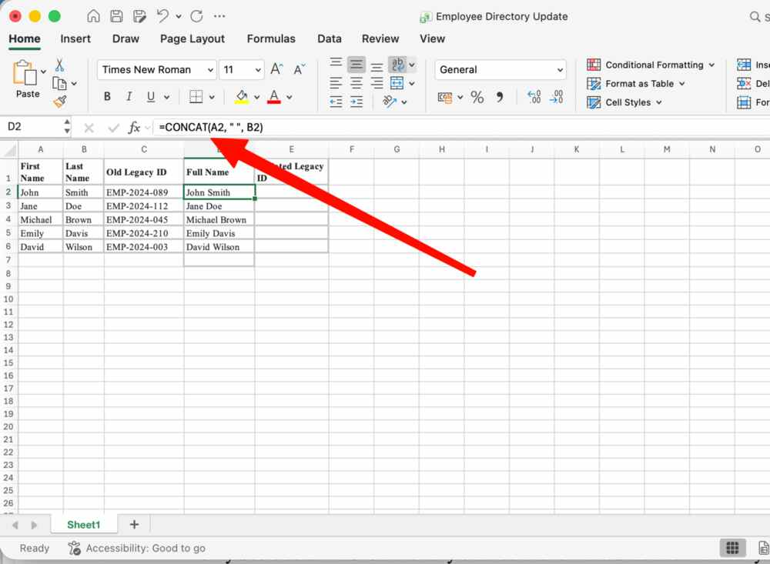
- In the Updated Legacy ID column, use the SUBSTITUTE function to search through the Old Legacy ID column and automatically replace the outdated year code “2024” with the current year code “2026”.


