Assignment – 5
Introduction: Excel has various functions for text selection and data conversion
Objective: Utilise such functions in Excel to cleanup data in two datasets.
- Import or create the Raw logistics dataset provided into a new Microsoft Excel worksheet.
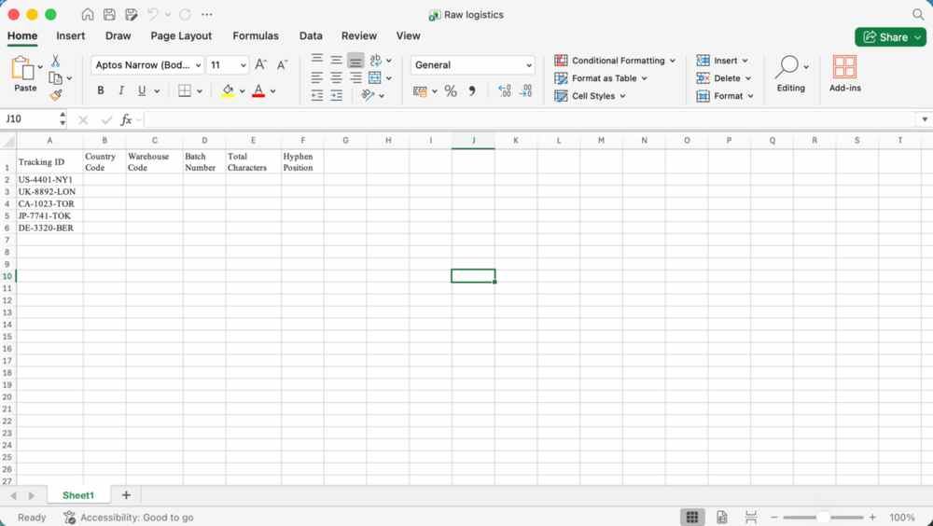
- Using the Home tab, format the worksheet by performing the following:
  - Make the heading row Bold.
Selectheading row, click on bold icon in home tab
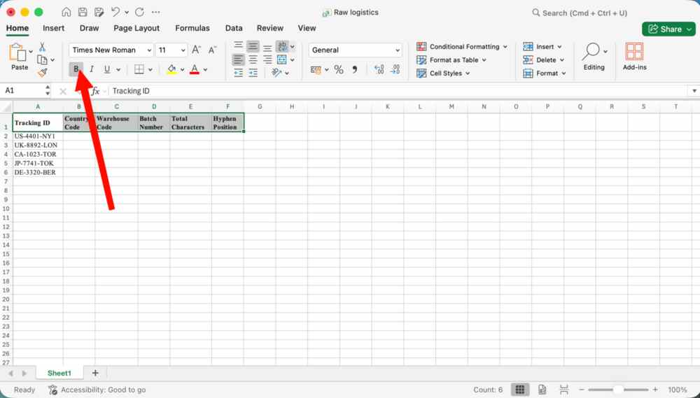
  - Change the heading font size to 14.
Select heading row, click on font size dropdown in home tab, click on 14
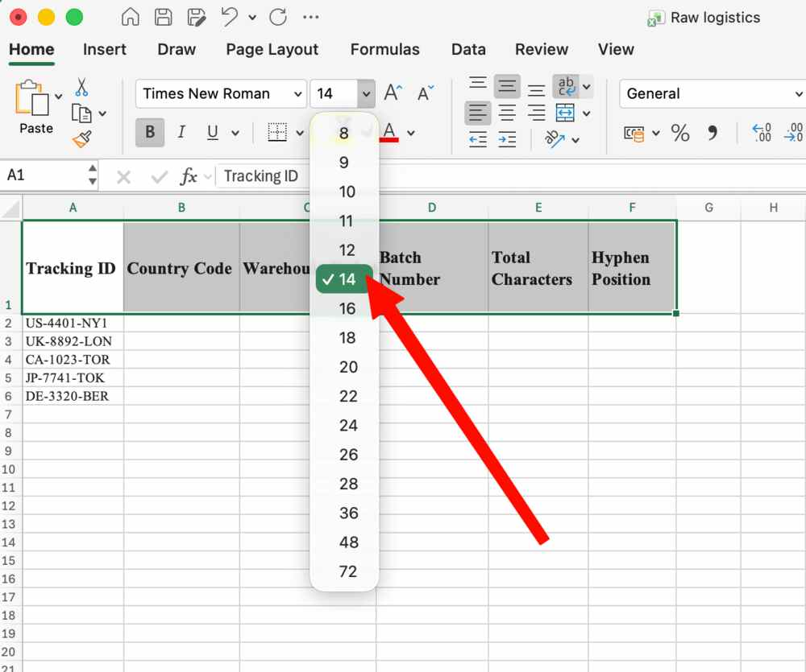
  - Apply a Light Purple background fill colour to the heading row.
Select heading row, click on background color drop down, select light purple shade.
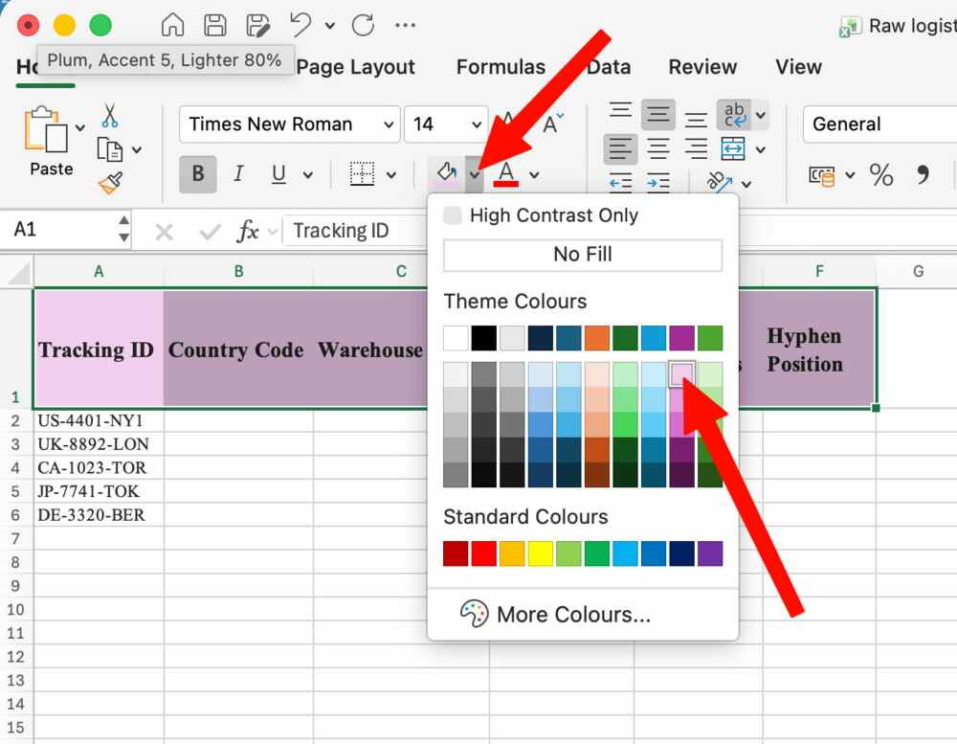
  - Centre-align all columns except the original Tracking ID column.
Select all the columns except tracking ID, click on centre align icon in home tab
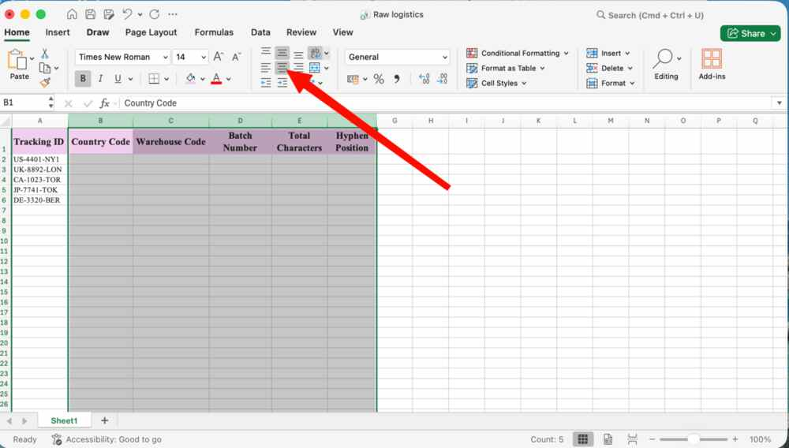
  - Apply All Borders to the entire data set.
Select the dataset, click on borders dropdown in home tab, click on all borders
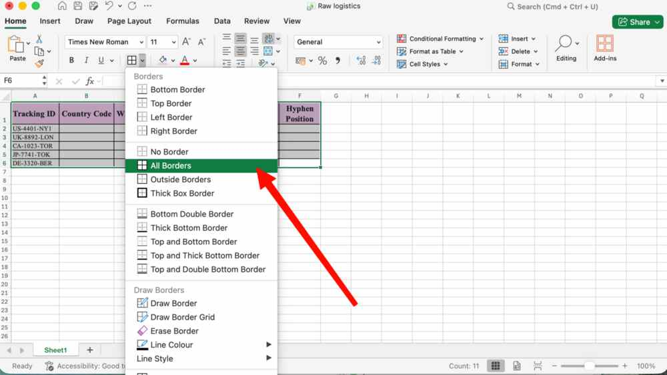
- In the Country Code column, use the LEFT function to extract the first 2 characters from the Tracking ID.
Use formula =LEFT(A2,2) and smart fill
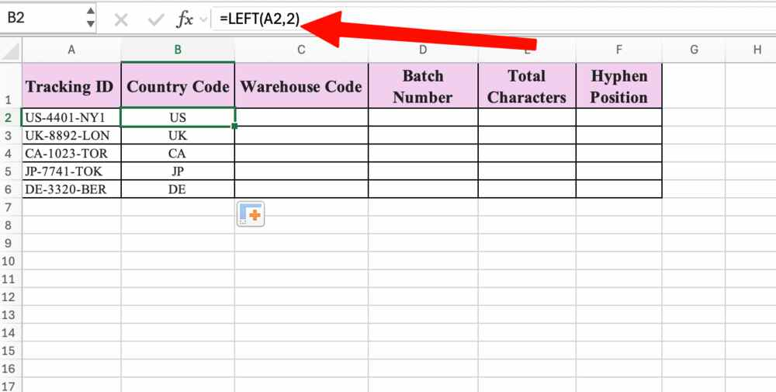
- In the Warehouse Code column, use the RIGHT function to extract the last 3 characters from the Tracking ID.
Use formula =RIGHT(A2,3) and smart fill
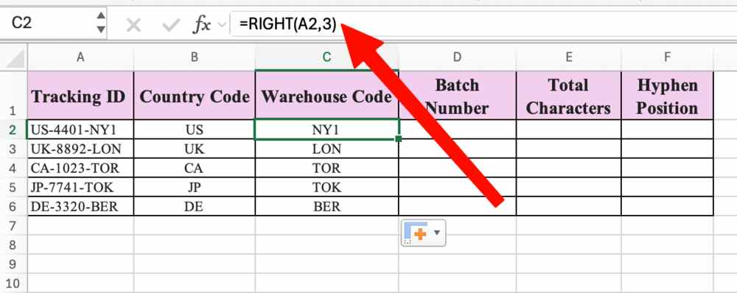
- In the Batch Number column, use the MID function to extract the 4-digit numerical batch located in the middle of the Tracking ID (starting at the 4th character).
Use formula =MID(A2,4,4) and smart fill
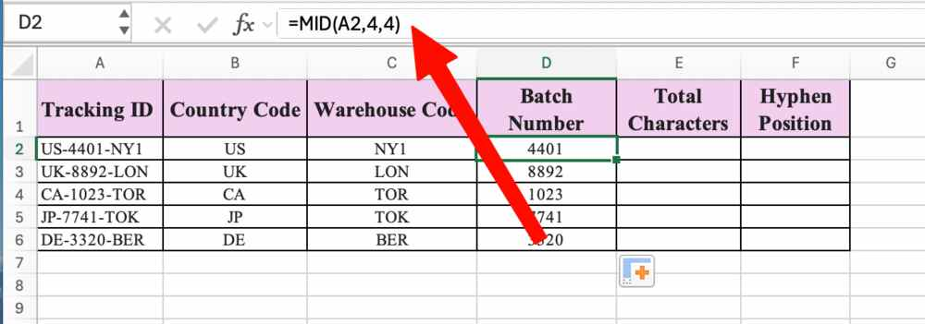
- In the Total Characters column, use the LEN function to calculate the complete length of the Tracking ID string.
Use formula =LEN(A2) and smart fill
- 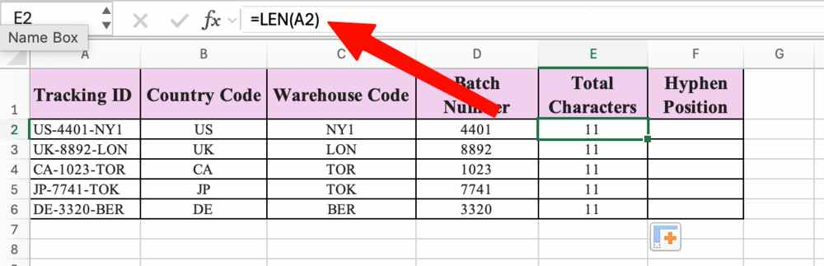
- Import the International shipping dataset provided into a new Microsoft Excel worksheet.
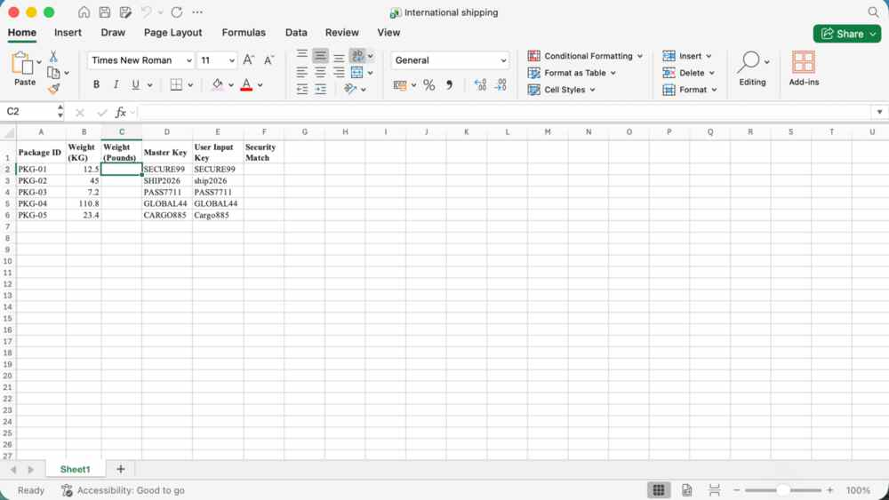
- In the Weight (Pounds) column, use the CONVERT function to transform the value in the Weight (KG) column from kilograms to pounds (Hint: Use ‘kg’ as the from_unit and “lbm” as the to_unit).
Use formula =CONVERT(B2,”kg”,”lbm”) and smart fill
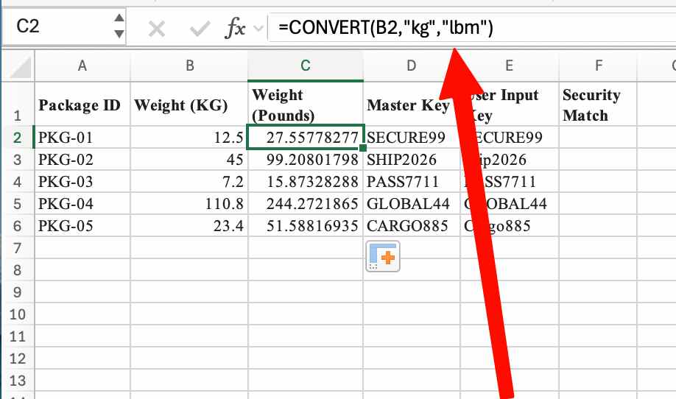
- In the Security Match column, use the EXACT function to perform a strict, case-sensitive comparison between the Master Key and the User Input Key to check if they match perfectly.
Use formula =EXACT(D2,E2) and smart fill


