Assignment – 6
Introduction: Excel has various functions that can be used to optimise datasets.
Objective: Utilise such functions in Excel to cleanup data in two datasets.
- Import the Product Logistics Dataset provided into a new Microsoft Excel worksheet.
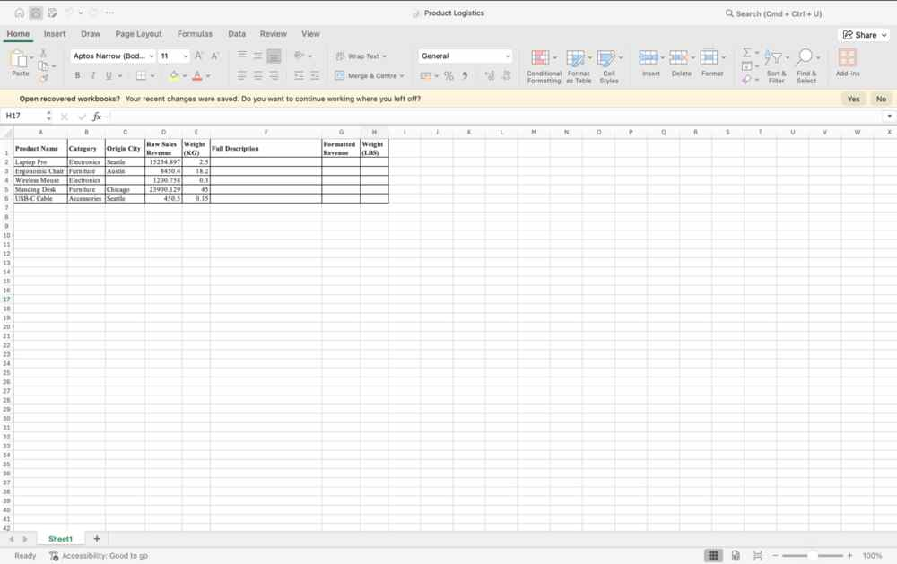
- In the Full Description column, merge the Product Name, Category, and Origin City into a single text string with a space delimiter (“ “).
Enter formula =TEXTJOIN(" ", TRUE, B2:D2) in F2, drag and smart fill in rest of the rows
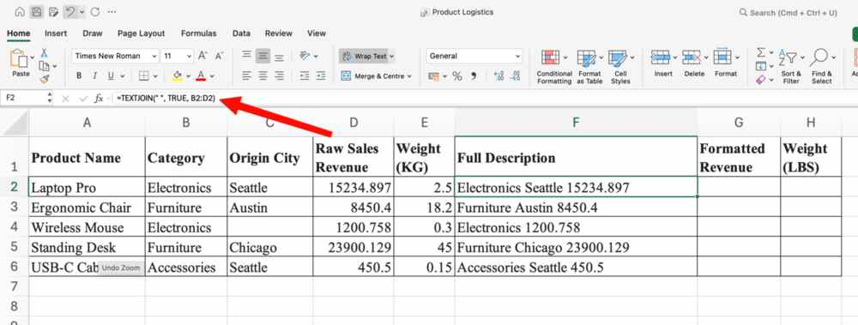
- In the Formatted Revenue column, round the Raw Sales Revenue to 2 decimal places with standard comma separators formatted as text.
Enter formula =ROUND(D2,2) and drag with smart fill
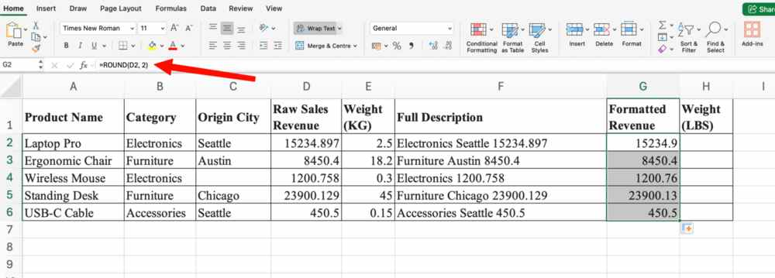
Click on number format dropdown in home tab and click on more formats
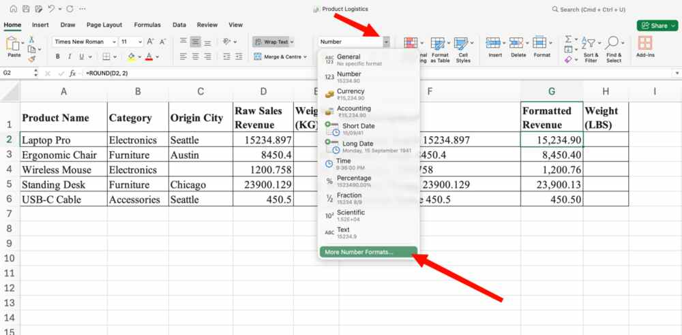
Set formatting for the number and click on OK.
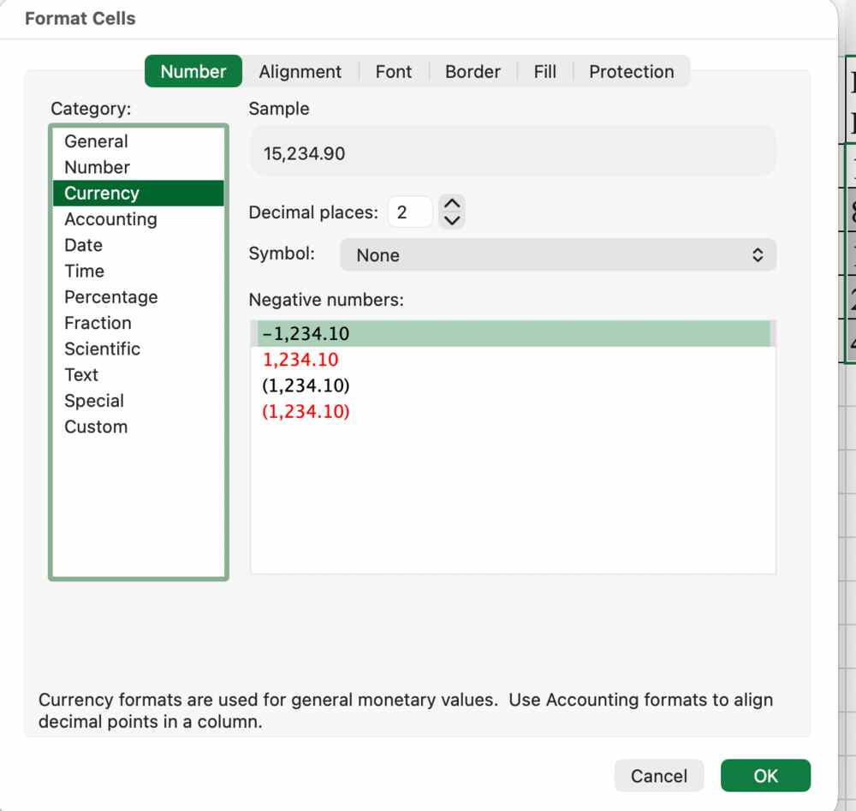
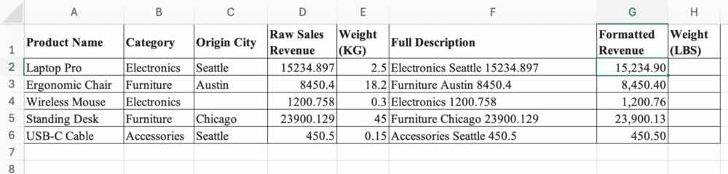
- In the Weight (LBS) column, convert the Weight (KG) values from kilograms (“kg”) into pounds (“lbm”).
Use Formula =CONVERT(CELL, “kg”, “lbm” and smart fill to other rows
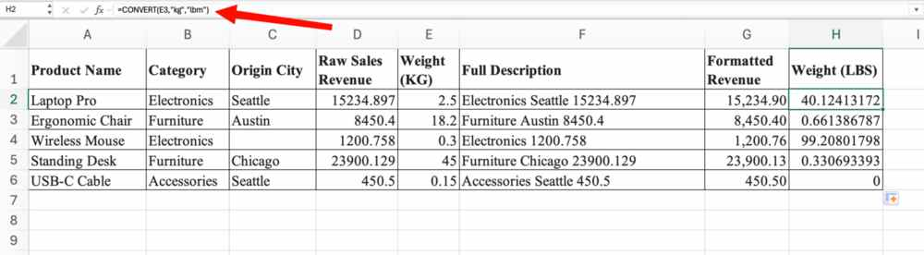
- Apply All Borders to the entire dataset, bold the heading row with a Light Teal background fill.
Select whole dataset, Click on the Borders drop-down in the home tab and click on all borders
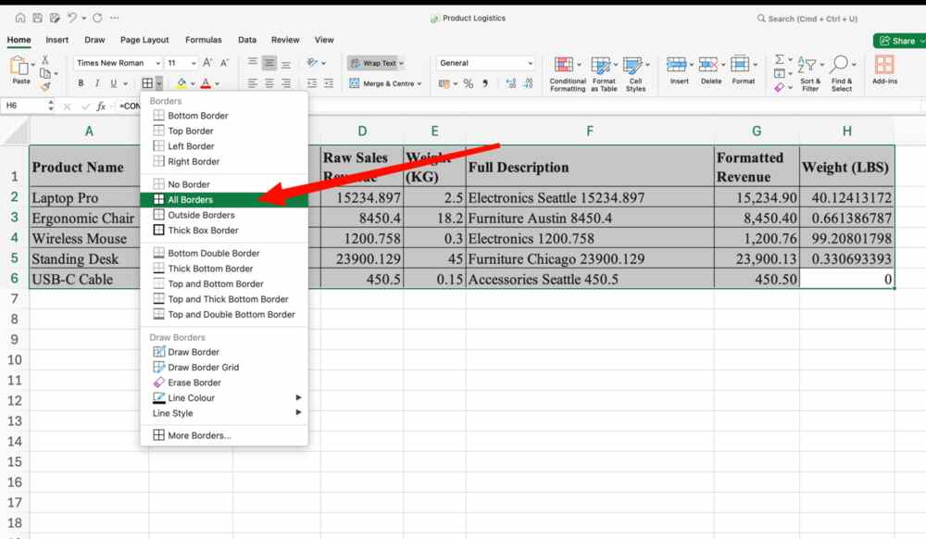
Select heading row, click on Bold in home tab
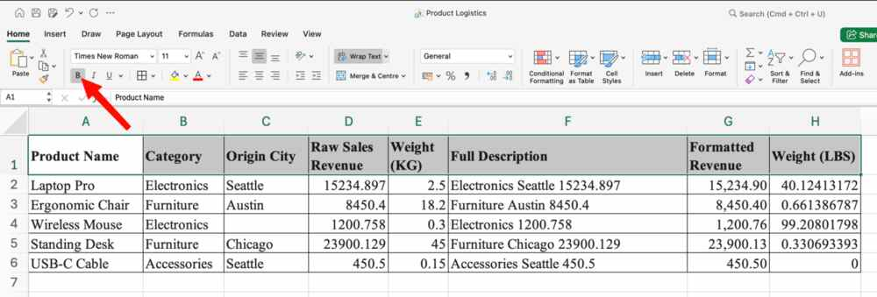
With the heading row selected, click on bucket fill dropdown for background fill colours and then click on light teal.
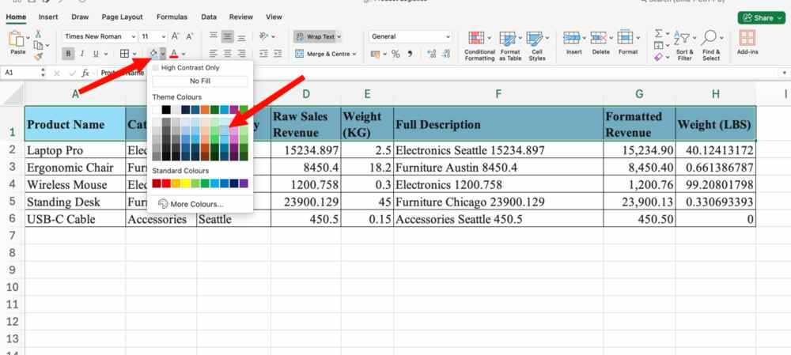
- Import the Experimental Time-Series Dataset provided into a new Microsoft Excel worksheet.
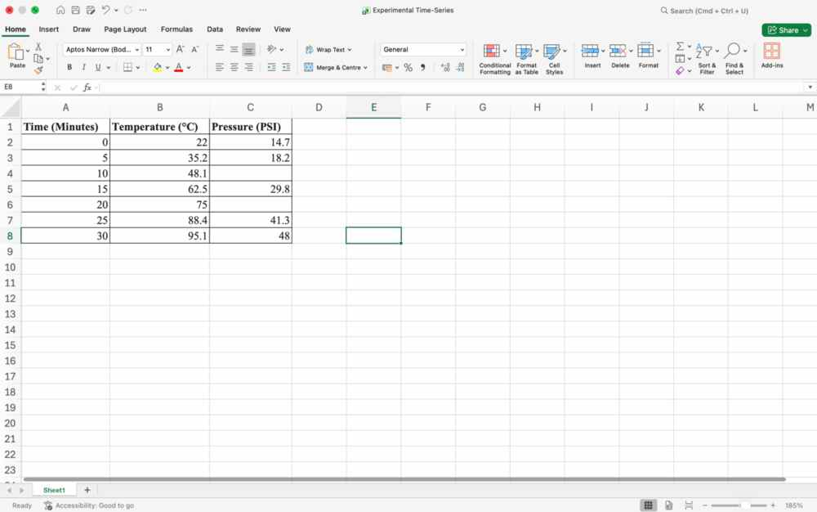
- Select the Time (Minutes) and Pressure (PSI) columns, create a Scatter with Straight Lines and Markers chart.
Select the two columns, go to insert tab, click on recommended charts and click on Scatter.
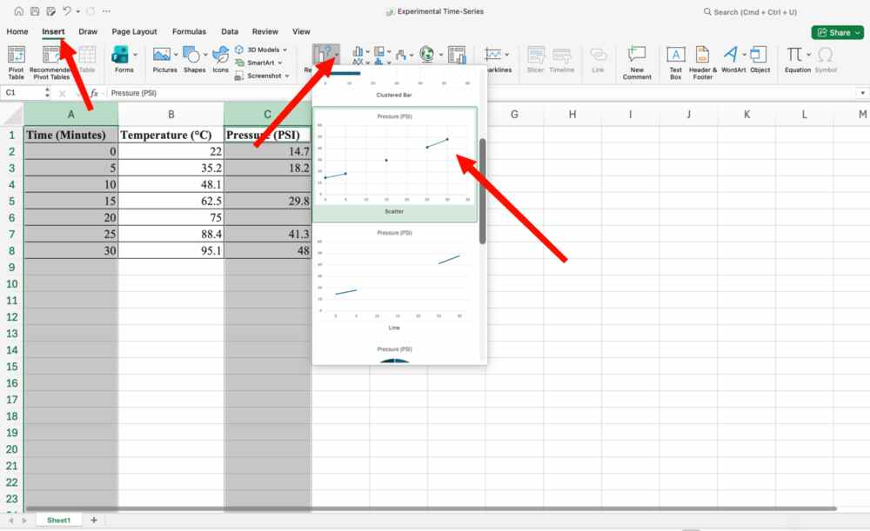
Or otherwise, you can click the scatter icon and click on scatter with straight lines
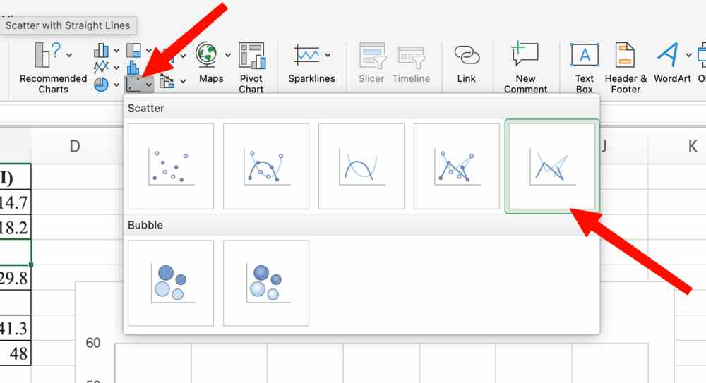
- Observe the gaps/discontinuities in the connecting line caused by the blank/missing data points in the dataset.
Gaps have been identified
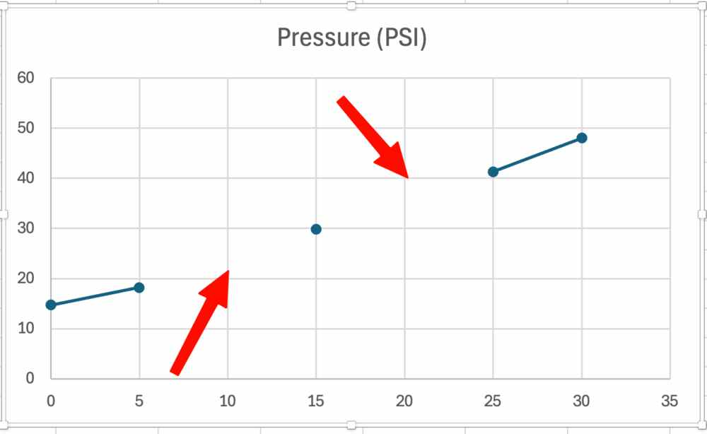
- Connect data points with line (or test replacing blank cells with =NA() to evaluate line continuity).
Enter =NA() in empty data and received a continuous chart.
- 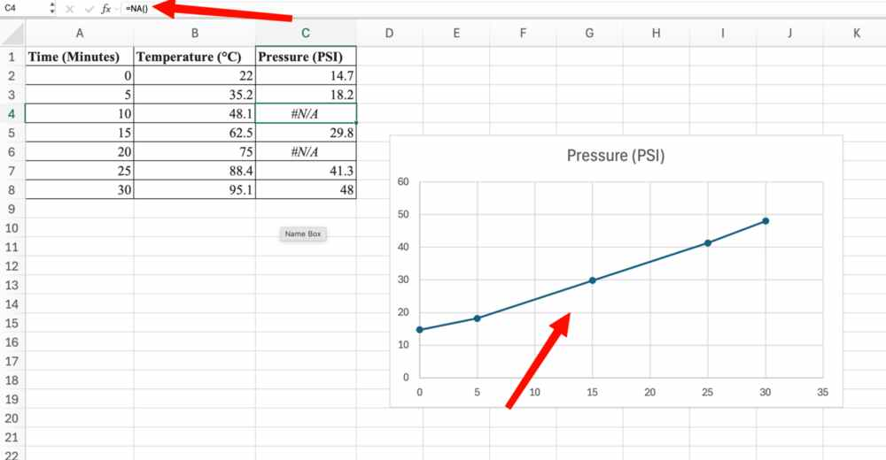
- Format the chart with a proper title (“System Pressure Over Time”) and Axis Titles.
Double click chart title, replace with new text
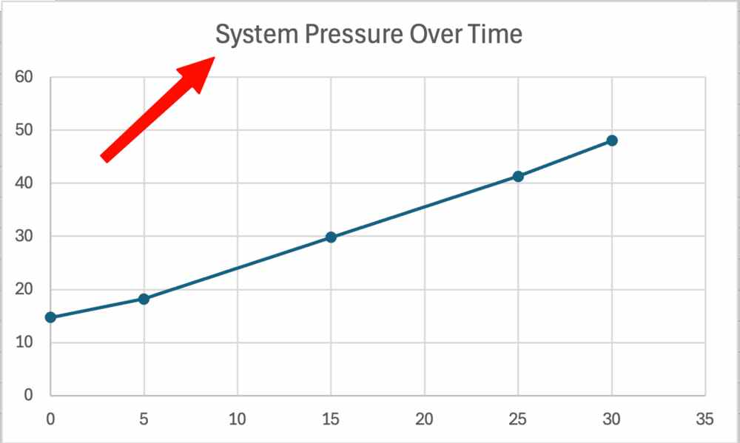

If there is no initial title, go to Chart Design, go to insert chart element and click on Chart title, finally add a title.
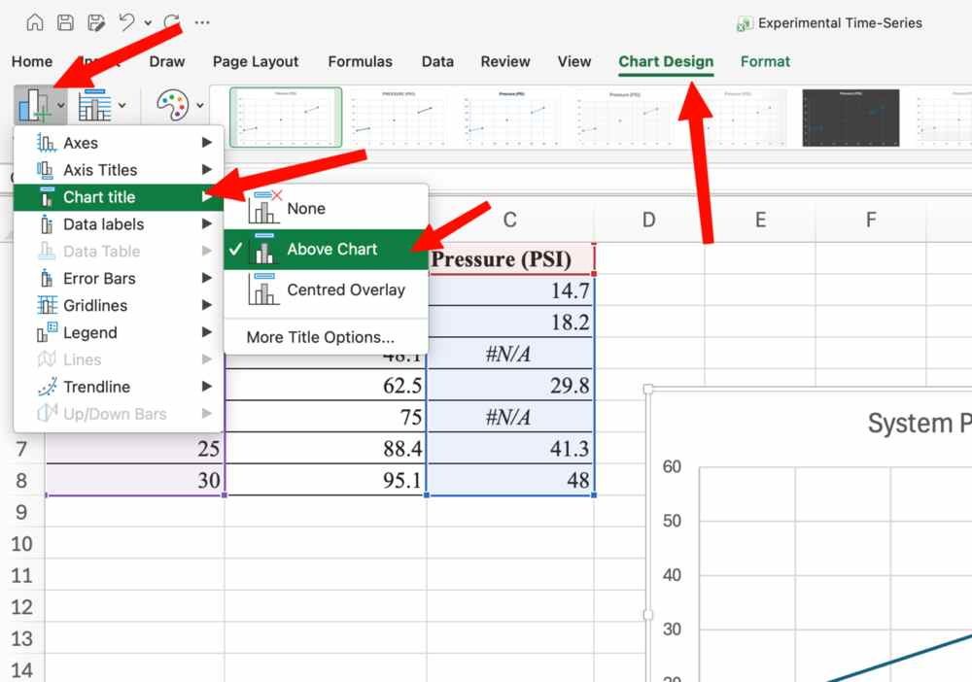
Similarly add Axis titles and double click to change. 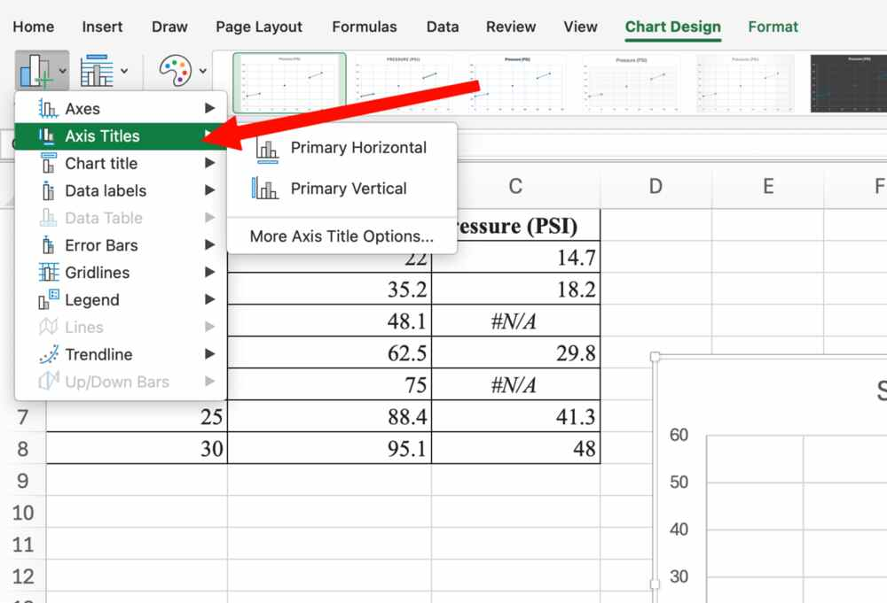
Result:


